UNIX

Assignment - 7

1. Write shell script for commands : more,nl,nice,passwd,pr,rlogin,rcp,rsh,talk,telnet,tput,tty,uname,wc,who,write
2. #!/bin/bash
3. # more command
4. more -d sample.txt
5. echo " "
6. more -f sample.txt
7. echo " "
8. more -p sample.txt
9. echo " "
10. more -c sample.txt
11. echo " "
12. more -s sample.txt
13. echo " "
14. more -u sample.txt
15. echo " "
16. more +30 sample.txt
17. echo " "
18. more +/reset sample.txt
19. # # nl command
20. nl file.txt
21. echo " "
22. nl -b a file.txt
23. echo " "
24. nl -l 1 file.txt
25. echo " "
26. nl -b a -l 3 file.txt
27. echo " "
28. nl -i 3 file.txt
29. echo " "
30. nl -v 4 file.txt
31. echo " "
32. nl -s "..." file.txt
33. echo " "
34. nl -w2 file.txt
35. echo " "
36. nl -n ln file.txt
37. # # pr command
38. pr --pages=1:2 list1.txt
39. echo
40. pr --columns=2 list1.txt
41. echo
42. pr -a list1.txt
43. echo
44. pr -c list1.txt
45. echo
46. pr -d list1.txt
47. echo
48. pr -D "%Y-%m-%d" list1.txt
49. echo
50. pr -e list1.txt
51. echo
52. pr -F list1.txt
53. echo
54. pr -h "Header" list1.txt
55. echo
56. pr -i$'\t' list1.txt
57. echo
58. pr -J list1.txt
59. echo
60. pr -l 26 list1.txt
61. echo
62. pr -m list1.txt list2.txt
63. echo
64. pr -n list1.txt
65. echo
66. pr -o 5 list1.txt
67. echo
68. pr -r list1.txt
69. echo
70. pr -sCHAR list1.txt
71. echo
72. pr -SSTRING list1.txt
73. echo
74. pr -t list1.txt
75. echo
76. pr -T list1.txt
77. echo
78. pr -v list1.txt
79. echo
80. pr -w 3 list1.txt
81. echo
82. # # who command
83. who
84. echo " "
85. who -m -H
86. echo " "
87. who -p -H
88. echo " "
89. who -T -H
90. echo " "
91. who -u
92. echo " "
93. who -b -H
94. echo " "
95. who -d -H
96. echo " "
97. who -l -H
98. echo " "
99. who -q -H
100. echo " "
101. who -r
102. echo " "
103. who -a
104. echo " "
105. whoami
106. echo " "
107. w
108. echo " "
109. id
110. echo " "
111. # # wc command
112. wc state.txt capital.txt
113. echo " "
114. wc -l state.txt capital.txt
115. echo " "
116. wc -w state.txt capital.txt
117. echo " "
118. ec -c state.txt capital.txt
119. echo " "
120. wc -m state.txt capital.txt
121. echo " "
122. wc -L state.txt capital.txt
123. echo " "
124. # # uname command
125. uname -a
126. echo " "
127. uname -s
128. echo " "
129. uname -n
130. echo " "
131. uname -r
132. echo " "
133. uname -v
134. echo " "
135. uname -m
136. echo " "
137. uname -p
138. echo " "
139. uname -i
140. echo " "
141. uname -o
142. echo " "
143. # # tty command
144. sudo tty
145. tty --version
146. # tput command
147. tput longname
148. echo " "
149. tput cols
150. echo " "
151. tput -T screen longname
152. echo " "
153. tput cup 5 20
154. echo " "
155. tput hc
156. echo " "
157. tput init
158. echo " "
159. tput clear
160. # #passwd command
161. passwd
162. echo " "
163. passwd -l lithin
164. passwd -u lithin

Sample.txt , file.txt :

Lithin

Kamalesh

Sai

Harshith

Karthik

Govardhan

Capital.txt :

Hyderabad

Itanagar

Dispur

Patna

Raipur

List1.txt :

Virginia

Connecticut

Connecticut

Delaware

Georgia

Maryland

Massachusetts

New Hampshire

New Jersey

New York

North Carolina

North Carolina

North Carolina

Pennsylvania

Rhode Island

South Carolina

Output :

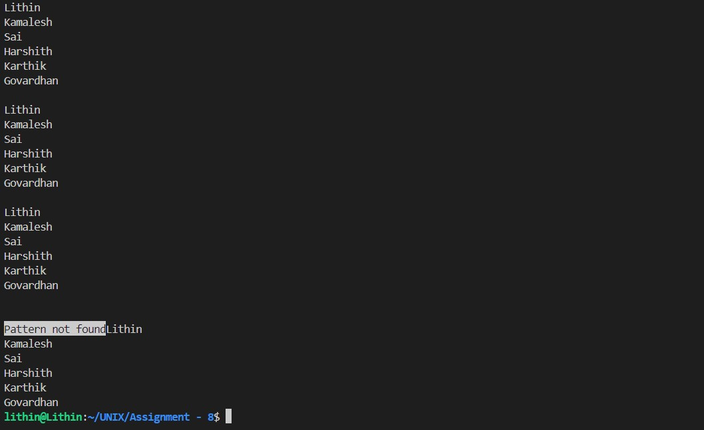

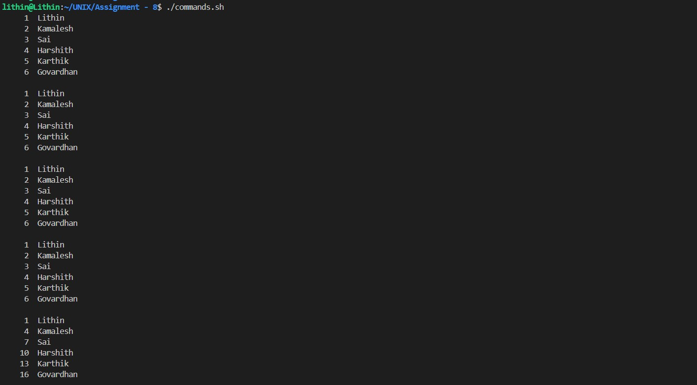

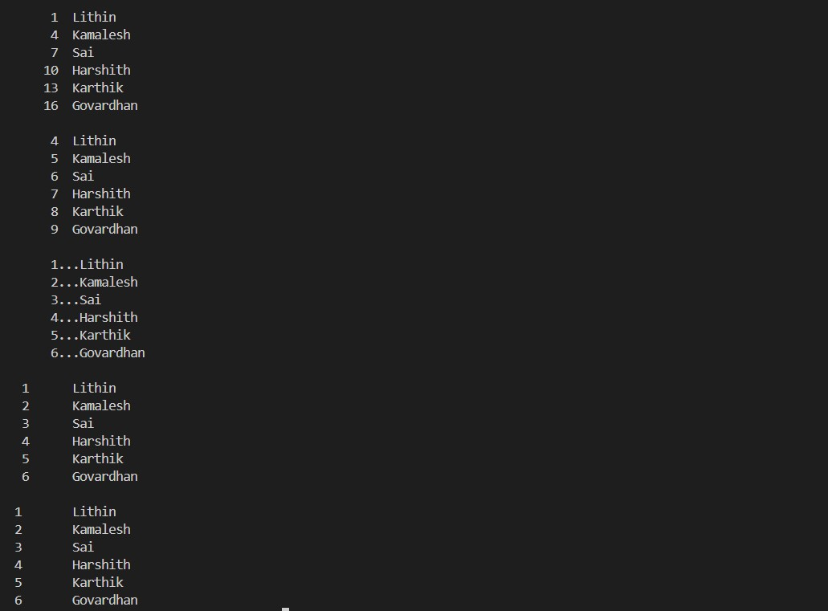

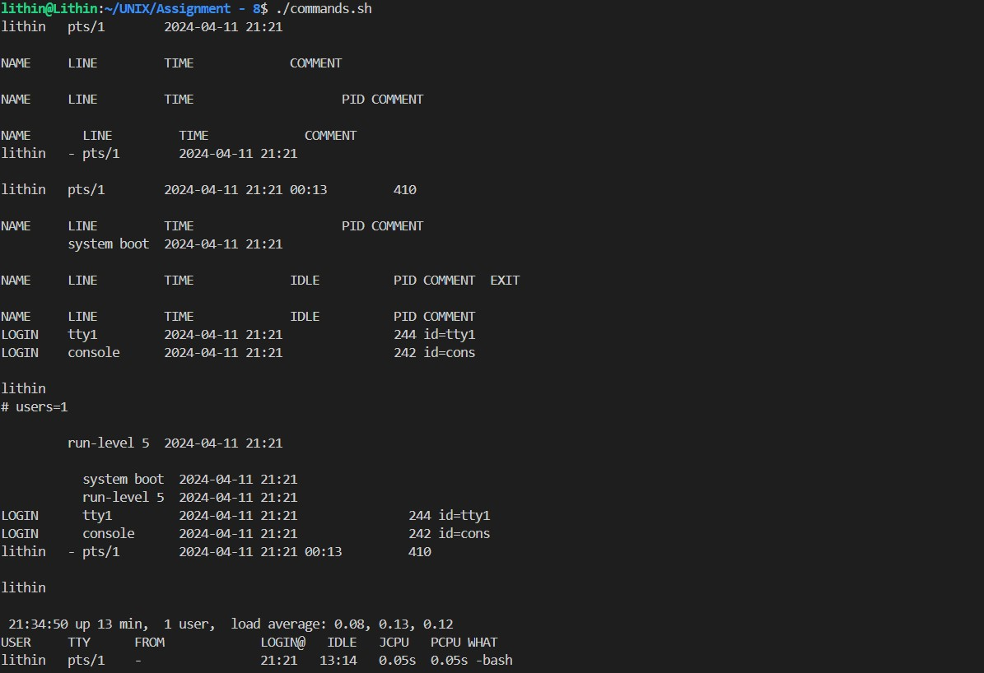

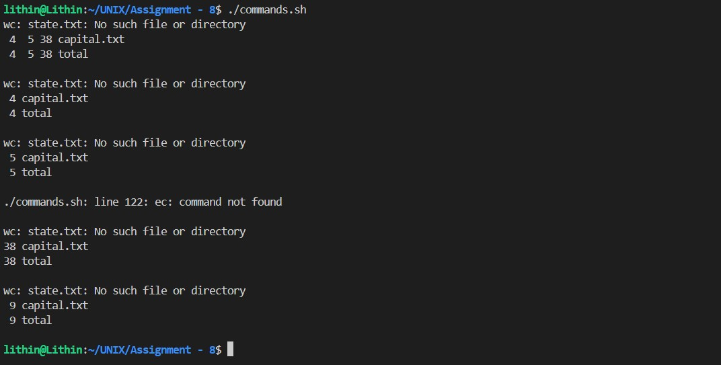



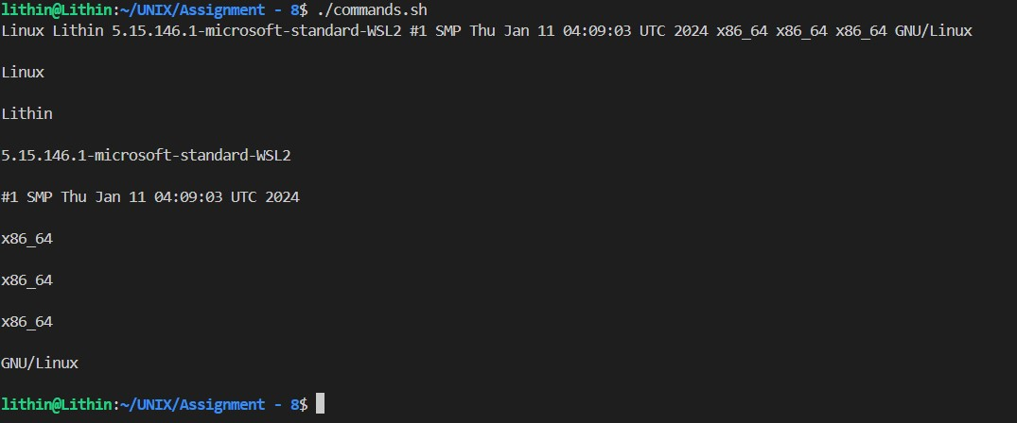

2. Write a shell script that list the memory usage and cpu usage of multiple machines.

