Using GIT Commands in VS Code

Open VS Code

Ctrl + `

To open terminal

Command 1 – To clone a repository

$ git clone [url]

Command 2 – To create a local branch

$ git branch [branch-name]

Command 3 – To view current branch info

$ git status

Command 4 – To remove a lock

rm -force .git/index.lock

Command 5 – To move file to staging. Mandatory before commit

$ git add “filename.extension”

Command 6 – To commit a file [do Prevision step for sure]

$ git commit -m “message”

Command 7 – To push Code for first time push

$ git push –set-upstream origin localbranchname or git push -u origin local-branch

Further pushes

$ git push

Tips:

If you get into GIT pages, use ‘q’ to quit from the editor

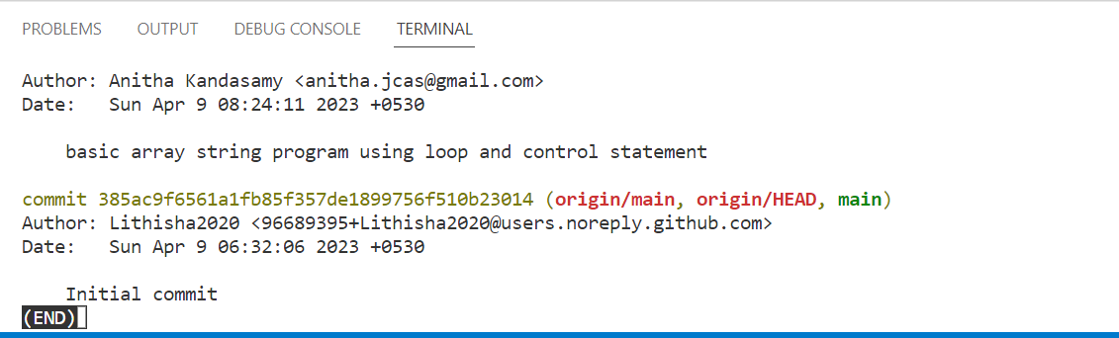

Now press q key to quit from this point