**Social-Network-Analysis**

Homework Address: Https://github.com/LitianD/Social-Network-Analysis

[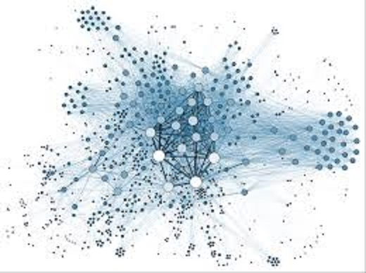](https://github.com/LitianD/Social-Network-Analysis/blob/master/img/1.jpg)

**Team members:**

**张力天 16301168 孙文举 16301048**

**薛飞跃 16301050 张袁峰 16301170**

**杨心怡 16301165 朱子潇 16221252**

Contents

**Social-Network-Analysis** 1

**1 Background Analysis** 3

**2 Model Hypothesis** 3

**3 Symbol Description** 4

**4 Model Building** 4

**4.1 Social Link Control** 4

**4.2 Definition Stage** 5

**4.3 Iterative competition phase** 6

**4.3.1 Judging social ability value** 6

**4.3.2 Whether to start social** 7

**4.3.3 Starting social** 7

**4.3.4 Changes in the number of resources** 7

**4.3.5 Change in social ability value** 8

**5 Simulation and Simulation Design** 8

**5.1 Programming** 8

**5.2 Experimental group design** 10

**5.3 Results Analysis Design** 11

**6 Statistic Analysis** 11

**6.1 Icon statistics** 11

**6.2 Group experiment comparison results** 14

**7 Evaluation improvement** 15

**7.1 Model advantage** 15

**7.2 Model disadvantage** 16

**7.3 Model improvement** 16

**1 Background Analysis**

A **social network** is a social structure made up of a set of social actors (such as individuals or organizations), sets of dyadic ties, and other social interactions between actors. In the context of networks, social capital exists where people have an advantage because of their location in a network. Contacts in a network provide information, opportunities and perspectives that can be beneficial to the central player in the network. Most social structures tend to be characterized by dense clusters of strong connections.

[](https://github.com/LitianD/Social-Network-Analysis/blob/master/img/1.jpg)

**Social Network Analysis** (SNA) is the process of studying social structure through the use of networks and graph theory. The network structure is characterized by nodes (individual roles in the network, people or things) and the relationships that connect them, edges or links (relationships or interactions).

In this experiment, we used the **cellular automaton model to perform a social network analysis on the relationship of anyone in the social network**, and designed one by controlling two variables of social competence and social resources. A series of social rules that look at the results of social networks reaching steady state in different situations.

**Keywords: Social Network、 Social Network Analysis、 Cellular Automata**

**2 Model Hypothesis**

* Each social entity has only **social ability** and **social resources**
* The total amount of resources in the closed social space remains unchanged
* Social individuals can only trade with neighbors
* After the sum of resources is greater than a certain Chengdu, social individuals must generate new individuals

**3 Symbol Description**

|  |  |
| --- | --- |
| Symbol | description |
| N | cell grid unilateral step size |
| R | Total resources, the sum of all social individual resources |
| P | The total number of social individuals |
| F(c) | Probability distribution function of individuals with different social abilities. The default is normal distribution. |
| r _j | The total number of resources owned by the individual j |
| c _j | The social ability value of the individual j |
| t _j | the j round iteration |
| T j _nm | indicates the exchange of the j round of individual n and individual m |

**4 Model Building**

**4.1 Social Link Control**

At this stage, the social scenes in real life are reasonably abstracted into mathematical problems in the model, and a comparison is made. As far as possible, the test results satisfy the true experimental scene. In a real social environment, everyone wants to benefit from socializing. Whether or not you can survive on a social field depends on two attributes: **social ability** and **social resource**.

**Social Resources**: Social resources represent the currency, information, or other things that this individual has that can be used to exchange with others on the social field. The social resources of an individual are constantly changing, and the amount of each increase or decrease is derived from the difference in the ability to exchange the two. In this system, resources can be created and not conserved.

**Social Ability**: Social ability reflects the ability of a person to exchange resources for social behavior. The stronger the ability, the more likely it is to obtain resources; the weaker the ability, the more likely the resources are plundered. Social ability is likely to increase in one-time social behavior and may weaken.

|  |  |
| --- | --- |
| Real scene | model abstraction |
| In real life, even if the neighbors do not necessarily have social interactions | two neighbors have a certain probability p(c _i/c _i+ c _j) exchange resources |
| In real life, after the failure of communication, it usually hits its self-confidence. | After trying social failure, the social ability will decrease. c _i=c _i - x |
| In real life, after the successful communication, it usually increases its self-confidence. | After trying to succeed, the social ability will increase c _i=c _i + x |
| It's hard to maintain social relationships when resources are scarce in real life | Social resources r _j=0 when individuals die, remove from the grid |
| When there are too many resources in real life, new social channels can be generated. | When individual resources reach a certain amount, there are empty cells around them, and individuals must split new individuals. |

**4.2 Definition Stage**

1. The social ability value c _j has a value range of 0<=c _j<=10 and is an integer
2. Set the total number of cell grids to N*N, and the total number of social individuals is P
3. Each cell has and can only have individuals, and individuals within each cell have different social ability values and resource numbers.
4. Individual distribution of different social ability values satisfies F(c) default compliance with normal distribution
5. The number of each social individual resource allocation is randomly assigned and satisfies sum(c _1+...c _P)=R

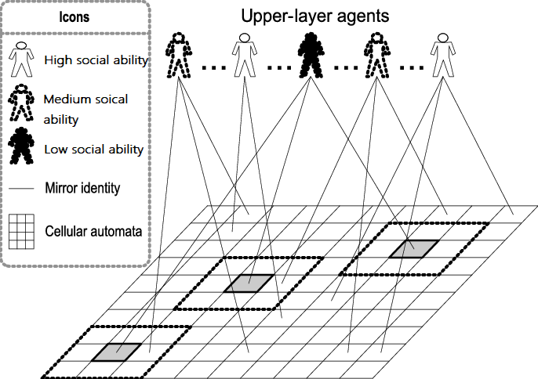

**4.3 Iterative competition phase**

Iterative hypothesis

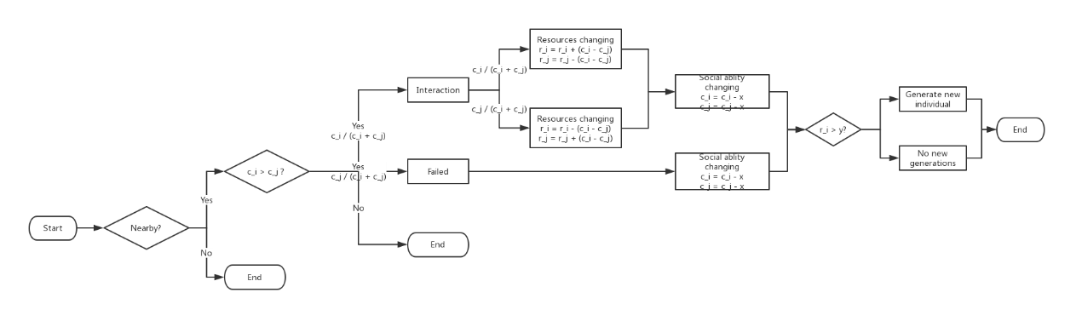Each iteration, the current individual in the traversal process, the social ability value is c_i, the number of resources is r_i, the social ability value of the individual adjacent to the individual is c_j, and the number of resources is r_j.

There are 5 links in each iteration, provided that two individuals are adjacent, and then proceed accordingly.

1. Judging social skills
2. Is there socialization?
3. Social selection resource exchange direction occurs
4. Changes in the amount of resources
5. Change the social ability value to complete the social status of each individual.

**4.3.1 Judging social ability value**

In real life, people with high social abilities take the initiative in the initiation of social relationships. Therefore, at the beginning of each iteration, each individual is traversed in turn, and the social ability value of all neighboring individuals around it is judged. We assume that each social interaction is initiated by individuals with higher social values. For example, the current cell is c_i and c_j is a neighbor of c_i. C_j is ignored when c_i < c_j, and c_j is called a social candidate of c_i when c_i >= c_j.

[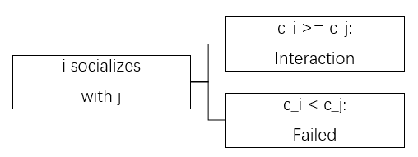](https://github.com/LitianD/Social-Network-Analysis/blob/master/img/9.png)

**4.3.2 Whether to start social**

In this step, the individual initiates a social behavior to the surrounding social candidate. But everything is accidental. People with high social skills don't necessarily socialize with everyone around you. For an individual c_i, even if c_i >= c_j, it does not necessarily socialize with c_j. We assume that the probability that this high social ability value individual (c_i) will socialize to a social candidate (c_j) is c_i / (c_i + c_j).

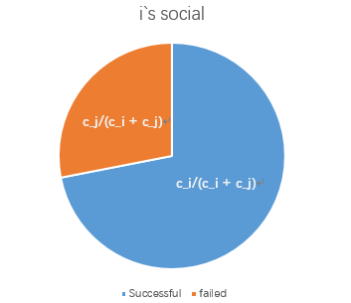

**4.3.3 Starting social**

Social interaction in reality is essentially the exchange of resources. For each social act, one party loses resources and the other gets resources. Individuals with high social ability values ​​do not always have access to resources, which is similar to social behavior in reality. We assume that the probability that the individual with high social ability value (c_i) obtains the number of resources is c_i / (c_i + c_j), and the probability of losing the number of resources c_j / (c_i + c_j).

**4.3.4 Changes in the number of resources**

For each social behavior, the number of resources exchanged between the two individuals who initiated the socialization is |c_i - c_j|. In other words, people with strong social skills will be more likely to get resources from social behavior. The more disparity between the social skills of the two sides, the more resources are acquired or lost.

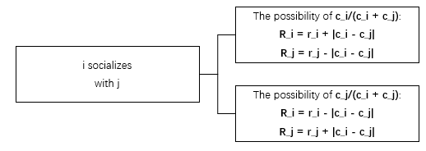

When the number of resources of an individual after the change in energy resources is zero, the individual will die and no longer participate in social behavior.

**4.3.5 Change in social ability value**

In the display society, each social behavior can bring success, positive social experience, and enhance self-confidence in the social process. A failed society can leave a shadow on people's minds and make people fear social. At the end of each iteration, if the social interaction between the two individuals is successful, the social ability is increased by x, otherwise the step is directly performed after judging that the social is initiated: both social skills are weakened by x.

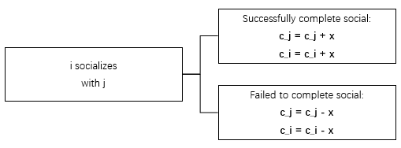

**5 Simulation and Simulation Design**

**5.1 Programming**

In order to validate the model, simulate the results of the social network environment, use the Java language for simulation, and observe the statistical results of the model under different conditions. We use the java graphical interface to visualize the individual's resources and individual social ability values, and record the individual changes in each iteration, and output them as files.

The programming framework is as follows:

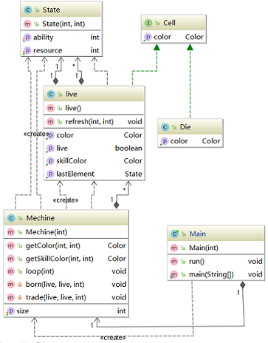

Using the JFrame visualization framework, the left image is the individual resource, the right image is the individual's social ability value, the light color indicates that the value is low, and vice versa indicates that the value is high.

The following is the individual distribution in the initial situation:

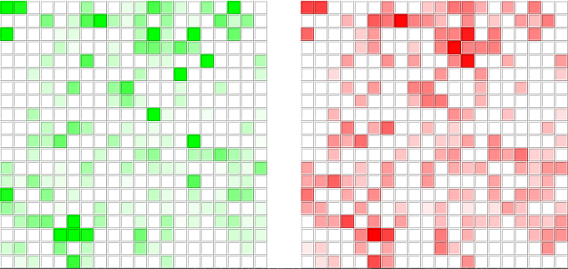

The following is the individual distribution under steady state conditions:

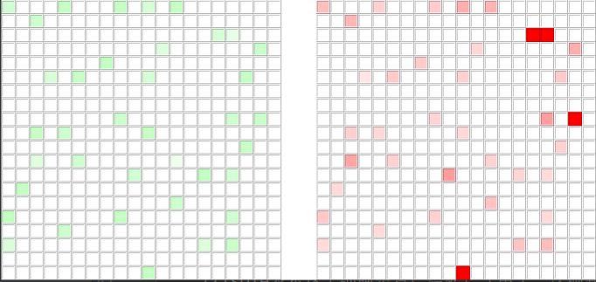

**5.2 Experimental group design**

The number of initial individuals is different (grid size 50*50), the initial social capacity distribution value is different, and the initial resource allocation mode is different.

The following 7 sets of experimental methods are designed to output and save statistics.

|  |  |  |  |
| --- | --- | --- | --- |
| Experiment number | initialize the number of individuals | initialize social capability value distribution | initialize resource allocation method |
| 1 | 30*30 | Normal distribution | Average distribution |
| 2 | 20*20 | Normal distribution | Average distribution |
| 3 | 10*10 | normal distribution | average distribution |
| 4 | 30*30 | Isocent distribution | Average distribution |
| 5 | 30*30 | Social ability value is relevant | Average distribution |
| 6 | 30*30 | Normal distribution | positive correlation with social ability value |
| 7 | 30*30 | Normal distribution | Negative correlation with social ability values |

**5.3 Results Analysis Design**

Three groups of analyses were conducted separately, and the results were statistically concluded.

|  |  |  |  |
| --- | --- | --- | --- |
| Group number | experimental variable | experimental quantification | combination |
| Group one | Number of individuals | individual distribution, resource allocation method | 1, 2, 3 |
| Group two | Individual Distribution | Individual Quantity, Resource Allocation Method | 1, 4, 5 |
| Group three | Resource allocation method | number of individuals, individual distribution | 1,6,7 |

**6 Statistic Analysis**

**6.1 Icon statistics**

The following is the statistical analysis process of Experiment 1.

|  |  |  |  |
| --- | --- | --- | --- |
| Experiment number | Initialize the number of individuals | Initialize social capability value distribution | Initialize resource allocation |
| 1 | 30*30 | Normal distribution | equally distributed |

After the end of the program running, the data is analyzed and statistically analyzed from 6 dimensions：

• The process of changing the sum of resources of each segment of capacity over time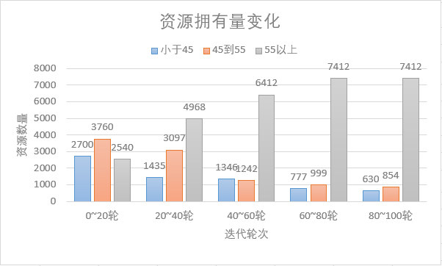

As can be seen from the first picture, in the initial situation, since the ability value obeys the normal distribution, the number of people with resources between 45 and 55 is the highest, and the number of people with less than 45 and the number of people with more than 5 are second. As the number of iterations increased, the population with a capacity of 55 or more gradually took control of most of the resources and stabilized in the 60th to 80th iterations. For people under 55, they control about one-tenth of the total resources, and continue to consume in the 60th to 100th rounds.

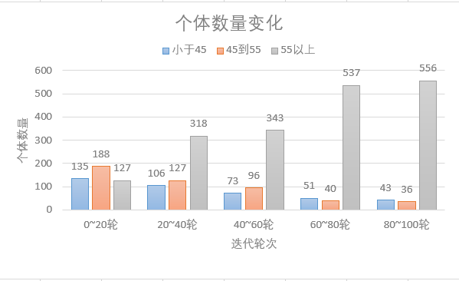• The process of changing the number of individuals in each segment of ability over time

As can be seen from the second graph, in the initial case, the individual exhibits a normal distribution according to the ability value. In multiple iterations, individuals with a abilities above 55 have steadily increased, while the other two categories have gradually decreased to one-tenth of the total, and the total is decreasing. After a period of social interaction, most people's social skills have been improved, and those with low ability have been eliminated, reflecting the evolution of the social population and the survival of the fittest.

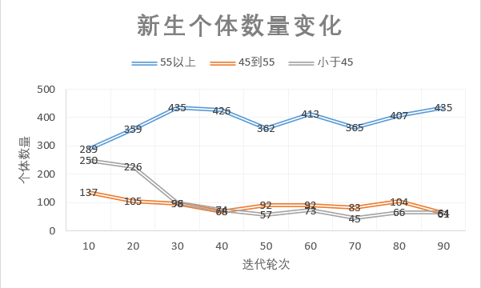• Number of new individuals generated over time

As can be seen from the third picture, the number of death individuals in the first 30 iterations is higher. In this process, the number of death individuals with a capacity value above 55 is gradually increased, while the number of death individuals from 45 to 55 is in the tenth round. The iteration is also similar to the number of deaths with high ability values, but after 20 iterations, it quickly drops to the same level as the number of new individuals with low ability values.

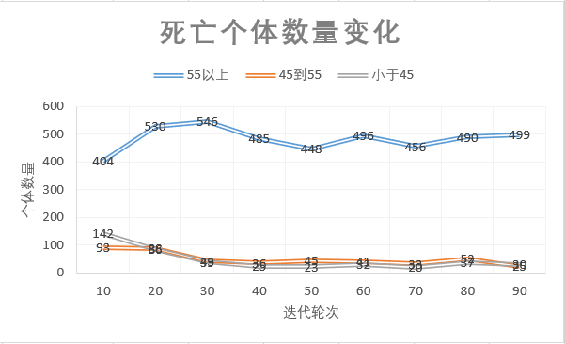• Number of dead individuals generated over time

As can be seen from the fourth graph, before the 10 rounds of iteration, the number of new individuals with medium and low ability values is relatively large, but after 30 iterations, it quickly drops to a lower level. The number of new individuals with high ability has been maintained at a high level. Combined with the previous graph of the number of death individuals, it can be seen that the number of high-capacity people gradually increases over time, consistent with the trend of the histogram in Figure 2.

• The proportion of social disintegration and the proportion of deaths in the overall

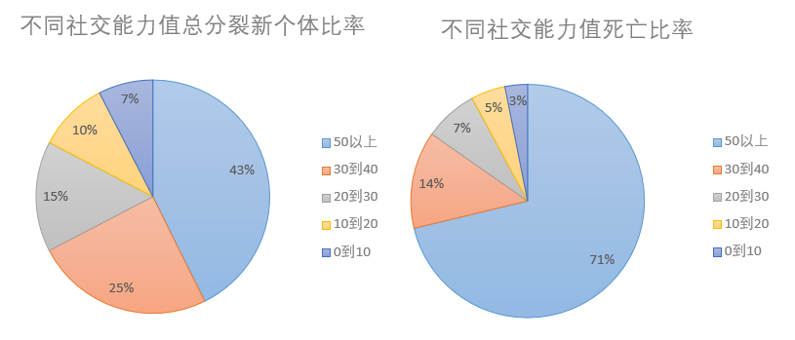

It can be seen from the split graph that, consistent with the conditions we have established, people with a capacity of more than 30 are more likely to split new individuals, while individuals with lower ability values are less likely to split new individuals. The ability value is positively correlated with the number of newborn individuals. This shows that it is difficult for people with low ability values to achieve resource accumulation, and the higher the ability value, the easier it is to accumulate resources.

From the death rate chart, we can see that only the number of individual deaths with a power value above 50 accounted for 71% of the total, and the number of deaths was positively correlated with the ability value. Mortality and resuscitation rates are interdependent, leaving the system in a state of constant change. It shows that risks and opportunities coexist in the social process.

**6.2 Group experiment comparison results**

• Individual number impact

According to the experimental data, the initial number of individuals is positively correlated with the total amount of resources and the number of competency groups, but it has no effect on the changing trend of resources and population, the rate of birth and mortality.

* The impact of individual distribution

According to the experimental data, under different distributions, the pre-iteration of each index is quite different. Under the mean distribution, the curve changes more smoothly, and the growth is basically monotonous. The change process shows obvious directionality. In the case of positive correlation with social competence, the curve tends to plain at a very fast speed and then fluctuates in a small range. Increasing the proportion of high-powered people accelerates the evolution process. It can be seen that no matter what distribution the individual obeys, as long as the law remains unchanged, the evolution direction of the whole social field will be the same, that is, the majority evolution and the minority elimination.

* The impact of resource allocation

In the negative correlation distribution, there are a large number of two extreme attributes of individuals different from case 1, that is, high-capacity low-resource-type individuals and low-capacity high-resource-type individuals. It can be predicted that, because the predation and giving of resources depend only on the ability and have nothing to do with the resources, they are the same as the experimental data: even in the initial iteration, the number of high-ability individuals and low-ability individuals, the number of holding resources, the number of deaths and the number of new births intersect, but after 50 rounds of iteration, the result still changes with case 1. The trend is the same. In experiment 7, the positive correlation between resource and capacity distribution aggravated the process and made the curves converge to steady state quickly. It can be seen that resource distribution only affects the time when the system reaches steady state, and does not affect the evolution direction of the whole system.

**7 Evaluation improvement**

**7.1 Model advantage**

• Each individual has both social ability values and resource numbers, and the interaction between individuals is more complex and closer to real social interaction.

• Social behaviors are influenced by social ability values, and interactions between individuals are more reasonable.

• Social and exchange of resources with a certain probability can effectively prevent the gap between the rich and the poor.

• Individuals can split, increase complexity, and to some extent avoid the gap between rich and poor.

**7.2 Model disadvantage**

• Only consider social value values as a factor that affects social behavior.

• Splitting behavior is determined by only one individual and does not match the real situation.

• Changes in social ability values and resources are not convincing.

**7.3 Model improvement**

• Appropriately increase factors affecting social behavior, such as personal emotions, to a certain extent affect social behavior.

• Consider simulating a real society where two individuals split new individuals.

• Design more rigorous variation formulas to increase the simulation level of the model.