Group members

16301168_张力天

16301170_张袁峰

16301167_张峰玮

16301096_厉欣林

**16301168_张力天**

**old man**



**An example visit**

One day an old man from German who has some problem with his eye wants to visit the exhibition. All items in exhibits have a QR code ,he scans them and get a audio about the item, but it is English, it is a little difficult for him to understand. The information about item detail on plasques is also English, and the front size is just 50pt,so he feels it is hard to see clearly. Last but not least he wants to see Roman manuscripts but there are too many high and strong man in the lightless room ,as a result he can see nothing.It is a pity.

**Work activities**

* read some items introduction
* surf the internet for information

**Household & leisure activities**

* read magazine
* watch TV
* sleep
* do some exercise

**Goals, fears & aspirations**

* goals
  + words bigger
  + sounds high
  + describe slowly
  + bigger button
  + different language for different countries people
* fears:
  + the UI is too complex to use it
  + the front is too small to see clearly
  + the sound is too slow
* aspirations:
  + easier to use,
  + maybe need more tips for them
  + the button should be bigger than normal
  + the UI should be simple and the main function should easy to see
  + High sound

**Computer skills, knowledge & abilities**



* computer skills: little
* knowledge: may be out of style

**Technology attitudes**

Do not care any morden technology and may get confused with them, and they hope it easy for them to read and use, so simple is their Technology attitude.

**Technology attributes**

**Pain points**

* How to let the UI simple and easy to understand
* How to highlight the key features
* How to simplify the complex UI
* How to care someone who has eye problem

**16301170_张袁峰**

**Student**



**An example visit**

A student visits the museum for studying. He/She may go there when he/she has some trouble in his/her class or just because of his/her curiosity. He/She will be happy if he/she get the knowledge he/she want. Or he/she just visit a museum for relax.

**Work activities**

* Search for information he/she want
* Get knowledge which can't be learnt from class
* Relax himself/herself

**Household & leisure activities**

* Read books
* Do his/her homework
* Do some extracurricular research
* Sports, game and music

**Goals, fears & aspirations**

**Goals**

* To get the knowledge he/she want
* To get more information about what he/she is researching for

**Fears**

* Can't get any information
* Get some useless information
* Can't finish his/her work

**Aspirations**

* Useful information
* Knowledge for his/her research
* Relax

**Computer skills, knowledge & abilities**

**Computer skills**

* Basic computer skills
* Can use apps of his/her mobile
* Know how to use ipad

**Knowledge**

* Basic idea of what he/she is major in
* Some advanced knowledge about what he/she is learning

**Abilities**

* Get useful information from articles
* Summarize from his/her practice

**Technology attitudes**

**Technology attributes**

**Pain points**

* Low learning efficiency
* Lack of knowledge
* Bad learning habits

**16301167_张峰玮**

**Doctor**



**An example visit**

A doctor visits the museum just for fun, she/he need relax because she’s too tired and she just want to know some history and consumption of time.

**Work activities**

* Search for information he/she want
* Relax himself/herself

**Household & leisure activities**

* Read books
* Do exercise regularly
* Sports, game and music

**Goals, fears & aspirations**

**Goals**

* To get the knowledge he/she want
* To relax

**Fears**

* Can't get any information

**Aspirations**

* Relax

**Computer skills, knowledge & abilities**

**Computer skills**

* Basic computer skills

**Knowledge**

* Basic idea of what he/she is major in

**Abilities**

* Get useful information from articles

**Technology attitudes**

**Technology attributes**

**Pain points**

* Don’t have enough time

**16301096_厉欣林**

### Student administrator：

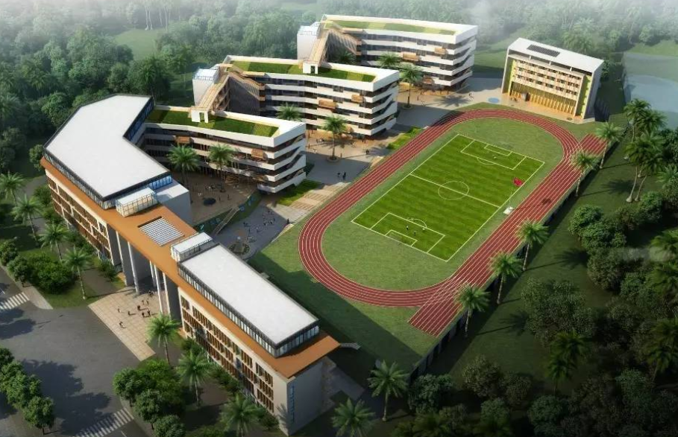

### An example visit：

Organize students to visit.

Book tickets for students and teachers.

Booking visit time.

### Work activities：

Choose the right front-end framework, choose the right platform (web page or app) for development.

Conduct in-depth communication with users to obtain specific needs of users and provide ideas for design.

Use a good framework or language, use a good server to optimize the application.

### Household & leisure activities：

School entity does not exist this respect content.

### Goals, fears & aspirations：

Let the students understand the relevant extracurricular knowledge.

Improve teaching quality.

Fear of student injury.

Fear of organizational delays.

Fear of inaccurate content.

### Computer skills, knowledge & abilities：

Not bad. There are some computer professors who can provide technical references

### Technology attitudes：

Support and acceptance.

### Technology attributes：

### Pain points：

The database is not easy to maintain because there are too many students.

The contents of the museum may not be correct.

The interface might crash because of the huge amount of traffic.