Structrual variant detection from long-reads

Litian Zhou

22/08/2018

Table of Contents

This is my work during my internship in Walter + Eliza Institute of Medical Research.  
In this document, I briefly introduce how to detect **structural variants (SVs)** from long-read data and validate those by short-reads.

Structural variations are the greatest source of genetic variation, but they remain poorly understood because of technological limitations. Single-molecule long-read sequencing has the potential to dramatically advance the field, although high error rates are a challenge with existing methods.

Also, for complex structrual variants (cxSV), whole genome sequencing and short-read data allow us to make more confident decision in clinical investigation1. So, my study used WGS data of Plasmodium falciparum from both long-read and short-read sequencing platform.

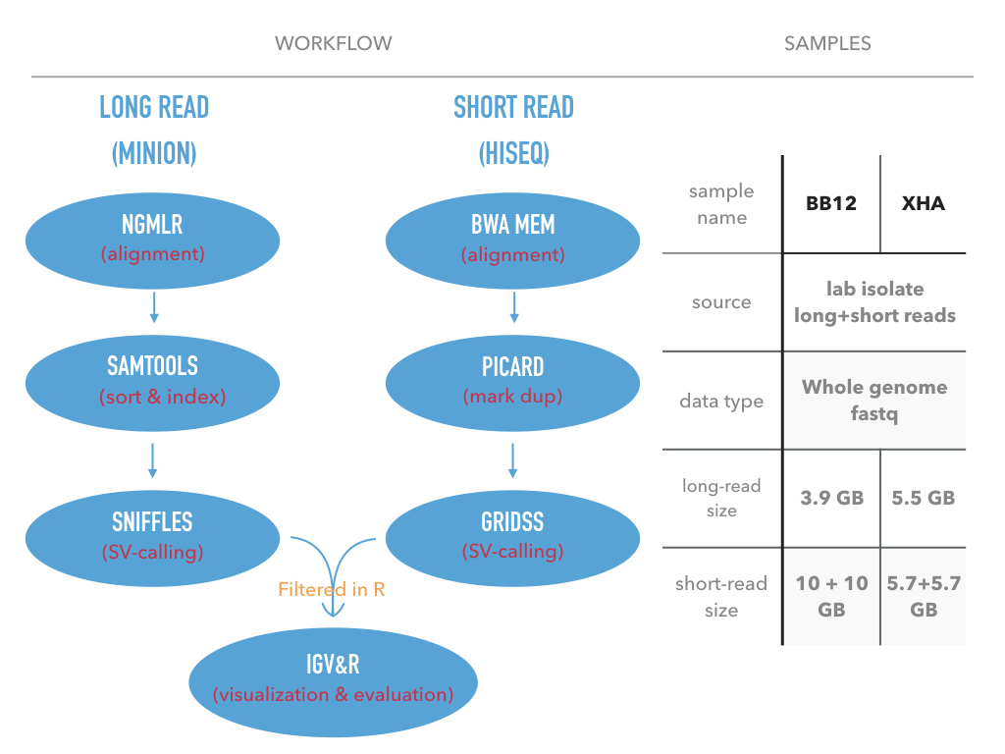

workflow and data

## Current situation

Most high-throughput sequencing technologies require users to sequence short lengths of DNA (typically 150-300bp). Clearly, these short reads are less likely to span larger structural variation, making analysis particularly challenging, especially in repetitive genomic regions. Given that repetitive regions (such as centromeres, telomeres and other repetitive elements) encompass over half of the human genome10, this is a significant concern when mapping structural variants using short-read technology. As a consequence, most existing genome assemblies, which have been created using short reads, exhibit numerous gaps, corresponding to repetitive regions and structural variation that cannot be resolved2.

## Why long-read

These challenges are now being addressed by the emergence of long-read nanopore sequencing, which allows entire DNA fragments to be sequenced, regardless of their length. Users can choose to sequence long fragments of several kilobases to ultra-long reads with lengths currently approaching 1 Mb14. Such long reads are able to span most structural variation and repetitive regions simplifying their analysis (Figure 2). Long-read lengths are more likely to contain the whole structural variant and/or repetitive region providing much simpler analysis and more accurate genome assemblies2. 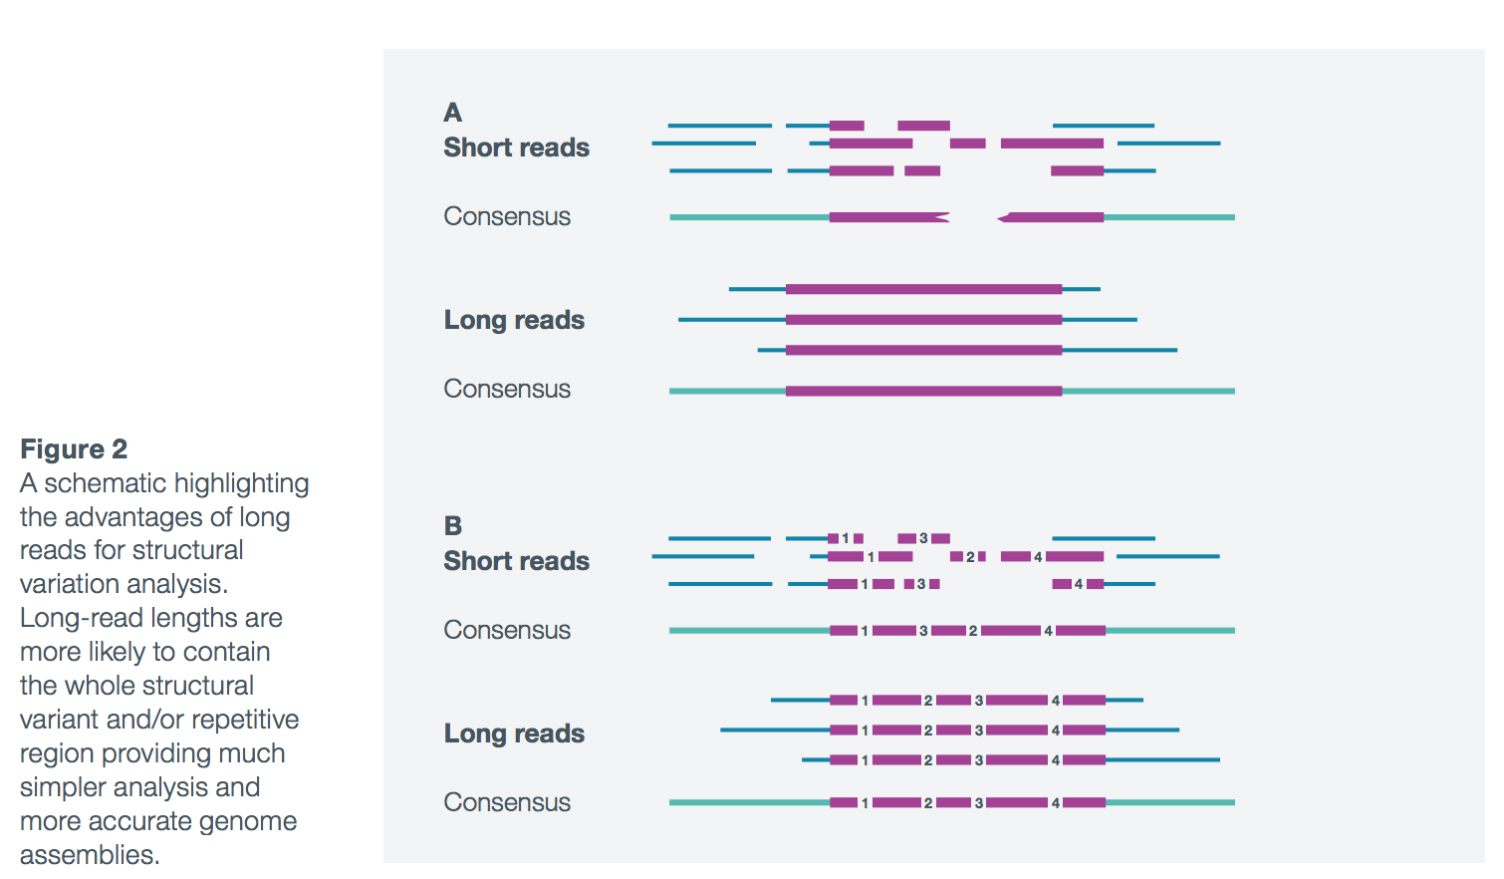

## Key info of Sniffles SV-callling

### What is Sniffles

Sniffles3 is a SV-detection software developed for long-reads sequencing data. It provides high sensitivity and precision for variant detection, even in repeat-rich regions and for complex nested events.  
### What Sniffles does - Detects indels, duplications, inversions, translocations, and nested events (Not found in my study)  
- Scanning the alignments of each read independently, then clustering the candidate SVs across all reads  
- Uses both within-alignment and split-read alignments paradigm - Genotyping and phasing of found SVs - Report adjacent or nested events in the VCF file

### Requirement for Sniffles

* Work best with NGMLR4 alignment results
* Minimum read-coverage:  
       10X coverage using 10 kbp long-reads  
       25X coverage using 2*100 bp short-reads

### Options and their default value

* Minimum read support (default: 10 reads)
* Minimum read length (default: 30 bp)
* Maxium distance to group SV together (default: 1kb)

# Code & result

In this document, I represent my work in two part

     Bash code: The pipeline for alighnment and SV-calling for both long-reads and short-reads.

     R code: The scripts for information extraction, comparation, and smmarization from the output vcf file.

## Bash code

*long_read.fastq -> SV.vcf*

### Sniffles pipeline

#### ngmlr + Sniffles

We use ngmlr for alignment and Sniffles for SV-calling (Figure 1).

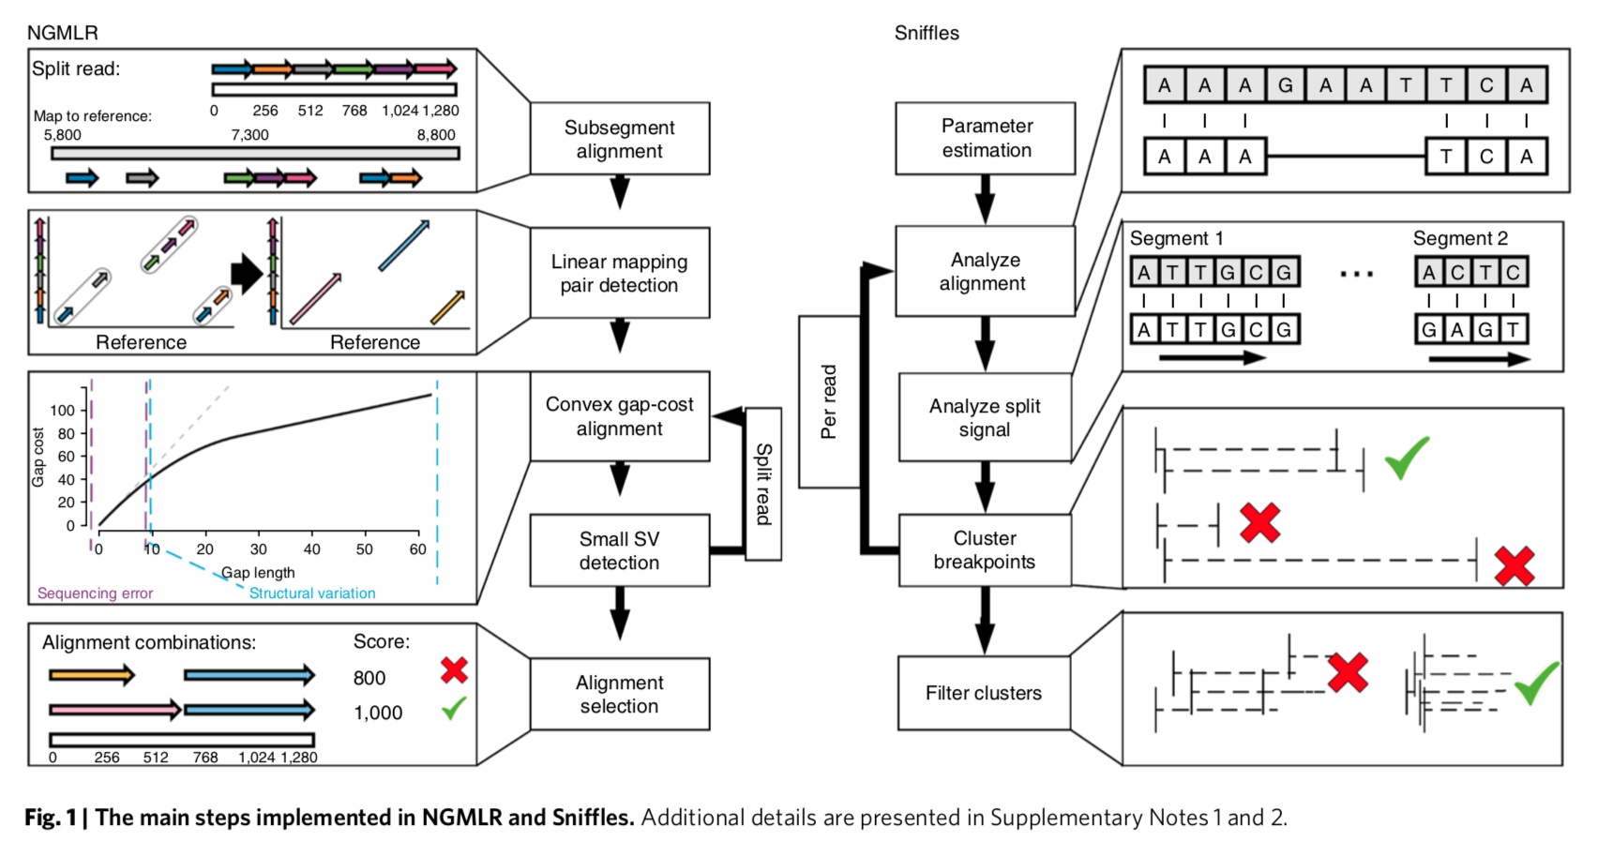

flow_chart_ngmlr+sniffles

Pipeline:

# Reference: ${REF}*  
# Query: ${QRY}  
  
REF=PlasmoDB-38_Pfalciparum3D7_Genome  
QRY=bb12 # you can change it if you have a different sample  
OUPUT="$HOME/ngm_sniff_output/"  
module load anaconda3  
source activate my_env  
  
ngmlr -t 4 -r ${REF}.fasta \  
 -q ${QRY}.fastq \  
 -o ngm.sam \  
 -x ont  
  
#Samtool for convert SAM to BAM and sort  
samtools view -S -b ngm.sam > ngm.bam  
samtools sort ngm.bam -o ngm.sorted.bam  
  
#indexingthe sorted BAM file:  
samtools index ngm.sorted.bam  
  
#sniffles SVs_calling  
sniffles -m ngm.sorted.bam -v sniffSV.vcf

*The fastq and fasta files can be found in this path:/wehisan/general/academic/malaria_genomics

#### SURVIVOR5

*merge vcf files from multiple samples or callers*

First, we collect all files that we want to merge in a file.  
ls *vcf > sample_file

Next, we use SURVIVOR to obtain a call set.  
./SURVIVOR merge sample_files 1000 2 1 1 0 30 sample_merged.vcf  
This will merge all the vcf files specified in sample_files together using a maximum allowed distance of 1kb. Furthermore we ask SURVIVOR only to report calls supported by 2 callers and they have to agree on the type (1) and on the strand (1) of the SV. Note you can change this behavior by altering the numbers from 1 to e.g. 0. In addition, we told SURVIVOR to only compare SV that are at least 30bp long and print the output in sample_merged.vcf.

### GRIDSS pipeline

We can easily get comprehensive SV calling from short-read data with gridss6

#!/bin/bash  
#PBS -l nodes=1:ppn=14,mem=0gb,walltime=24:00:00  
#PBS -N bwa_gridss  
#PBS -o bwa_gridss_out  
#PBS -e bwa_gridss_err  
  
REF=PlasmoDB-38_Pfalciparum3D7_Genome.fasta  
QRY=Illu-bb12-R  
  
# load anaconda and activate my_env2:  
module load anaconda3 bwa samtools R java  
source activate my_env2  
  
if [[ ! -f bwa_sorted_dupMarked.bam ]] ; then  
 # samtools sort:  
 #Samtool for convert SAM to BAM and sort  
 bwa mem -t 14 $REF ${QRY}1.fastq ${QRY}2.fastq | \  
 samtools sort - -o bwa_sorted.bam && \  
 samtools index bwa_sorted.bam && \  
 picard CollectAlignmentSummaryMetrics \  
 R=$REF \  
 I=bwa_sorted.bam \  
 O=marked_dup_metrics.txt && \  
 picard MarkDuplicates \  
 I=bwa_sorted.bam \  
 O=bwa_sorted_dupMarked.bam \  
 M=marked_dup_metrics.txt  
fi  
  
GRIDSS_JAR=gridss-1.7.2-gridss-jar-with-dependencies.jar  
java -ea -Xmx24g \  
 -Dreference_fasta="$REF" \  
 -Dsamjdk.create_index=true \  
 -Dsamjdk.use_async_io_read_samtools=true \  
 -Dsamjdk.use_async_io_write_samtools=true \  
 -Dsamjdk.use_async_io_write_tribble=true \  
 -Dgridss.gridss.output_to_temp_file=true \  
 -cp $GRIDSS_JAR gridss.CallVariants \  
 TMP_DIR=. \  
 WORKING_DIR=. \  
 REFERENCE_SEQUENCE="$REF" \  
 INPUT="bwa_sorted_dupMarked.bam" \  
 OUTPUT="$QRY.gridss.vcf" \  
 ASSEMBLY="$QRY.gridss.assembly.bam" \  
 WORKER_THREADS=14 \  
 2>&1 | tee -a gridss.$HOSTNAME.$$.log

The fastq and fasta files can be found in this path:/wehisan/general/academic/malaria_genomics

## R code

*SV.vcf -> R objects -> visualization*

### Extraction and summarization from vcf file

#### Read vcf file into R

*and filter out obvious false-positives*

# source("https://bioconductor.org/biocLite.R")  
# biocLite("VariantAnnotation")  
  
library(VariantAnnotation) # bioconductor, version 1.26.1  
sniffles_vcf = readVcf("./bam&vcf/sniffles_bb12.vcf", "pf3d7")  
sniffles_vcf = sniffles_vcf[granges(sniffles_vcf)$FILTER == "PASS"   
 & info(sniffles_vcf)$RE < 500   
 & info(sniffles_vcf)$SVLEN < 99999]  
  
# convert vcf object to data.frame object  
sniffles_df = as.data.frame(info(sniffles_vcf))

#### Plot **SV types counts** and **SV length ECDF**

*using packages: dplyr and pplot2*

# install.packages("dplyr")  
# install.packages("ggplot2")  
  
library(dplyr) # version 0.7.6  
library(ggplot2) # version 2.2.1  
  
sniffles_df %>%  
 group_by(SVTYPE) %>%  
 summarize(counts = n()) %>%  
 ggplot(aes(x=SVTYPE, y=counts)) + geom_bar(colour="grey", fill="grey",stat = "identity")

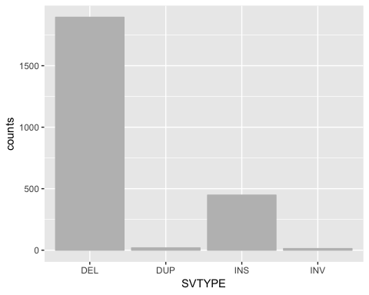

sniffles_df %>%  
 mutate(log10.SVLEN = log10(SVLEN)) %>%   
 ggplot(aes(log10.SVLEN)) +  
 stat_ecdf(geom = "point", colour="grey") +  
 labs(title="ecdf of log10(SVLEN)")

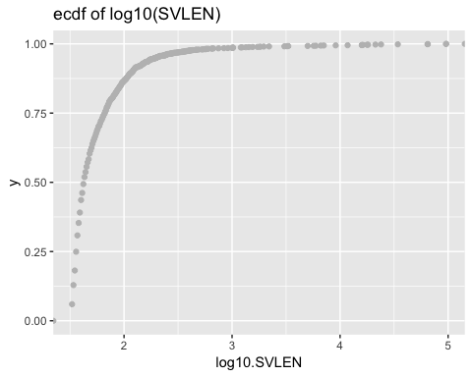

#### Extract other information

1.**support type (SUPTYPE)** counts

sniffles_df %>%  
 count(SUPTYPE) %>%  
 ggplot(aes(x=SUPTYPE, y=n)) + geom_bar(colour="grey" , fill="grey", stat = "identity")

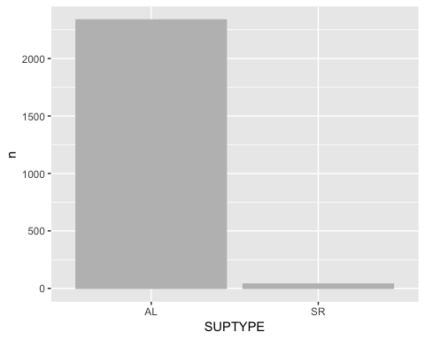

1. **support read (RE)** counts

sniffles_df %>%  
 ggplot(aes(x=RE)) +  
 geom_histogram(binwidth = 10, colour="white", fill="grey") +  
 geom_vline(aes(xintercept=mean(RE)), colour="red", linetype="dashed", size=1)

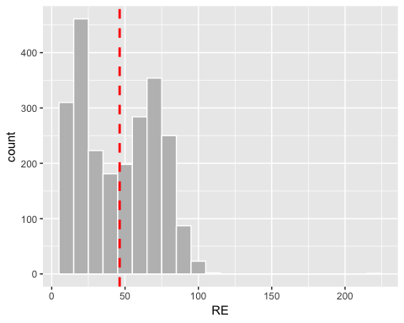

### SVs validation from short-read data

#### Convert vcf to gRange object

(gRange is an R object for genomic data)

# install.packages("stringr")  
# install.packages("devtools")  
  
library(stringr)  
library(devtools)  
install_github("PapenfussLab/StructuralVariantAnnotation")  
library(StructuralVariantAnnotation)  
  
# Read and filter gridss vcf (The QUAL>1000 threshold is recommended by GRIDSS)  
gridss_vcf = readVcf("./bam&vcf/gridss_bb12.vcf", "pf3d7")  
gridss_vcf = gridss_vcf[granges(gridss_vcf)$QUAL>1000]  
gridss_vcf = gridss_vcf[granges(gridss_vcf)$FILTER == "PASS"]  
  
# Convert gridss_vcf to a gRange object  
gridss_gr = breakpointRanges(gridss_vcf)

#### Annotate SVs

# Simple SV type classifier  
simpleEventType <- function(gr) {  
 return(ifelse(seqnames(gr) != seqnames(partner(gr)), "ITX", # inter-chromosomosal  
 ifelse(gr$insLen >= abs(gr$svLen) * 0.7, "INS", # TODO: improve classification of complex events  
 ifelse(strand(gr) == strand(partner(gr)), "INV",  
 ifelse(xor(start(gr) < start(partner(gr)), strand(gr) == "-"), "DEL",  
 "DUP")))))  
}  
  
svtype <- simpleEventType(gridss_gr)  
info(gridss_vcf)$SIMPLE_TYPE <- NA_character_  
info(gridss_vcf[gridss_gr$vcfId])$SIMPLE_TYPE <- svtype  
info(gridss_vcf[gridss_gr$vcfId])$SVLEN <- gridss_gr$svLen

#### Overlaps between short-read and long-read

*according to the SV-TYPE*

# Convert sniffles_vcf to a gRange object  
sniffles_gr = breakpointRanges(sniffles_vcf)  
  
hits = findBreakpointOverlaps(gridss_gr, sniffles_gr, maxgap=15)  
  
# create a new column as a flag of overlapping  
gridss_gr$match2sniffles = NA  
gridss_gr[hits$queryHits]$match2sniffles = names(sniffles_gr)[hits$subjectHits]  
  
sniffles_gr$match2gridss = 'no'  
sniffles_gr[hits$subjectHits]$match2gridss = 'yes'  
sniffles_gr$match2gridssID = NA  
sniffles_gr[hits$subjectHits]$match2gridssID = names(gridss_gr)[hits$queryHits]  
sniffles_gr$Counts = 1  
  
# draw overlapping bar plot  
sniffles_df <- data.frame(sniffles_gr)  
sniffles_df %>%  
 ggplot(aes(x=svtype, y=Counts, fill=match2gridss)) +  
 geom_bar(stat = "identity")

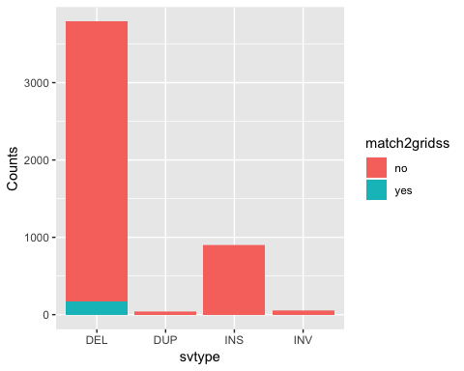

## Reference

1. Complex Structural Variants Resolved by Short-Read and Long-Read Whole Genome Sequencing in Mendelian Disorders Alba Sanchis-Juan, Jonathan Stephens, Courtney E French, Nicholas Gleadall, Karyn Mégy, Christopher Penkett, Kathleen Stirrups, Isabelle Delon, Eleanor Dewhurst, Helen Dolling, Marie Erwood, Detelina Grozeva, Gavin Arno, Andrew R Webster, Trevor Cole, Topun Austin, Ricardo Garcia Branco, NIHR BioResource NIHR BioResource, Willem H Ouwehand, F Lucy Raymond, Keren J Carss bioRxiv 281683; doi: <https://doi.org/10.1101/281683>
2. White paper: Nanopore sequencing The application and advantages of long-read nanopore sequencing to structural variation analysis, Oxford Nanopore Technologies.
3. Accurate detection of complex structural variations using single molecule sequencing Fritz J Sedlazeck, Philipp Rescheneder, Moritz Smolka, Han Fang, Maria Nattestad, Arndt von Haeseler, Michael Schatz bioRxiv 169557; doi: <https://doi.org/10.1101/169557>
4. Accurate detection of complex structural variations using single molecule sequencing Fritz J Sedlazeck, Philipp Rescheneder, Moritz Smolka, Han Fang, Maria Nattestad, Arndt von Haeseler, Michael Schatz bioRxiv 169557; doi: <https://doi.org/10.1101/169557> Now published in Nature Methods doi: 10.1038/s41592-018-0001-7
5. Transient structural variations have strong effects on quantitative traits and reproductive isolation in fission yeast. Jeffares, Daniel C; Jolly, Clemency; Hoti, Mimoza; Speed, Doug; Shaw, Liam; Rallis, Charalampos; Balloux, Francois; Dessimoz, Christophe; Bähler, Jürg; Sedlazeck, Fritz J. Nature communications, Vol. 8, 14061, 24.01.2017, p. 1-11. <DOI:10.1038/NCOMMS14061>
6. GRIDSS: sensitive and specific genomic rearrangement detection using positional de Bruijn graph assembly. Cameron DL, Schröder J, Penington JS, et al. Genome Research. 2017;27(12):2050-2060. <doi:10.1101/gr.222109.117>.