https://ww2.mathworks.cn/company/newsletters/articles/continuous-integration-for-verification-of-simulink-models.html?s_v1=39098&elqem=3295803_EM_CN_21-07_NEWSLETTER_CG-DIGEST-DEFAULT-RESP&elqTrackId=7f388f6461da4f07ba5b78806028f889&elq=dc566e41a063422f888b7f03185145aa&elqaid=39098&elqat=1&elqCampaignId=14360

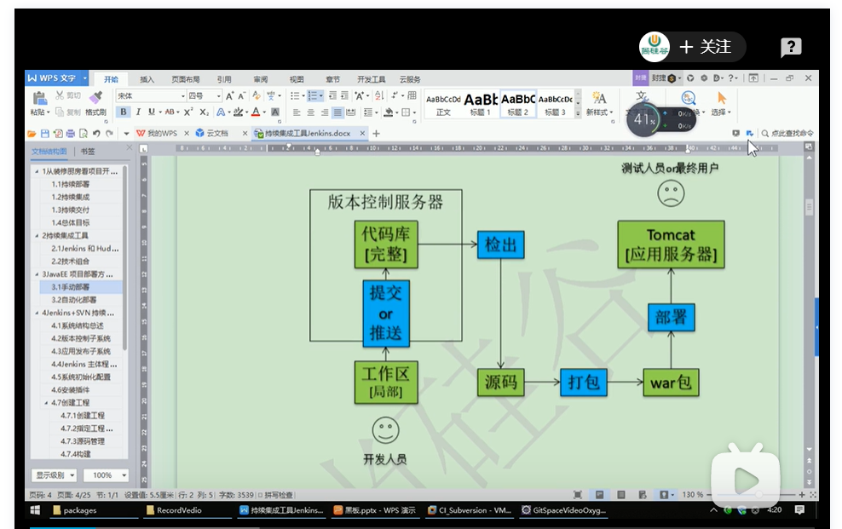

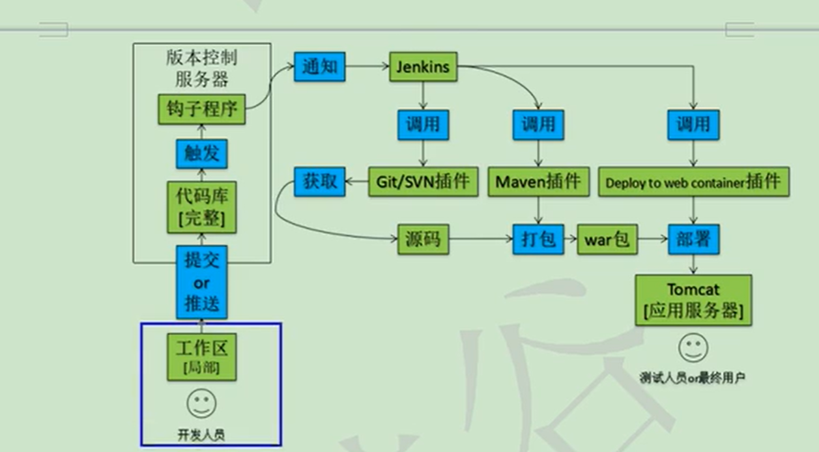

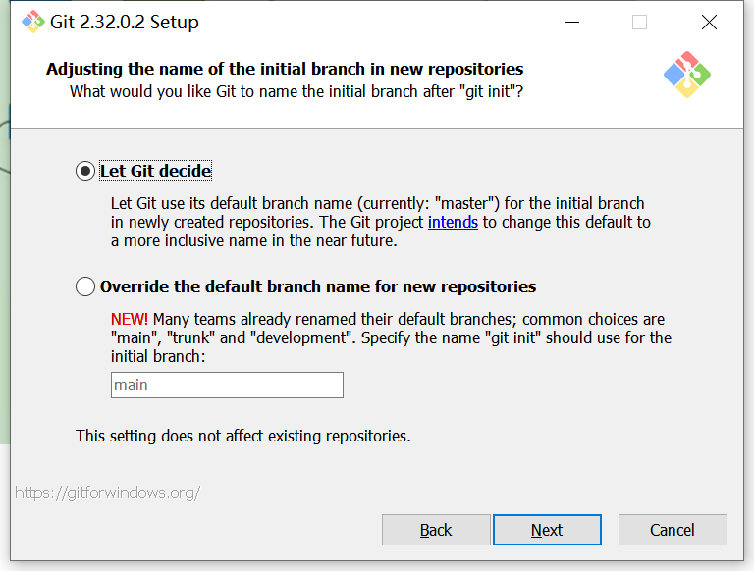

**Build:** Source code and models become object files and executables.

**Test:** Testing is performed as a quality gate.

**Package:** Executables, documentation, artifacts, and other deliverables are bundled for delivery to end users.

**Deploy:** Packages are deployed to the production environment.

<https://blog.csdn.net/weixin_42715225/article/details/110822825>

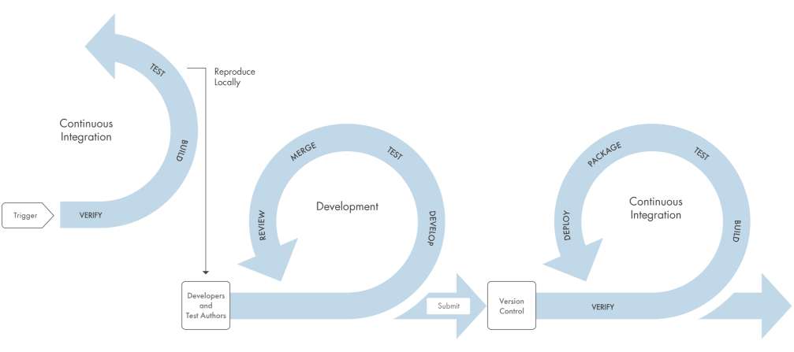

编码 --> 构建 --> 集成 --> 测试 --> 交付 --> 部署

( Matlab ) ( gitlab ) ( jenkins )

**jk搭建:**

1）参考资料

<https://www.cnblogs.com/kaerxifa/p/7857552.html>

<https://www.cnblogs.com/linuxchao/p/linuxchao-jenkins-setup.html>

<https://jingyan.baidu.com/article/2a1383289e5195074b134f4f.html>

（第三为证实有用）

1. 概述搭建过程

* 下载Java，注意版本不宜过新，推荐版本[8,11]，附[jdk-8u301-windows-x64](https://www.oracle.com/java/technologies/javase/javase-jdk8-downloads.html" \l "license-lightbox)版下载链接

<https://www.oracle.com/java/technologies/javase/javase-jdk8-downloads.html>

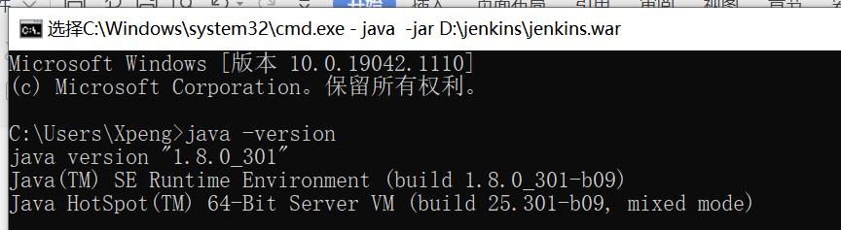

* 改环境变量

新建JAVA_HOME系统环境变量，变量值处输入JDK安装目录，如 "D:\Program Files\Java\jdk1.8.0_66"

新建CLASSPATH变量，变量值为".;%JAVA_HOME%\lib\dt.jar;%JAVA_HOME%\lib\tools.jar"

修改Path变量，在最后添加";%JAVA_HOME%\bin"

在cmd中输入"java -version"，有版本信息返回，说明已添加成功

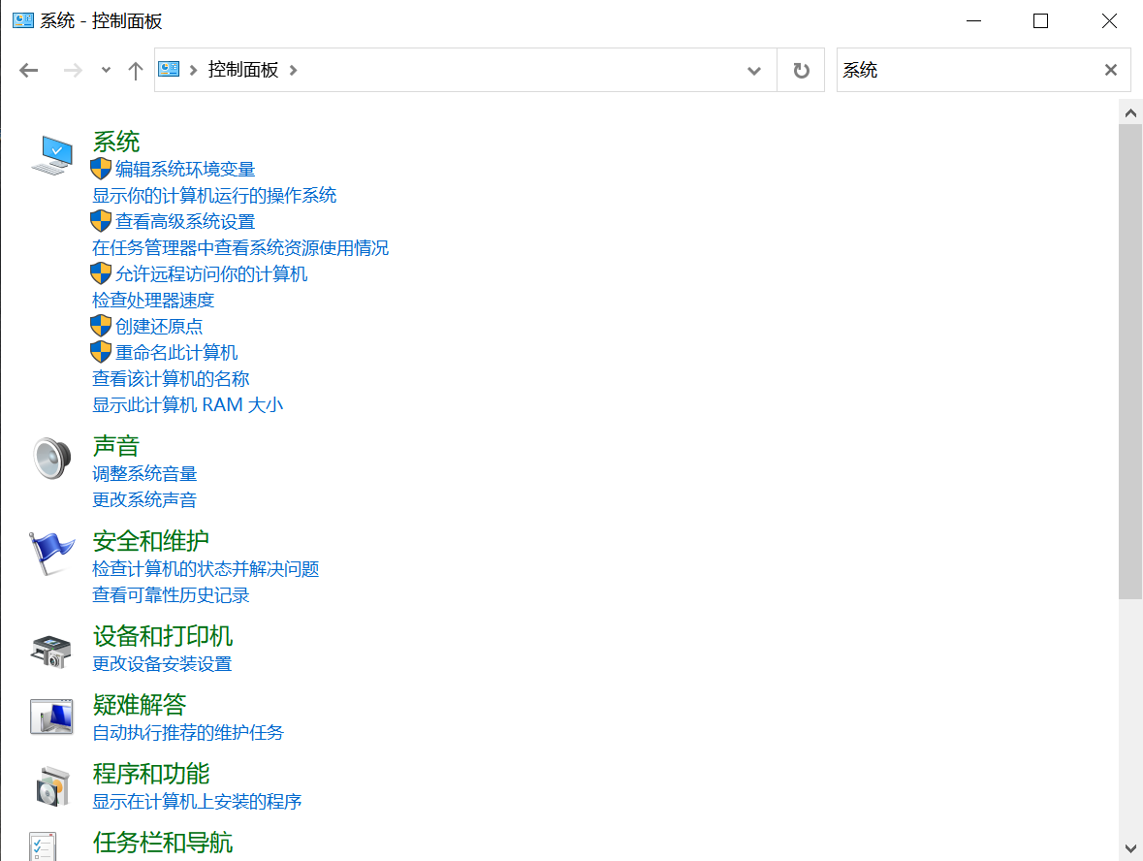

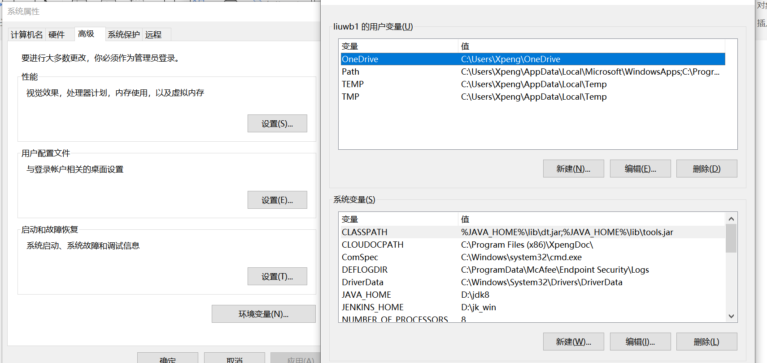

* 下载Jenkins的安装包，war文件格式，官网下载
* 命令窗口输入代码，地址自定义

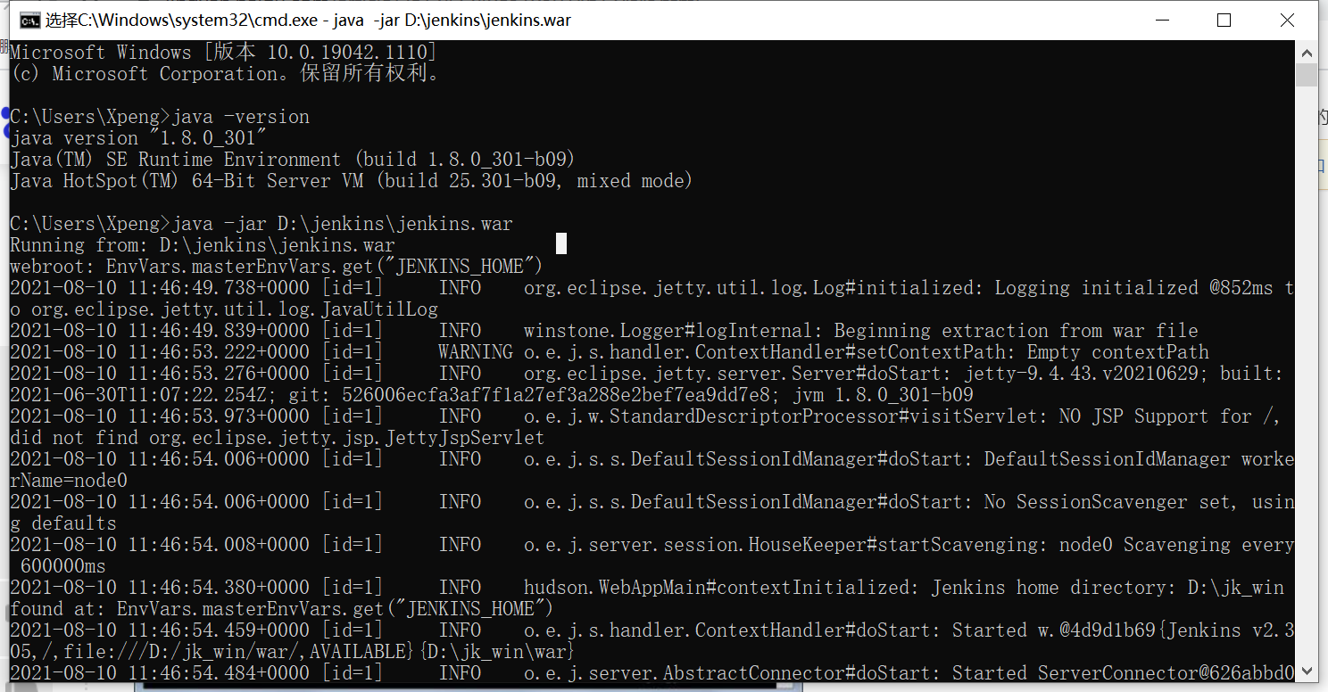

运行成功

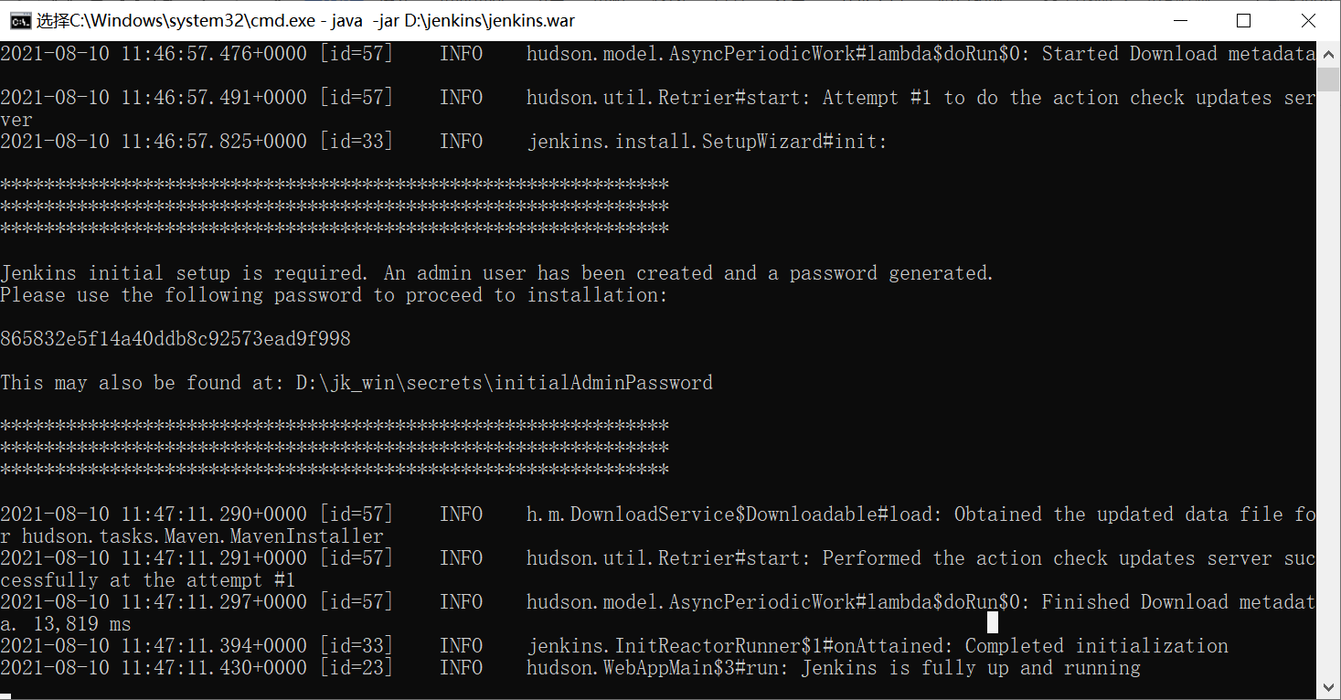

* 进行地址访问，默认地址http://localhost:8080/。按照指引找到密码，进入如下页面

