**Name:** Daniel Yusoff bin Asri

**ID:** 1221303541

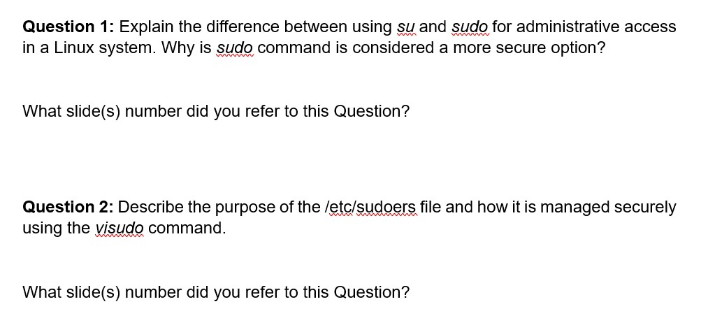

**Answer:**

**su (Switch User):**

* Opens a new shell as another user (typically root).
* Requires the target user’s password.
* Grants full root privileges until the session is exited.
* Commonly used for multiple administrative commands in a session.

**Sudo (Superuser Do):**

* Executes a single command as another user (usually root).
* Requires the current user’s password if they are authorized in sudoers.
* Grants temporary root privileges only for the specific command.
* Safer and prefers because it logs the command and limits scope.

The key difference between su and sudo is that su switches to the root user for a full session, requiring the root password. Meanwhile, sudo runs one command with elevated privileges, requiring the user’s password. The sudo command is considered a more secure option because it avoids sharing the root password, offers granular control, provides an audit trail, and limits the scope of administrative access. This minimizes the risks and improves accountability compared to su.

I referred to slide 6 and slide 7 for these answers.

**Answer:**

The /etc/sudoers file controls who can use the sudo command, what commands they can execute, and whether they need to authenticate with a password. It is critical for managing system security and should not be edited directly to avoid syntax errors. Instead, the visudo command is used, as it locks the file during editing to prevent simultaneous changes, validates syntax before saving, and ensures the system remains functional. I referred to slide 6 and 7 for this answer.

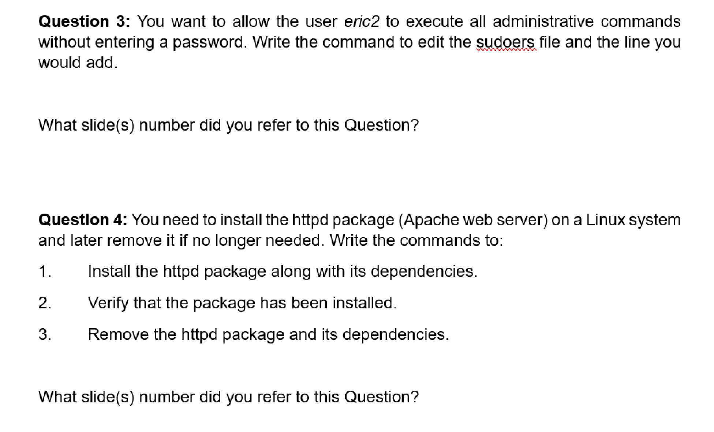

**Answer:**

To allow the user eric2 to execute all administrative commands without entering a password by these steps.

1. sudo visudo (command to edit the sudoers file)
2. eric2 ALL=(ALL) NOPASSWD: ALL (add this line into the sudoers file)
3. press Esc and “type :wq” to write and quit. Press enter. (Save the changes and exits the editor.)

I referred to slide 8 for this answer.

**Answer:**

To install, verify, and remove the httpd (Apache web server) package on a linux system by following these steps.

1. sudo yum install httpd (install the httpd package along with its dependencies)
2. rpm -q httpd (verify that the package has been installed)
3. sudo yum remove httpd (remove the httpd package and its dependencies)

I referred to slide 15 and slide 17 for answering this question.

**Answer:**

To rebuild the RPM database and clean up the YUM cache by following these steps:

1. sudo rpm –rebuilddb (Rebuild the RPM database)
2. sudo yum clean all (Clean up the YUM cache)

I referred to slide 27 for this answer.

**Answer:**

To check if the SSH service is running and enable it to start on boot if it’s disabled by following these steps:

1. sudo systemctl status sshd (check if the SSH service is running)
2. sudo systemctl enable sshd (enable SSH to start on boot if it’s disabled)
3. sudo systemctl start sshd (start the SSH service if it is not running)

I referred to slide 31 for this answer.

**Answer:**

To schedule the script netbackup.sh to run weekly at 6:00 AM by following these steps:

1. The correct directory under /etc/cron* is /etc/cron.weekly/ as it is specifically meant for tasks that need to run weekly.
2. sudo cp /home/user/scripts/netbackup.sh /etc/cron.weekly/ (command to copy the script to the appropriate directory)
3. sudo chmod +x /etc/cron.weekly/netbackup.sh (is to make the script executable)
4. sudo crontab -e (crontab is a configuration or a cron job file to specify the time)
5. 0 6 * * 1 /home/user/scripts/netbackup.sh (add this line to run it weekly at 6:00 AM).

I referred to slide 9 and 10 for this answer.