|  |
| --- |
| Matthias Madzak  17.10.2011 |

Documentation

Superstations file

This document shows what steps have to be taken if either a new VLBI station is observing or a change in existing VLBI telescopes have to be dealt with (earthquake, new antenna, …).

Content

1 How to create a superstations file 2

2 New antenna 2

3 Changes in existing antenna 3

4 List of files 4

# 

# How to create a superstations file

## Using the interface

A superstations file can be created using the GUI ‘createSuperstationsFile.m’. Just run this function in matlab and the interface appears (see Fig 1). All files have to be specified or set to download (note: not all files are downloadable!).

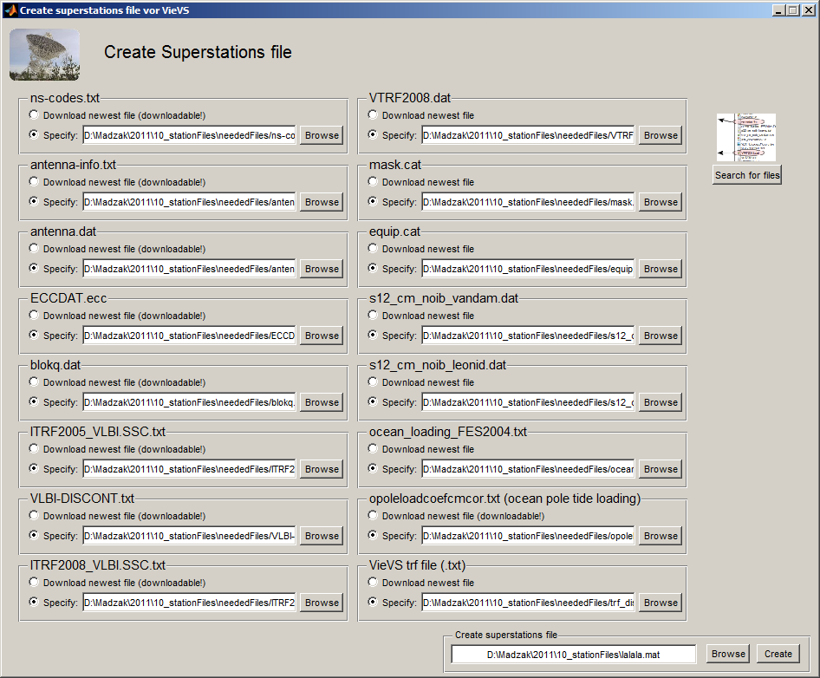

Fig 1. GUI to create a superstations file.

By using the button “search for files” the program looks for the needed files in *../ neededFiles/* and writes – if found – the correct files to the textboxes. The output file must be specified at the bottom right. The program is started by clicking the *Create* button.

## Using the .m-file

The program may also be used directly from the matlab editor: Open *mk_superstatFile.m* in the *code* folder, specify all files as mentioned in the beginning of the file (don’t forget the outFile-variable) and run the program.

# New antenna

What is needed?

* Coordinates (own trf file – manually add) and write “0” to the end of line (see screenshot) if this station should not take part in NNT/NNR condition.



* Ocean tidal loading:

1. Run ‘createSuperstationsFile.m’ to get list of stations. Format:

WETTZELL 4075539.757 931735.399 4801629.449

1. Go to <http://froste.oso.chalmers.se/loading//>, look for ‘Select ocean tide model’ and select:

* FES2004
* vertical and horizontal displacements
* NO correct
* NO plot
* BLQ format
* Add station information lines (from command window in matlab) to textbox on webpage
* Enter e-mail address and click submit

You get an e-mail containing the ocean loading data. Save them together into one file (using an editor) and give it a proper name (e.g. ocean_loading_FES2004.txt). Use this file in the GUI (‘createSuperstationsFile.m’).

* Thermal antenna deformation?

1. Add values to THERMAL.DEF (../Vievs/THERMDEF). Unknown values!
2. Run matlab function to create .mat file (../VieVS/THERMDEF/temp/termdef2mat.m) – be sure to use the correct THERMAL.DEF file in function.
3. Put TDEF.mat in ../Vievs/THERMDEF

* non-/tidal atmosphere loading? Grid!

Z.B. s12_cm_leonid

# Changes in existing antenna

## After earthquake

In order to not take wrong coordinates, insert an end-break to all “official” TRFs (ITRF2005_VLBI.SSC.txt, ITRF2008_VLBI.SSC.txt, VTRF2008.dat): Get the DOMES number (e.g. from ns_codes.txt) for the station you want to insert that end-break (since the names/ivs-names are not equal in ITRF files, but the DOMES should be distinct!)

Example: Tsukuba earthquake took place 2011, doy: 70. Ivsname: TSUKUB32, DOMES: 21730S007, “name” (in ITRF files): TSUKUBA.

|  |  |  |
| --- | --- | --- |
|  | 🡪 |  |
|  | 🡪 |  |
|  | 🡪 |  |

If you have new coordinates: Insert these coordinates as a new line in your “own TRF” file: Don’t forget to also change the end-epoch of the previous break). Decide whether these coordinates are already good enough (and should therefore be part of the NNT/NNR condition) – then write a 1 to the end of the line or leave it empty as it is.

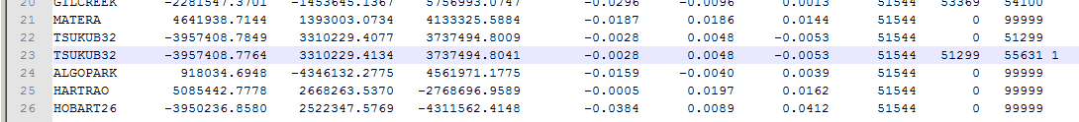

Fig 2. After the earthquake, if coordinates available: New line to „own TRF“ file – a 1 at the end indicates that this station already takes part in NNT/NNR condition (the same is done when nothing is written to end of the line).

If you don’t have any coordinates (usually shortly after the earthquake): Copy the “original” line, end the first break with the Earthquake-mjd. The second (copied) line should have (nothing better yet available) the same coordinates, start break=earthquake mjd, end break 99999. Write a 0 to end of that line, indicating that this station does not take part in NNT/NNR condition.



Fig 3.The zero at the end of the line simply indicates that the station does not take part in NNT/NNR.

It is important to have coordinates (even wrong) for every station because the coordinates in the “own” TRF file are the backup coordinates in vievs – even if those are estimated (indicated by the 0 at the end), they need a priori coordinates!

Examples for is datum (vtrf2008 stands for any TRF except vievsTrf):

|  |  |  |  |  |
| --- | --- | --- | --- | --- |
| Chosen TRF in GUI | Coords exist in chosen TRF | Coords exist in vievsTrf | ‘indatum’ given in manual (vievs) Trf | NNT/NNR in processing |
| vtrf2008 | 1 |  |  | 1 |
| vtrf2008 | 0 | 1 | doesn’t matter | 0 |
| vtrf2008 | 0 | 0 | not available | no coords at all (**should not happen**) |
| vievsTrf | 1 |  | yes | taken from manual (vievs) Trf |
| vievsTrf | 1 |  | no | 1 |
| vievsTrf | 0 |  | not available | no coords at all (**should not happen**) |

# List of files

## NS codes

This file defines the order of our superstations-file. It consists of all IVS VLBI station and provides following information: 2-letter code, 8-letter station name, DOMES number, CDP number and Comments/descriptions.

Download: <ftp://ivscc.gsfc.nasa.gov/pub/control/ns-codes.txt>

## Antenna info

This file consists of mounting information of all IVS antennas, e.g. mounting types, antenna diameters, thermal deformation coefficients, etc.  
Download: <http://vlbi.geod.uni-bonn.de/IVS-AC/Conventions/antenna-info.txt>

## antenna.dat

This file consists of names and descriptions of antennas. Apart from that one can find approximate station coordinates.  
Download: <http://gemini.gsfc.nasa.gov/solve_save/antenna.dat>

## ECCDAT.ecc

This files defines a monument number for each VLBI station and an eccentricity vector from the monument to the antenna's reference point (axis intersection).  
Download: <http://gemini.gsfc.nasa.gov/solve_save/ECCDAT.ecc>

## blokq.dat

VLBI station positions, ocean loading catalog and source catalog.  
Download: <http://gemini.gsfc.nasa.gov/apriori_files/blokq.dat>

## ITRF2005_VLBI.SSC.txt

ITRS realization of VLBI stations from 2005.  
Download: itrf.ensg.ign.fr/ITRF_solutions/2005/doc/ITRF2005_VLBI.SSC.txt

## VLBI-DISCONT.txt

Containing VLBI position discontinuities, i.e. a “list of earthquakes”.  
Download: <http://vlbi.geod.uni-bonn.de/IVS-AC/data/VLBI-DISCONT.txt>

## ITRF2008_VLBI.SSC.txt

ITRS realization of VLBI stations from 2008.  
Download: <http://itrf.ensg.ign.fr/ITRF_solutions/2008/doc/ITRF2008_VLBI.SSC.txt>

## VTRF2008.dat

A terrestrial reference frame based on VLBI sites positions.

## mask.cat

Station horizon/coordinate masks for VLBI stations.

## equip.cat

VLBI station equipment.

## s12_cm_noib_vandam.dat

Atmospheric pressure loading data for VLBI stations for the model from Tony vanDam. For new or other stations, a grid is used and the values are interpolated.

## s12_cm_noib_leonid.dat

Atmospheric pressure loading data for VLBI stations for the model from Leonid Petrov. For new or other stations, a grid is used and the values are interpolated.

## ocean_loading_FES2004.txt

Ocean tide loading corrections. Can be calculated using the web form at <http://froste.oso.chalmers.se/loading//>.

## Own TRF file

A textfile containing “own” coordinates of stations. This is the file to be modified when there is an earthquake or a new antenna observing and this station needs new coordinates (see chapter 2 and 3 for details). For all stations in ns_codes (4.1) where are no vievsTrf (from this file) coordinates available, approximate coordinates are taken from the blokq.dat file (4.5). If there are no coords for a station in vievsTrf, that station might not work in VieVS because that TRF is used as backup for other TRFs.