1. Batch norm

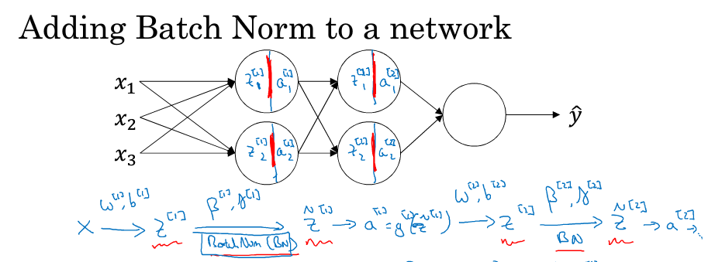

$μ=\frac{1}{m}\sum_{i=1}^{m}{Z^{(i)}}$

$σ^{2}=\frac{1}{m}\sum_{i=1}^{m}{{{(μ-Z}^{(i)})}^{2}}$

${Z_{norm}}^{(i)}=\frac{Z^{(i)}-μ}{\sqrt[2]{σ^{2}+ε}}$

${\hat{Z}}^{(i)}=γ{{*Z}_{norm}}^{(i)}+β$

Test-time: use Exponentially weighted averages.

1. Softmax regression

$σ\left(z\right)=\frac{e^{-z(i)}}{\sum{e^{-z(i)}}}$

$loss=-\sum{y\log{\hat{y}}}$