Conv

**1.edge detection**

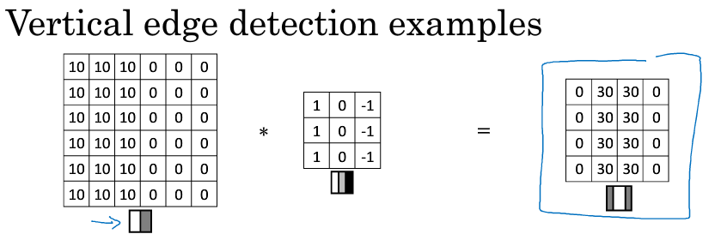

Find the feature of img

**2.padding**

Valid: $n×n * f×f=n-f+1 × n-f+1$

Padding: $n×n * f×f=n×n$

Zero-padding.

Combat: ①shrinking shape ② throw away info from edge

**3.strided convolution**

**4. pooling**

Max pooling

Ave pooling

**5.why convolution**

①*Parameter sharing*: A feature detector that’s useful in one part of the img is probably useful in another part of the image

②*Sparsity of connections*: In each layer, each output value depends on a small number of inputs