create database temp;

use temp;

create table student(

name varchar(20) NOT NULL,

telephone varchar(20) NOT NULL,

email varchar(30) NOT NULL,

birthday varchar(20) NOT NULL,

province varchar(20) NOT NULL,

city varchar(20) NOT NULL,

account int PRIMARY KEY,

password varchar(20) NOT NULL);

create table stud_login (

account int NOT NULL ,

CONSTRAINT fk_stud_account FOREIGN KEY(account)

REFERENCES student(account) ,

loginkey varchar(20) NOT NULL);

set names 'gb2312';

insert into student values ('mitsuha',

'15767855213','2426443099@qq.com','1998/12/16','云南','丽江',

1001,'111111');

select * from student;

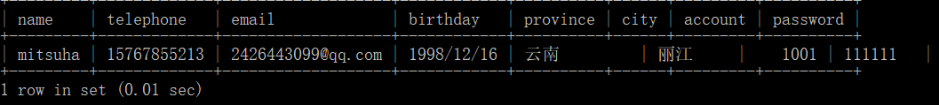

insert into stud_login values (1001,'logined');

select * from stud_login;

