BioKLab

Home
Welcome to BioKLab!
BioKLab focuses on integrating computational approaches with biomedical big data to unravel mechanisms of complex diseases and advance translational medicine. Our vision is to bridge the gap between bench research and clinical practice by decoding molecular regulators of disease progression, enabling precise diagnosis and targeted therapy development.
To achieve this vision, we leverage a combination of computational algorithms & AI, multi-omics data integration, and translational validation.
Computational Algorithms & AI. We develop and apply statistical learning and deep learning techniques to mine biomedical data, with a focus on deep learning interpretability and predictive modeling for disease-related traits.
Multi-Omics Data Integration. We integrate single-cell omics, genomic, and clinical datasets to dissect cell-specific transcriptional regulation and molecular mechanisms underlying cancer metastasis and respiratory diseases.
Translational Validation. We conduct computational screening of anti-metastatic drugs and validate key findings through functional associations, accelerating the translation of basic research to clinical applications.

News
October 2025
Undergraduate students Qichen and Shihang join BioKLab. Welcome!

September 2025
Yueqi and Maowang join BioKLab. Welcome!

September 2025
Undergraduates Fuhan Lei and Jifeng Yu Admitted to Harbin Institute of Technology and Tsinghua University for Direct Ph.D. Studies!
Congratulations to undergraduate student Fuhan Lei for being directly admitted to the Ph.D. program at Harbin Institute of Technology, and Jifeng Yu for direct admission to the Ph.D. program at Tsinghua University. This achievement highlights the laboratory's success in cultivating outstanding young talent. We take great pride in their accomplishments.

June 2025
Master's student Jing Li has successfully completed her studies and obtained her Master's degree. During her time in the lab, Jing was the leader of the “TNBC_heterogeneity” project, and also actively participated in other’s research. We wish her continued success in her future career.
Undergraduate student Yinzhi joins BioKLab. Welcome!

September 2024
Ziyi and Sirui join BioKLab. Welcome!

September 2023
Shumin, Yang, and Xueying join BioKLab. Welcome!

June 2023
Undergraduate student Fuhan join BioKLab. Welcome!

February 2023
Collaborative Paper "Histone tyrosine sulfation by SULT1B1 regulates H4R3me2a and gene transcription" was in published in Nature Chemical Biology.

September 2022
Undergraduate students Jifeng and Weihang join BioKLab. Welcome!

June 2022
Jing, Chunyang, and Xiuyuan join BioKLab. Welcome!

March 2022
Ke joins the National Institute of Health Data Science at Shandong University and BioKLab opens!

People
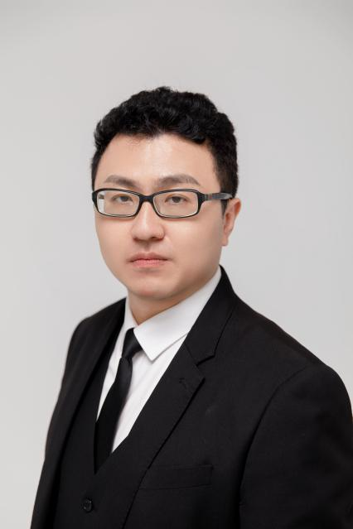
Ke Liu, Ph.D.
Dr. Ke Liu holds an interdisciplinary background in computer science, biology, and statistics. His research focuses on leveraging advanced computational approaches—such as statistical learning and artificial intelligence—to extract insights from biomedical big data, with the goal of advancing translational medical research from bench to bedside for complex diseases.
Dr. Liu completed his undergraduate studies in Computer Science and Technology at Shandong University (2004–2008) and earned his Ph.D. in Biology from Tsinghua University (2008–2015). He further enriched his expertise through postdoctoral training at the University of California, Berkeley (Department of statistics, 2015–2017), the University of California, San Francisco (Institute for Computational Health Sciences, 2018), and Michigan State University (Department of Pediatrics and Human Development, 2018–2022).
His research program centers on three main areas: (1) cell-specific transcriptional regulation using single-cell omics data, (2) interpretability in deep learning models, and (3) computational analysis of multi-omics data to elucidate cancer metastasis mechanisms and support anti-metastatic drug screening.

Ph.D. Students


Jin Xiuyuan, Ph.D. Student, received her Master of Biostatistics from Shandong University in 2023. Her current research focuses on using multi-omics approaches to elucidate the cellular heterogeneity and molecular mechanisms of Congenital Pulmonary Airway Malformation (CPAM) in children. Email: jinxiuyuan@mail.sdu.edu.cn
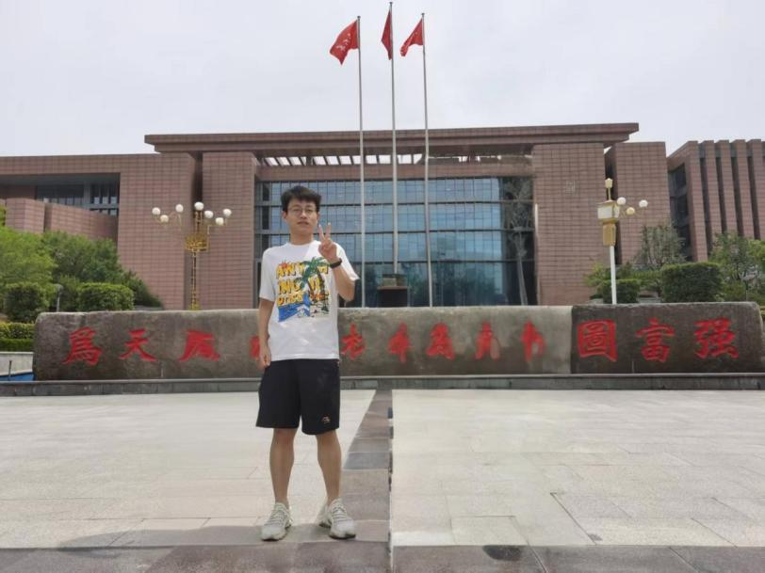
Fu Chunyang, Ph.D. Student, graduated from Shandong University with a Bachelor's degree in Preventive Medicine. He joined the laboratory in 2022 and transitioned to the Ph.D. program in 2024. Email: chunyangfu@mail.sdu.edu.cn

Liu Yang, Ph.D. Student, holds a Bachelor's degree in Medicine from Shandong University. He joined the laboratory as a Master's student in 2023 and transitioned to the Ph.D. program in 2025. His research focuses on utilizing omics data to elucidate the pathogenic mechanisms of pediatric pulmonary mucoepidermoid carcinoma.

Master's Students
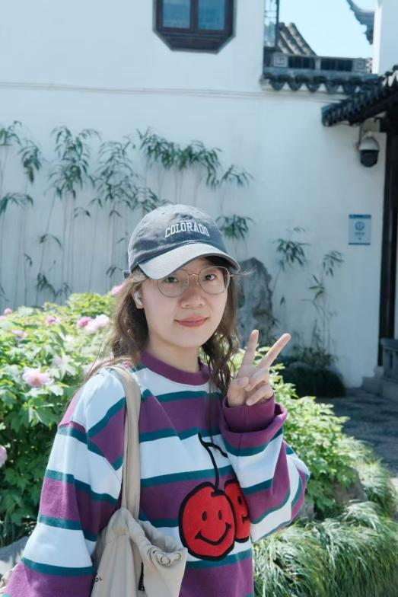
Liu Xueying, Master's Student, received her Bachelor's degree in Biology from China Pharmaceutical University in 2023. She is currently pursuing a Master's degree in Biostatistics at Shandong University. Her research interests lie in cancer genomics and computational methods for understanding tumor biology. Email: xueyingliuu@126.com

Hao Yueqi, Master's Student, graduated from Hainan Normal University with a Bachelor's degree in Statistics. She is currently a Master's student in the laboratory, and her research direction is bioinformatics. Email: haoyueqi0724@163.com
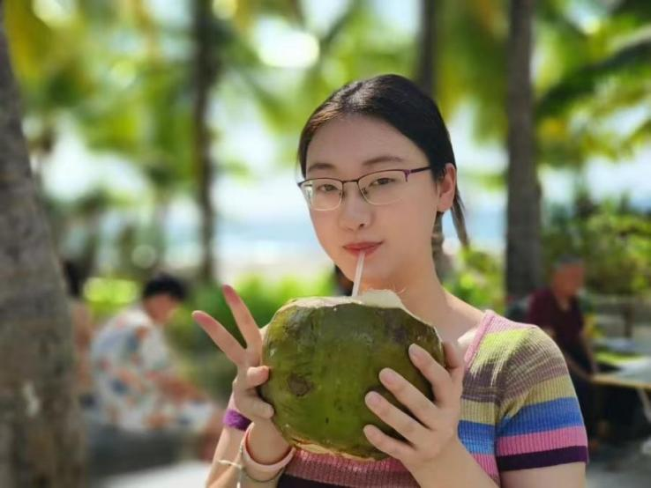
Wang Ziyi, Master's Student, graduated from Shanxi Medical University with a Bachelor's degree in Information Management and Information Systems. She entered Shandong University in 2024 to pursue a Master's degree in Public Health (Biostatistics). Her current research focuses on using transcriptomics technologies to identify the tissue of origin for Cancers of Unknown Primary (CUP). Email: 1303610295@qq.com
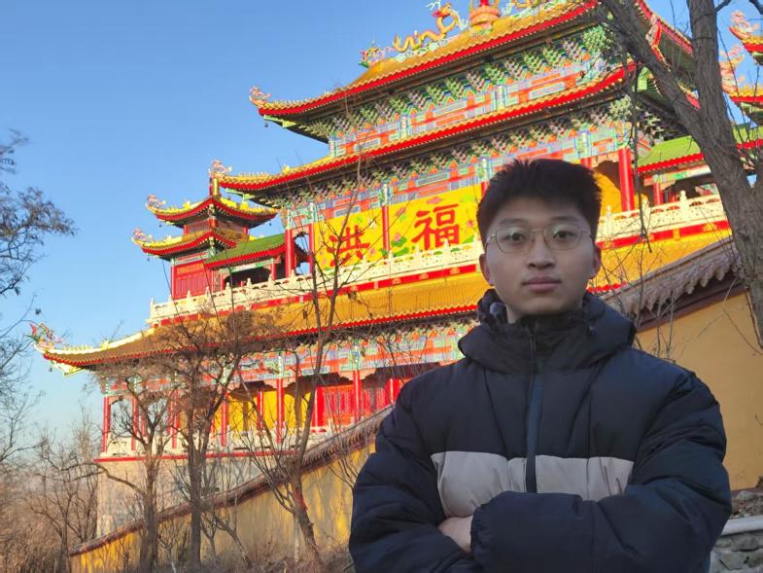
Bian Maowang, Master's Student, holds a Bachelor's degree in Preventive Medicine. He is currently pursuing a Master's degree in Biostatistics in the laboratory, with research interests in biomedicine. His hobbies include fitness and playing badminton. Email: bianmaowang2002@163.com

Yin Shumin, Master's Student, graduated from Shandong University with a Bachelor's degree. Her research focuses on algorithms for identifying marker genes in single-cell transcriptomics. Email: shuminyin@mail.sdu.edu.cn
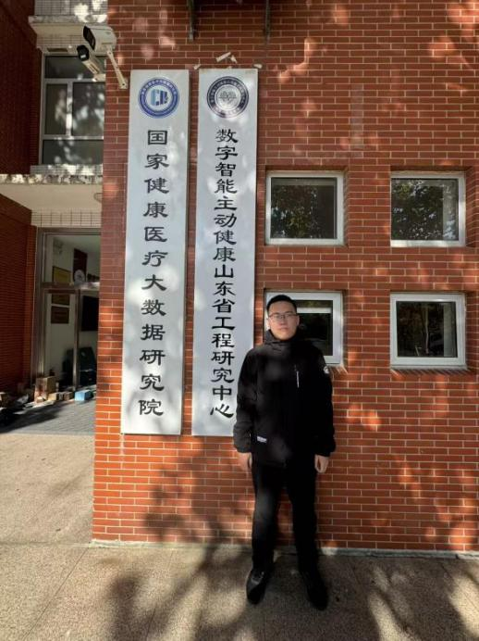
Zhang Sirui, Master's Student, graduated from Shandong University with a Bachelor's degree in Preventive Medicine. His research involves using statistical learning to evaluate the perturbing effects of the Hepatitis B Virus (HBV) on alternative splicing in hepatocytes. Email: 3494747883@qq.com

Undergraduate Students
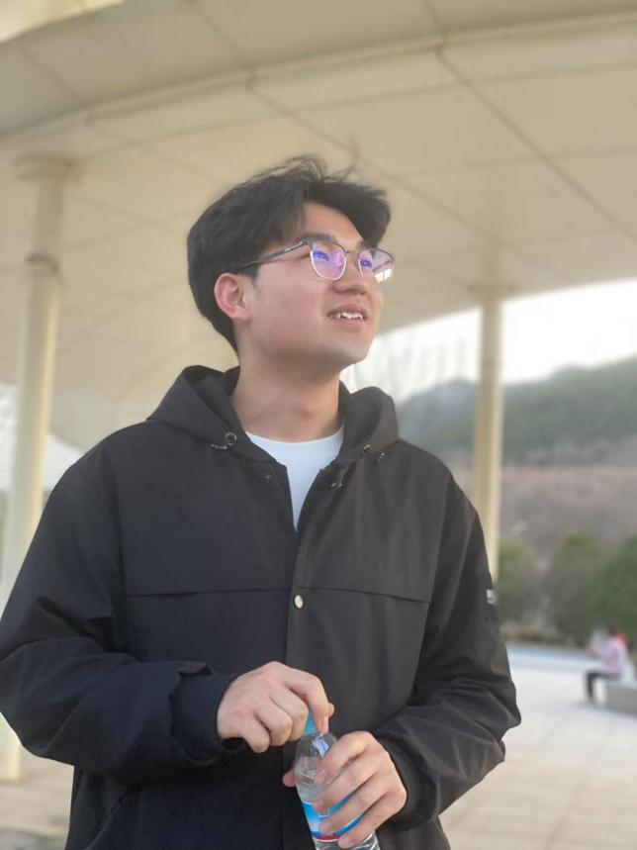
Yu Jifeng, Undergraduate Student, majors in Biomedical Data Science at Shandong University. His research focuses on enhancing the interpretability of autoencoder models in genomics by mapping latent neurons to biological pathways, aiming to develop methods for linking model activations to tissue-specific functions to discover biomarkers. Email: 202200222007@mail.sdu.edu.cn
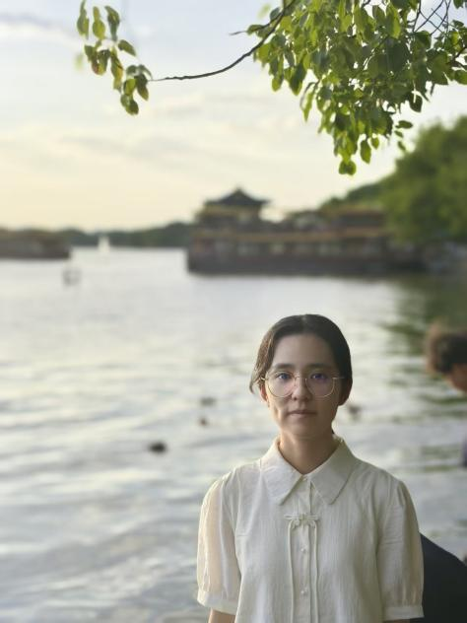
Lei Fuhan, Undergraduate Student, majors in Biomedical Data Science at Shandong University. Her research direction involves interdisciplinary studies in bioinformatics and artificial intelligence. Email: 202200222005@mail.sdu.edu.cn
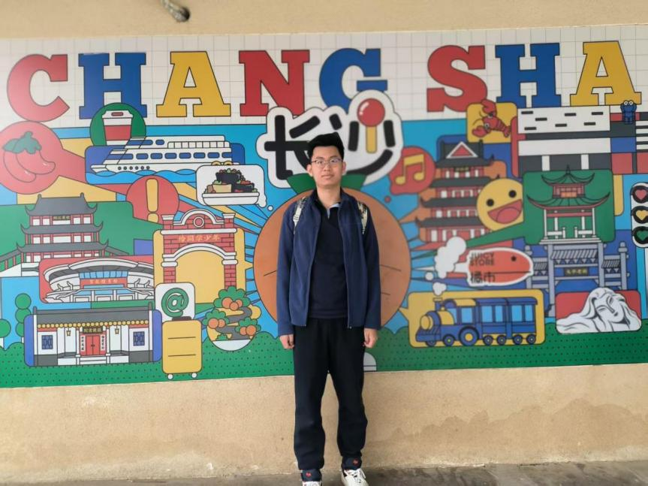
Ju Weihang, Undergraduate Student, majors in Biomedical Data Science at Shandong University. Email: 772853178@qq.com

Sha Shihang, Undergraduate Student, majors in Biomedical Data Science at Shandong University. Email: sha714204078@outlook.com
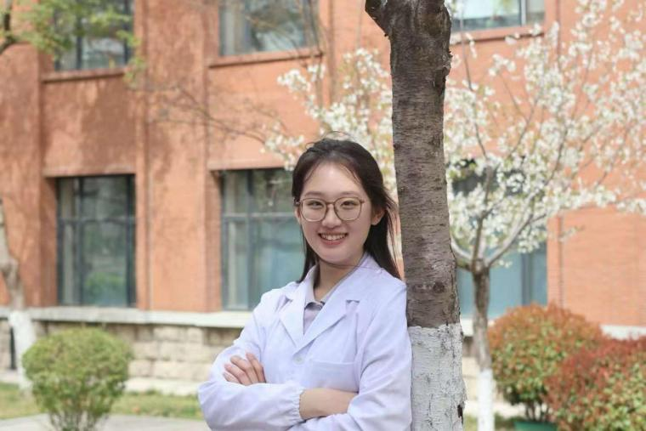
Huang Yinzhi, Undergraduate Student, majors in Biomedical Data Science at Shandong University. Email: huangyinzhi@mail.sdu.edu.cn

Sun Qichen, Undergraduate Student, majors in Biomedical Data Science at Shandong University. Email: 1207478481@qq.com

Publications

Weixing Yu, Runxin Zhou, Nan Li, Zhi-Chao Lei, Dingyuan Guo, Fei Peng, Yan Li, Xue Bai, Shan Feng, Yu Wang, Jie He, Sibi Yin, Xiao Zeng, Leya He, Yuan Gao, Mingchang Li, Yusong R. Guo, Ke Liu & Yugang Wang (2023). Histone tyrosine sulfation by SULT1B1 regulates H4R3me2a and gene transcription. Nature Chemical Biology.
https://www.nature.com/articles/s41589-023-01267-9

Ke Liu, Martin Witteveen-Lane, Benjamin S Glicksberg, Omkar Kulkarni, Rama Shankar, Evgeny Chekalin, Shreya Paithankar, Jeanne Yang, Dave Chesla, Bin Chen. (2022). BGLM: big data-guided LOINC mapping with multi-language support. JAMIA Open, 5(4).

Ke Liu, Omkar Kulkarni, Martin Witteveen-Lane, Bin Chen, Dave Chesla. (2022). MetBERT: a generalizable deep learning model for prediction of metastatic cancer. AMIA 2022 Informatics Summit.

Jing Xing, Shreya Paithankar, Ke Liu, Katie Uhl, Xiaopeng Li, Meehyun Ko, Seungtaek Kim, Jeremy Haskins, Bin Chen. (2021). Published anti-SARS-CoV-2 in vitro hits share common mechanisms of action that synergize with antivirals. Briefings in Bioinformatics, 22(6).
https://doi.org/10.1093/jamiaopen/ooac099

Ke Liu, Elizabeth Theusch, Yun Zhou, Tal Ashuach, Andrea S. Dose, Peter J. Bickel, Marisa W. Medina, Haiyan Huang. (2019). GeneFishing to reconstruct comprehensive context-specific portraits of biological processes and its application to cholesterol metabolism. Proceedings of the National Academy of Sciences of the United States of America, 116(38), 18943-18950.
https://doi.org/10.1073/pnas.1820340116

Ke Liu, Patric Newbury, Benjamin Glicksberg, Eran Andrechek, Bin Chen. (2019). Evaluating cell lines as models for metastatic breast cancer through integrative analysis of genomic data. Nature Communications, 10(2138).
https://www.nature.com/articles/s41467-019-10148-6

Yugang Wang, Yusong R. Guo, Ke Liu, Zheng Yin, Rui Liu, Yan Xia, Lin Tan, Peiying Yang, Jong-Ho Lee, Xin-jian Li, David Hawke, Yanhua Zheng, Xu Qian, Jianxin Lyu, Jie He, Dongming Xing, Yizhi Jane Tao and Zhimin Lu. (2017). KAT2A coupled with the α-KGDH complex acts as a histone H3 succinyltransferase. Nature, 552(7684), 273–277.
https://www.nature.com/articles/nature25003

Ke Liu, Zhangming Yan, Yuchao Li, Zhirong Sun. (2013). Linc2GO: a human lincRNA function annotation resource based on ceRNA hypothesis. Bioinformatics, 29(17), 2221-2222.
https://academic.oup.com/bioinformatics/article/29/17/2221/242211

Preprints
Shumin Yin, Ke Liu. (2025). CFMF: A Clustering-Free Cell Marker Finder for Single-Cell Transcriptomics Data. bioRxiv.
https://doi.org/10.1101/2025.10.26.683836

Chunyang Fu, Ke Liu. (2025). Pan-Cancer Single-Cell Profiling Uncovers the Biological Characteristics of Cancer-Testis Genes. bioRxiv.
https://doi.org/10.1101/2025.08.25.672079

Xueying Liu, Weixing Yu, Xiuyuan Jin, Yugang Wang, Ke Liu. (2025). Multi-omics evaluation of cell lines as models for metastatic prostate cancer. bioRxiv.
https://doi.org/10.1101/2025.07.17.665334

Jing Li, Yuan Gao, Shouhui Guo, Qingzhen Hou, Shisong Zhang, Weixing Yu, Ke Liu. (2024). Single-cell molecular subtyping reveals novel intratumor heterogeneity in human Basal-like breast cancer. bioRxiv.
https://doi.org/10.1101/2024.06.02.597060

Join

Join Us!
We are an interdisciplinary research team dedicated to leveraging artificial intelligence and statistical learning methods to analyze biomedical big data, with the goal of tackling major health challenges such as cancer and genetic diseases. We welcome students and colleagues with backgrounds in life sciences, medicine, mathematical statistics, physics, and related fields to join us. Our lab focuses on the intersection of biomedical big data and advanced computational methods. Key research areas include cell-specific transcriptional regulation based on single-cell omics data, interpretability research in deep learning, and the analysis of cancer metastasis mechanisms coupled with computational screening for anti-metastatic drugs using multi-omics data. We emphasize the integration of computational method development with real-world biological and medical questions, driving translational research from data to discovery.

About the National Institute of Healthcare Big Data
Our lab is centrally supported by the National Institute of Healthcare Big Data. This institute is a national-level innovation platform for healthcare big data, possessing unique, population-scale life-cycle health data resources covering tens of millions of individuals. This provides unparalleled conditions for conducting real-world research with significant societal impact. Here, you will not only engage in cutting-edge research on a first-class academic platform but also personally contribute to advancing the field of national health medical big data.

Graduate Students
We recruit doctoral and master's students interested in bioinformatics and computational biology. Students can join the lab through relevant programs at Shandong University, such as Biostatistics, Bioinformatics, and Data Science. We provide systematic interdisciplinary research training, high-performance computing resources, and encourage students to pursue innovative research aligned with their interests. We also welcome inquiries and potential rotations for students from other related schools and departments within the university.
Postdoctoral Fellows
We sincerely invite applications for postdoctoral researchers who have obtained or are about to obtain a Ph.D. in bioinformatics, computational biology, computer science, statistics, or related fields. Applicants should possess strong programming and data analysis skills, or have extensive experience with omics data. We offer competitive compensation, excellent career development support, and are committed to assisting successful applicants in applying for various research grants. If you are interested in applying or would like more information, please send your CV, a statement of research interests, and other relevant materials to: keliu.iluke@email.sdu.edu.cn

Other Inquiries
If you are interested in our research direction but do not see a suitable position listed above, you are also welcome to contact us via email to inquire about potential collaborations or visiting opportunities.

Contact Us
The BioKLab is located in the National Institute of Healthcare Big Data at Shandong University.
BioKLab
National Institute of Healthcare Big Data
Shandong University, Xinglongshan Campus
Room 224
Jinan, Shandong 250002
P. R. China

