The result of Sarsa and Q_Learning with epsilon=0.1,0.05 and 0.0

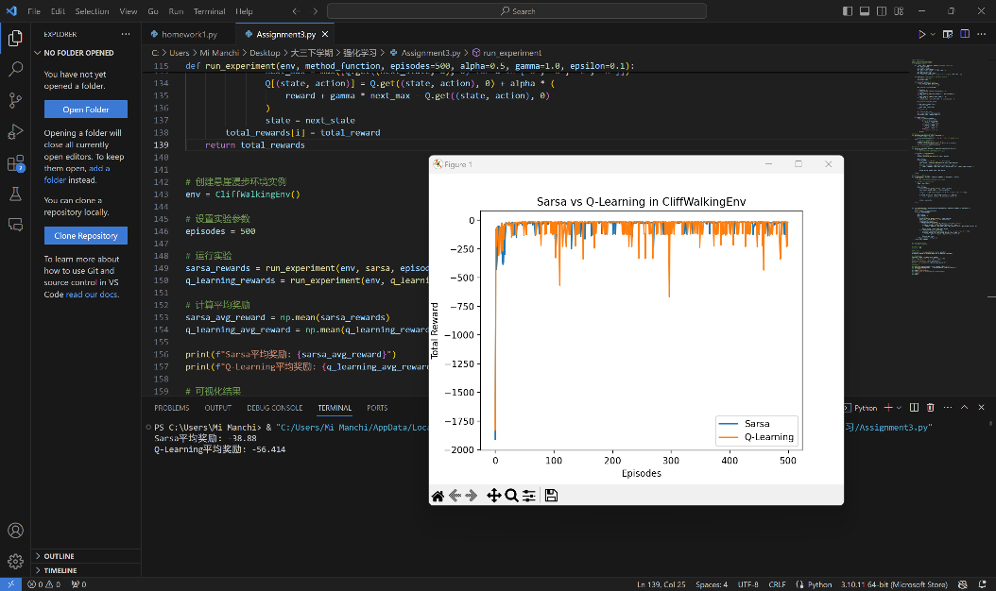 Epsilon = 0.1, considering the average reward of two method:

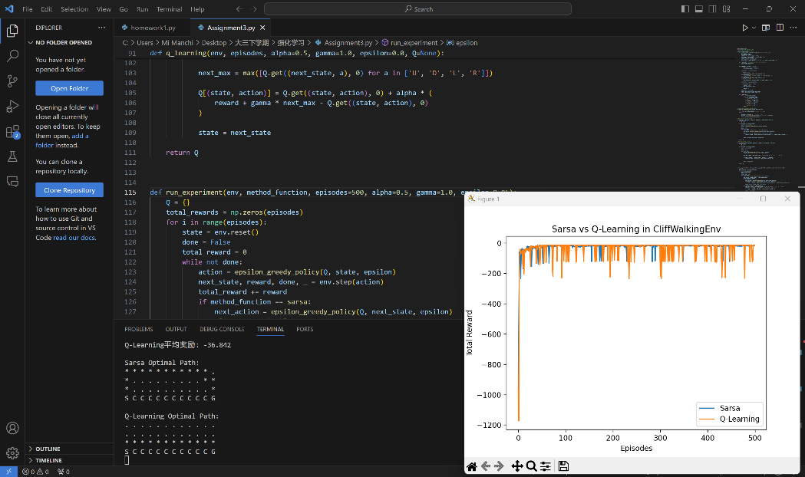Epsilon = 0.05, considering the average reward of two method:

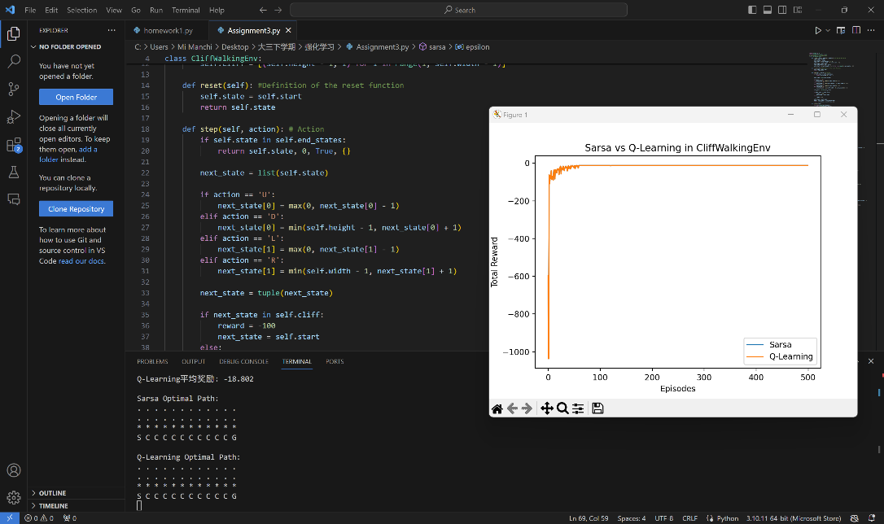Epsilon = 0.0, considering the average reward of two method: