Overview: This practical was focused around working with logic using C, and analysing it afterwords. The first part was to create a program that takes a reverse-polish-notation formula and number of variables as arguments and then and prints out a complete logic truth table for that sum in a specified format. For parts two and three we were to use this program to prove some laws and then solve some logical puzzles.
Design:
Part 1: Truth Table Creator. I chose to create each logical operation used a method and store them all in one file titled operations.c. I then made the rest of the methods needed in another file titled functions.c. I then created headers for each of these and used ifndef to avoid circular loops of reliance. From the main method I get the required information from the arguments then call the required method. First I have one that prints out everything for the first two lines, the header and the = marks needed. I created a method that could return the value a specific bit would be in a number to print the left hand side of the truth table which uses a mask and bitwise shifts. After printing that out for the row I then call the solve method which returns a string of the result from each calculation and the final result added on the end. It then prints this all out to finish the row. It loops through this process for each row in the truth table.
Part 2: Laws of Boolean Algebra. To prove the two laws we had to do I chose to take each side of the equation and calculate the truth table for it, and then compare it against the truth table from the other half, if the laws hold true then both truth tables should be the exact same. The Table below shows each law and the truth table for each half.
Distribution Laws
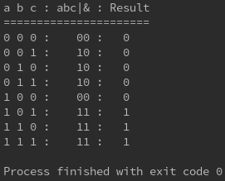  A&(B|C) | 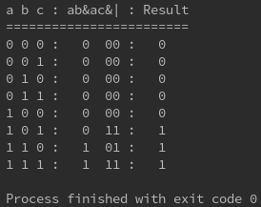  (A&B)|(A&C)
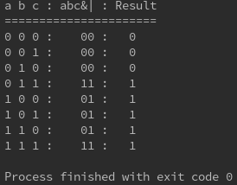  A|(B^C) | 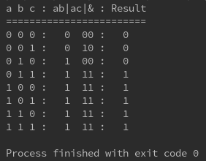  (A|B)&(A|C)
De Morgan’s Laws
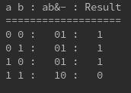  -(A&B) | 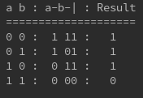  -A|-B
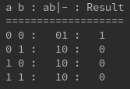  -(A|B) | 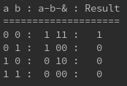  -A&-N

Part 3: Encoding and Solving Logic Puzzles. For this I went through each puzzle and first figured out how many dependants or variables there were. I then assigned these to alphabet letters to make it easier to write as a formula. For example as seen in Figure 1 the variables in the puzzle were Chris, Iain and the Coin outcome. I then read each sentence and broke it down into a logical association. Once I had all these rules I combined them and then ran it through the checker. For some of the puzzles I found there were hidden or implied rules not specifically mentioned such as in the age puzzle, not being able to be the oldest and the youngest, with that example being one I initially overlooked and later added to get my rules working. As shown on figures 4 to 6 below the outcomes of when these sums were put into the truth table creator. This shows that Chris always wins the coin game, the oldest brother is Steve, youngest being Chris and thus the middle being Ian. For the dinner the guests that attended were Deborah and Eleanor.

Testing: For testing there were some stacschecks provided, which I ran to ensure the program worked to specification. I also ran the program to generate a truth table for each logical operator available to ensure the base maths within the program was correct. This can be seen in the table below. I also made use of Valgrind to ensure that a) no frees were being missed and thus a memory leak was possible, and b) to ensure that my malloc/calloc’s were being done correctly and to the correct size.

Test Case | Expected | Result
And | 0 0 : 0  0 1 : 0  1 0 : 0  1 1 : 1 | 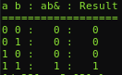
Or | 0 0 : 0  0 1 : 1  1 0 : 1  1 1 : 1 | 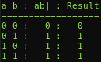
Exclusive Or | 0 0 : 0  0 1 : 1  1 0 : 1  1 1 : 0 | 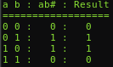
Not | 0 : 1  1 : 0 | 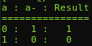
Implication | 0 0 : 1  0 1 : 1  1 0 : 0  1 1 : 1 | 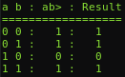
Equals | 0 0 : 1  0 1 : 0  1 0 : 0  1 1 : 1 | 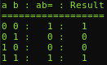
Stacscheck | Pass | 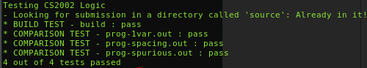
Valgrind | No Leaks  All Freed | 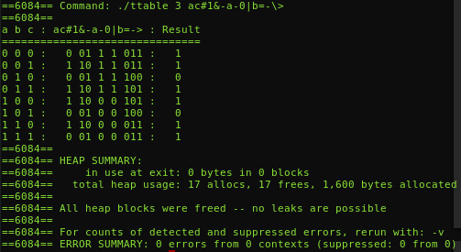

Extension: For the extensions I did extension 1, 4 and 5. In order to run the extension, set the relevant flag to 1 in arguments as explained in the README.txt file.
- Extension 1 - For this extension there wasn’t too much I had to change, I modified the printRow method so that it returned the value of that row, 1 or 0. then in main I check if the flag is set, and if it is set valid to true, satisfied to false. Then if I come across a 0 I can lower valid to false, and if I see a 1 I raise satisfied to true. Then after all rows are done I print out the required string using the valid and satisfied variables. Due to invalid and satisfied being modes that once entered are not left, this made the checks for it much easier.
- Extension 3 - For this extension again there was not too much that had to be modified. Initially I check the flag from the arguments, at the start of print row I check whether on not the flag is true, if it is I call the solver first, check the final char of it to see if the result is 1 or 0, and then decider whether to print like normal or not.
- Extension 4 - For this extension I chose to make the shunting algorithim work from a completely different d
Evaluation:

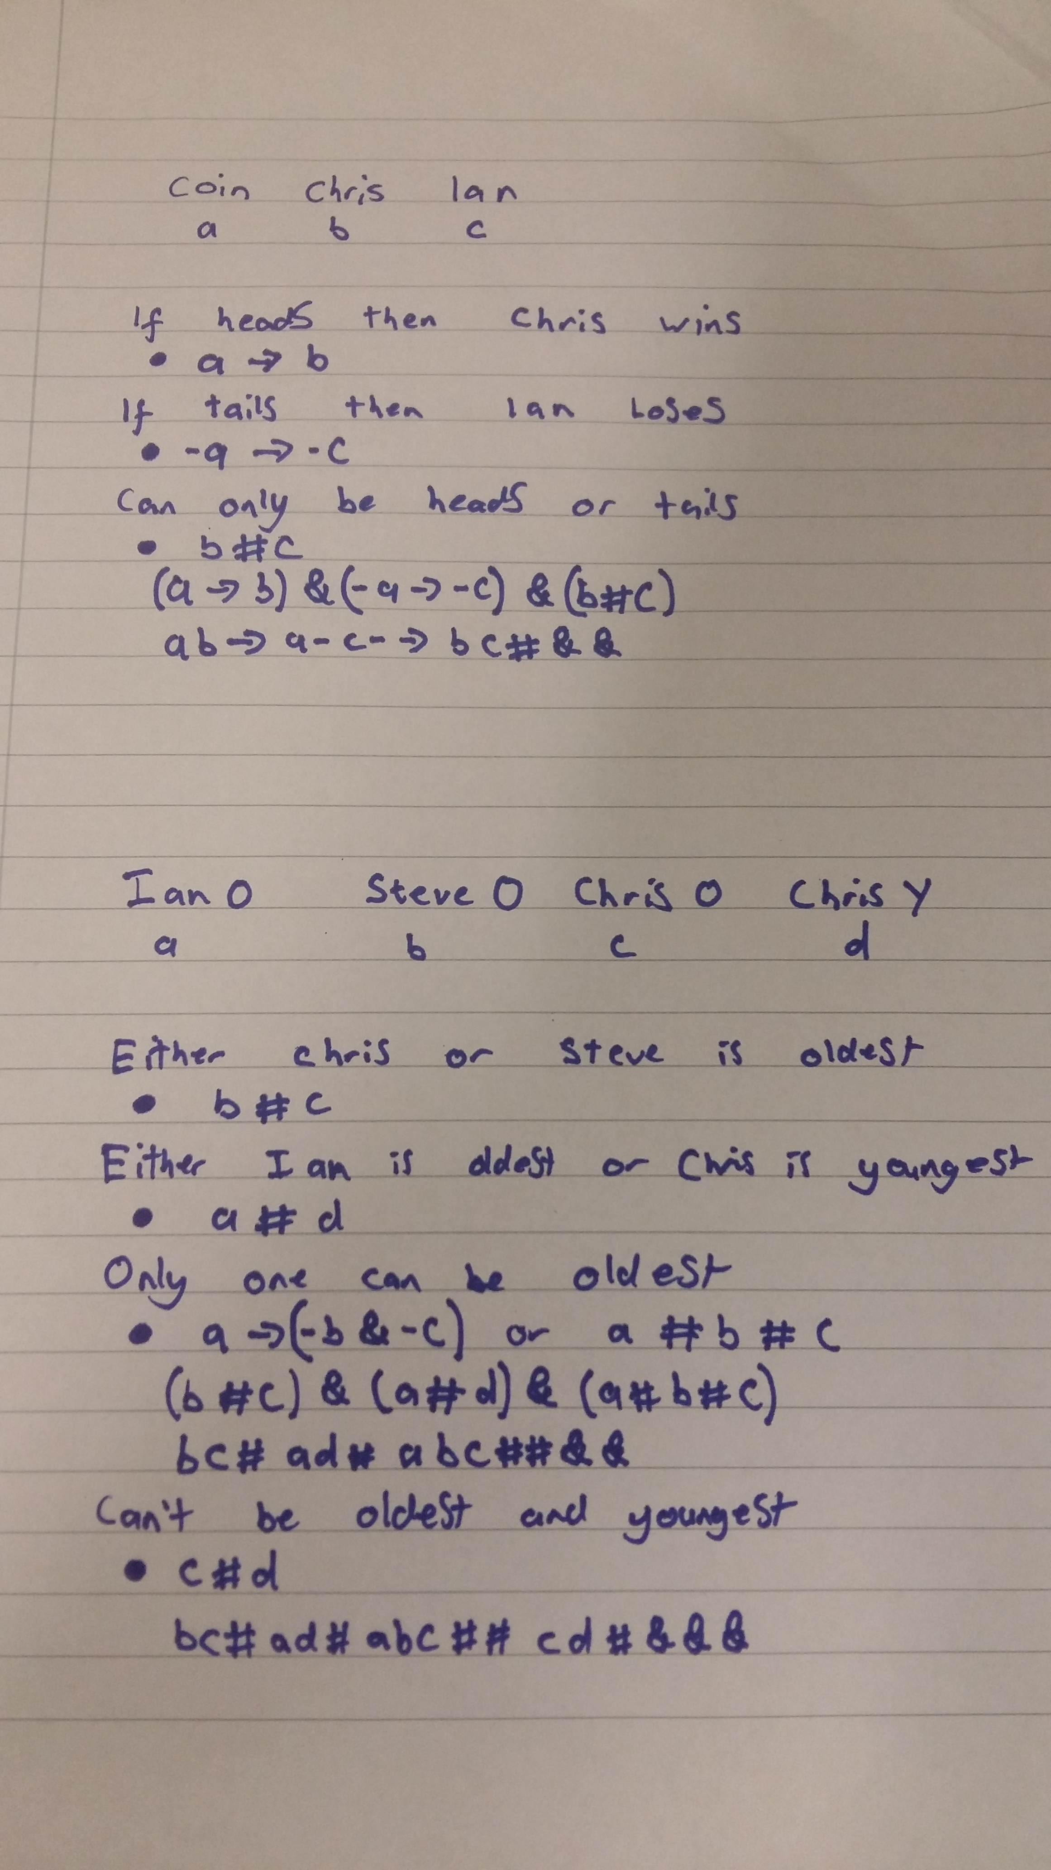Figure 2: Breakdown of the age puzzle
Figure 1: Breakdown of the coin puzzle
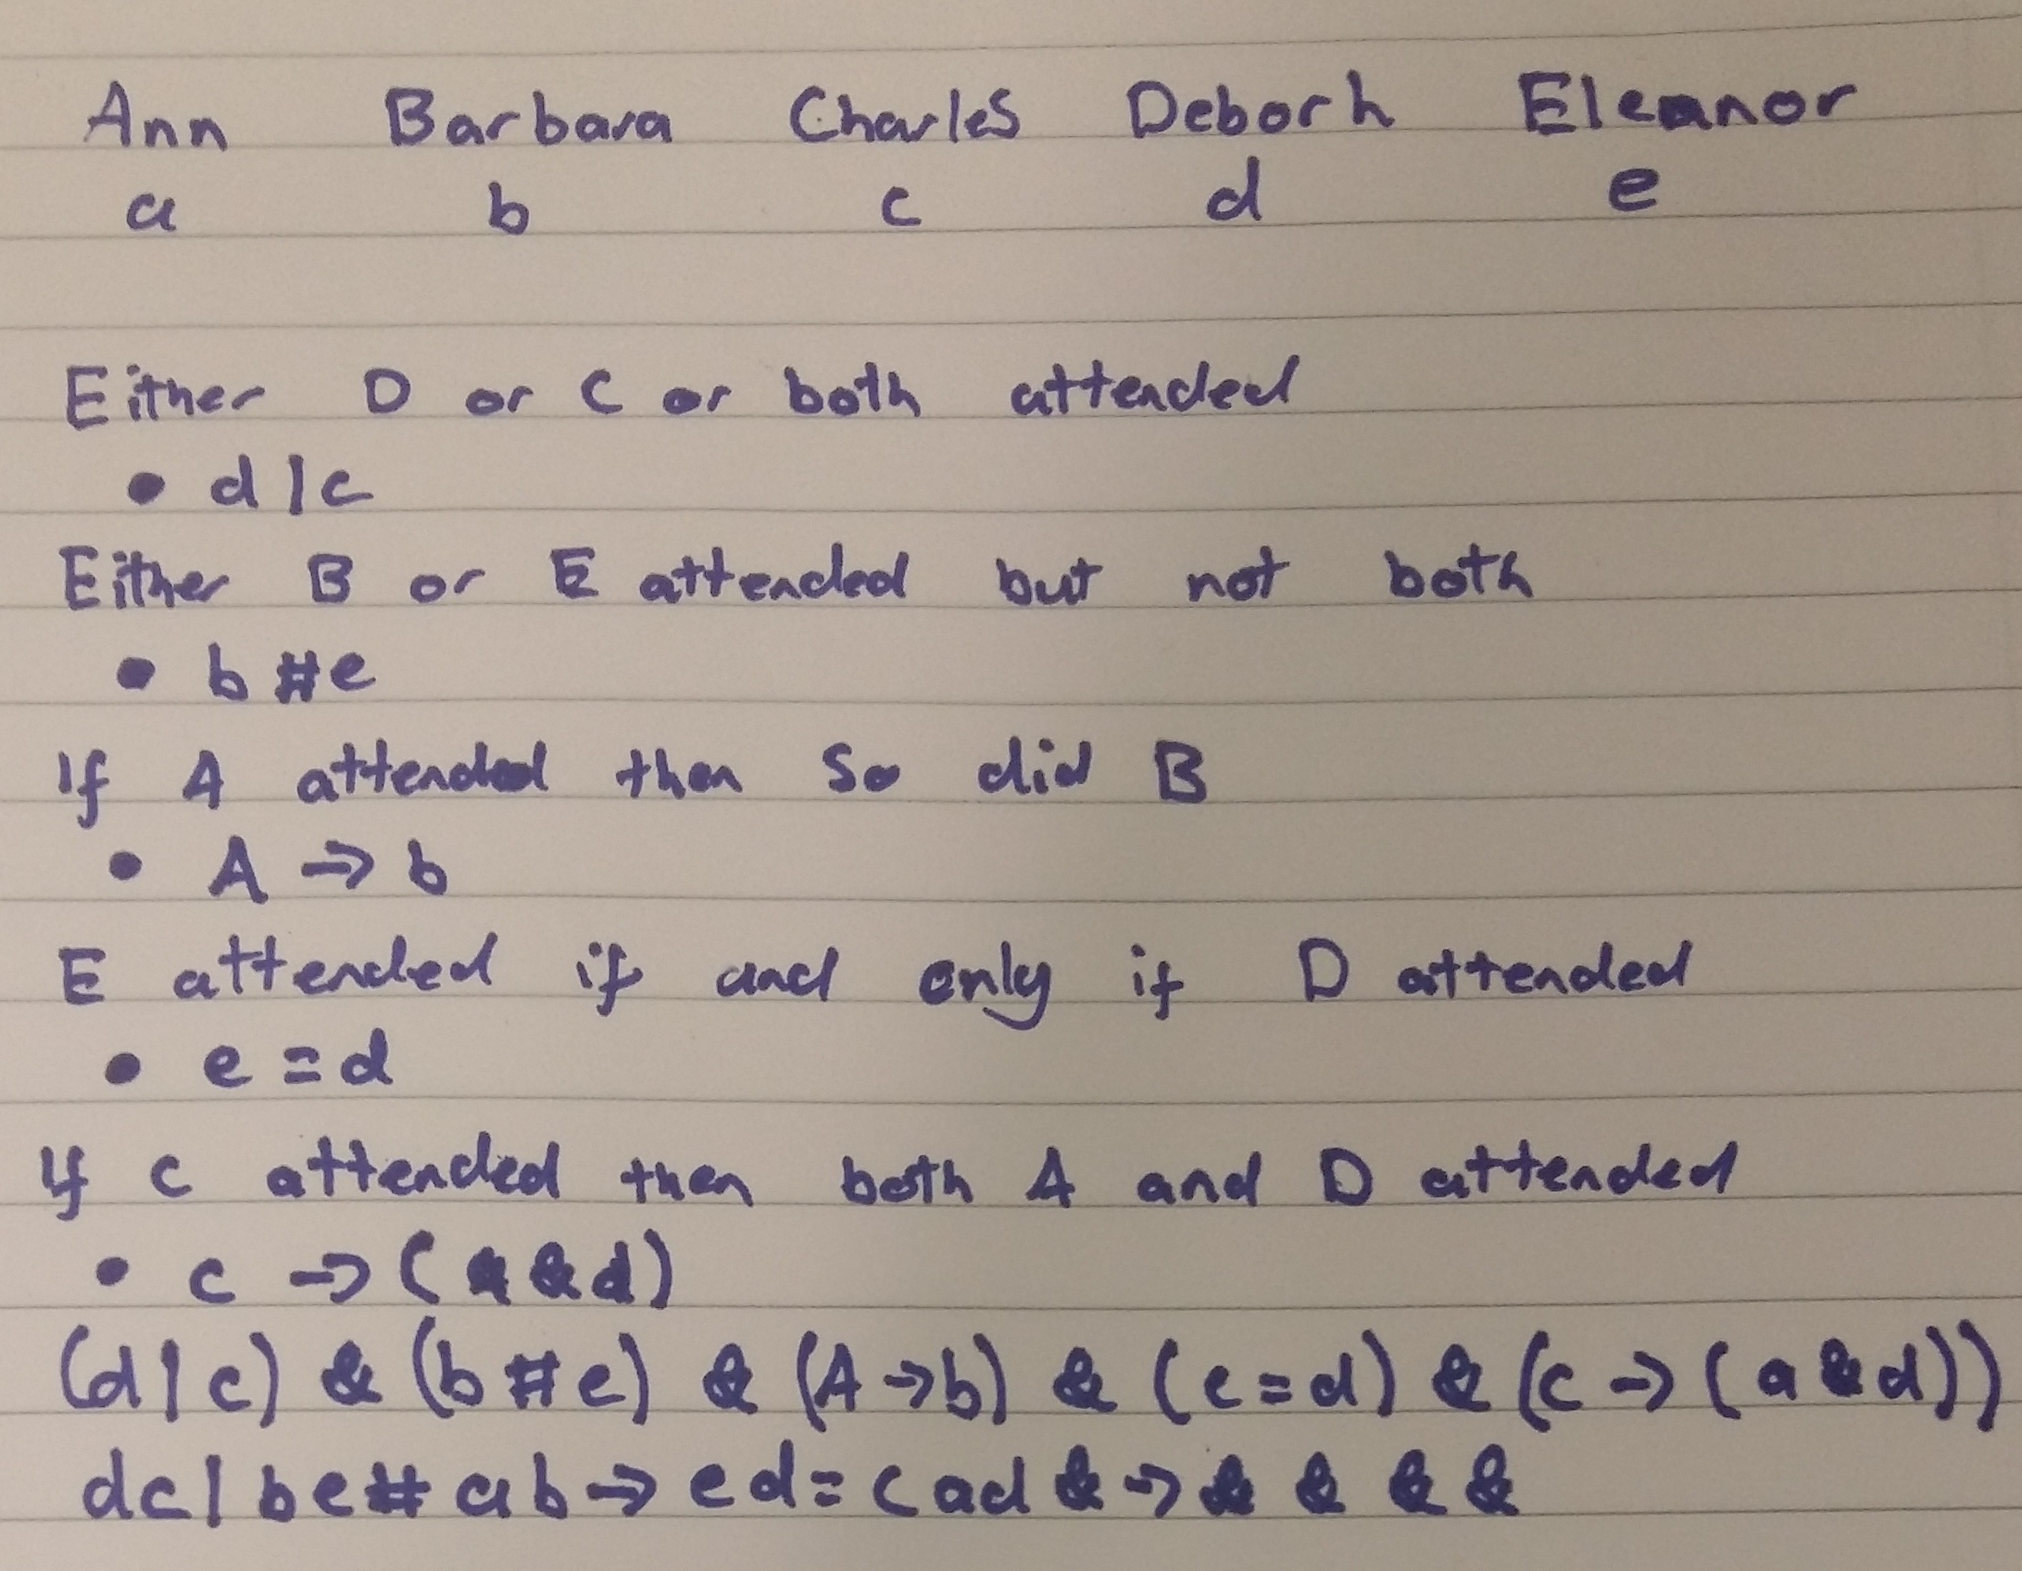Figure 3: Breakdown of the dinner puzzle

