Лабораторная работа №2

Михалович Татьяна Владиславовна

Группа 150501

Для генератора ПСП опытным путем были найдены примитивные полиномы:

x5 + x2 + 1

x5 + x3 + 1

x5 + x4 + x2 + x + 1

x5 + x3 + x2 + x + 1

x5 + x4 + x3 + x + 1

x5 + x4 + x3 + x2 + 1

Выбранный полином g(x) = x5 ⊕ x4 ⊕ x3 ⊕ x2 ⊕ 1

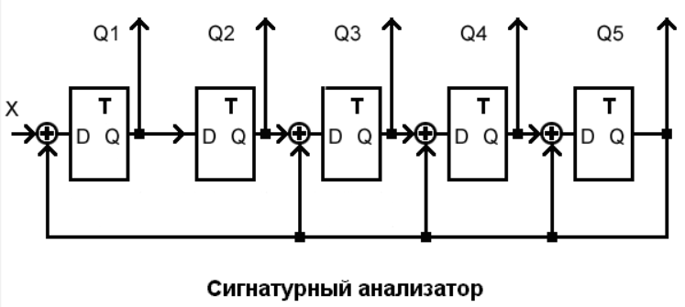

Сигнатура

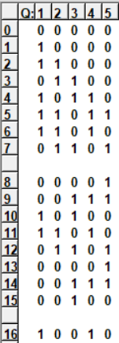

Сигнатуры совпадают в аналитическом и имитационном способах.

G’(x) = x5g-1(x) = x5(x-5 󠇯+ x-4 + x-3 + x-2 + 1) = 1 + x + x2 + x3 + x5

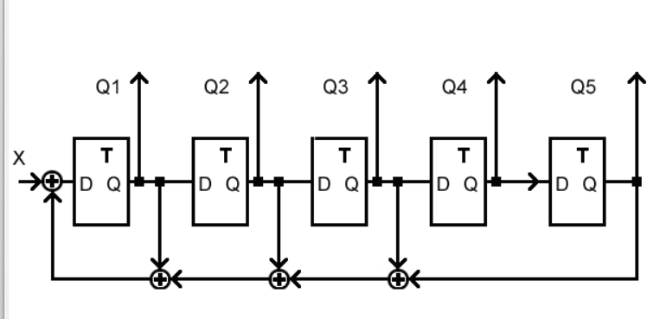

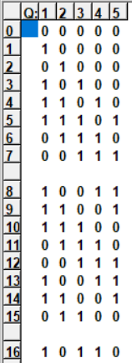

С помощью имитационного моделирования найдено S’(x) = 01101

Матрица, составленная из коэффициентов полинома делителя:

|  |  |  |  |  |
| --- | --- | --- | --- | --- |
| 1 | 0 | 0 | 0 | 0 |
| 1 | 1 | 0 | 0 | 0 |
| 1 | 1 | 1 | 0 | 0 |
| 1 | 1 | 1 | 1 | 0 |
| 0 | 1 | 1 | 1 | 1 |

M(x) =

|  |  |  |  |  |
| --- | --- | --- | --- | --- |
| 1 | 0 | 0 | 0 | 0 |
| 1 | 1 | 0 | 0 | 0 |
| 1 | 1 | 1 | 0 | 0 |
| 1 | 1 | 1 | 1 | 0 |
| 0 | 1 | 1 | 1 | 1 |

|  |
| --- |
| 0 |
| 1 |
| 1 |
| 0 |
| 1 |

|  |
| --- |
| 0 |
| 1 |
| 0 |
| 0 |
| 1 |

S(x) = M*S’(x) =

Сигнатура, полученная при умножении матриц, совпадает с сигнатурой, полученной методом аналитического деления и имитационного моделирования.

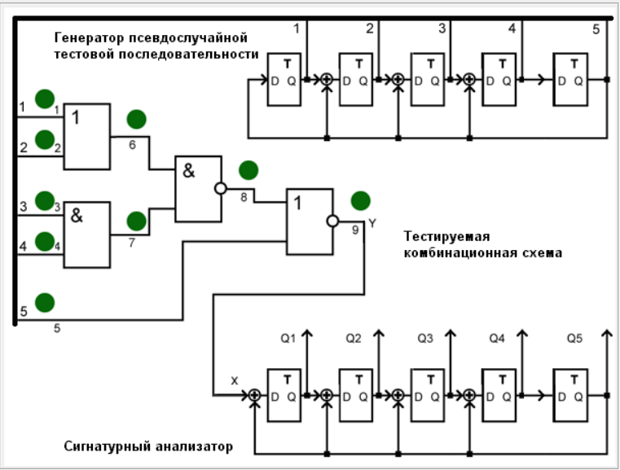

Таблица 1 – Карта эталонных сигнатур в полюсах 6, 7, 8 и 9

|  |  |  |  |  |  |  |  |  |  |  |  |  |  |  |  |  |  |  |  |  |  |  |  |  |  |  |  |  |  |  |  |  |  |  |  |  |  |  |  |  |  |  |  |  |  |  |  |  |  |  |  |  |  |  |  |  |  |  |  |
| --- | --- | --- | --- | --- | --- | --- | --- | --- | --- | --- | --- | --- | --- | --- | --- | --- | --- | --- | --- | --- | --- | --- | --- | --- | --- | --- | --- | --- | --- | --- | --- | --- | --- | --- | --- | --- | --- | --- | --- | --- | --- | --- | --- | --- | --- | --- | --- | --- | --- | --- | --- | --- | --- | --- | --- | --- | --- | --- | --- |
| **№** | **Y** | ПСП | | | | | ЭС | | | | | 6/0 | | | | | | 6/1 | | | | | | 7/0 | | | | | | 7/1 | | | | | | 8/0 | | | | | | 8/1 | | | | | | 9/0 | | | | | | 9/1 | | | | | |
| Q1 | Q2 | Q3 | Q4 | Q5 | Q1 | Q2 | Q3 | Q4 | Q5 | **Y** | Q | Q2 | Q3 | Q4 | Q5 | **Y** | Q1 | Q2 | Q3 | Q4 | Q5 | **Y** | Q1 | Q2 | Q3 | Q4 | Q5 | Y | Q1 | Q2 | Q3 | Q4 | Q5 | Y | Q1 | Q2 | Q3 | Q4 | Q5 | Y | Q1 | Q2 | Q3 | Q4 | Q5 | Y | Q1 | Q2 | Q3 | Q4 | Q5 | Y | Q1 | Q2 | Q3 | Q4 | Q5 |
| **0** | **0** | 1 | 1 | 1 | 1 | 1 | 0 | 0 | 0 | 0 | 0 | **0** | 0 | 0 | 0 | 0 | 0 | **0** | 0 | 0 | 0 | 0 | 0 | **0** | 0 | 0 | 0 | 0 | 0 | **0** | 0 | 0 | 0 | 0 | 0 | **0** | 0 | 0 | 0 | 0 | 0 | **0** | 0 | 0 | 0 | 0 | 0 | **0** | 0 | 0 | 0 | 0 | 0 | **1** | 0 | 0 | 0 | 0 | 0 |
| **1** | **0** | 1 | 0 | 0 | 0 | 1 | 0 | 0 | 0 | 0 | 0 | **0** | 0 | 0 | 0 | 0 | 0 | **0** | 0 | 0 | 0 | 0 | 0 | **0** | 0 | 0 | 0 | 0 | 0 | **0** | 0 | 0 | 0 | 0 | 0 | **0** | 0 | 0 | 0 | 0 | 0 | **0** | 0 | 0 | 0 | 0 | 0 | **0** | 0 | 0 | 0 | 0 | 0 | **1** | 1 | 0 | 0 | 0 | 0 |
| **2** | **1** | 1 | 0 | 1 | 1 | 0 | 0 | 0 | 0 | 0 | 0 | **0** | 0 | 0 | 0 | 0 | 0 | **1** | 0 | 0 | 0 | 0 | 0 | **0** | 0 | 0 | 0 | 0 | 0 | **1** | 0 | 0 | 0 | 0 | 0 | **1** | 0 | 0 | 0 | 0 | 0 | **0** | 0 | 0 | 0 | 0 | 0 | **0** | 0 | 0 | 0 | 0 | 0 | **1** | 1 | 1 | 0 | 0 | 0 |
| **3** | **0** | 0 | 1 | 0 | 1 | 1 | 1 | 0 | 0 | 0 | 0 | **0** | 0 | 0 | 0 | 0 | 0 | **0** | 1 | 0 | 0 | 0 | 0 | **0** | 0 | 0 | 0 | 0 | 0 | **0** | 1 | 0 | 0 | 0 | 0 | **0** | 1 | 0 | 0 | 0 | 0 | **0** | 0 | 0 | 0 | 0 | 0 | **0** | 0 | 0 | 0 | 0 | 0 | **1** | 1 | 1 | 1 | 0 | 0 |
| **4** | **0** | 1 | 1 | 0 | 1 | 1 | 0 | 1 | 0 | 0 | 0 | **0** | 0 | 0 | 0 | 0 | 0 | **0** | 0 | 1 | 0 | 0 | 0 | **0** | 0 | 0 | 0 | 0 | 0 | **0** | 0 | 1 | 0 | 0 | 0 | **0** | 0 | 1 | 0 | 0 | 0 | **0** | 0 | 0 | 0 | 0 | 0 | **0** | 0 | 0 | 0 | 0 | 0 | **1** | 1 | 1 | 1 | 1 | 0 |
| **5** | **0** | 1 | 0 | 0 | 1 | 1 | 0 | 0 | 1 | 0 | 0 | **0** | 0 | 0 | 0 | 0 | 0 | **0** | 0 | 0 | 1 | 0 | 0 | **0** | 0 | 0 | 0 | 0 | 0 | **0** | 0 | 0 | 1 | 0 | 0 | **0** | 0 | 0 | 1 | 0 | 0 | **0** | 0 | 0 | 0 | 0 | 0 | **0** | 0 | 0 | 0 | 0 | 0 | **1** | 1 | 1 | 1 | 1 | 1 |
| **6** | **0** | 1 | 0 | 1 | 1 | 1 | 0 | 0 | 0 | 1 | 0 | **0** | 0 | 0 | 0 | 0 | 0 | **0** | 0 | 0 | 0 | 1 | 0 | **0** | 0 | 0 | 0 | 0 | 0 | **0** | 0 | 0 | 0 | 1 | 0 | **0** | 0 | 0 | 0 | 1 | 0 | **0** | 0 | 0 | 0 | 0 | 0 | **0** | 0 | 0 | 0 | 0 | 0 | **1** | 0 | 0 | 0 | 0 | 1 |
| **7** | **0** | 1 | 0 | 1 | 0 | 1 | 0 | 0 | 0 | 0 | 1 | **0** | 0 | 0 | 0 | 0 | 0 | **0** | 0 | 0 | 0 | 0 | 1 | **0** | 0 | 0 | 0 | 0 | 0 | **0** | 0 | 0 | 0 | 0 | 1 | **0** | 0 | 0 | 0 | 0 | 1 | **0** | 0 | 0 | 0 | 0 | 0 | **0** | 0 | 0 | 0 | 0 | 0 | **1** | 0 | 1 | 1 | 1 | 0 |
| **8** | **0** | 1 | 0 | 1 | 0 | 0 | 1 | 1 | 1 | 1 | 0 | **0** | 0 | 0 | 0 | 0 | 0 | **0** | 1 | 1 | 1 | 1 | 0 | **0** | 0 | 0 | 0 | 0 | 0 | **1** | 1 | 1 | 1 | 1 | 0 | **1** | 1 | 1 | 1 | 1 | 0 | **0** | 0 | 0 | 0 | 0 | 0 | **0** | 0 | 0 | 0 | 0 | 0 | **1** | 1 | 0 | 1 | 1 | 1 |
| **9** | **0** | 0 | 1 | 0 | 1 | 0 | 0 | 1 | 1 | 1 | 1 | **0** | 0 | 0 | 0 | 0 | 0 | **0** | 0 | 1 | 1 | 1 | 1 | **0** | 0 | 0 | 0 | 0 | 0 | **1** | 1 | 1 | 1 | 1 | 1 | **1** | 1 | 1 | 1 | 1 | 1 | **0** | 0 | 0 | 0 | 0 | 0 | **0** | 0 | 0 | 0 | 0 | 0 | **1** | 0 | 0 | 1 | 0 | 1 |
| **10** | **0** | 0 | 0 | 1 | 0 | 1 | 1 | 1 | 0 | 0 | 1 | **0** | 0 | 0 | 0 | 0 | 0 | **0** | 1 | 1 | 0 | 0 | 1 | **0** | 0 | 0 | 0 | 0 | 0 | **0** | 0 | 0 | 0 | 0 | 1 | **0** | 0 | 0 | 0 | 0 | 1 | **0** | 0 | 0 | 0 | 0 | 0 | **0** | 0 | 0 | 0 | 0 | 0 | **1** | 0 | 1 | 1 | 0 | 0 |
| **11** | **0** | 1 | 1 | 1 | 0 | 0 | 1 | 0 | 0 | 1 | 0 | **0** | 0 | 0 | 0 | 0 | 0 | **0** | 1 | 0 | 0 | 1 | 0 | **0** | 0 | 0 | 0 | 0 | 0 | **1** | 1 | 1 | 1 | 1 | 0 | **1** | 1 | 1 | 1 | 1 | 0 | **0** | 0 | 0 | 0 | 0 | 0 | **0** | 0 | 0 | 0 | 0 | 0 | **1** | 1 | 0 | 1 | 1 | 0 |
| **12** | **1** | 0 | 1 | 1 | 1 | 0 | 0 | 1 | 0 | 0 | 1 | **0** | 0 | 0 | 0 | 0 | 0 | **1** | 0 | 1 | 0 | 0 | 1 | **0** | 0 | 0 | 0 | 0 | 0 | **1** | 1 | 1 | 1 | 1 | 1 | **1** | 1 | 1 | 1 | 1 | 1 | **0** | 0 | 0 | 0 | 0 | 0 | **0** | 0 | 0 | 0 | 0 | 0 | **1** | 1 | 1 | 0 | 1 | 1 |
| **13** | **0** | 0 | 0 | 1 | 1 | 1 | 0 | 1 | 0 | 1 | 0 | **0** | 0 | 0 | 0 | 0 | 0 | **0** | 0 | 1 | 0 | 1 | 0 | **0** | 0 | 0 | 0 | 0 | 0 | **0** | 0 | 0 | 0 | 0 | 1 | **0** | 0 | 0 | 0 | 0 | 1 | **0** | 0 | 0 | 0 | 0 | 0 | **0** | 0 | 0 | 0 | 0 | 0 | **1** | 0 | 0 | 0 | 1 | 1 |
| **14** | **0** | 1 | 1 | 1 | 0 | 1 | 0 | 0 | 1 | 0 | 1 | **0** | 0 | 0 | 0 | 0 | 0 | **0** | 0 | 0 | 1 | 0 | 1 | **0** | 0 | 0 | 0 | 0 | 0 | **0** | 1 | 1 | 1 | 1 | 0 | **0** | 1 | 1 | 1 | 1 | 0 | **0** | 0 | 0 | 0 | 0 | 0 | **0** | 0 | 0 | 0 | 0 | 0 | **1** | 0 | 1 | 1 | 1 | 1 |
| **15** | **0** | 1 | 0 | 0 | 0 | 0 | 1 | 1 | 1 | 0 | 0 | **0** | 0 | 0 | 0 | 0 | 0 | **0** | 1 | 1 | 1 | 0 | 0 | **0** | 0 | 0 | 0 | 0 | 0 | **1** | 0 | 1 | 1 | 1 | 1 | **1** | 0 | 1 | 1 | 1 | 1 | **0** | 0 | 0 | 0 | 0 | 0 | **0** | 0 | 0 | 0 | 0 | 0 | **1** | 0 | 1 | 0 | 0 | 1 |
| **16** | **0** | 0 | 1 | 0 | 0 | 0 | 0 | 1 | 1 | 1 | 0 | **0** | 0 | 0 | 0 | 0 | 0 | **0** | 0 | 1 | 1 | 1 | 0 | **0** | 0 | 0 | 0 | 0 | 0 | **1** | 0 | 1 | 0 | 0 | 1 | **1** | 0 | 1 | 0 | 0 | 1 | **0** | 0 | 0 | 0 | 0 | 0 | **0** | 0 | 0 | 0 | 0 | 0 | **1** | 0 | 1 | 0 | 1 | 0 |
| **17** | **0** | 0 | 0 | 1 | 0 | 0 | 0 | 0 | 1 | 1 | 1 | **0** | 0 | 0 | 0 | 0 | 0 | **0** | 0 | 0 | 1 | 1 | 1 | **0** | 0 | 0 | 0 | 0 | 0 | **0** | 0 | 1 | 0 | 1 | 0 | **1** | 0 | 1 | 0 | 1 | 0 | **0** | 0 | 0 | 0 | 0 | 0 | **0** | 0 | 0 | 0 | 0 | 0 | **1** | 1 | 0 | 1 | 0 | 1 |
| **18** | **0** | 0 | 0 | 0 | 1 | 0 | 1 | 1 | 1 | 0 | 1 | **0** | 0 | 0 | 0 | 0 | 0 | **0** | 1 | 1 | 1 | 0 | 1 | **0** | 0 | 0 | 0 | 0 | 0 | **0** | 0 | 0 | 1 | 0 | 1 | **1** | 1 | 0 | 1 | 0 | 1 | **0** | 0 | 0 | 0 | 0 | 0 | **0** | 0 | 0 | 0 | 0 | 0 | **1** | 0 | 0 | 1 | 0 | 0 |
| **19** | **0** | 0 | 0 | 0 | 0 | 1 | 1 | 0 | 0 | 0 | 0 | **0** | 0 | 0 | 0 | 0 | 0 | **0** | 1 | 0 | 0 | 0 | 0 | **0** | 0 | 0 | 0 | 0 | 0 | **0** | 1 | 1 | 1 | 0 | 0 | **0** | 0 | 0 | 1 | 0 | 0 | **0** | 0 | 0 | 0 | 0 | 0 | **0** | 0 | 0 | 0 | 0 | 0 | **1** | 1 | 0 | 0 | 1 | 0 |
| **20** | **1** | 1 | 1 | 1 | 1 | 0 | 0 | 1 | 0 | 0 | 0 | **0** | 0 | 0 | 0 | 0 | 0 | **1** | 0 | 1 | 0 | 0 | 0 | **0** | 0 | 0 | 0 | 0 | 0 | **1** | 0 | 1 | 1 | 1 | 0 | **1** | 0 | 0 | 0 | 1 | 0 | **0** | 0 | 0 | 0 | 0 | 0 | **0** | 0 | 0 | 0 | 0 | 0 | **1** | 1 | 1 | 0 | 0 | 1 |
| **21** | **0** | 0 | 1 | 1 | 1 | 1 | 1 | 0 | 1 | 0 | 0 | **0** | 0 | 0 | 0 | 0 | 0 | **0** | 1 | 0 | 1 | 0 | 0 | **0** | 0 | 0 | 0 | 0 | 0 | **0** | 1 | 0 | 1 | 1 | 1 | **0** | 1 | 0 | 0 | 0 | 1 | **0** | 0 | 0 | 0 | 0 | 0 | **0** | 0 | 0 | 0 | 0 | 0 | **1** | 0 | 0 | 0 | 1 | 0 |
| **22** | **0** | 1 | 1 | 0 | 0 | 1 | 0 | 1 | 0 | 1 | 0 | **0** | 0 | 0 | 0 | 0 | 0 | **0** | 0 | 1 | 0 | 1 | 0 | **0** | 0 | 0 | 0 | 0 | 0 | **0** | 1 | 0 | 1 | 0 | 1 | **0** | 1 | 0 | 1 | 1 | 0 | **0** | 0 | 0 | 0 | 0 | 0 | **0** | 0 | 0 | 0 | 0 | 0 | **1** | 1 | 0 | 0 | 0 | 1 |
| **23** | **0** | 1 | 0 | 1 | 1 | 0 | 0 | 0 | 1 | 0 | 1 | **0** | 0 | 0 | 0 | 0 | 0 | **0** | 0 | 0 | 1 | 0 | 1 | **0** | 0 | 0 | 0 | 0 | 0 | **1** | 1 | 0 | 1 | 0 | 0 | **1** | 0 | 1 | 0 | 1 | 1 | **0** | 0 | 0 | 0 | 0 | 0 | **0** | 0 | 0 | 0 | 0 | 0 | **1** | 0 | 0 | 1 | 1 | 0 |
| **24** | **0** | 0 | 1 | 0 | 0 | 1 | 1 | 1 | 1 | 0 | 0 | **0** | 0 | 0 | 0 | 0 | 0 | **0** | 1 | 1 | 1 | 0 | 0 | **0** | 0 | 0 | 0 | 0 | 0 | **0** | 1 | 1 | 0 | 1 | 0 | **0** | 0 | 1 | 0 | 1 | 1 | **0** | 0 | 0 | 0 | 0 | 0 | **0** | 0 | 0 | 0 | 0 | 0 | **1** | 1 | 0 | 0 | 1 | 1 |
| **25** | **0** | 1 | 1 | 0 | 1 | 0 | 0 | 1 | 1 | 1 | 0 | **0** | 0 | 0 | 0 | 0 | 0 | **0** | 0 | 1 | 1 | 1 | 0 | **0** | 0 | 0 | 0 | 0 | 0 | **1** | 0 | 1 | 1 | 0 | 1 | **1** | 1 | 1 | 0 | 1 | 1 | **0** | 0 | 0 | 0 | 0 | 0 | **0** | 0 | 0 | 0 | 0 | 0 | **1** | 0 | 0 | 1 | 1 | 1 |
| **26** | **0** | 0 | 1 | 1 | 0 | 1 | 0 | 0 | 1 | 1 | 1 | **0** | 0 | 0 | 0 | 0 | 0 | **0** | 0 | 0 | 1 | 1 | 1 | **0** | 0 | 0 | 0 | 0 | 0 | **0** | 0 | 1 | 0 | 0 | 0 | **0** | 0 | 0 | 0 | 1 | 1 | **0** | 0 | 0 | 0 | 0 | 0 | **0** | 0 | 0 | 0 | 0 | 0 | **1** | 0 | 1 | 1 | 0 | 1 |
| **27** | **0** | 1 | 1 | 0 | 0 | 0 | 1 | 1 | 1 | 0 | 1 | **0** | 0 | 0 | 0 | 0 | 0 | **0** | 1 | 1 | 1 | 0 | 0 | **0** | 0 | 0 | 0 | 0 | 0 | **1** | 0 | 0 | 1 | 0 | 0 | **1** | 1 | 1 | 1 | 1 | 1 | **0** | 0 | 0 | 0 | 0 | 0 | **0** | 0 | 0 | 0 | 0 | 0 | **1** | 0 | 1 | 0 | 0 | 0 |
| **28** | **0** | 0 | 1 | 1 | 0 | 0 | 1 | 0 | 0 | 0 | 0 | **0** | 0 | 0 | 0 | 0 | 0 | **0** | 1 | 0 | 0 | 0 | 0 | **0** | 0 | 0 | 0 | 0 | 0 | **1** | 1 | 0 | 0 | 1 | 0 | **1** | 0 | 0 | 0 | 0 | 1 | **0** | 0 | 0 | 0 | 0 | 0 | **0** | 0 | 0 | 0 | 0 | 0 | **1** | 1 | 0 | 1 | 0 | 0 |
| **29** | **0** | 0 | 0 | 1 | 1 | 0 | 0 | 1 | 0 | 0 | 0 | **0** | 0 | 0 | 0 | 0 | 0 | **1** | 0 | 1 | 0 | 0 | 0 | **0** | 0 | 0 | 0 | 0 | 0 | **0** | 1 | 1 | 0 | 0 | 1 | **1** | 0 | 1 | 1 | 1 | 0 | **0** | 0 | 0 | 0 | 0 | 0 | **0** | 0 | 0 | 0 | 0 | 0 | **1** | 1 | 1 | 0 | 1 | 0 |
| **30** | **0** | 0 | 0 | 0 | 1 | 1 | 0 | 0 | 1 | 0 | 0 | **0** | 0 | 0 | 0 | 0 | 0 | **0** | 1 | 0 | 1 | 0 | 0 | **0** | 0 | 0 | 0 | 0 | 0 | **0** | 1 | 0 | 0 | 1 | 0 | **0** | 1 | 0 | 1 | 1 | 1 | **0** | 0 | 0 | 0 | 0 | 0 | **0** | 0 | 0 | 0 | 0 | 0 | **1** | 1 | 1 | 1 | 0 | 1 |
| **31** | **0** | 1 | 1 | 1 | 1 | 1 | 0 | 0 | 0 | 1 | 0 | **0** | 0 | 0 | 0 | 0 | 0 | **0** | 0 | 1 | 0 | 1 | 0 | **0** | 0 | 0 | 0 | 0 | 0 | **0** | 0 | 1 | 0 | 0 | 1 | **0** | 1 | 0 | 1 | 0 | 1 | **0** | 0 | 0 | 0 | 0 | 0 | **0** | 0 | 0 | 0 | 0 | 0 | **1** | 0 | 0 | 0 | 0 | 0 |

Начиная с залитых ячеек начинается несоответствие сигнатур. Первым набором, для которого сигнатуры при всех неисправностях начинают отличатся от эталонных, является набор № 27.

Таблица 2 – Сводная таблица несоответствий сигнатур для набора № 15

|  |  |  |  |  |  |  |
| --- | --- | --- | --- | --- | --- | --- |
| Неисправность | Q1 | Q2 | Q3 | Q4 | Q5 | Аналогична |
| 6/0 | 0 | 0 | 0 | 0 | 0 | 7/0, 8/1, 9/0 |
| 6/1 | 1 | 1 | 1 | 0 | 0 | – |
| 7/0 | 0 | 0 | 0 | 0 | 0 | 6/0, 8/1, 9/0 |
| 7/1 | 0 | 0 | 1 | 0 | 0 | – |
| 8/0 | 1 | 1 | 1 | 1 | 1 | – |
| 8/1 | 0 | 0 | 0 | 0 | 0 | 6/0, 7/0, 9/0 |
| 9/0 | 0 | 0 | 0 | 0 | 0 | 6/0, 7/0, 8/1 |
| 9/1 | 0 | 1 | 0 | 0 | 0 | – |

Неисправности 6/0, 7/0, 8/1, 9/0 соответственно имеют одинаковые сигнатуры, следовательно, определить, какая именно из этих неисправностей имеется, невозможно. В таблице 3 представлены сигнатуры для определения конкретных неисправностей либо их наборов.

Таблица 3 – сигнатуры для обнаружения неисправностей набором № 15

|  |  |  |  |  |  |
| --- | --- | --- | --- | --- | --- |
| Неисправности | Q1 | Q2 | Q3 | Q4 | Q5 |
| 6/0, 7/0, 8/1, 9/0 | 0 | 0 | 0 | 0 | 0 |
| 6/1 | 1 | 1 | 1 | 0 | 0 |
| 7/1 | 0 | 0 | 1 | 0 | 0 |
| 8/0 | 1 | 1 | 1 | 1 | 1 |
| 9/1 | 0 | 1 | 0 | 0 | 0 |