Documentation
Friday, 16 February 2024
13:59

Date | Tasks | Notes | summary
16/02/2024 14:06 | Research:  Frequency Controller  F Control vs V Control | Frequency Controller  - F: cycles per sec  - Transformer  - Controlling the frequency, we control the rotational speed of the motor  - Variable Frequency Drives Explained - VFD Basics IGBT inverter  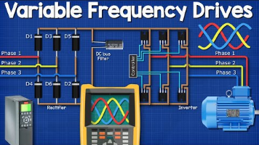  - Advantages:  - Energy Saving  - Smoother control  - It can be used to vary the frequency -> thus varying the speed of the motor  VFD Structure  - Rectifier: Diodes  In: AC  Output: Rough DC  Ripples, half waves  - DC bus: Filter (Capacitor)  In: Ripples, rough DC  Out: Smooth DC voltage  - Inverter: Switches (IGBT)  In: DC  Out: AC current  How VFD work  - Rectifier  - 6 diodes,  - The current can flow through one phase and return to the source though another; It can do this because the current flows forward and backwards at different points in time.  Current comes in though phase one and can only flow in one direction, which is through diode 1, then it passes through the load and (what does it do next?) It goes back to the source through diode 2. The reason is phase 2 is in its negative half. And so on…  - Capacitor (storage tank)  - Smooths the DC output via absorbing and injecting electrons  - Inverter (DC to AC)  - IGBT switches that can turn on and off via a PWM controller to generate the desired wave shape (voltage and frequency)  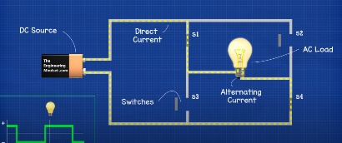  The direction of current going through some load can be reversed by opening and closing switches in the right order (AC current)  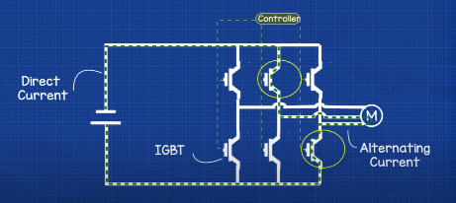  We can time the switches the generate the right form of wave.  For a 3 phase AC output, The inverter will have 6 switches and by controlling the order and timing,  Closing switches 1 and 6 will direct the current to flow through phase one (postive) and phase two (negative), then opening switch 2 and closing switch 2 will direct the current to go through phase one and phase 3 …  Frequency control  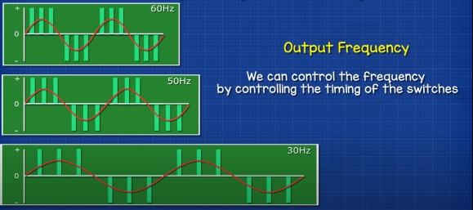  Voltage control  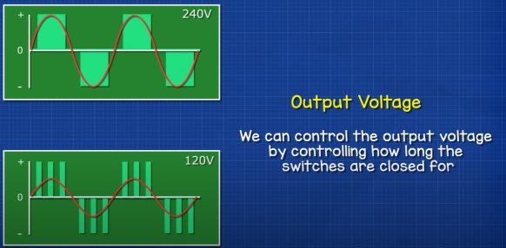  The output voltage can be controlled  The frequency can also be controlled  Notes  - Once you have DC voltage, you can do anything you want with it; Change the voltage, amplitude, frequency  Voltage / Frequency  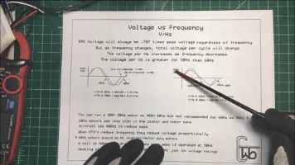  Thyristor and Triac  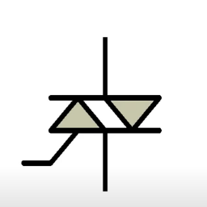  - AC power  - 3 terminals  - G, MT1, MT2  - Trigger through the gate, allows current to flow  Electronic Basics #20: Thyristor, Triac || Phase Angle Control  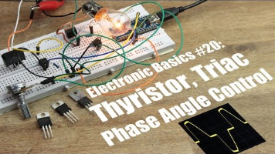  - Latching current  - Turn off time  - V Drop  - P lose  - Zero point indicator  - Full bridge rectifier with an Auto coupler, in order to create a voltage burst  - This configuration gets used with feeding elements or to adust the speed of a universal motor  - Constantly decreasing power factor due to the non-sinusoidal current  Power factor  Power Factor Explained - The basics what is power factor pf  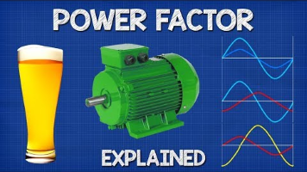  - AC  - Power factor = True power/ Apparent Power  - KW KVA  - Bad power factor of the customers  - Perfect power factor  - Good, poor, bad  - KVar  - Inductive load  - Lagging power  - Correcting powr factors, capacitors, inductors,  - Transformer  -----------------------------------------------------------------------
17/02/2024 15:07 | VFD for single phase  Voltage- frequency curve  VFD control  Electromagnetic vibration control | VFD for single phase  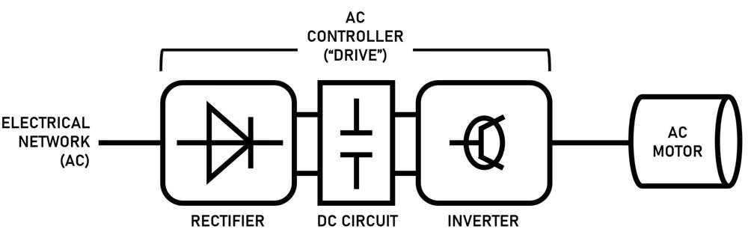  Voltage-Frequency Curve  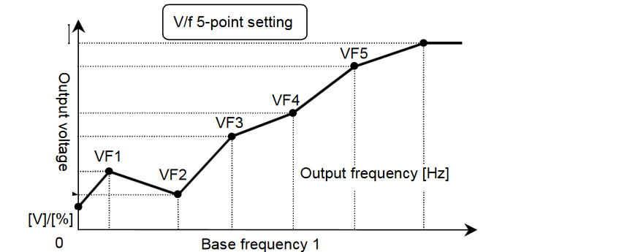  - A graphical representation of the relationship between the voltage V and the frequency of the voltage.  - Control the speed of an induction motor (and feeder).  - The shape of the curve can be adjusted to suit the needs of the application; For applications that require high torque at low speeds, a steeper slope can be used. While a shallower slope may be used for applications that require high speed at low torque.  - allows for precise control of the motor speed using a VFD and can help to improve the efficiency and reliability of systems.  SCR (Silicon Control Rectifier)  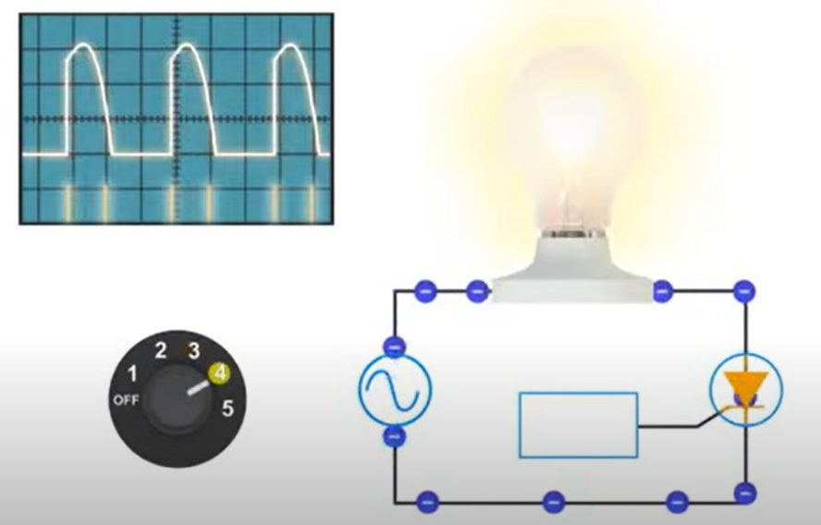  - Control the current follow via the gate  - Diode with Gate Control  - Dimmer  Vibrating Feed Control Circuit  Three types of REVF:  - Sub-resonant mode  - Resonant mode  - Super-resonant mod  - Triac, SRC, and other components were used  - Generates triangle-shaped current pulses for the electromagnetic actuator.  - Mechanical resonance  - switching frequencies.  - Triangle-shaped wave instead of a perfect siosoidal shape wave  Triangle-shape wave vs Sinosoidal wave form  Efficiency:  Triangle pulses require lower switching frequency: Compared to sinusoidal pulses, which require high-frequency switching for accurate waveform generation, triangle pulses can be achieved with lower switching frequencies. This reduces switching losses in the power converter, leading to higher overall efficiency.  2. Implementation simplicity:  Easier control and generation: Generating triangle pulses is simpler than generating precise sinusoidal waveforms, especially with lower-cost microcontrollers or control systems. This reduces circuit complexity and potentially lowers component costs.  While sinusoidal pulses might theoretically offer smoother operation and potentially lower vibration noise, the trade-off in efficiency and implementation complexity often makes triangle pulses a more practical choice for industrial applications like REVFs.  Here are some additional points to consider:  The paper mentions that the specific control method employed (pulse width modulation with triangle current pulses) still allows for adjustments of both frequency and amplitude, achieving the desired control over the feeder's operation.  In some REVF applications, minimizing noise or achieving very specific vibration patterns might be crucial, and sinusoidal pulses could be preferred despite the efficiency drawbacks. However, for many industrial feeding tasks, the efficiency gains and implementation simplicity of triangle pulses outweigh the potential benefits of sinusoidal waveforms.  Applications  - Used in charging a capacitor | Common ways of generating the output current other than Silicon-controlled rectifier (SCR) converters are:  - Solid State Relay (SSR) converters: These use transistors or thyristors to switch the power to the heater, but they have a slower switching rate and a higher on/off effect than SCR converters1.  - Phase Angle Control (PAC) converters: These use triacs or SCRs to vary the phase angle of the input voltage, which results in a smooth and continuous control of the output current2.  - Pulse Width Modulation (PWM) converters: These use MOSFETs or IGBTs to switch the power to the heater with a high frequency, which results in a low on/off effect and a high efficiency3.  Each of these methods has its own advantages and disadvantages, depending on the application and the requirements of the system. For example, SSR converters are simple and inexpensive, but they have a high power loss and a low accuracy. PAC converters are accurate and reliable, but they generate harmonics and noise. PWM converters are efficient and flexible, but they require complex and expensive circuitry.
 | Resonance and driving frequency | Resonance  Resonance in a vibratory feeder is achieved by designing the system such that the natural frequency of the system matches the driving frequency. Here are the key components involved in achieving resonance:  - Drive Unit: The drive unit, typically consisting of an electromagnetic coil and a spring system, produces the necessary vibrations to move the parts1.  - Controller: The controller regulates the frequency and amplitude of the vibrations, allowing for precise control over the feeding process2.  - Elastic Component: The design of the vibratory feeder with electromagnetic excitation is based on a system of two masses coupled by means of an elastic component consisting of flexible leaf composite springs3. The quantity of leaf springs fitted up determines the resonant operation of the equipment3.  - Tuning: Maximum feed rate can be “fixed” or set by adjusting the small eccentric weights located on the motor or vibrating shaft. Stroke can also be adjusted by the use of tuning springs to vary the resonance effect1.  By carefully selecting and adjusting these components, the system can be made to vibrate at its natural frequency, which is the frequency at which the system tends to oscillate in the absence of any driving or damping force. When the driving frequency matches this natural frequency, resonance is achieved, leading to larger oscillations and more efficient operation of the vibratory feeder.  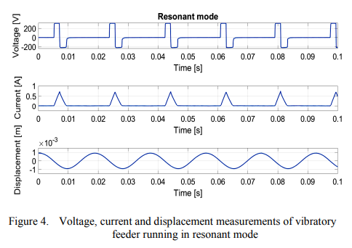 | 1. Operating the Electromagnetic Vibratory Feeder (EVF):  - Operating the EVF at resonance has advantages but it can also be dangerous if not properly controlled.  2. Changing the Speed of the Tray:  - In an early version, the speed of the tray was changed by increasing the voltage. This means increasing the amplitude of the frequency; the displacement of the armature, without changing the frequency.  3. Efficiency of the System:  - High current of the electromagnetic coil of the feeder represents a non-efficient system.  4. Achieving Resonance:  - To achieve resonance, the current pulse was synchronized with the natural frequency of the mechanical system. This resulted in minimal energy consumption and maximum vibration amplitude  The EVF controller has to permit frequency control because it should operate at resonance.
23/02/2024 | Circuit analysis:  How to build EVF control circuit?  Why does a square wave can be smoothed out into a triangular wave? | The power converter consists of three power converter:  - Front end high frequency AC/DC converter with power factor correction (PFC) control, The PFC is not required for the first prototype  - DC/DC link converter with high frequency duty-cycle control (step-down i.e. “buck” converter) This is an essential step for the project  Active Power Factor Correction  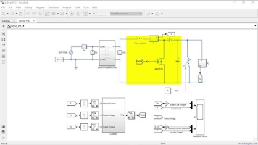  - Low frequency IGBT converter with triangle pulsating output current [25] Control is here  PFC rectifier  Power Factor Correction | Active Power Factor Correction | PFC Control | Boost PFC  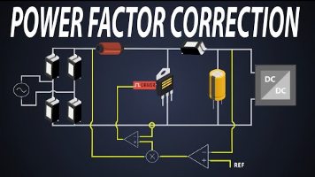  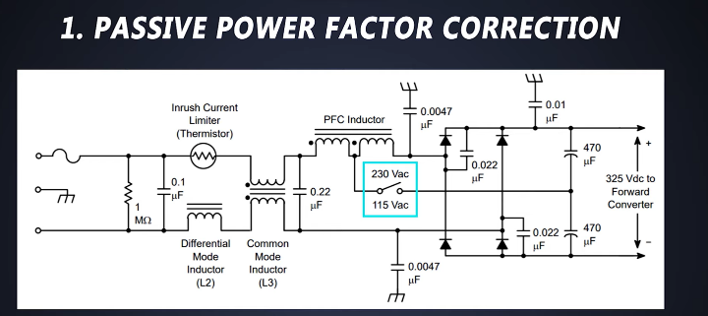  Power Factor Correction (PFC) – Critical Condu1ction Mode  - Shaping the Input Current: A PFC rectifier intentionally shapes the input current to be in phase with the instantaneous line voltage  - Reducing Harmonics  - Efficiency and Size: The use of PFC allows the manufacturer of electrical load to use smaller components  - Regulated Output Voltage: It offers a stable regulated output voltage  Why do we need PFC rectifier:  - current becomes more stable  - Different classes of loads  - Class D is for small Power consumption  - 2 PFC  - Passive  - Inefficient  - Active  - More common  - Boost  - 2 techniques  - Continuous conduction mode  - Critical conduction mode -> for low loads  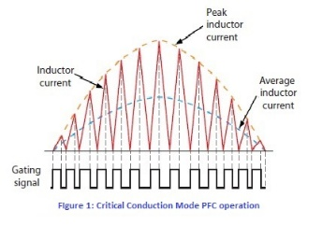  - Even though there might be no phase shift, we can still have low power factor.  DC/DC link - capacitors  A closer look at the DC Link (https_chargedevs.com)  - Junction between two power conversion  - It also smooths the pulses out into more of a triangle or sawtooth shape  - Electrolytic capacitor  - How to Smooth a Rectified Waveform Using Capacitors  - 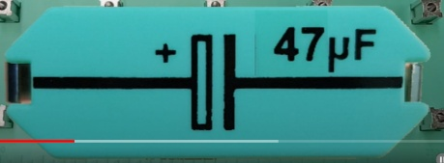  - larger values of capacitors can produce smoother filtering  - 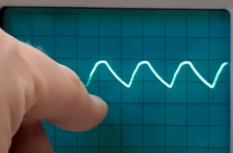  -   - 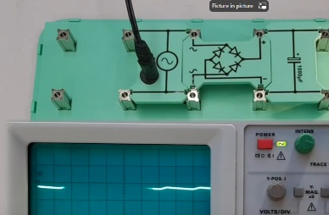  - The biggest capacitor gave an even smoother wave (when we say the biggest, do we mean the in size or in capacitance?)  - Bigger capacitor also results in a brighter lamp  - Capacitor is similar to a water storage tank  - Capacitors Explained - The basics how capacitors work working principle  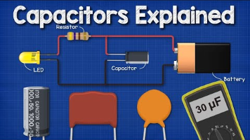  - Voltage difference is the difference between the pressure of two points  When do we use capacitors? lol  - Power factor correction  - Rectifiers  If we have a square wave voltage input, what would be our current, is it a square wave as well? - Quora  - If we have a square wave voltage input, what would our current output look like, A square wave too?  - What would the current look like if it's pure resistance?  It follows the shape of the input  - What would it look like if it's pure induction?  - Triangle  - What would it look like if it's pure capacitance? Infinite for a fraction of a second then zero afterwards  - The capacitor has to have a voltage rating greater than the power source  Opto-isolated  - Aka Optocoupler  - Used with MCU for protection  - Protects from voltage spikes
28/02/2024 | How build a rectifier  What safe volage to work with  What values of components to choose  What load  How build a Buck Converters  How build a Boost Converter  How build a Flyback converter  How build a Combines boost and buck converters  Low frequency IGBT converters | How2Power.com - Answering Your Questions About Power Design: : Electronics Design Services : Voltage Regulator : Industrial Power Supplies : Semiconductors : Transformer : IGBT Module : Software : Digital Power Supply DC  How To Choose The Right Rectifier & Capacitor For Rectifing AC to DC  What Resistor Do I Need For an LED | DigiKey Electronics  Power-supply filtering  - Ripples  - Ripple factor  - Capacitors  - Diodes  Forward continuous current  Repetitive current  Reverse current  How To Choose The Right Rectifier & Capacitor For Rectifing AC to DC  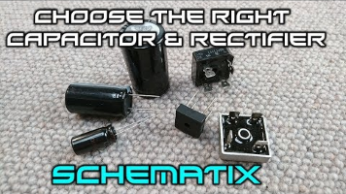  The right Diode  - We need to look at the  - reverse voltage Vrms  - 20%-30% headroom recommended  - Voltage drop: less power at the output  - Calculate the heat dissipation through a diode  The Right Capacitor  - We need to look at:  Voltage: The voltage cannot > the power source  - 20-30% headroom recommended  Capacitance:  Based on:  - the current we are going to be drawing from the power source  - The frequency  - The acceptable voltage drop  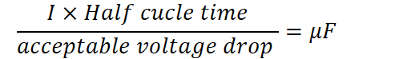  Ex. Assuming 50Hz AC => half cycle time = (1/50)/2=0.01  - Capacitance: High-frequency applications call for smaller capacitance values, whereas energy storage and filtering applications benefit from larger capacitance values.  - Voltage rating (volts): Higher voltage rating.  - Most capacitors are polarity sensitive  The Right resistor with an LED using ohm's law  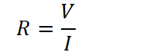  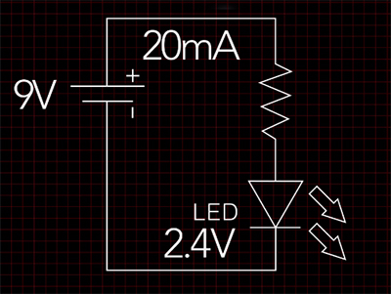  In this case V circuit is the led voltage. You should also account for other components.  ------------------------------------------------------------------------------------------------------------------------------------------------------------------------------------------------  Active rectifier  The End of the Full Bridge Rectifier? (Sorry ElectroBOOM) Active Rectifier is here!  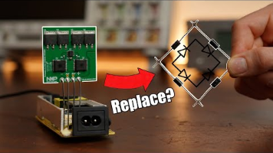  Full Wave Active Bridge Rectifier Controller  TEA2208T  Tea2206  Notes  - You can buy a rectifier  - Bleeder resistor: high value resistor in parallel with the load  Ee13 Ee16 Ee19 Electrical Powewr 230V 12V AC Flyback Transformer Manufacturer - China Flyback Transformer and Ee13 Ee16 Ee19 Transformer (made-in-china.com)  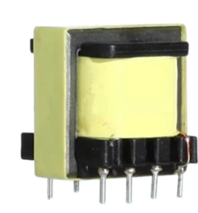  EEVBlog #1116 - How to Remove Power Supply Ripple  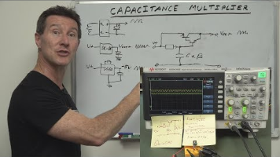
01/03/2024 | How build a Buck Converters  Which is more efficient rectificaion then step dowm or the reverse | Buck Converters  Basic Calculation of a Buck Converter's Power Stage (Rev. B)  Switching Buck Converter Component Sizing | Phil's Lab | Altium  Is this the BEST Voltage Converter? Trying to build a Synchronous Converter!  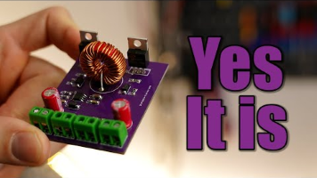  Half bridge driver ??  SMPS  High frequency XL6009 >>  - capacitor: smoothing  - Inductor: amp?  - Schokky diode  - Built in MOSFET  - Fixed frequency  Voltage divider  Lm2576 KC Package  LM2576xx Series SIMPLE SWITCHER Power Converter 3-A Step-Down Voltage Regulator datasheet (Rev. G) (ti.com)  LM2576T-ADJG onsemi | Mouser Vietnam  The Right MOSFET  - N type  - 10kohm pull down between source and gate to prevent accidental activation  - Linear region where the resistance is almost constant  - Source to ground  MOSFET DRIVERS  LM2576xx Series SIMPLE SWITCHER Power Converter 3-A Step-Down Voltage Regulator datasheet (Rev. G) (ti.com)  IR2110 pdf, IR2110 Description, IR2110 Datasheet, IR2110 view ::: ALLDATASHEET :::  IR2184 pdf, IR2184 Description, IR2184 Datasheet, IR2184 view ::: ALLDATASHEET :::  *91045.pdf (vishay.com)  Why do we need a driver?  - Because the MOSFET has parasitic capacitance that require current to charge up. This currrent output exceeds the current of the microcontroller  - Current charges and discharges the gate during activation  - We need a powerful current source to charge up the gate faster, thus MOSFET ON  Current Ripple  Switching Regulators  - Converts input voltage into higher or lower voltage  - Inductors are used to store energy temporarity  How to Calculate and Design Buck Converter using MATLAB Simulink  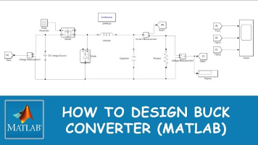
 | Using Oscilloscope | Zero point  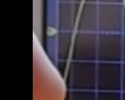  Trigger button is there the oscilloscope starts measuring  50% button sets the trigger to 50% of the signal  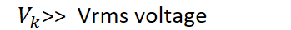
 | PWM Generation  Using MOSFETs | Creating a project  - Activate the pins  - Choose crystial  ----------------------------------------------------------------------------------------------------------------------------  Toggling an LED  HAL_GPIO_WritePin(GPIOC, GPIO_PIN_13, 1);  HAL_Delay(2000);  HAL_GPIO_WritePin(GPIOC, GPIO_PIN_13, 0);  HAL_Delay(2000);  ----------------------------------------------------------------------------------------------------------------------------  Generating PWM  PWM (Pulse Width Modulation) in STM32 (controllerstech.com)  - Activate timer and configure clock speed  - set the PWM Frequency and duty cycle using the following formulas  1. Set prescaler  Ex. 100 MHz → 100 kHz  2. Set ARR Value =  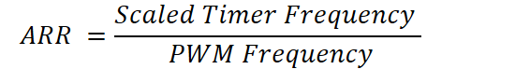  Ex. Desired PWM = 100KHz, Timer Frequency = 1MHz  -> ARR = 20-1  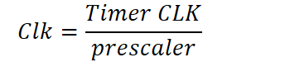  3. Choose duty cycle  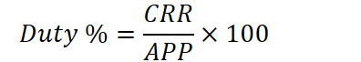  TIM1->CCR1 = 30;  HAL_TIM_PWM_Start(&htim1, TIM_CHANNEL_1);  STM32 Blue Pill Note  Solved: Did I "brick" my "blue pill" board(s) - ST-LINK V2... - STMicroelectronics Community  The STM32 Blue Pill requires  - Boot 0  Notes  - Explore clock configuration
 | MOSFETs  Why a pull up resistor? | Electrical characteristics of MOSFETs (Static Characteristics IGSS/IDSS/V(BR)DSS/V(BR)DXS) | Toshiba Electronic Devices & Storage Corporation | Asia-English (semicon-storage.com)  MOSFETs Parameters:  - P type and N type  - Source to gate capacitance  - Inter  Drive the gate with a 10v to drive it fully on    P Channel MOSFETs  - Activates when Negative Voltage applied to the gate relative to the source  - In this type of MOSFETs, the source is connected to VCC, The drain is connected to the ground, To activate it (-) voltage needs to applied to gate relative to the source  - So the voltage applied to the gate needs to be negative compared to the source  - In the case where the mosfet is closer to the load than the ground, the negative voltage applied to the gate has to be negative enough because the mosfet is close to Vcc, so it's already experiencing so the activation voltage is low  Mosfets, Enhancement-Type require a certain voltage value to activate.  - (relative to the Ground)  P-Channel MOSFET and Arduino. Switching a 12V Motor. - Circuit Journal  To activate the MOSFET with a U, the if  Type P: High output turns the mosfet OFF  Type N: Low output turns the mosfet OFF  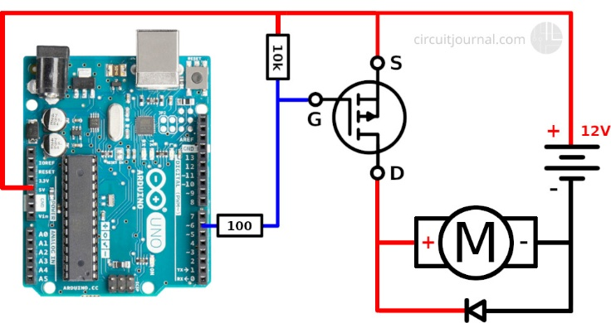  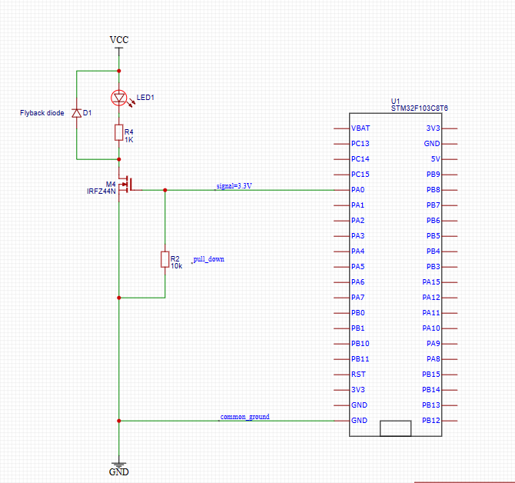  LOGIC LEVEL GATE DRIVE  The selected mosfet  Important convepts  - TYPE  - LOGIC MOSFETS VS no-logic mosfets vs insulated  IRFZ44N VS IRLZ44N vs IRLI244N  P channel have higher resistance than N channel  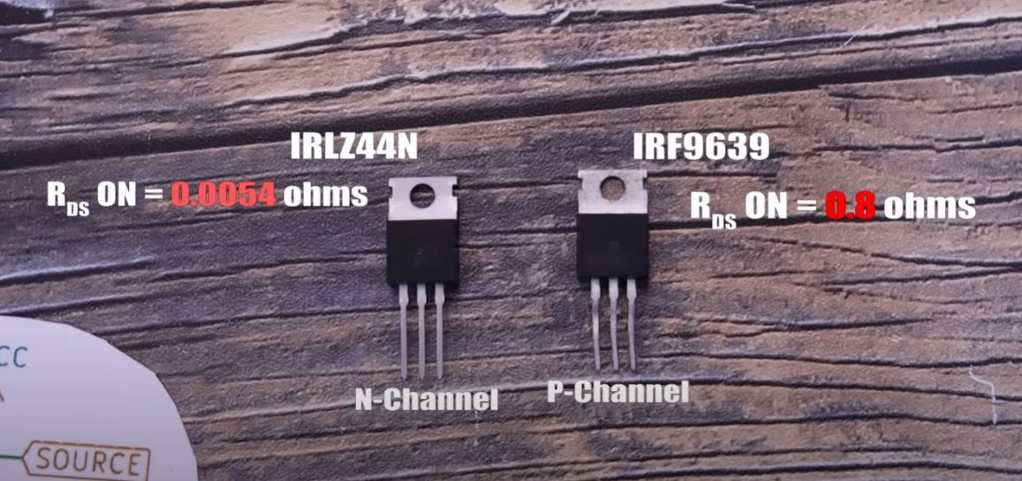  - DRIVER  - LOGIC LEVEL  - POWER DISSIPATION  - BOOTSTAP  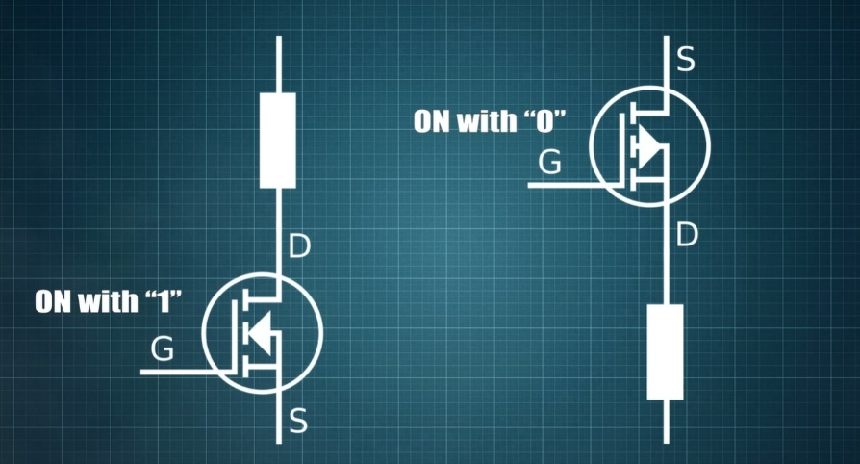  Mistakes  - Capacitor polarity x2
11/03/2024  Week 5 probation  20 days left | How does bootsrapping work?  How to implement it?  What are it's parameters?  Bootstrapping  Half bridge  H bridge driving for generating a sine wave  How to determine the values of the components?  If my signal is 3.3V will ir2110 work properly? | MOSFET Bootstrapping  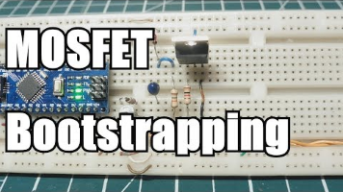  EasyEDA(Standard) - A Simple and Powerful Electronic Circuit Design Tool  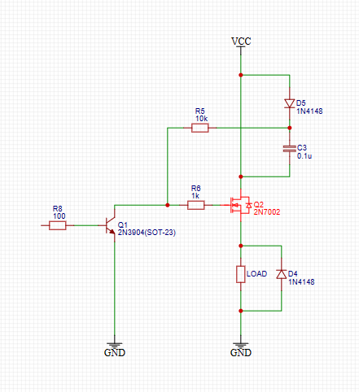  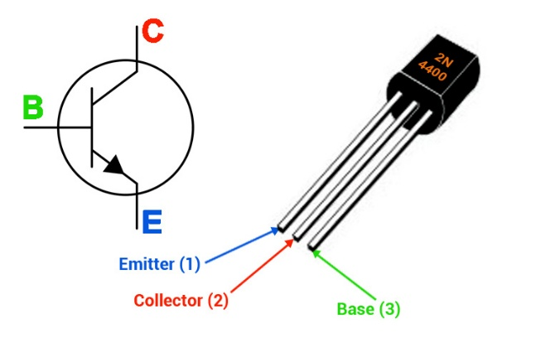  Is it safe to connect VCC and GND of the controller to the driver VCC?  How to use MOSFET/IGBT DRIVER IR2110 (https_microcontrollerslab.com)  - IR2110 can drive both low side and high side in half bridge and low bridge circuits  Miller effect  Many Driver configurations. Most common is totem pole output; low input impedance and high drive current  TOTEM POLE OUTPUT USE AND APPLICATIONS  Floating circuit to drive high side MOSFET. H-bridge used to in pure sine wave inverter  IR2110 can be used to generate a pure sinewave  - Can drive up to 500V (offset voltage)  - 2 A of current  - Floating point  What's offset voltage?  Pinout  LO Output pin for a low side gate driver  2 COM return path for low side configuration  3 VCC power supply pin for low side  5 VS floating-point return path for high side drive  6 VB floating supply for high side drive  7 HO output signal for high side mosfet  9 VDD Power supply +5V  10 HIN PWM signal input for high side  11 SD shutdown pin to turn off system automatically  12 LIN PWM signal input for low side  13 VSS Power supply ground  - VDD pin 9 is a logical supply pin. Its value should be around 5 volts. But if you used voltage less than 4 volts it may not give you the required result.  Schematic of an  ir2110 typical circuit - Search Images (bing.com)  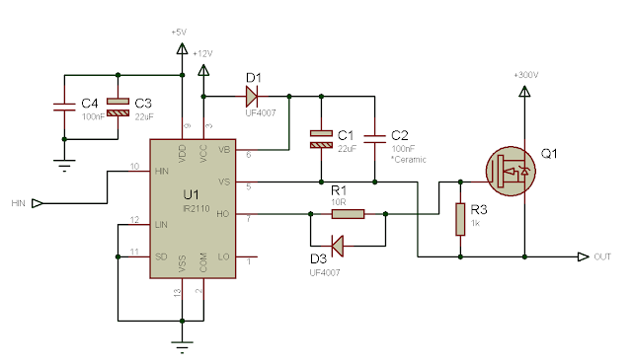  Notes  Selection of bootstrap components  *an978.p65 (mit.edu)  *dt98-2.pdf (irf.com)  Simulation Result  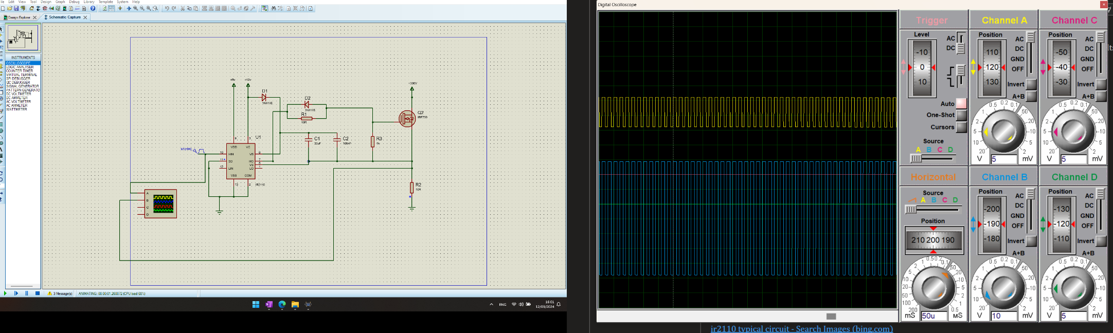  The amplifier npn mosfet doesn't work properly for a mysterious reason.  There's current flowing through it even without applying current to the base/  Using a potentiameter to control pwm signal  while(dutyCycle < 65535) { TIM2->CCR1 = dutyCycle; dutyCycle += 100; HAL_Delay(1); } while(dutyCycle > 0) { TIM2->CCR1 = dutyCycle; dutyCycle -= 100; HAL_Delay(1); }  HAL_ADC_PollForConversion(&hadc1,1000);  readValue = HAL_ADC_GetValue(&hadc1);  TIM1->CCR1 = (int)(readValue*100/4095);  Potentiometer ADC (micropeta.com)  STM32 Blue Pill Timer PWM Mode with LED Dimmer Example (microcontrollerslab.com)  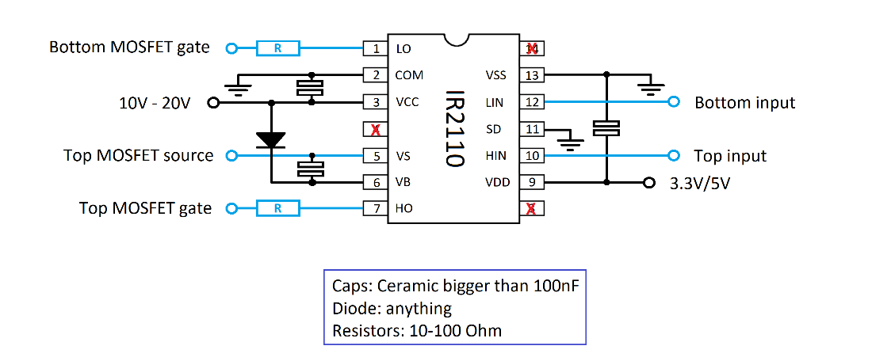  How to use the IR2110 gate driver – Krakkus.com  What are MOSFET gate drivers? Why do we need MOSFET gate driver? MOSFET driver explained.  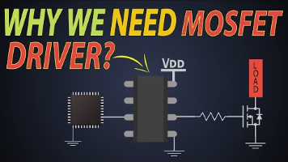  Why gate driver circuit?  - Logic MOSFET driving a power MOSFET  - A negative pulse to turn off a MOSFET  - 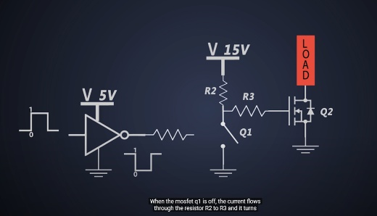  - NOT at the GATE  - Low switching speed, high switching loss  -   - Inductance coupled with capacitance => Generate ringing, which could damage the gate driver  Gate driver IC  - No ringing  - High gate capacitance  - Low voltage compatibility  - Transient protection  - Isolation  Resistor to drive the MOSFET  - 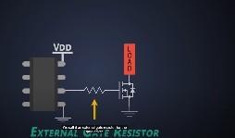  External gate resistors  Why the right size of gate driver resistor is so important?  The gate resistors affect the following:  - Swiching speed  - Power dissipation  - Power losses  - Voltage Overshoot  - Gate Ringing  - Electromagnetic interference  - Reverse recovery  - Tradeoff between noise and efficiency  - Resistor should be placed next the MOSFET gate  Totem Pole  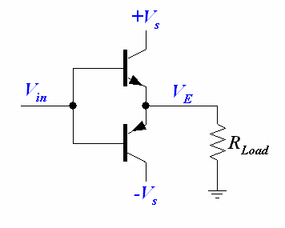  - Requirements?
 | Floating circuit  Bootstrap  VCC and VDD  Totem Pole  H-bridge | APPLICATION NOTE  Adjusting the signal so that it would reach the required gate voltage; When a driver IC is missing, the signal would need to be amplified using a transistor  Floating Power Supply  In a floating Power supply the output is isolated from the input, including not sharing a common ground connection.  - Isolation  - The output is not referenced to any ground or other power supplies  - It allows the power supply to be used independently without relying on existing circuit ground connections.  - Application  - Flexible grounding  - Noise reduction  VDD and VCC  - VCC: powers circuit  - VDD: powers logic gates, transistors and MOSFETs  - VCC is the power supply voltage of the circuit, VDD is the working voltage of the chip  - VSS is the ground point.  Some ICs have both VDD and VCC pins, which means that the device itself has a voltage conversion function.  Gate Floating  The gate current is specifically related to controlling the MOSFET’s gate voltage, while the drain-source current is associated with its overall conduction behavior. 🛠️⚡  Floating the gate above the source  Input to high side MOSFETs has to be level shifter to whatever potential the tub is floating at  Floating the gate: gate voltage is controlled relative to the source volt at a given instance  Driver Requirements  - Gate Reqirements:  - Gate voltage must be 10-20 V above the source voltage  - The gate voltage must exceed the rail voltage  - Gate voltage must be referenced to ground which has to be referenced to GND  - Level shifting  - The logic signal coming from the controller needs to be level shifted to the level of the source terminal of the HS switching transistor  - In most applications, this source terminal swings between the two rails (high voltage and ground)  components operate at different levels  - For example, logic circuits (such as microcontrollers or digital ICs) typically work with low voltages (e.g., 3.3V or 5V), while power devices (such as MOSFETs or IGBTs) may operate at much higher voltages (e.g., 12V, 24V, or even hundreds of volts).  Level Shifting  When we say that a signal is **"level-shifted,"** we are referring to the process of adjusting its voltage level or reference point. Let me explain further:  1. **Context**:  - In electronic circuits, different components or subsystems often operate at different voltage levels.  - For example, logic circuits (such as microcontrollers or digital ICs) typically work with low voltages (e.g., 3.3V or 5V), while power devices (such as MOSFETs or IGBTs) may operate at much higher voltages (e.g., 12V, 24V, or even hundreds of volts).  2. **High-Side Switching Example**:  - Consider a high-side power switch (like a MOSFET) that controls a load connected to a high voltage rail (e.g., a motor or a lamp).  - The gate voltage required to turn on the MOSFET must be higher than the source voltage (which is connected to the high voltage rail).  - However, the control signals from logic circuits are usually referenced to ground (0V).  3. **Level Shifting Process**:  - To make the control signals compatible with the high-side power device, we need to **shift their voltage level**.  - This involves adjusting the signal so that it reaches the required gate voltage relative to the source terminal of the power device.  - Common methods for level shifting include using **transistors, resistors, or specialized ICs** designed for this purpose.  4. **Example**:  - Suppose we have a microcontroller output that switches between 0V (logic low) and 3.3V (logic high).  - To drive a high-side MOSFET with a gate-source voltage of 12V, we need to level-shift the microcontroller signal.  - A simple level-shifting circuit might use a **voltage divider** or a **N-channel MOSFET** to achieve this.  Bootstrapping  High-Side Gate Drive:  - In the context of MOSFET circuits, bootstrapping is commonly used to pull up the operating point of a transistor above the power supply rail.  - Specifically, it raises the gate voltage of an N-channel MOSFET or IGBT above the power rail supply (V+).  - By doing so, it ensures proper biasing and minimizes heat loss.  Transition Threshold  - The level at which a digital signal switched between high and low or vice-versa.  - In some devices (such as MGDs, e.g., IRS211x), the transition threshold is proportional to the logic supply voltage (VDD).  Bootstrap Capacitor  dt04-4.pdf (irf.com) = IS TOO DETAILED FOR THE CURRENT STATE. This can be used in the phase 2 of the design  - The bootstrap supply is formed by a diode and a capacitor  - Proper capacitor choice can reduce drastically these limitations.  - To size the bootstrap capacitor,  - the first step is to establish the minimum voltage drop (ΔVBS) that we have to guarantee when the high side IGBT is on.  - If VGEmin is the minimum gate emitter voltage to maintain, the voltage drop must be:  - 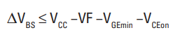  - 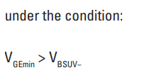  - YOU WANNA KEEP IT ABOVE THE HIGH LIMIT FOR WORST CASE SENARIO  - There is an upper limit to the bootstrap capacitance set by the RC time constant of the bootstrap charging circuit and the minimum on time of the low-side transistor.  - N=1  - Q_g=  High-Side Drive, High-Side Solenoid Monitor With PWM Rejection (Rev. D)  [FAQ] UCC27282: How to Correctly Size the Bootstrap Capacitor for Half-Bridge Gate Drivers - Power management forum - Power management - TI E2E support forums  Driving PWM Loads with TI High-Side Switches  AN296235-Driving-Inductive-Loads.pdf  *dt04-4.pdf (irf.com)  *dt98-2.pdf (irf.com)  Fundamentals of MOSFET and IGBT Gate Driver Circuits (Replaces SLUP169) (Rev. A) (ti.com)  Half Bridge  - What is ground  - Deadtime between the activation between the two MOSFETs  Driving HS switching MOSFET with varying duty cycles  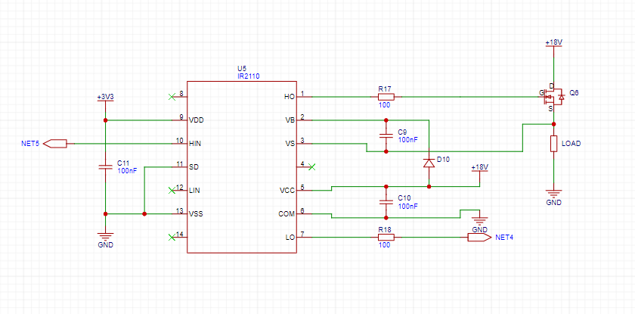  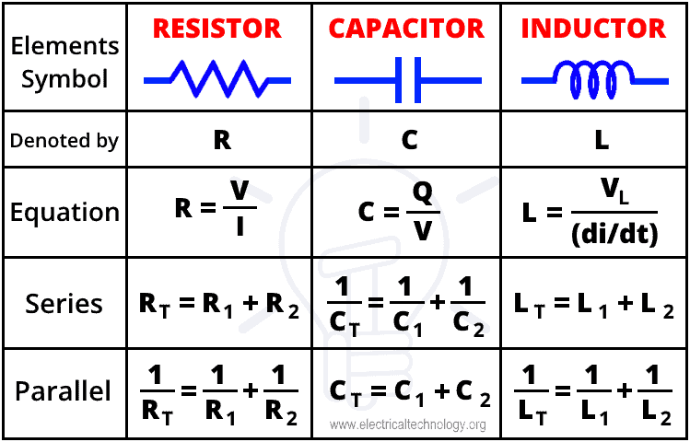
21/03/2024 | Buck Implementation | The implementatoin of buck has been sucessful. With efficiency of 75%  This technique can also be used in place of a dedicated supply to power the PWM controller, as well as the IR2110 and other auxilliary circuits, if the output voltage of the buck converter is between 10 and 20V | VS pin wasn
22/03/2024 | Power Inverter  How do they work?  How to build one?  Important considerations | Power Inverters Explained - How do they work working principle IGBT  IGBT  Across the load  Close switch 1 & 4  Generating a sine wave  2 comparators for the 4 switches  1 comparator controls s1, s2 and the other controls s3,s4  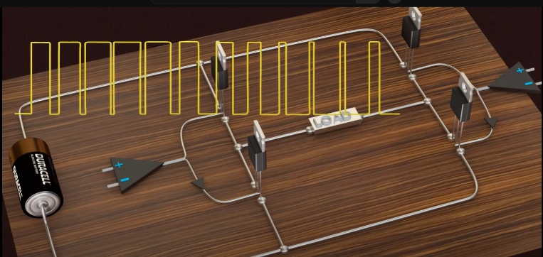
27/03/2024 | Voltage divider  How to build  Control Algorithm | PWM can be used as a voltage divider. Does it divide the current drawn as well? - Using Arduino / General Electronics - Arduino Forum  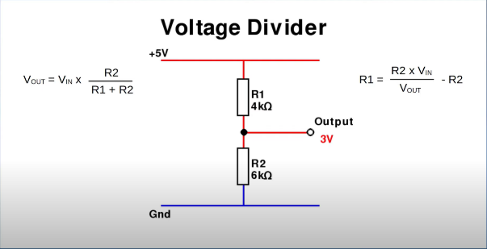  Motor behaves as a low pass filter  Put a 3A HRC fuse in the lead from the battery, physically located as close to the battery as possible with no other component between the battery and the fuse.  Current meter  Read the analog value  Voltage = readValue*3.3/resolution  V_in = Voltage*12/2  readValue = HAL_ADC_GetValue(&hadc1); // Store the ADC value in readValue  v_out = readValue * 3.3 / 4095; // Covvert the adc read value to volts  v_in = v_out * R_tot / R2;  error = v_ref - v_in; // Compute the error and convert to percentage  // Adjust the PWM duty cycle based on the error  if (error > 0) {  // Increase the duty cycle if the output voltage is too low  v_err += error * gain;  } else if (error < 0) {  // Decrease the duty cycle if the output voltage is too high  v_err += error * gain; // Gain is negative  }  // Make sure the duty cycle stays within valid bounds  duty += v_err * 100 / 18;  // Update the PWM signal with the new duty cycle  update_duty(duty);
27/03/2024 | Inverter  This is a big a deal | Alternative Solutions  - Use 555 timer DIY Inverter tutorial - Arduino or 555  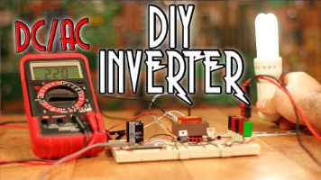  - Use EGS002 DIY 1kW Sine Wave Inverter (12V-220V - EGS002)  EGS002-EG8010 Sine pulse generating circuit, voltage: 5VDC, output: 5V, frequency: 50Hz, 60Hz, 0-100Hz, 0-400Hz (thegioiic.com)  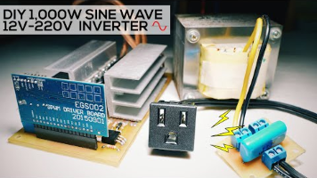  - Mains voltages => 50 or 60 Hz  - To step up voltages, you can use transformers in reverse  - Diodes will be used around the mosfets for protection against mf
 | Inverter Concept | مقتطفات من الحلقة 61 من دورة التصميم الالكتروني المحترف - مبادئ عمل الانفيرتر  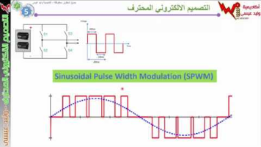  في المختبر:: 65- انفيرتر .... ولكن !!  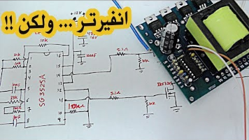  H bridge  - Discharge a capacitor  - SG3525A IC PWM Generator, with some capacitors, resistors we can adjust the frequency of oscillation and dead time of Mosfets  - Resistors are placed before MOSFET gate to filter out any spikes.  DIY 1kW Sine Wave Inverter (12V-220V - EGS002)  Gate Driver Circuit for Three Phase Inverter : 9 Steps - Instructables  Micro-Cap Tutorial: MOSFET Inverter Three Phase (Motor Control)  VFD Variable Frequency Drive Teardown Reverse Engineering | Electronics Materials and Quality Check  How to make a Variable Frequency Drive (VFD) | 1: Overview & Basics  Design Strategy for a 3-Phase Variable Frequency Drive (VFD) (calpoly.edu)  Does it suck? Chinese DIY Pure Sine Wave Inverter || Sinusoidal PWM (SPWM) Tutorial
 | Deadtime Generation Cicuit  How to create deadtime? | في المختبر:: 168- ما هي (Deadtime Generator Circuit) وما أهميتها مع اختبار دائرتين  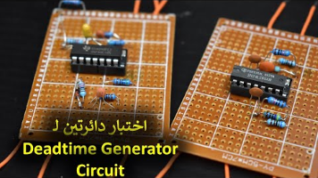  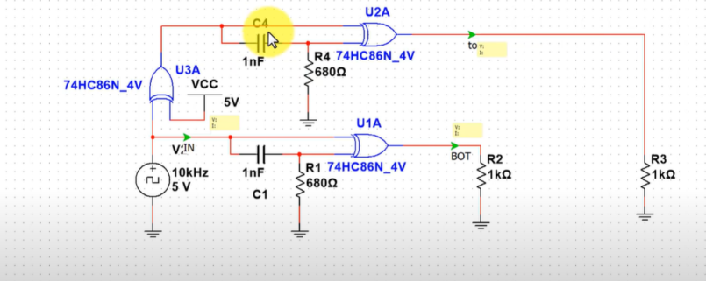  How to size the components?  Experiment  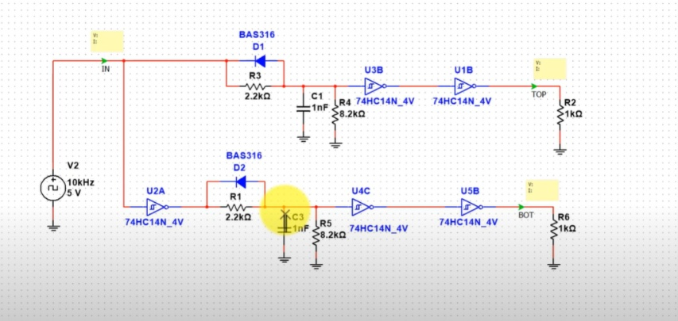  How to size the components?  Experiment  Every IC requires 100nF to prevent damage  Modifying the values of R5, R7 could change the deadtime  1n1448 fast switching diode
 | Bootstrapping | في المختبر:: 171- ما هو Bootstrapping in Gate Driver مع دائرة عملية - جزء 1  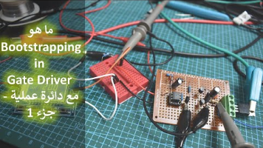  What does a zinner diode do in such a circuit?  TLP250 pdf, TLP250 Description, TLP250 Datasheet, TLP250 view ::: ALLDATASHEET :::  UCC2813  PMP20182 reference design | TI.com  TL494 pdf, TL494 Description, TL494 Datasheet, TL494 view ::: ALLDATASHEET ::: Can be used instead of a microcontroller  1ED020I12-F2_DS_V2.0.book (rs-online.com)
0‎5/ 04/ ‎2024 | Deadtime Simulation | H-bridge motor controller design using Nexperia discrete semiconductors and logic ICs  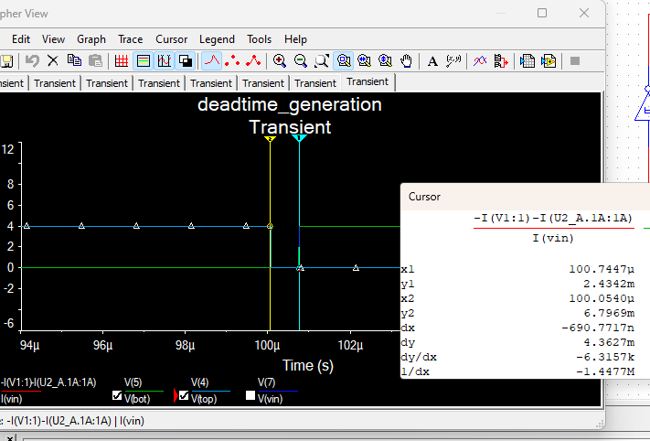  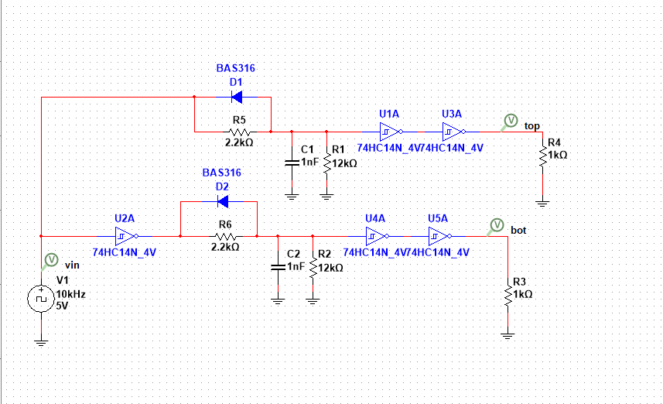  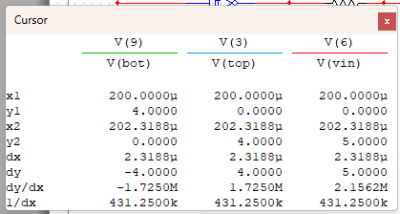  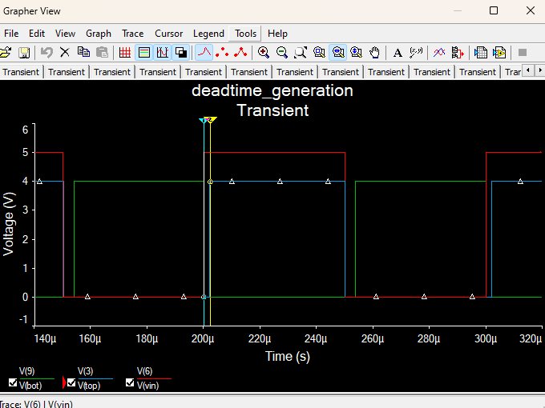
 | Inverter Simulation | how to make H bridge using IR2110 (microcontrollerslab.com)  EGS002.PDF  how to make H bridge using IR2110 (microcontrollerslab.com)
 | Buck Simulation | The  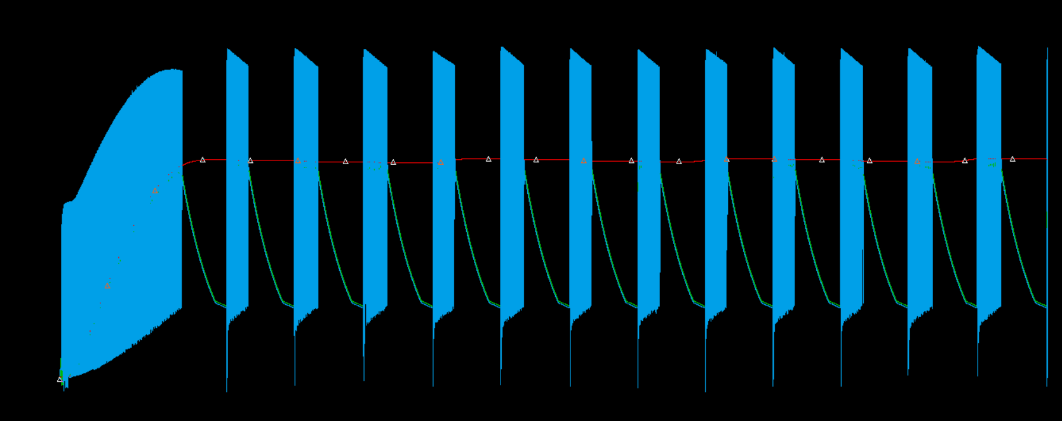  This is due to the bootstrap. The capacitor doesn’t have enough charge for the bootstrap to function normally.  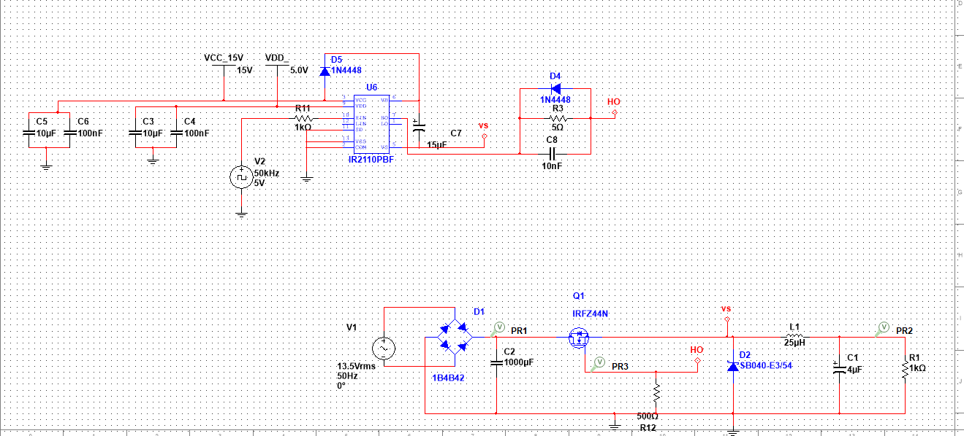  The gate voltage isn't driven to 0 during the  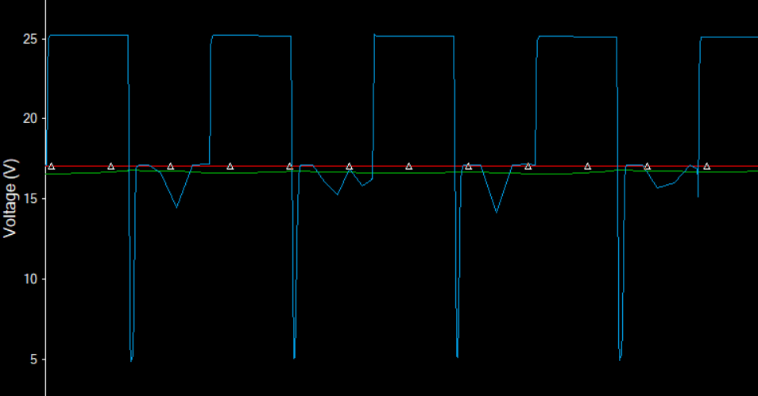
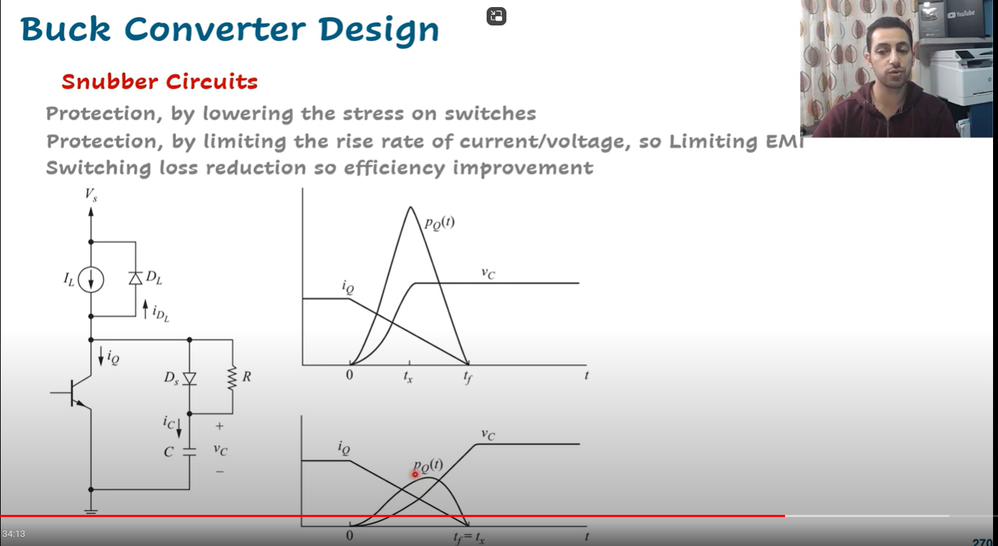

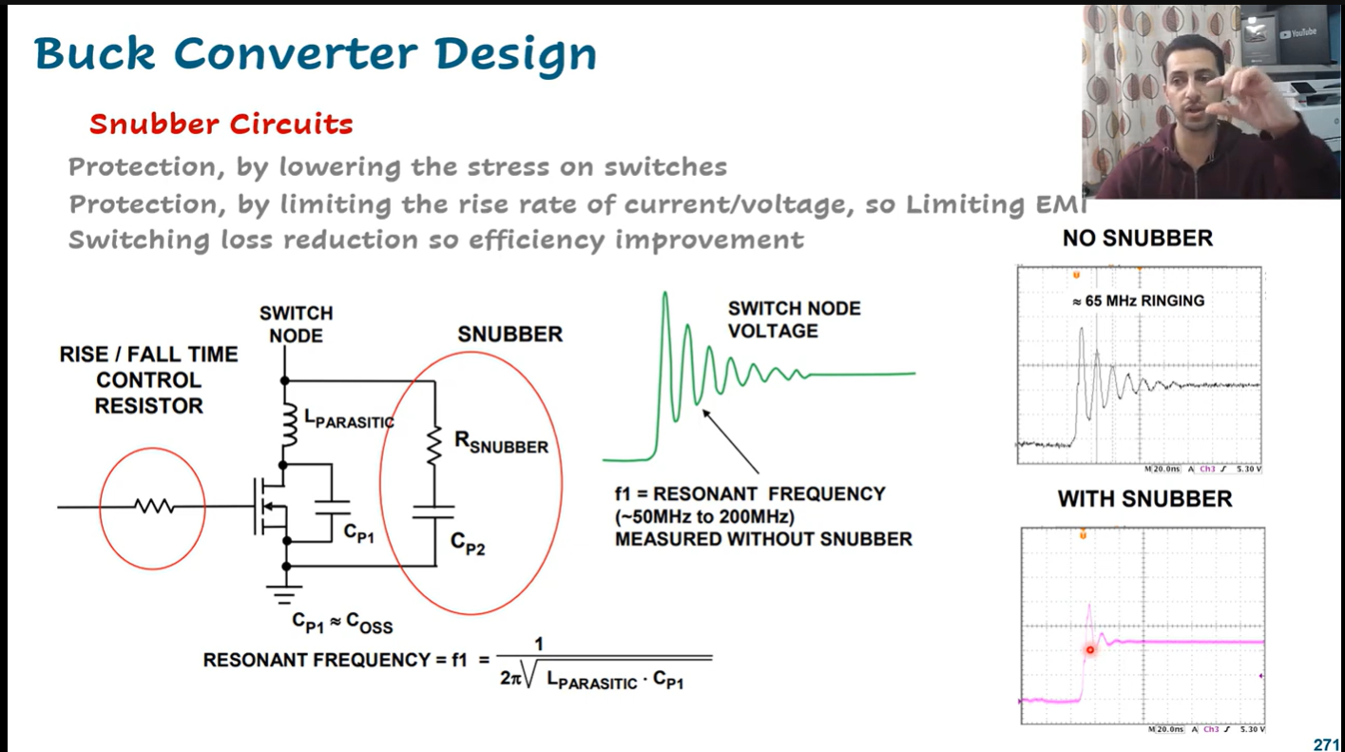

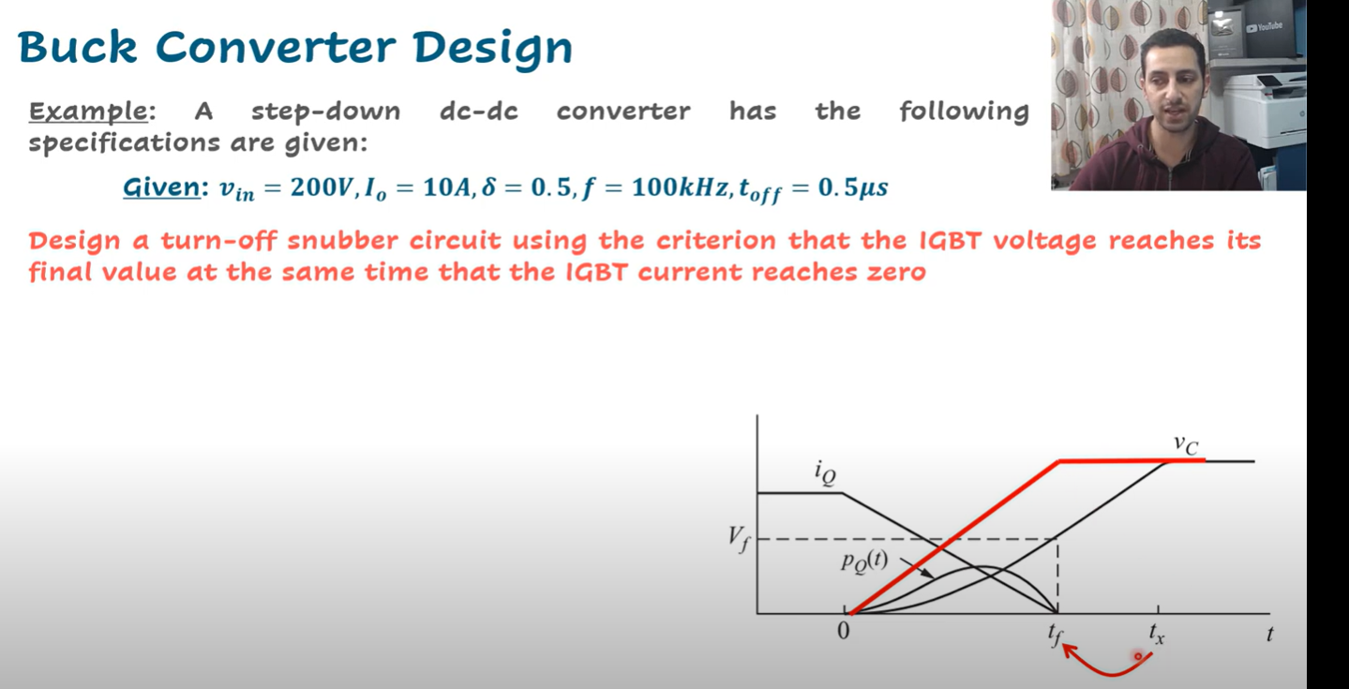

Inductive loads

 | Buck converter implementation | Fast recovery  Fast switching  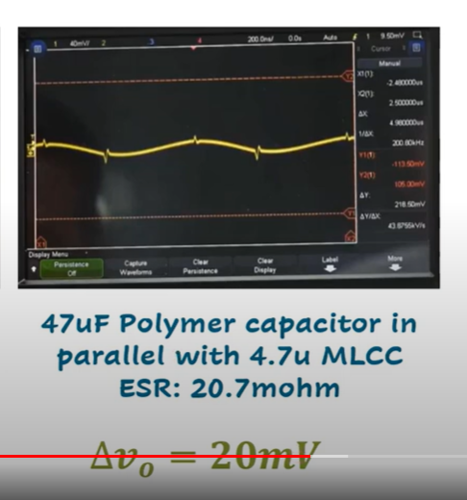  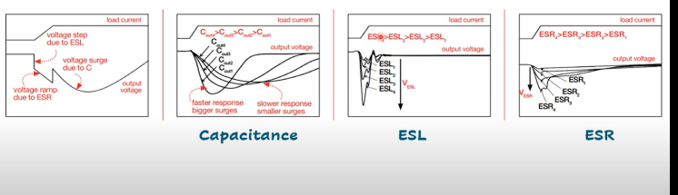  Lab 3 Buck Converter in LTSpice | Power Electronics    Circuit analysis  Discontinuous Conduction Mode vs Continuous Conduction Mode  The relationship between the duty cycle and the output current should be linear =>  In this example the input voltage is 50 v and the duty is 50%, the output voltage is expected to 25v. However, we get 35v which is too high. The reason is because the system is operating in discontinuous conductive mode which is means that our system is no longer linear. As demonstrated in the below example  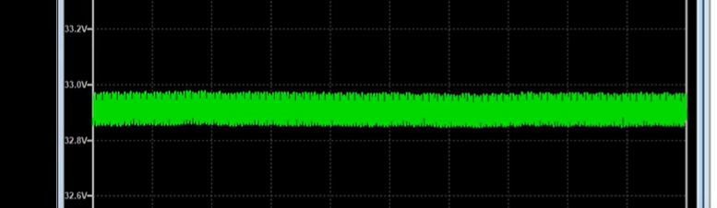  Discontinuous conduction mode  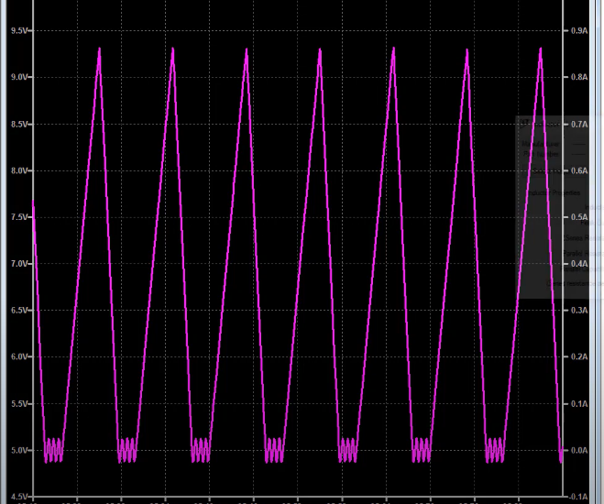  Increasing the inductance or decreasing the load produces this output  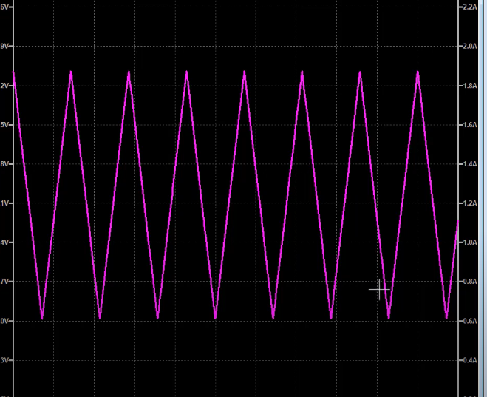  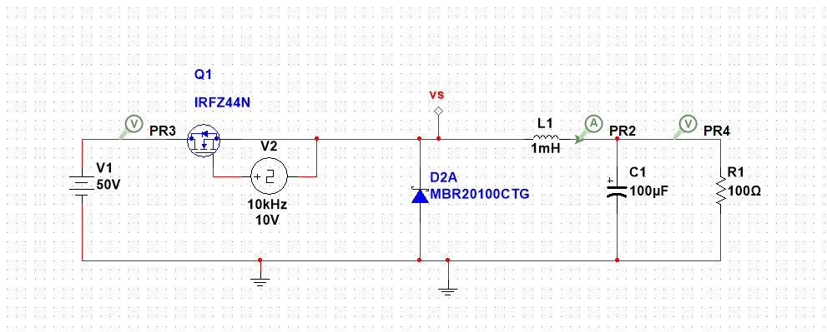  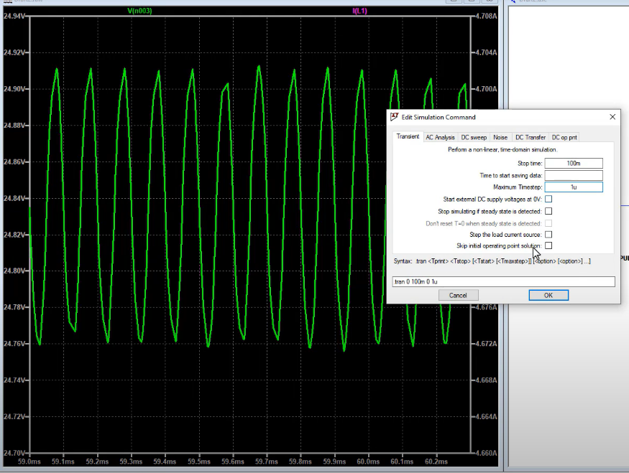  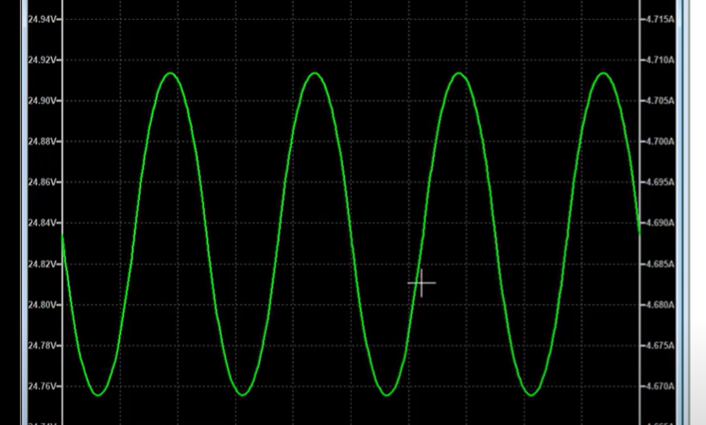  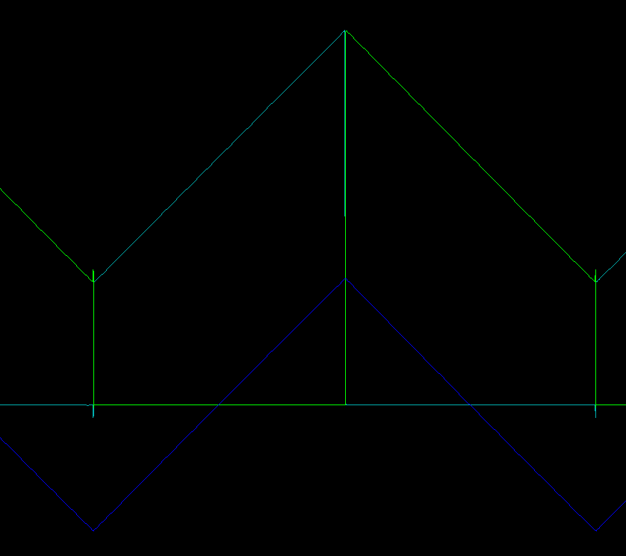  The effect of parasitic resistance in a capacitor ESR  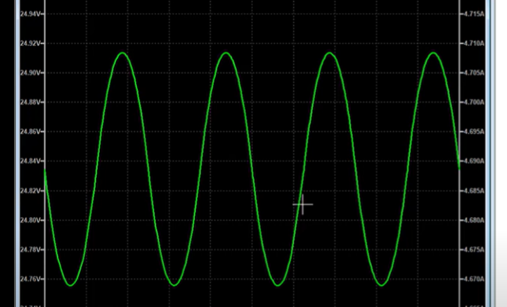  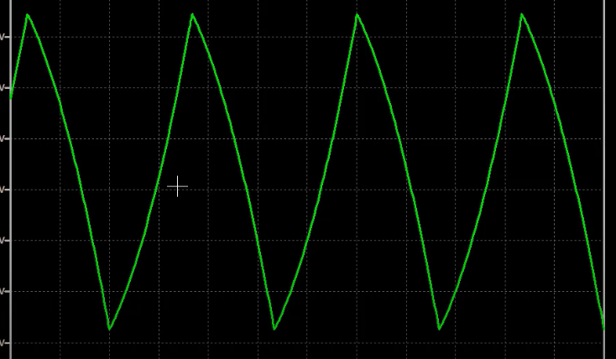  The voltage mirrors the inductor current because the resistor mirrors the inductor current  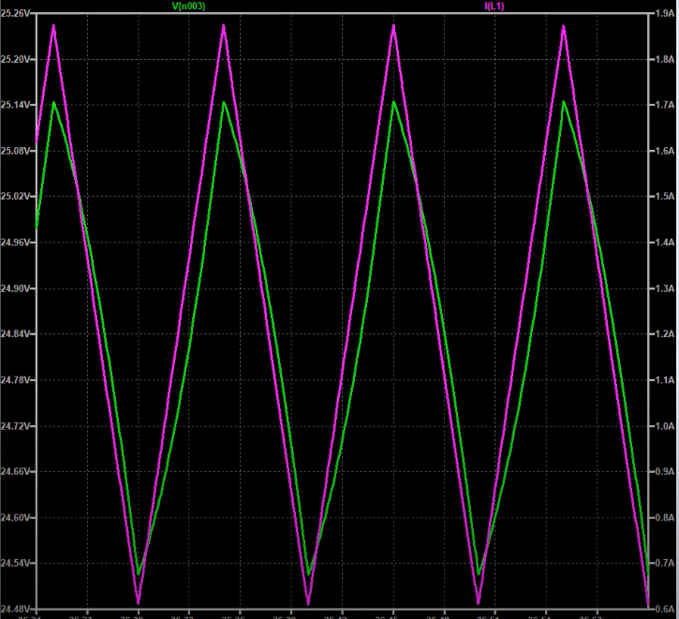  When adding parasitic inductance  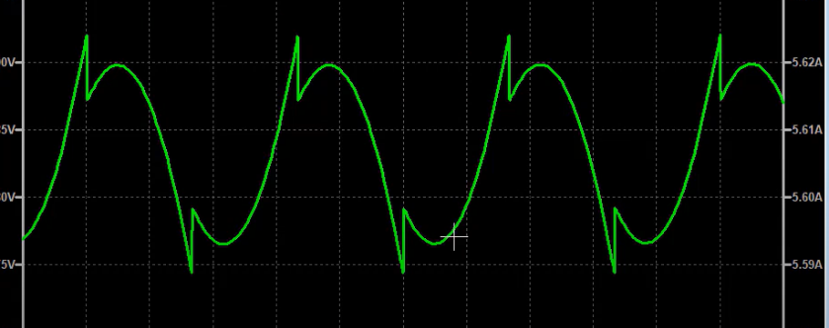  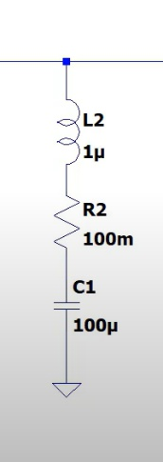  Long leads or long tracs on the pcb lead to parasitic inductance Lp  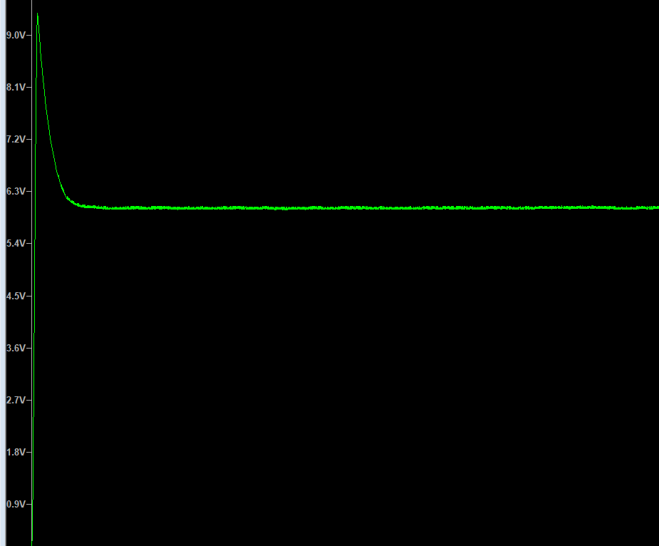  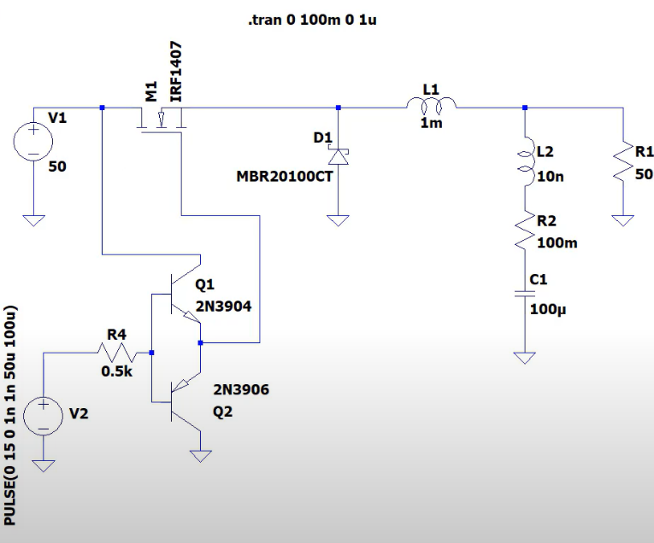  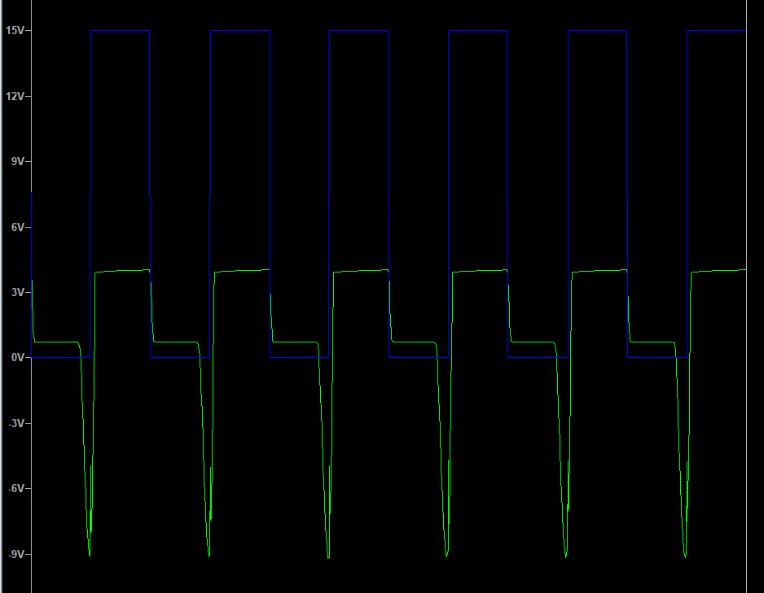  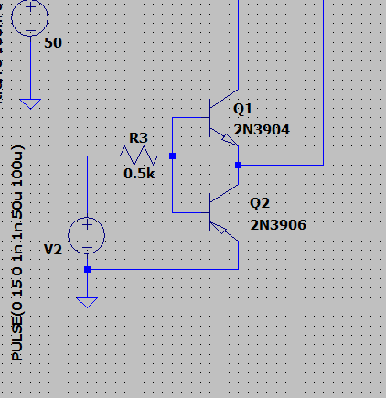  Push-pull is good for low side switching
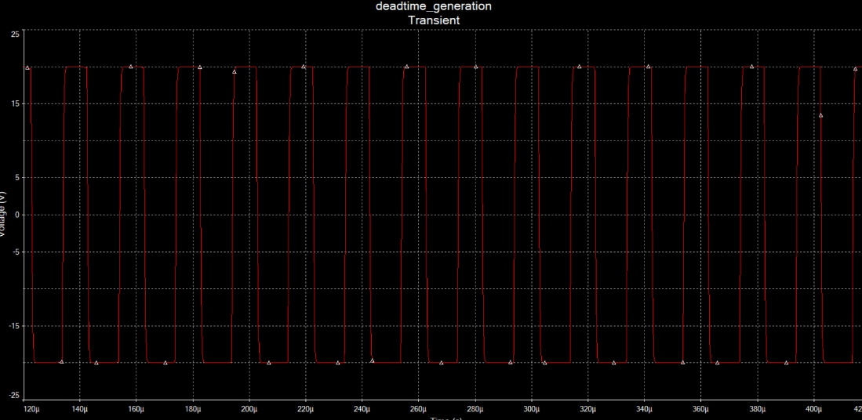
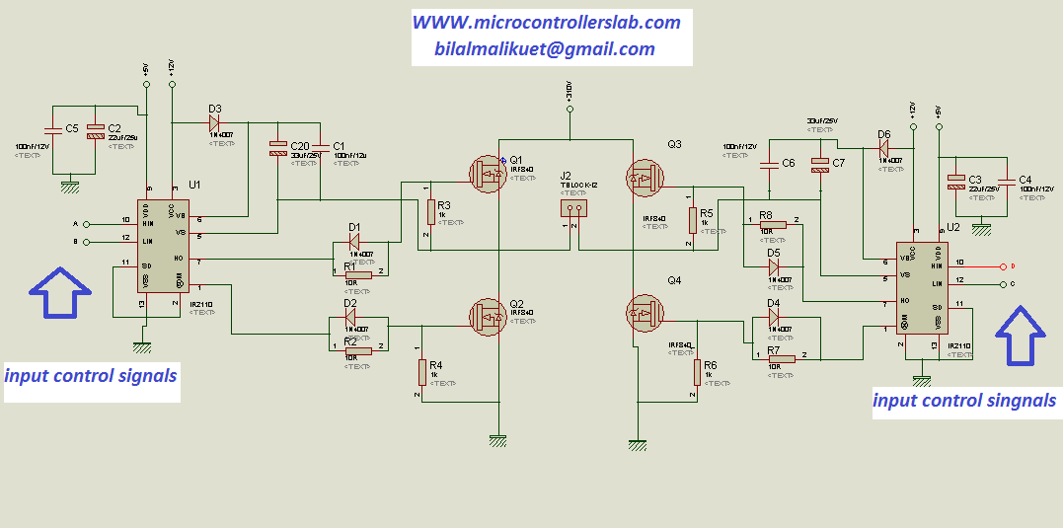

 | Buck design | - For a buck converter to function normally a feedback is required  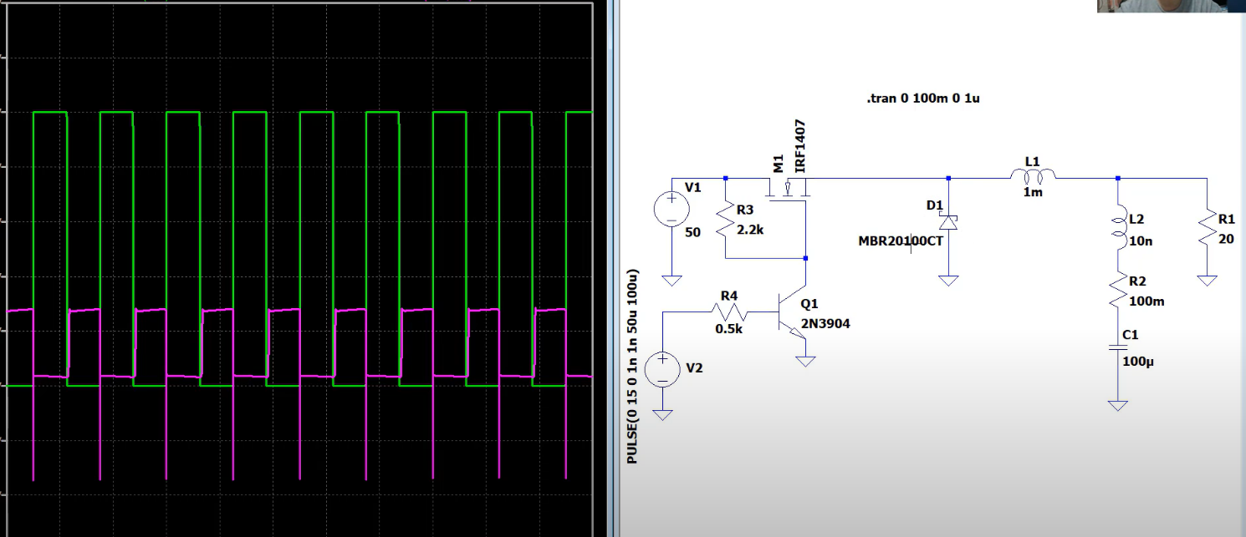  The negative voltage ripples between the peaks in the purple waveform can be attributed to several factors related to the operation of the DC-DC converter circuit, particularly during the switching transitions. Here's a detailed explanation:  Inductor Current Behavior  - Inductor Charging and Discharging:  - When the MOSFET (M1) is on, current flows through the inductor (L1), storing energy in its magnetic field. The voltage across the inductor is positive during this time.  - When the MOSFET turns off, the inductor's current continues to flow, but it needs a path. The current flows through the diode (D1), and this current helps maintain the load voltage. During this period, the inductor's voltage reverses (Lenz's Law), which can cause the output voltage to drop.  Freewheeling Diode and Inductor Voltage  - Diode Forward Voltage Drop:  - When the MOSFET turns off, the freewheeling diode (D1) conducts. However, the diode has a forward voltage drop (around 0.2-0.4V for Schottky diodes, but higher for others), which can cause a temporary dip in the output voltage.  - This forward voltage drop can create a negative dip if the load voltage momentarily drops below the reference ground level due to the switching dynamics.  Switching Transients  - Switching Transients:  - During the switching transitions, there can be high-frequency oscillations or ringing caused by parasitic inductances and capacitances in the circuit. These transients can temporarily pull the voltage below zero.  - The inductive kickback, a phenomenon where the inductor resists the sudden change in current when the MOSFET switches off, can also cause a negative voltage spike.  Parasitic Elements  - Parasitic Inductances and Capacitances:  - Parasitic inductances in the circuit board traces and connections can contribute to the negative voltage spikes during the rapid switching of the MOSFET.  - Parasitic capacitances can resonate with these inductances, leading to oscillatory behavior and negative voltage ripples.  Circuit Design and Component Values  - Component Values and Layout:  - The values of the inductor (L1) and the capacitor (C1) play a significant role in filtering out these ripples. Insufficient filtering capacitance or inappropriate inductance value can result in inadequate suppression of these negative transients.  - The physical layout of the circuit, including trace lengths and the positioning of components, can influence the magnitude of these negative ripples due to varying inductive and capacitive effects.  Example Explanation in Context  In the provided circuit:  - When the pulse signal (green waveform) turns off the MOSFET (M1), the inductor (L1) tries to maintain the current flow, causing a temporary negative voltage at the output due to the inductor's behavior and the forward voltage drop across the diode (D1).  - The ringing or oscillations in the purple waveform can be due to the parasitic elements in the circuit and the sudden switching transitions.  Conclusion  The negative voltage ripples between the peaks in the purple waveform are a result of the inductor's energy release, the forward voltage drop of the diode, switching transients, and parasitic elements in the circuit. To minimize these negative ripples, you can:  - Use a snubber circuit across the MOSFET to dampen switching transients.  - Increase the capacitance of the output capacitor (C1) to better filter out the voltage dips.  - Optimize the physical layout to reduce parasitic inductances and capacitances.
Here are the key points about different types of diodes, particularly focusing on their applications and limitations:

### Schottky Diodes
- **Characteristics**: Schottky diodes have a low forward voltage drop (typically 0.2 to 0.3 V) and fast switching times.
- **Limitations**: They are not suitable for high-voltage applications. Their reverse voltage rating is generally low, typically below 200V.
- **Applications**: Used in low-voltage circuits, power rectification, and fast switching applications.

### Recovery Diodes
- **Characteristics**: Recovery diodes are designed to handle high-voltage and high-current applications. They have a higher reverse recovery time compared to Schottky diodes.
- **Types**:
- **Fast Recovery Diodes**: Designed to have a shorter reverse recovery time than standard diodes. Suitable for high-frequency applications.
- **Ultra-Fast Recovery Diodes**: Have even shorter recovery times than fast recovery diodes, making them ideal for very high-frequency applications.
- **Applications**: Used in power supplies, motor drives, and other high-voltage circuits where high efficiency and fast recovery are required.

### Switching Diodes
- **Characteristics**: Switching diodes are optimized for switching applications. They have low capacitance and are capable of high-speed operation.
- **Applications**: Commonly used in digital circuits, signal processing, and high-speed switching applications.

### Summary of Applications
- **Schottky Diodes**: Low-voltage circuits, power rectification, fast switching.
- **Recovery Diodes**: High-voltage and high-current applications, power supplies, motor drives.
- **Switching Diodes**: Digital circuits, signal processing, high-speed switching.

By understanding the characteristics and limitations of each type of diode, you can select the appropriate one for your specific application requirements.

 | Buck converter feedback | 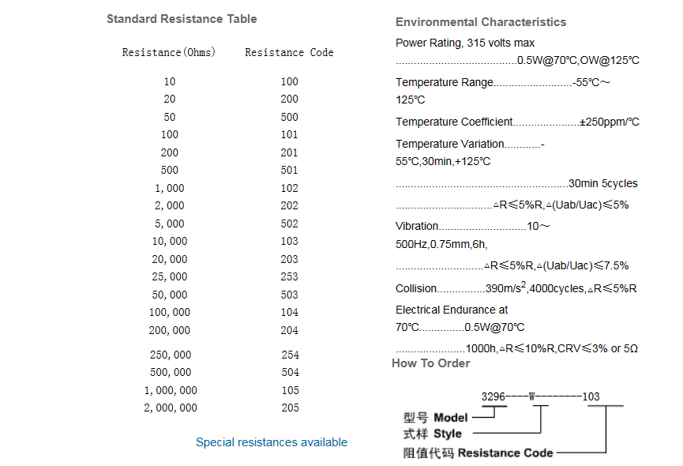
 | Test FB | To measure the voltage over different resistors and configure the TIM1 timer on an STM32 microcontroller, follow these organized steps:  ### Voltage Measurement  1. **Measure the voltage over a \(100 \, \Omega\) resistor.**  2. **Repeat the measurement for a \(200 \, \Omega\) resistor.**  ### Timer Configuration for STM32 Microcontroller  To configure the TIM1 timer to operate at \(50 \, \text{kHz}\) using a \(72 \, \text{MHz}\) clock, follow the instructions below:  1. **Understanding Timer Frequency Formula**  The timer frequency (in Hz) is given by the formula:  \[  f_{\text{timer}} = \left( \text{prescaler} + 1 \right) \times \left( \text{ARR} + 1 \right) \times f_{\text{clk}}  \]  Where:  - \( f_{\text{timer}} \) is the desired timer frequency (\(50 \, \text{kHz}\)).  - \( f_{\text{clk}} \) is the clock frequency (\(72 \, \text{MHz}\)).  - Prescaler and ARR are the values to be set in the timer’s configuration registers.  2. **Rearranging the Formula**  Rearrange the formula to solve for ARR:  \[  \text{ARR} = \frac{f_{\text{clk}}}{f_{\text{timer}}} \times \left( \text{prescaler} + 1 \right) - 1  \]  3. **Calculate ARR Value**  Assume the prescaler is set to 0 (full clock speed):  \[  \text{ARR} = \frac{72 \times 10^6 \, \text{Hz}}{50 \times 10^3 \, \text{Hz}} \times \left( 0 + 1 \right) - 1 = 1439  \]  4. **STM32 HAL Library Configuration**  Here’s how to configure the TIM1 timer in your code using the STM32 HAL library:  ```c  TIM_HandleTypeDef htim1;  htim1.Instance = TIM1;  htim1.Init.Prescaler = 0;  htim1.Init.Period = 1439; // ARR value  htim1.Init.ClockDivision = TIM_CLOCKDIVISION_DIV1;  htim1.Init.CounterMode = TIM_COUNTERMODE_UP;  if (HAL_TIM_Base_Init(&htim1) != HAL_OK)  {  // Insert error handling code here  }  ```  This sequence ensures you properly measure the voltage over different resistors and correctly configure the TIM1 timer for the desired frequency.
 | Ground Isolation | How to detect actuator feedback voltage using Arduino/esp32? | Forum for Electronics (edaboard.com)
 | Power supplies | - Buck Converter: A buck converter is a DC-to-DC power converter which steps down voltage from its input (supply) to its output (load). It’s more efficient than linear voltage regulators.  - Transformer: For AC voltages, a transformer can be used to step down the voltage. The ratio of primary (input) windings to secondary (output) windings determines the output voltage.  - Resistor Divider: A simple method is to use a resistor divider circuit. However, this method is not very efficient and the output voltage can vary with the load.  - Zener Diode: A Zener diode can be used to provide a constant output voltage regardless of the input voltage, but only up to a certain current limit.  - Linear Regulator: While I mentioned voltage regulators earlier, it’s worth noting that there are different types, and linear regulators are one of them. They are simple and cheap, but not as efficient as switching regulators or buck converters.  Zener Diode or voltage regulator
 | Testing Inverter + deadtime generation
 | Additional Inverter components | A Noise-Free DIY Switching Power Supply - How Hard Can It Be?    - PCB tips  How to sense the voltage?  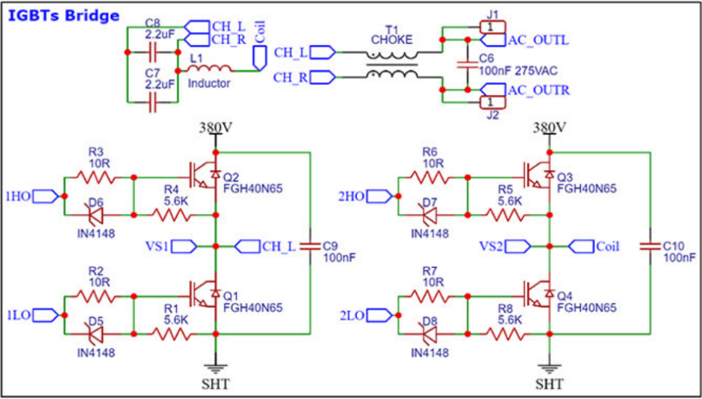  Inverter output circuit  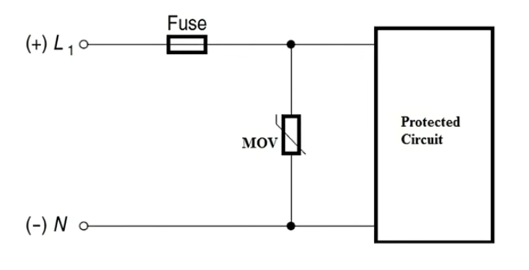  EMI FOR BEGINNERS EXPLAINED| ELECTROMAGNETIC INTERFERENCE FOR BEGINNERS - COMPLETE EMI GUIDE    EMI FILTER DESIGN GUIDE | EMI INPUT FILTER DESIGN | DESIGN GUIDE | ELECTROMAGNETIC INTERFERENCE  
 | Bias Voltage  Power supply | PMP9640 reference design | TI.com  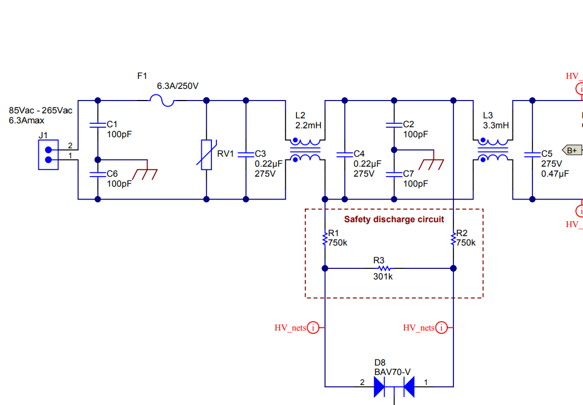  HV to LV Power supply  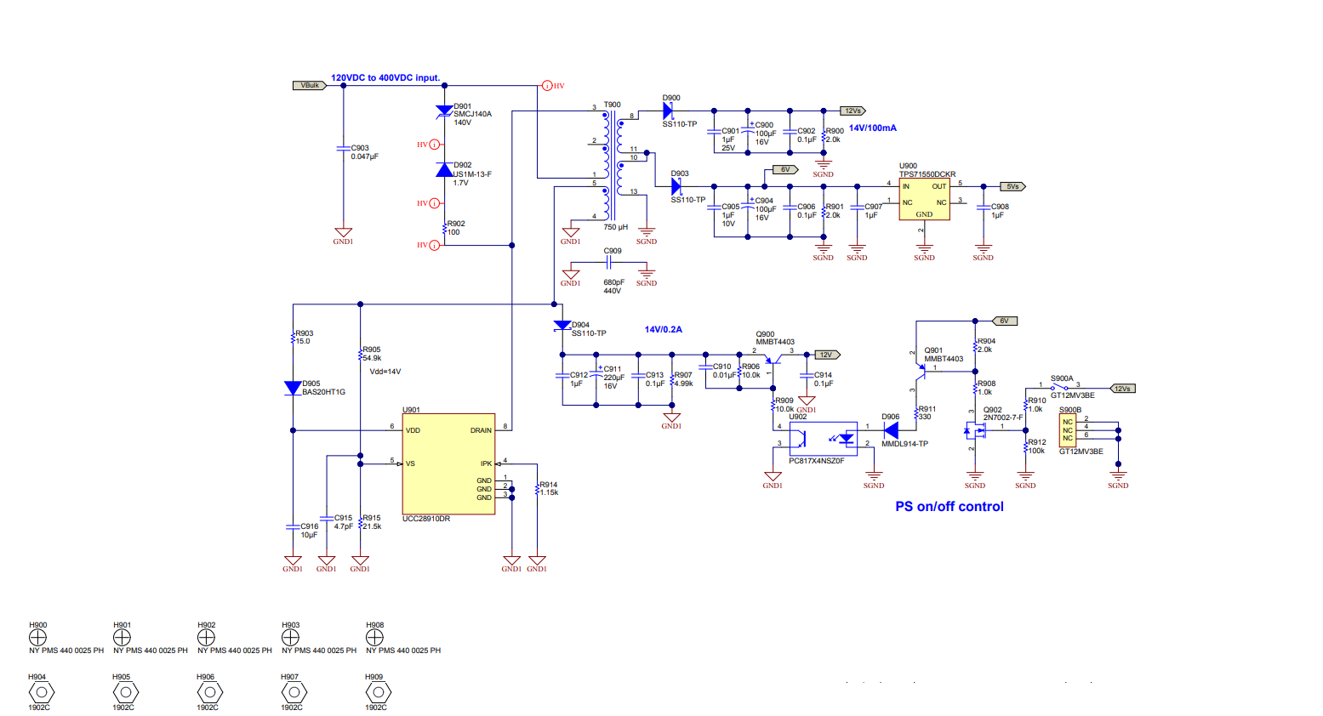  PMP22606 reference design | TI.com  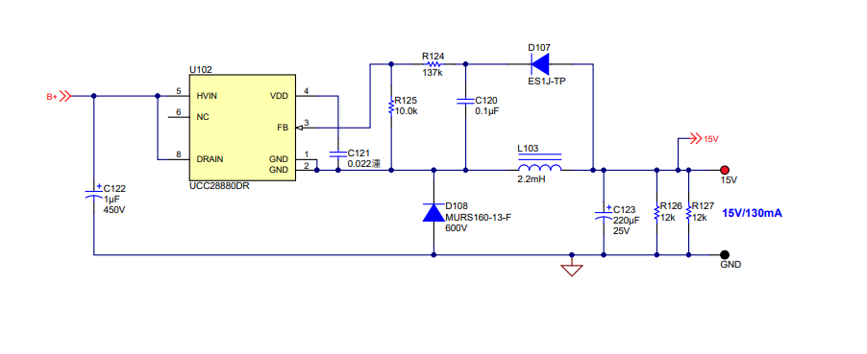  DC Power supply
Buck Converter Design and Feedback Controller Using Core Independent Peripherals (microchip.com)

PIC-003 (aosmd.com)

 | PID simulation Simulink | Simulink Control Systems and PID, Matlab R2020b  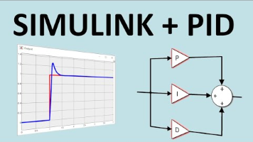  Buck design  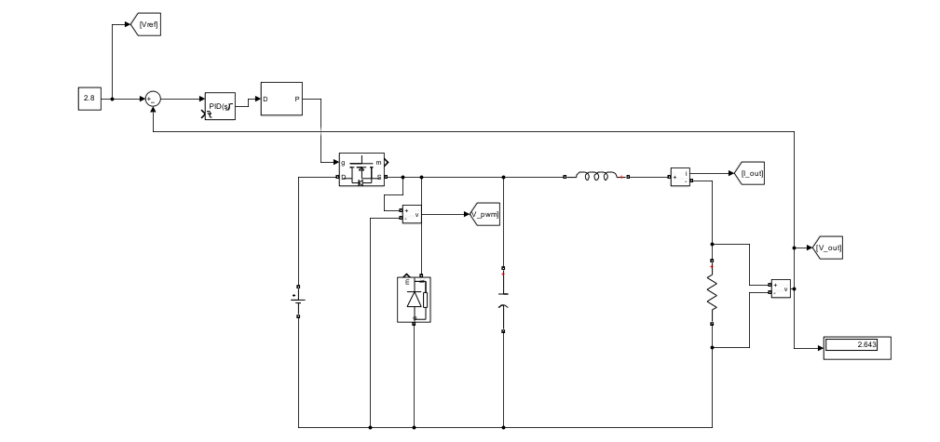  PID result  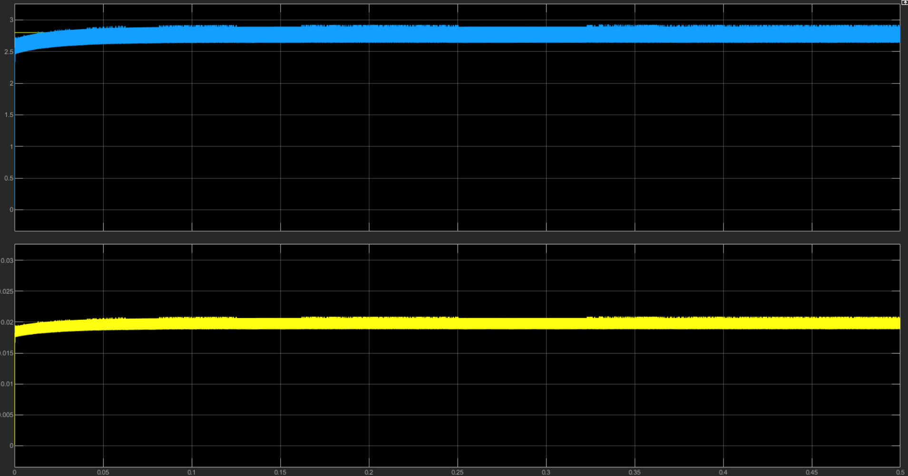
 | Research  Study  Implementation  Topic  Noise Simulation | Resources  Components  Additional Notes  Results  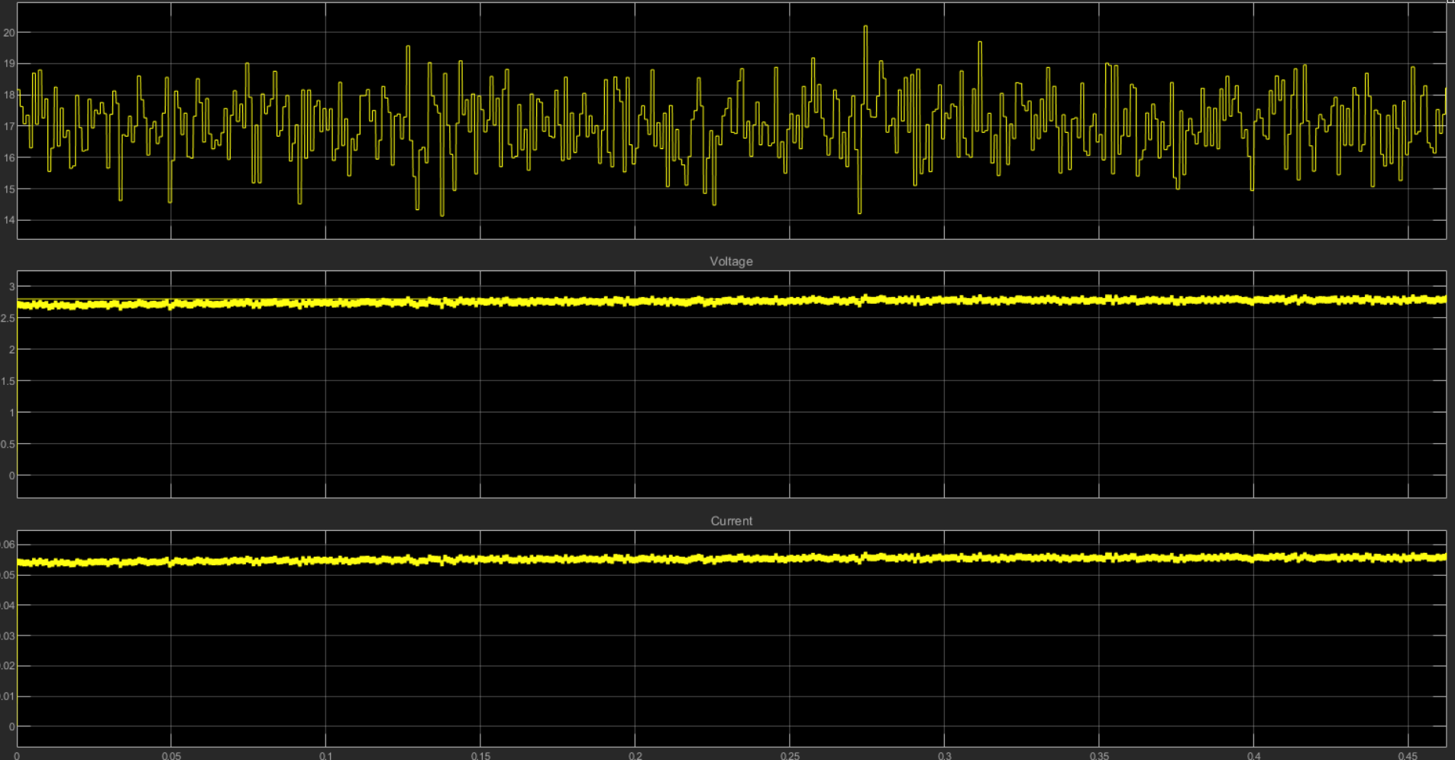
 | Research  Study  Implementation  Topic  Voltage feedback | Simple voltage divider  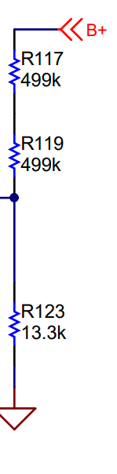  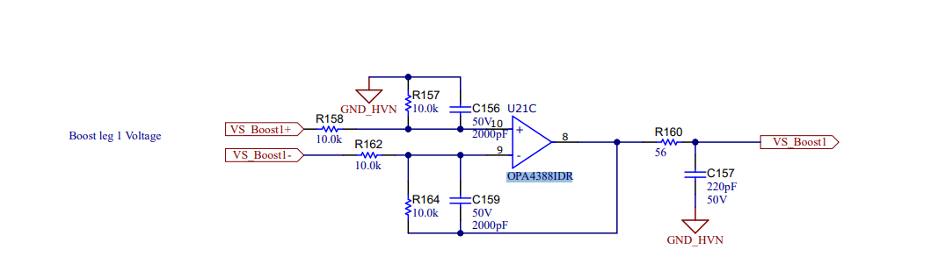  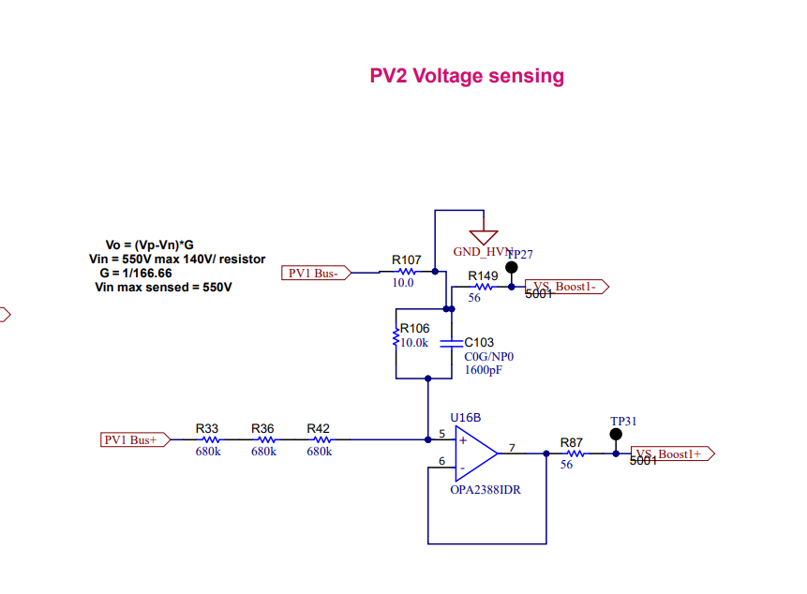  TIDA-010938 reference design | TI.com
30/05/2024 | Research  Study  Implementation  Topic  Voltage sensing | Extra notes  TL432LI data sheet, product information and support | TI.com  Crowbar circuit : used to short the circuit so as to blow the fuse  Undervoltage Proteciton  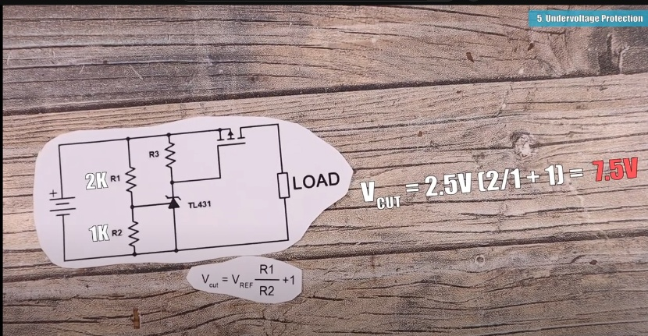  This IC is Multifunctional - TL431 Circuits  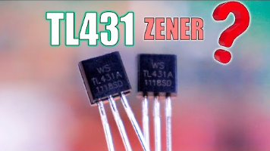  Delay Timer  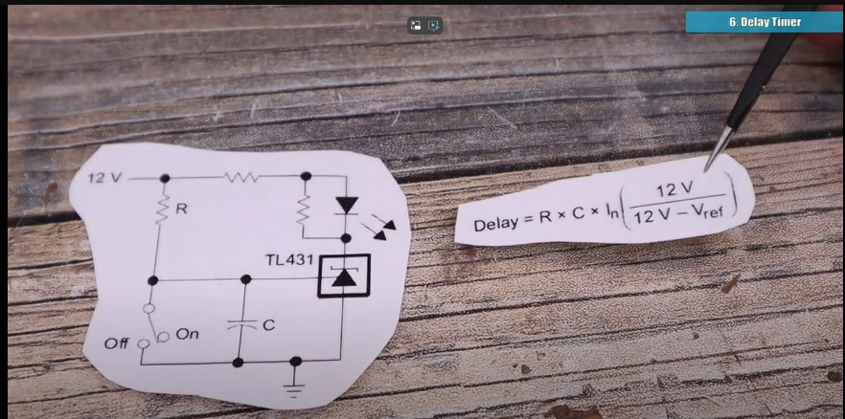
 | F






