Log
Thursday, 30 May 2024
08:48

Date:  30/05/2024 09:02 | Topic  voltage sensing circuit  Task  Research  Study  Implementation | Resources  High DC voltage sensor module design #E08 | Vaibhav Sugandhi: advanced voltage sensing method  Components  The AMC1311 is a versatile and reliable isolated amplifier suitable for a wide range of high-voltage sensing applications. Its high accuracy, isolation capability, and robustness against noise make it an excellent choice for designing voltage sensing circuits in high-voltage systems.  AMC1311  *AMC1311x High-Impedance, 2-V Input, Reinforced Isolated Amplifiers datasheet (Rev. C) (ti.com)  AMC1311 data sheet, product information and support | TI.com  TL431  #277 Understanding OPTOCOUPLER or OPTO-ISOLATOR (youtube.com)  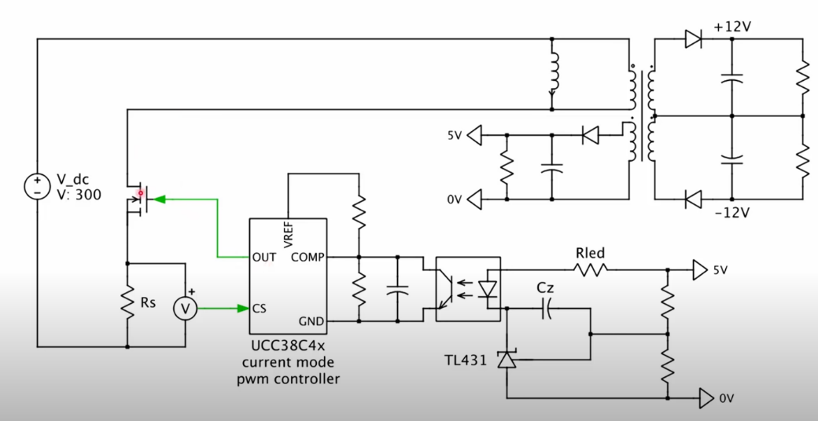  Switching mode power supply  #277 Understanding OPTOCOUPLER or OPTO-ISOLATOR  Zener Diode  1N4727A  Additional Notes  - Safety discharge resistor/ bleeder resistor  Results
Date: | Topic  Task  Research  Study  Implementation  Circuit analysis | Resources  SLURAQ7.PDF  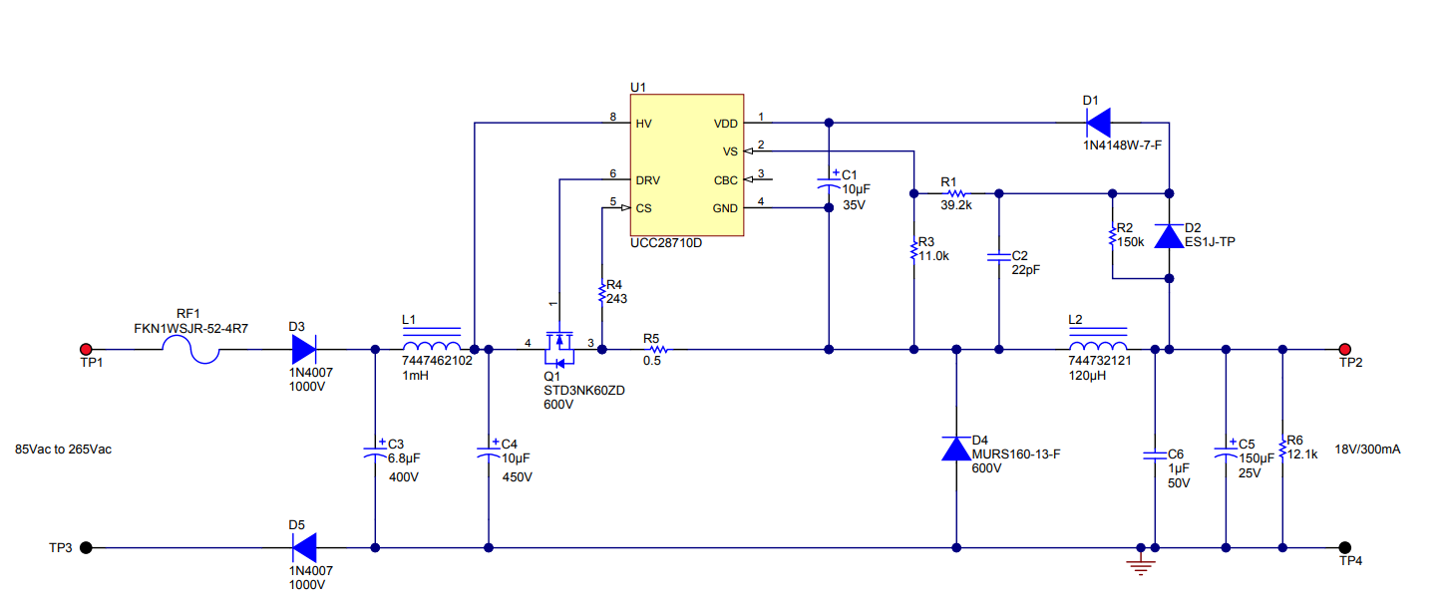  Components  Additional Notes  The circuit uses a half bridge rectifier. Diode  Results
Date:  31/05/2024 | Topic  Schematic drawing  Task  Research  Study  Implementation  Circuit analysis | Resources  UCC28910 | Buy TI Parts | TI.com  Components  UCC28910DR  Additional Notes  Results
Date:  31/05/2024 | Topic  Schematic drawing  Task  Research  Study  Implementation  Circuit analysis | Components  Safety capacitors:  A safety capacitor is a special type of capacitor designed to improve the safety of electronic circuits, particularly those dealing with high voltage or AC (alternating current).  They primarily address two issues:  - Transient voltage spikes: These are sudden bursts of voltage that can damage circuits. Safety capacitors act like a surge protector, diverting excess energy to ground and protecting the device.  - Electromagnetic interference (EMI): This is the emission of electromagnetic waves by electronic devices, which can disrupt the operation of other devices nearby. Safety capacitors can help filter out EMI, ensuring cleaner operation.  There are two main types of safety capacitors:  - Class X capacitors: These are placed directly across the AC power line and are used for line filtering. They typically fail in an open way, meaning they just stop working, which might cause the device not to function but won't create a shock hazard.  - Class Y capacitors: These connect one side of the AC line to the chassis ground. They are crucial for preventing shock hazards and are designed to fail open as well. A failing Y capacitor would mean the EMI filtering wouldn't work, but there wouldn't be a risk of electric shock.  Safety capacitors are found in many electronic devices, including power supplies, modems, and even everyday appliances. They play a vital role in ensuring the safe and reliable operation of electronics.
Date:  03/06/2024 | Topic  Bypass capacitor  Study | Resources  ChatGPT - Tutor Me  Notes  The value of the capacitance in bypass capacitors is important because it determines how effectively the capacitor can filter out noise. Here's how:  - Low Capacitance: Smaller capacitors (e.g., in the picofarad (pF) range) are better at filtering out high-frequency noise. They react quickly to rapid voltage changes.  - High Capacitance: Larger capacitors (e.g., in the microfarad (µF) range) are better at filtering out lower-frequency noise. They provide more energy storage, which helps smooth out larger voltage fluctuations over a longer period.  In practice, designers often use a combination of capacitors with different values to cover a wide range of frequencies. For example, they might use both a small capacitor (pF range) and a larger capacitor (µF range) in parallel to filter out both high and low-frequency noise effectively.  The material used in bypass capacitors affects their performance, cost, and suitability for different applications. Here are some common types:  - Ceramic Capacitors:  - Material: Ceramic  - Advantages: Low cost, small size, good high-frequency performance, and stability.  - Applications: Commonly used for high-frequency noise filtering and general-purpose bypassing in digital circuits.  - Film Capacitors:  - Material: Various plastic films (polyester, polypropylene, etc.)  - Advantages: Good stability, low loss, and excellent performance at high frequencies.  - Applications: Used in applications requiring stable capacitance and low dissipation, such as audio circuits and precision analog applications.  - Electrolytic Capacitors:  - Material: Electrolyte and aluminum or tantalum  - Advantages: High capacitance values, suitable for low-frequency filtering.  - Applications: Often used in power supply filtering and decoupling where larger capacitance is needed.  - Tantalum Capacitors:  - Material: Tantalum  - Advantages: High capacitance per volume, stable, reliable, and long life.  - Applications: Used in space-constrained applications and where high reliability is crucial, such as in aerospace and medical devices.  - Polymer Capacitors:  - Material: Conductive polymer  - Advantages: Low equivalent series resistance (ESR), good high-frequency performance, and long life.  - Applications: Used in high-performance applications such as computer motherboards and high-frequency circuits.  The choice of material depends on the specific requirements of the circuit, such as the needed capacitance value, frequency range, physical size constraints, and cost considerations.
Date:  03/06/2024 | Topic  Voltage sensor  Task  Research  Study  Implementation | Resources  في المختبر: 95- صنع دائرة منافسة (Isolated Voltage Sensor)  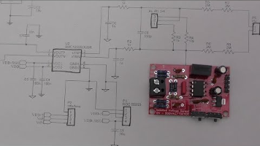  Components  AMC1200  ROE050S  Additional Notes  Results
Date:  04/06/2024 | Topic  Building buck HV  Task  Research  Study  Implementation | Notes  Built a PCB following  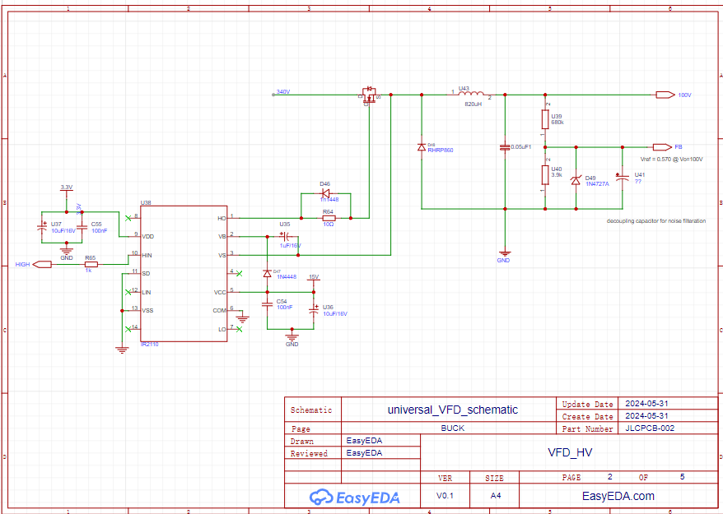  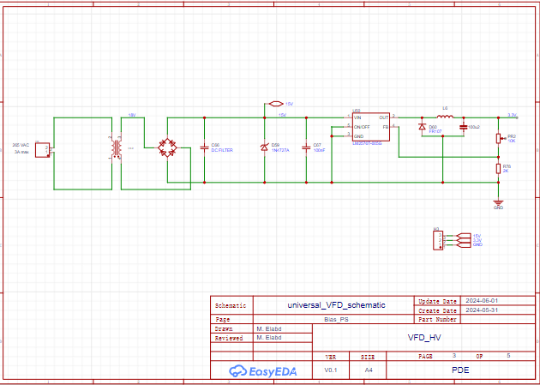  Results  - High output ripple  - High spike on the one gate  - Zener voltage is approx 12V, less than the required 15V needed for IR2110 VCC
Date:  07/06/2024 | Topic  Buck HV  Task  Research  Study  Implementation | Log:  - Testing IR2110 functionality  Notes  The IR2110 has malfunctioned due to …connecting ground??  The entire buck got damaged.  I am going to rebuild it  When building a buck converter and using an IR2110 gate driver to control the switching MOSFET, several factors can lead to MOSFET damage. Here are common reasons for MOSFET failure:  - Overvoltage:  - Drain-Source Overvoltage (Vds): Exceeding the maximum voltage rating can cause breakdown and permanent damage.  - Gate-Source Overvoltage (Vgs): Applying a voltage higher than the maximum Vgs can damage the gate oxide layer, leading to failure.  - Overcurrent:  - Excessive Drain Current (Id): High currents can cause excessive heating and thermal runaway, leading to failure.  - Insufficient Gate Drive Voltage:  - The IR2110 requires a proper supply voltage to fully turn on the MOSFET. Insufficient gate drive voltage can result in partial turn-on, leading to high Rds(on) and increased power dissipation.  - Poor Gate Drive Design:  - Gate Resistor: An incorrect gate resistor value can lead to slow switching times, increasing switching losses and heat.  - Parasitic Inductance and Capacitance: These can cause ringing and oscillations, potentially leading to overvoltage and damage.  - Inadequate Cooling:  - Poor thermal management can cause the MOSFET to overheat. Ensure proper heat sinking and airflow to dissipate heat.  - Switching Losses:  - Frequent switching at high frequencies can lead to significant switching losses. Proper selection of the MOSFET with low gate charge (Qg) and switching energy (Eon, Eoff) is crucial.  - Layout Issues:  - Long PCB Traces: High inductance in long PCB traces can cause voltage spikes.  - Poor Grounding: A poor ground plane can lead to noise and unstable operation.  - Parasitic Elements:  - Parasitic Inductance: Inductance in the gate drive circuit can cause ringing and overvoltage conditions.  - Parasitic Capacitance: High-frequency operation can cause parasitic capacitances to impact switching performance.  - Incorrect Bootstrapping:  - If the IR2110 high-side driver uses a bootstrap circuit, ensure the bootstrap capacitor is correctly sized to provide sufficient charge for the high-side MOSFET gate drive.  - Fault Conditions:  - Short Circuits: A short circuit can cause high current and rapid thermal failure.  - Load Transients: Sudden changes in load can induce voltage spikes and stress the MOSFET.  To mitigate these issues, consider the following:  - Use snubber circuits to dampen voltage spikes.  - Ensure the gate drive circuit is properly designed with appropriate resistors and layout considerations.  - Use thermal pads, heat sinks, or active cooling to manage heat dissipation.  - Select MOSFETs with adequate voltage and current ratings, and appropriate Rds(on) for your application.  - Validate your design with simulations and thorough testing to identify and address potential issues early.  If you encounter MOSFET failures, providing specific details about your circuit, including schematics, operating conditions, and any observed symptoms, can help in diagnosing the issue more effectively.  Resources  Components  Results  IR2110: failed  Reasons: unsure, most likely groundco  Increase gate resistance. Ask for suggestions  Power dissipation. Ask it to show you how for mosfet and diodes  Ask it help you size the bootstrap capacitor | - When the system malfunctions. Identify the damaged compon
Date:  10/06/2024 | Topic  Mosfet Drivers  Heat Management  Task  Research  Study  Implementation | Questions  - Driving an inductive load safety concerns.  - Freewheeling diodes or MOSFETs with in body diodes  - MOSFET selection criteria  - Voltage Rating (Vds):  - Current Rating (Id):  - On-Resistance (Rds(on)):  - Lower Rds(on) values result in lower conduction losses, which is crucial for efficient operation. Select MOSFETs with the lowest possible Rds(on) that meet other criteria.  - Thermal Management:  - Ensure the MOSFET can dissipate heat effectively. Look at the thermal resistance (RθJA, RθJC) and ensure adequate heatsinking or thermal management.  - Switching Speed:  - Body Diode Performance:  - The body diode's reverse recovery time (trr)  - reverse recovery charge (Qrr) should be low to handle inductive kickback efficiently.  High-performance MOSFETs will have body diodes optimized for fast recovery.  - Safe Operating Area (SOA):  - Ensure the MOSFET's SOA encompasses the operating conditions, including any transient conditions.  - 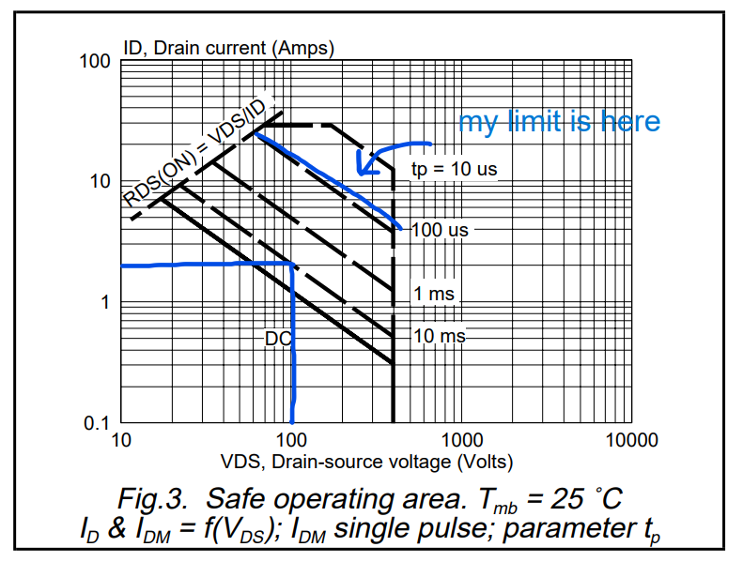  - Ruggedness and Reliability:  - Look for MOSFETs designed for high-reliability applications, with ratings that ensure they can withstand harsh conditions, including avalanche energy ratings.  Ensuring Body Diodes Can Handle Inductive Kickback  - Reverse Recovery Characteristics:  - Reverse Recovery Time (trr): The time it takes for the diode to switch from conducting to blocking mode. Shorter trr reduces the duration of the reverse current spike.  - Reverse Recovery Charge (Qrr): The charge that flows during the reverse recovery time. Lower Qrr reduces the energy dissipated during switching and minimizes voltage spikes.  - Thermal Considerations:  - Ensure the body diode can handle the power dissipation during the reverse recovery period without exceeding its thermal limits. Check the datasheet for power dissipation ratings and thermal resistance.  - Current Rating:  - The body diode should have a peak current rating sufficient to handle the inductive kickback without damage.  - Paralleling MOSFETs:  - In high current applications, paralleling MOSFETs can help distribute the current and reduce stress on individual body diodes.  - Snubber Circuits:  - Use RC snubber circuits across the MOSFETs to dampen voltage spikes and protect the body diodes from excessive dv/dt.  - Gate Drive Management:  - Proper gate drive design can ensure smooth switching transitions, reducing the stress on the body diodes. The gate driver should be capable of providing sufficient drive current and voltage to switch the MOSFETs quickly and efficiently.  - Power Dissipation Calculation  - <<Power Dissipation in MOSFETs.pdf>>  - Snubber circuit Design  - Decoupling Capacitors  Resources  Components  CSD19534Q5A 100 V N-Channel NexFET Power MOSFETs datasheet (ti.com)  TIDRN75.PDF  TIDA-00365 reference design | TI.com  Understanding Buck Power Stages Mode Power Supplies (tij.co.jp)  π120u30 Digital Isolator | Tiny Transistors  Additional Notes  Results
Date:  12/06/2024 | Topic  Inverter & Buck control & coding  Task  Research  Study  Implementation | Notes  Code Analysis  Overview  - Initialization  - PWM configuration  - ADC configuration  - PI controller  Setting Up Hardware  Voltage Divider Circuit  Power Supply and Decoupling:  - Ensure a stable 3.3V supply for the MCU and reference voltage.  - Use decoupling capacitors (e.g., 0.1 µF ceramic capacitor) close to the ADC input pin to filter out high-frequency noise.  Setting Up Software  - ADC Configuration: Initialize and configure the ADC to read the voltage at VfbV_{\text{fb}}Vfb​. Ensure the ADC is set to use a 3.3V reference.  - Voltage Calculation: Convert the ADC reading to the corresponding VoutV_{\text{out}}Vout​ value in software.  LV_Buck feedback voltage setting  Voltage reference???  Resources  Components  Results | Inconclusive
Date:  13/06/2024 08:11 | Topic  Inverter:  Human interface  Task  Research  Study  Implementation | Write a function to increment the frequency of the inverter:  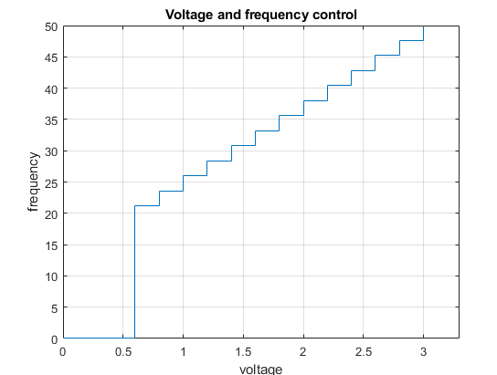  Resources  Components  Additional Notes  Results
Date:  14/06/2024 | Dead Time Generation | Resources  Components  Additional Notes  Results  Simulation  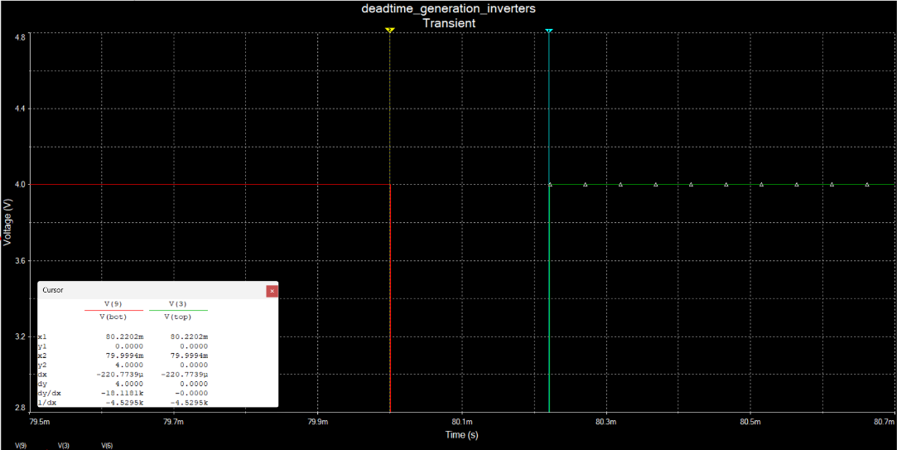  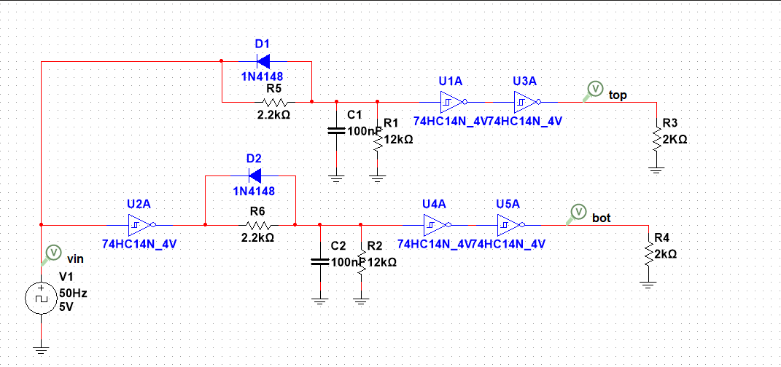  Increased the Deadtime to 200us, since the inverter frequency low  Used 100 nF capacitor
Date:  17/06/2024 | Topic  Debugging Bias circuit (3.3V bias voltage)  What went wrong with LM2576T?  Task  Research  Study  Implementation | Resources  LM2576-5 buck converter overheating advice. - Page 1 (eevblog.com)  Components  Notes  LM2576T heats up, with very little load  Once connected, it exploded  What's the total load?  IR2110  74HC14N  STM32F10  Does the total load exceed the rated IC current?  ----------------------  Is the MCU drawing too much current?  Is the voltage divider circuit drawing too much current?  Results  Wrong wiring in schematic
Date:  19/06/2024 | Topic  Buck converter Debugging  Task  Research  Study  Implementation | Using a safety capacitor with Buck  - EMI suppression capacitors are not used for power supply filtration.  Buck Converter Capacitor considerations  - Capacitance Value  - Capacitor Type: Ceramic (X7R or X5R) with low ESR and ESL  What’s the voltage and current passing through the gate diode  Resources  Components  Additional Notes  In the Initial Design I used the wrong Value of Capacitor 19/06/2024 10:42  The buck converter operates normally with low resistive loads, but does not when it's hooked to an inductive load.  The mosfet switching is inconsistent. Tends to skip switching cycles.  The Buck lacks decoupling capacitors  Proper isolation and decoupling between the buck converter and the inverter are crucial to prevent interference and ensure stable operation. Let's delve into how to achieve this:  GPT  /*  1. Decoupling Capacitors  Decoupling capacitors are used to filter out high-frequency noise and provide a local reservoir of charge to stabilize voltage levels.  Placement: Place decoupling capacitors as close as possible to the power supply pins of both the buck converter and the inverter.  Types and Values: Use a combination of different capacitors to cover a broad frequency range. Common values include:  Ceramic Capacitors: 100 nF, 1 µF, 10 µF  Electrolytic Capacitors: 100 µF or higher for bulk decoupling  2. Grounding Scheme  A proper grounding scheme is essential to avoid ground loops and ensure a clean signal ground reference.  Star Grounding: Use a single point (star ground) where all grounds from the buck converter and the inverter are connected. This minimizes ground loop issues.  Separate Ground Planes: If possible, use separate ground planes for the power and signal grounds and connect them at a single point.  3. Filtering  Add filters to suppress high-frequency noise and harmonics that might be coupling between the buck converter and the inverter.  LC Filters: Use LC filters at the output of the buck converter and the input of the inverter to attenuate high-frequency noise.  Ferrite Beads: Place ferrite beads in series with power lines to further reduce high-frequency noise.  4. Shielding and Layout  Proper PCB layout and physical separation can significantly reduce interference.  Physical Separation: Keep the buck converter and inverter circuits physically separated on the PCB to minimize coupling.  Shielding: Use shielding around critical components and signal traces if necessary.  5. Snubber Circuits  Snubber circuits can help dampen oscillations and protect components from voltage spikes.  RC Snubbers: Place RC snubbers across the switching MOSFETs in both the buck converter and the inverter to reduce switching noise and ringing.  Immediate Steps to Implement Isolation and Decoupling  Add Decoupling Capacitors:  Place a 100 nF ceramic capacitor and a 10 µF ceramic capacitor close to the power supply pins of the buck converter.  Repeat the same for the inverter.  Check Grounding:  Ensure all grounds from both stages meet at a single point.  Use a star grounding scheme.  Implement LC Filters:  Add an LC filter at the output of the buck converter (e.g., 10 µH inductor and 10 µF capacitor).  Add another LC filter at the input of the inverter.  Test with Load:  Test the buck converter with both resistive and inductive loads.  Verify stable DC output before connecting to the inverter.  */  Filtering  Pi Filter  - SoCs  - a high pass filter or a low pass filter  - 3rd order in nature and provide strong rolloff above the cutoff (~20 dB/decade).  - 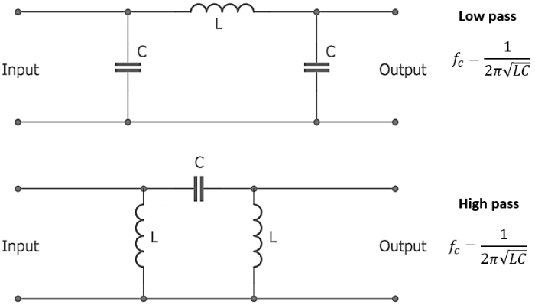  - We design for the ripple factor  - Ripple factor = (V_max -V_min)/V_output  - Ripple factor depends on the load  - 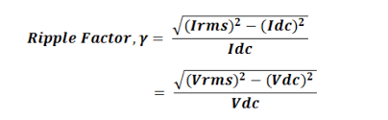  - The power remains constant, but the other variables change; that is the voltage, current and the current varies with varying the load  Regulated power supplies  - Switched  - Linear  - The value of the ripple factor depends on the Load R. For an unregulated power supply this is the load connected at the output.  - Ferrite choke as the inductor. ESR, Series resistor on the ferrite choke to dampen the ringing in these filters.  - They should be used with switched mode power supplies.  - Impedance matching: Matching the source resistance to the load  - Two ways to designing a PI filer:  - the cutoff frequency  Results  Pulsating output.
Date: | Topic  Power Supply Design  Task  Research  Study  Implementation | Resources  tidm559.pdf  PMP30446 reference design | TI.com  Components  UCC28051DR  UCC21220AD  UCC2871x Constant-Voltage, Constant-Current Controller With Primary-Side Regulation datasheet (Rev. C)  Additional Notes  Results
Date:  21/06/2024 | Topic  Power Supply Design  Task  Research  Study  Implementation | Resources  Power supplies  TI Reference Designs Library  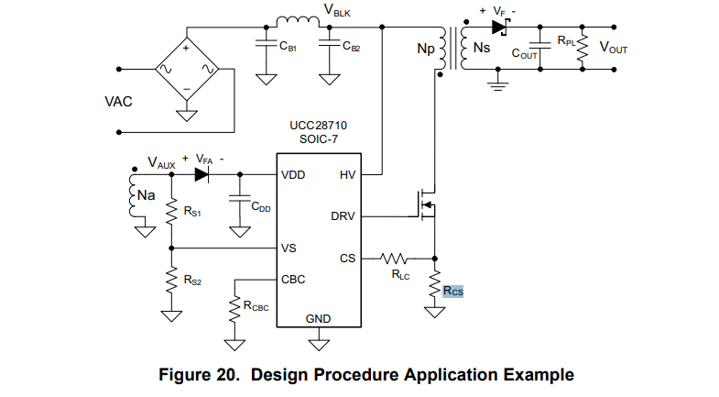  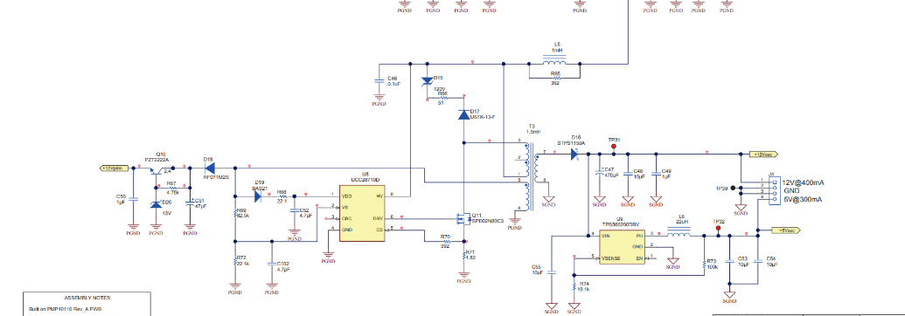  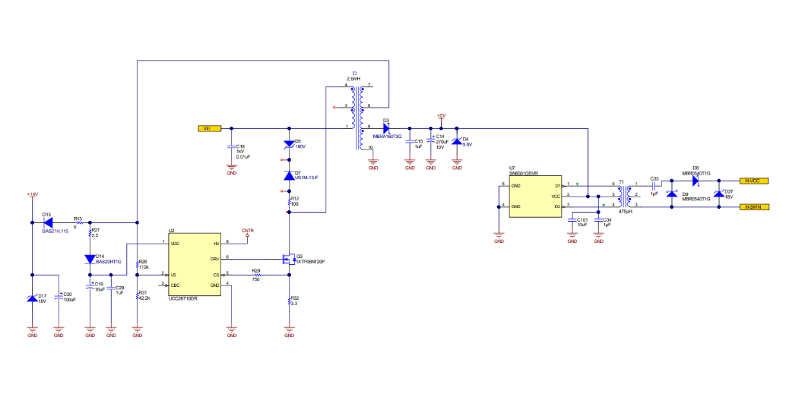  PMP10110 Rev_D Schematic.PDF  PMP10110 reference design | TI.com  *PMP20122_AssemblyRelease (ti.com)  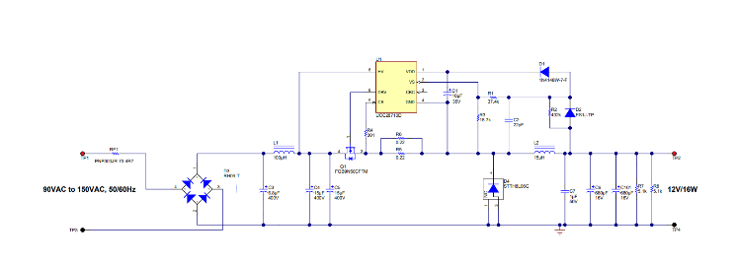  Buck converter  Components  Additional Notes  flyback power supply controller  Can I find a reference design that can give me exactly 15V?  Yes  Can I buy the kind of Transformer that I need?  https://www.mouser.vn/datasheet/2/447/P846-2902981.pdf  Results  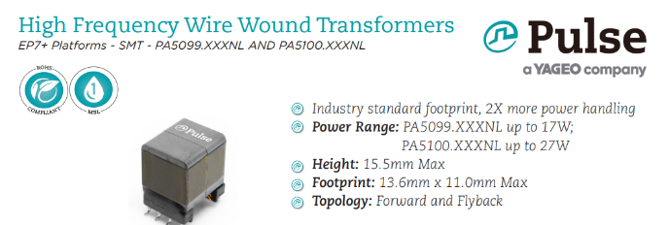  Input Voltage is: 33-57v  https://www.mouser.vn/ProductDetail/Wurth-Elektronik/750343068?qs=qSfuJ%252Bfl%2Fd5S1vXLpvktrw%3D%3D  ------------------------------------------------------------------------------------------------------------------  Flyback Transformers  No Description Primary Voltage Rating Secondary Voltage Rating Power Freq kHz  750312495 750 uH 21.6 W 85 VAC to 265 VAC 12 V 21.6 W 100  750311771 400 uH 45 W 157 V to 629 VAC 15 V 45 W 60 - 400  750311715 224 uH 30 W 94 VAC to 940 VAC 15 V 30 W
 | Power Supply Design  350V - 15V-3V  -----------------------------  - Smallest packages I am going for are 0603  - Buying according to stock | References  https://www.ti.com/lit/df/tidrak4/tidrak4.pdf?ts=1719046893456  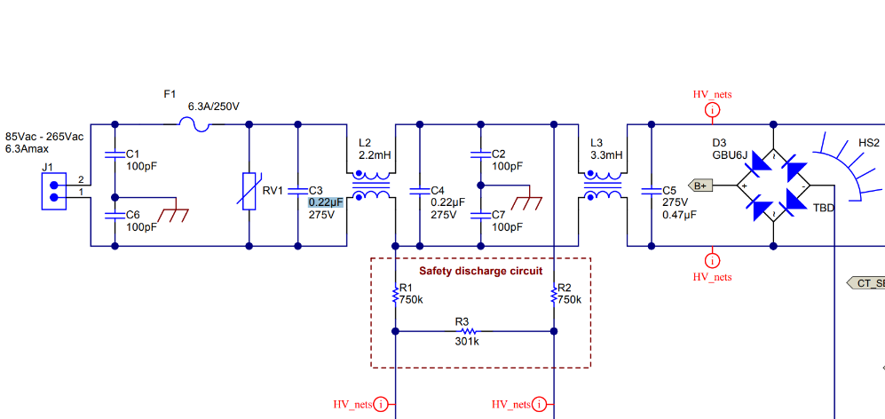  CMC is used when AC/DC  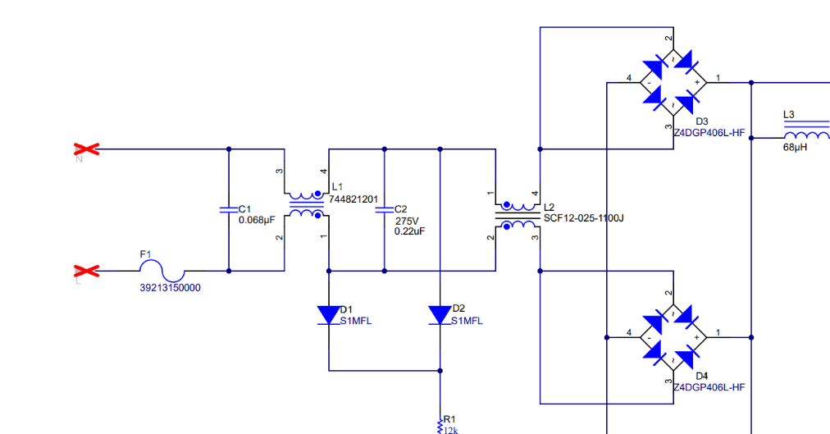  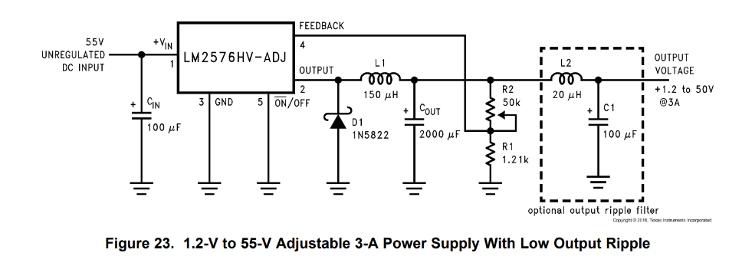  L2: 11mH, 250V  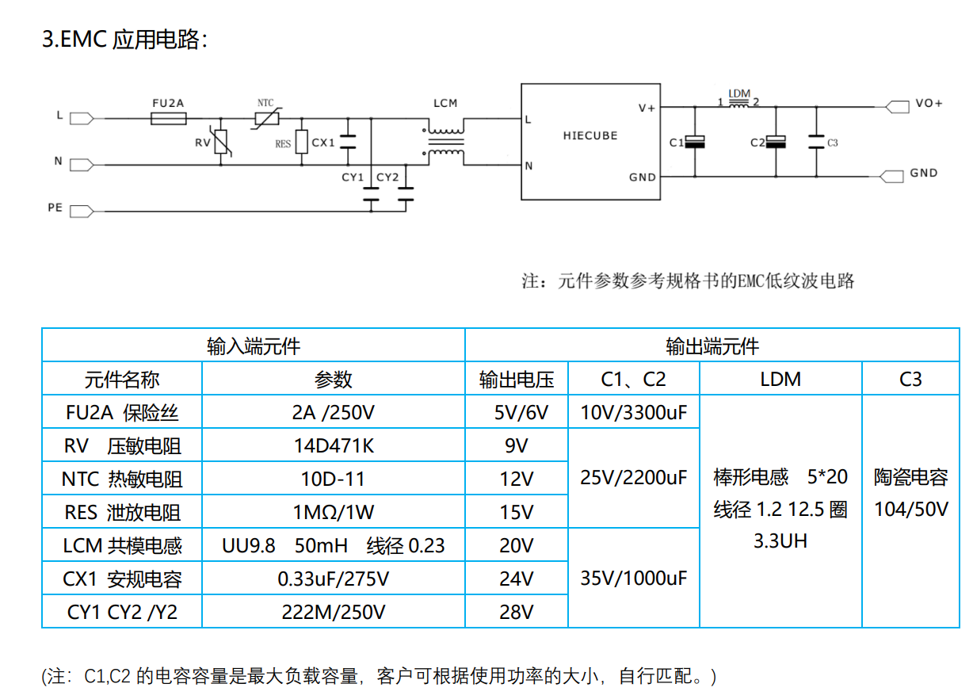  BPWX 0.5-14-33 BIAS Power | Mouser Vietnam  PMP41037_ControlE1(001)_Sch.PDF  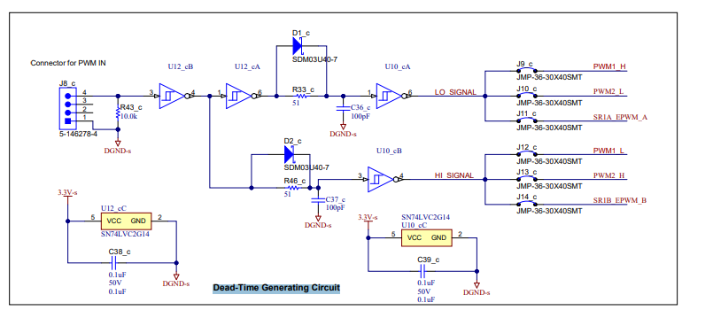  Power Line inductors  Cutoff frequency  Current  Result  15V  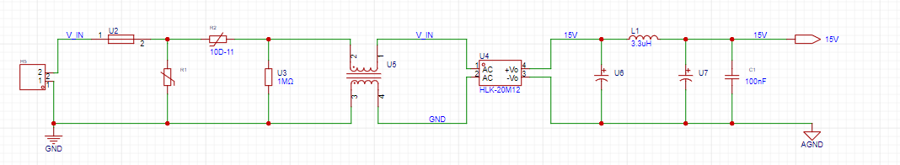  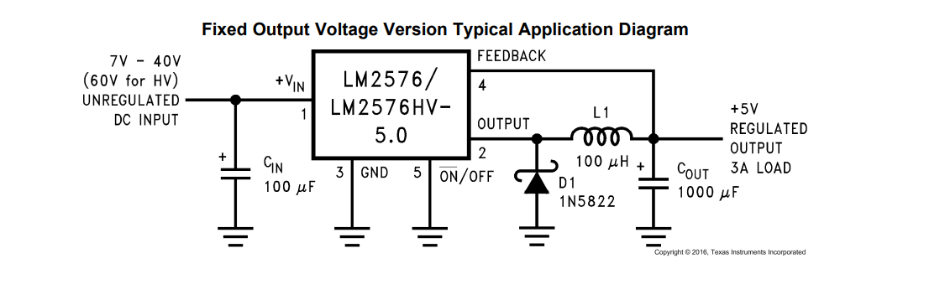  3.3V  Using a buck converter  Isolated 3.3V  SN6501: 350 mA  TPSM84209 data sheet, product information and support | TI.com  Ca be used to get 3.3V with minimal componets  ------------------------------------------------------------  Gonna use the IC I have lm2576-3.3V  LM2576T-ADJ/NOPB Texas Instruments | Mouser Việt Nam  Passive componets  Inductor  470uH  1A  YPRH1209-471M | YJYCOIN | Power Inductors | JLCPCB  1N5822 | MDD(Microdiode Electronics) | Schottky Barrier Diodes (SBD) | JLCPCB  C_in  CC0603KRX7R9BB104 | YAGEO | Multilayer Ceramic Capacitors MLCC - SMD/SMT | JLCPCB  Bulk cap  RT1A102M0810 | ROQANG | Aluminum Electrolytic Capacitors - SMD | JLCPCB  AC Filter w  Components  37013150000 | Littelfuse | Fuses | JLCPCB  TIDA-050074 Schematic  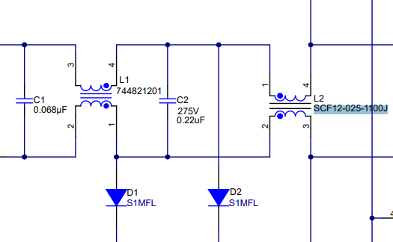  Footprint check  744822301 Datasheet WE-CMB Common Mode Power Line Choke (we-online.com)  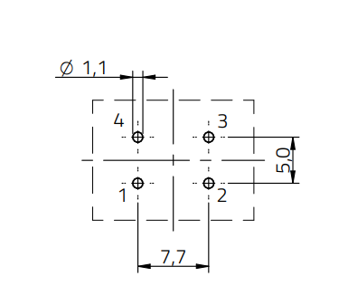  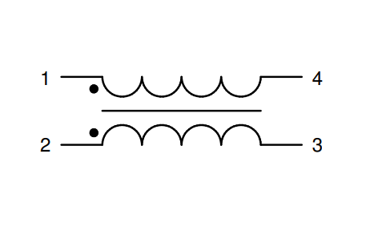  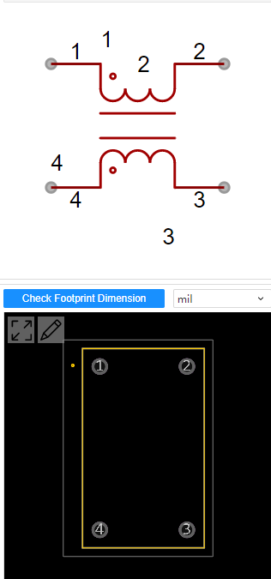
24/06/2024 | Bulk Capacitor Selection | 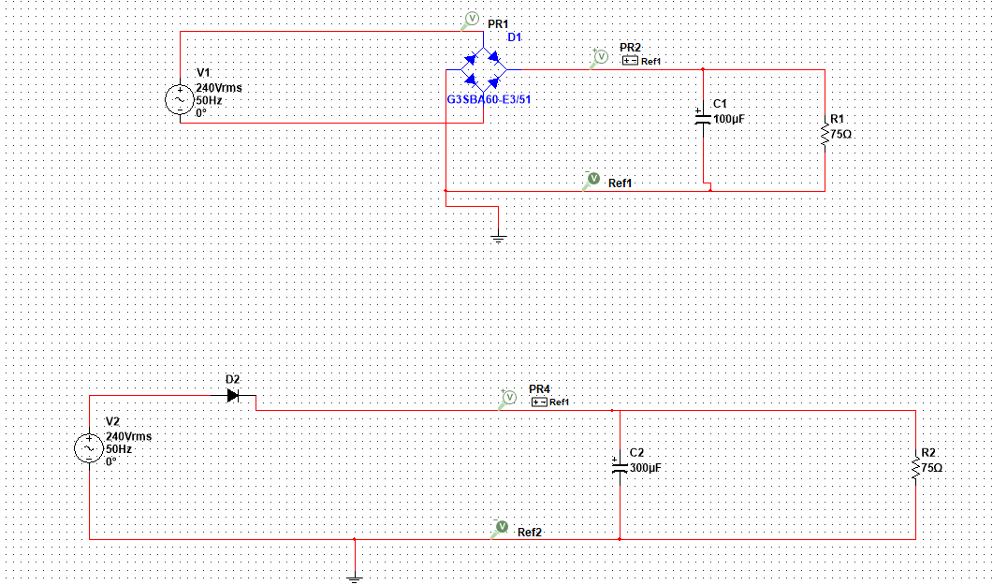  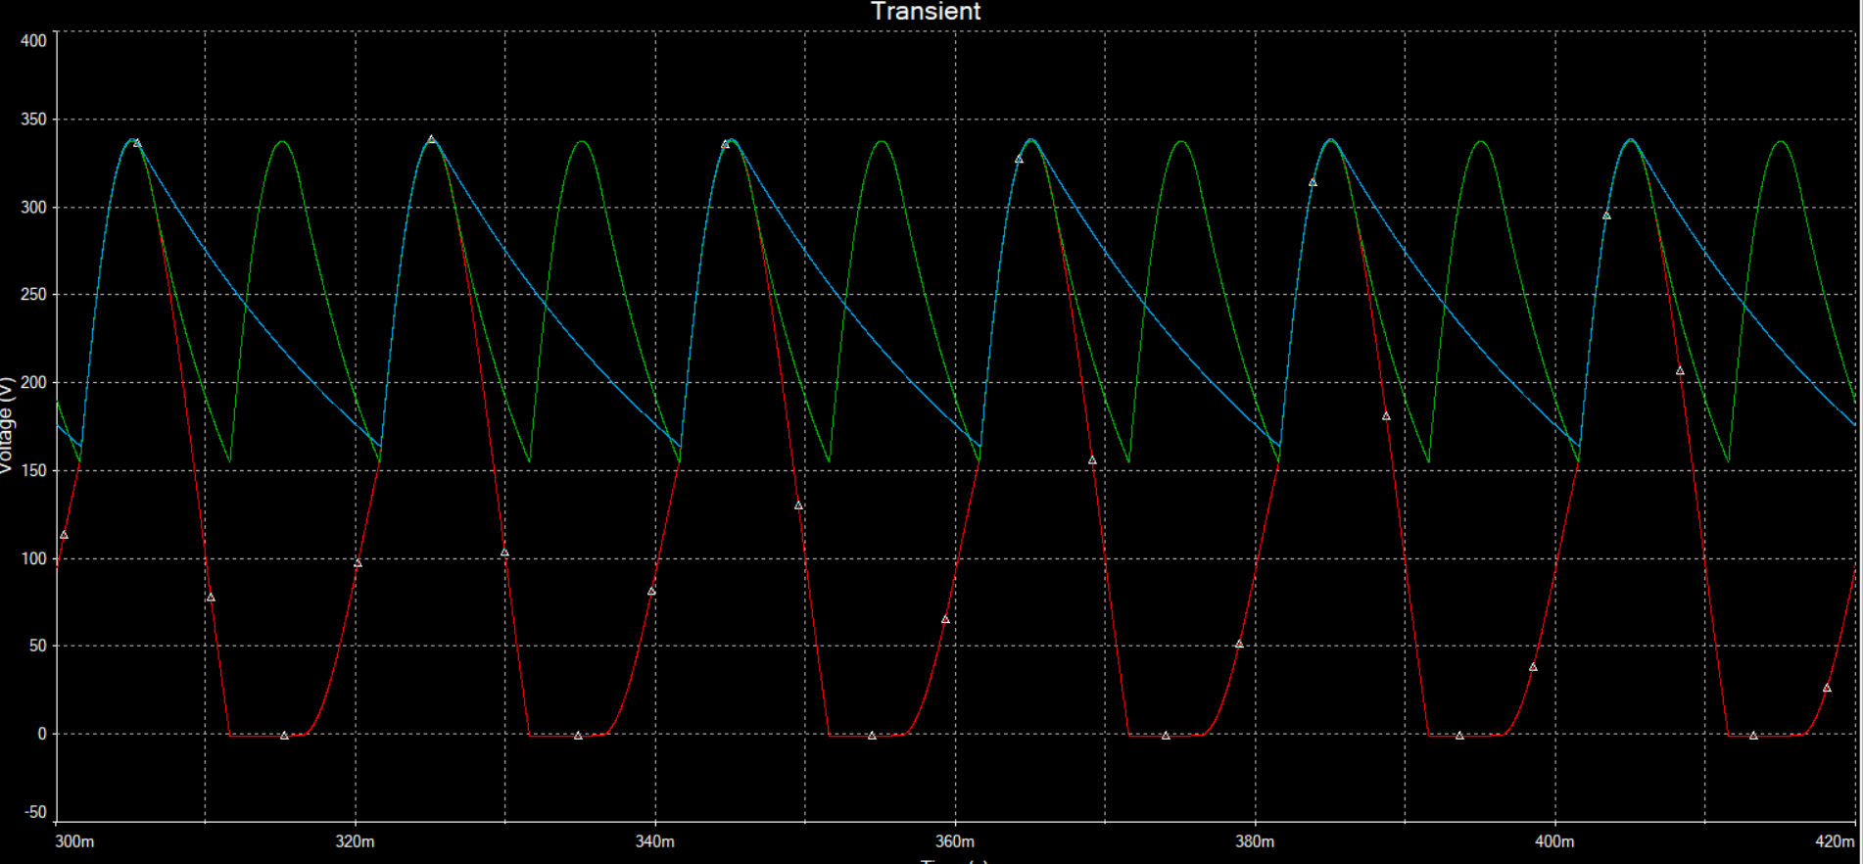  Bulk Capacitor Calculation  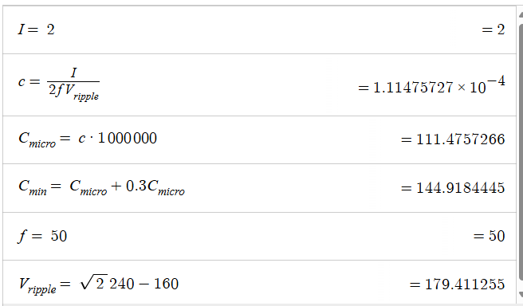  Cap >150uF
 | Voltage Sensing Circuit Design | Voltage Sensing Circuit  Resources  AMC1311x High-Impedance, 2-V Input, Reinforced Isolated Amplifiers datasheet (Rev. C) (ti.com)  -----------------------------------------------------------------------------------------------------------------------  في المختبر: 95- صنع دائرة منافسة (Isolated Voltage Sensor)    Video Notes  LV25-p sensor  - High V in - low V out  - +, - power supply  - Ac output voltage -> voltage shifting  AMC12XX isolated amplifiers features  - High in low out  - 250mV in  - Fixed gain  - Frequency bandwidths  - 8x gain  - Level shift  - Output is shifted according to the VDD  - If 5VDD, output is 2.55V  - If 3.3VDD, output is 1.29V  Isolated Power supply  - 5V in, 5V out  Schematic  - 10X 1X amplification option  - 3.3V, 5V option  - 3.3V regulator to step down 5 - 3.3V- switch seleciton  - Big componets for testing  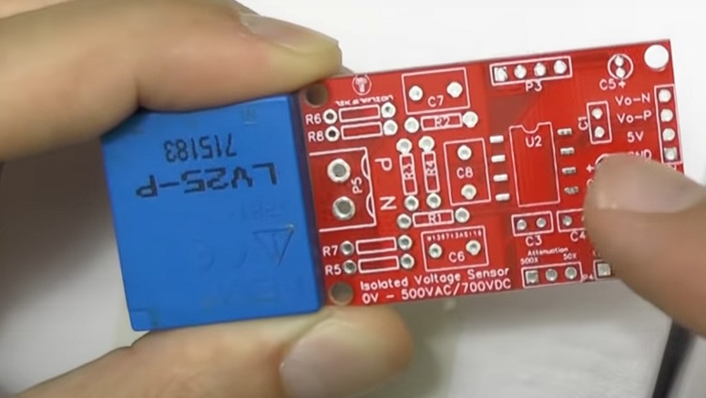  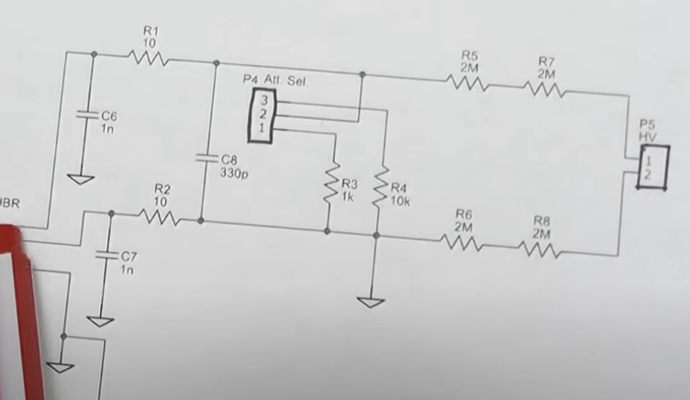  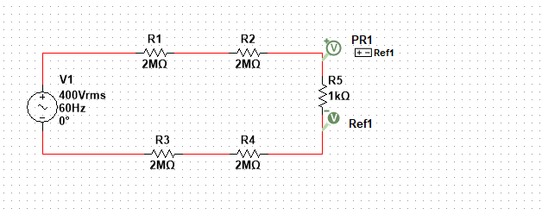  ----------------------------------------------------------------------------------------------------------------------  TIDA-010054 reference design | TI.com  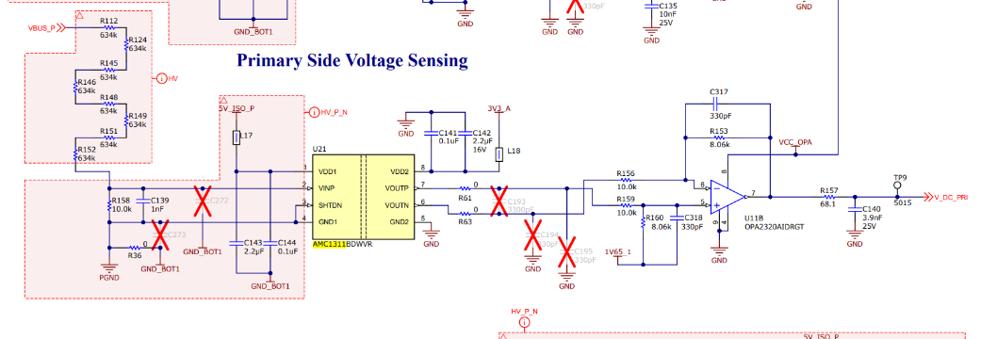  -----------------------------------------------------------------------------------------------------------------------------  AMC1113 Datasheet  Missing high side indication  100 mW  Keep input voltage below 2V  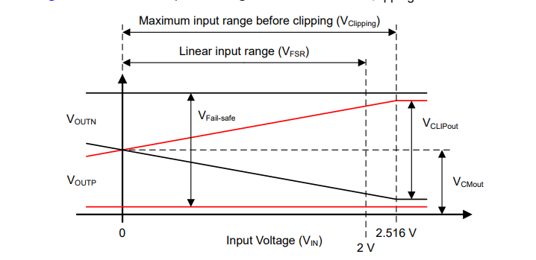  Output common-mode voltage VCMout 1.44  If the input voltage exceeds the abs max rating, the current must be limited to the max value  Current shouldn't exceed 10mA, V  The maximum continuous input current for the IN pin, as specified in the Absolute Maximum Ratings section, is ±10 mA.  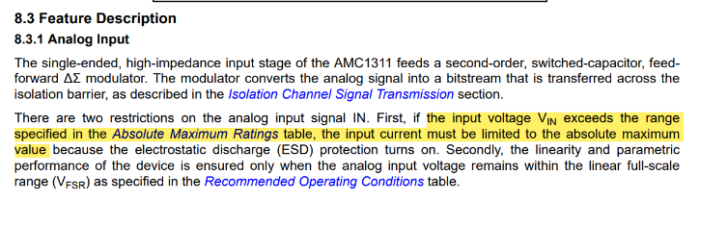  ----------------------------------------------------------------------------------------------------------------------------------------------------------------------  Circuit Design  Multilayer Ceramic Capacitors MLCC - SMD/SMT | Capacitors | JLCPCB Assembly Parts Library  16V 1uF X5R ±10% 0603  CL05B104KO5NNN 100nF 0603 X7R  CL10B105KA8NNNC 1uF 0603 X7R  CC0603KRX7R9BB101 50V 100pF 0603 X7R  Resistors  C245367 125mW Thick Film Resistors 150V 665kΩ 0805  0603WAF2002T5E 75V 20kohm  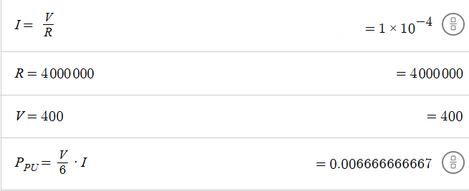  We have 6 resistors  Power per 1 resistor is 6mW  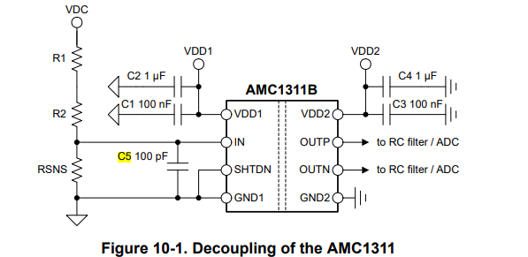  Side Notes  - "amplifiers" doesn’t strictly means amplifying it also indicated attenuation  - Shunt resistors  - Planer transformer  - PGND, SGND, GND  - Dual, precision, zero-crossover,  - Low ESR capacitors. X5R, X7R  - MLCC_2014_1_표지 (lcsc.com) solid supplier
 | Buck Design  - SWITCHING ELEMENT SELECITON  - Inductor Selection  - Inductor layout  - Diode Selection | Selection Criteria  V > 350  I > 3  MOSFET Selection  No V_DS I_D R(on) mΩ Gate Charge (nC) Tr nS t_d(on) t_d(off) t_f f(Mhz)  IRf730 400 5.5 1000 38 15 10 38 14 12  IPA60R280CFD7XKSA1 600 6 A 237 18 14 17 53 9 10  IMBG65R260M1H 650 6 A 346 22 5 5.3 7.7 13 32  IRF730 is sufficient for our current application. Switching losses is very high. Switching frequency is sufficient for this applicaiotn  ----------------------------------------------------------------------------------------------------------------------------  Inductor Selection  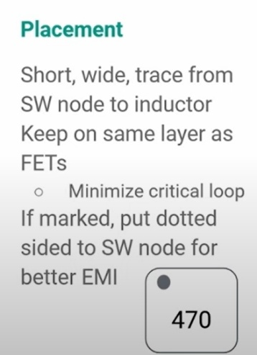  Board Layout application Notes for switching regulators  https://www.mouser.vn/ProductDetail/Schurter/DSO1-48-0001?qs=A5k8bsa1loCxJozGZre6sQ%3D%3D  Model Current Inductance  2319-V-RC 3A 390 uH  HCTI-390-5.0 5A 390 uH  --------------------------------------------------------------------------------------------------------------  Diode Selection  RHRP860  Diode meets the criteria  --------------------------------------------------------------------------------------------------------------  How to design the power supply circuitry to garaurntee proper isolation?  3.3V power supply to MCU, AGND  15V  RO153.3S  ----------------------------------------------------------------------------------------------------  Protection Circuit  Fuse  Varistor Selection  Model Continuous DC voltage Varistor Voltage  100 V >100V  V120MA2S 102 120  MOV-20D121K 100 120  V120ZA20P 102 108  ----------------------------------------------------------------------------------------------------  Bulk Capacitor selection  Criteria: size voltage and capacitance  Gate Diode & Gate Resistor  Voltage 15V, fast switching, fast recovery  Bootstrap Diode  https://www.mouser.vn/ProductDetail/Diodes-Incorporated/MURS160-13-F?qs=hiZRsJxw0h10uqIKGq7eFw%3D%3D
 | Circuit Review | Power Supply Design  V_in  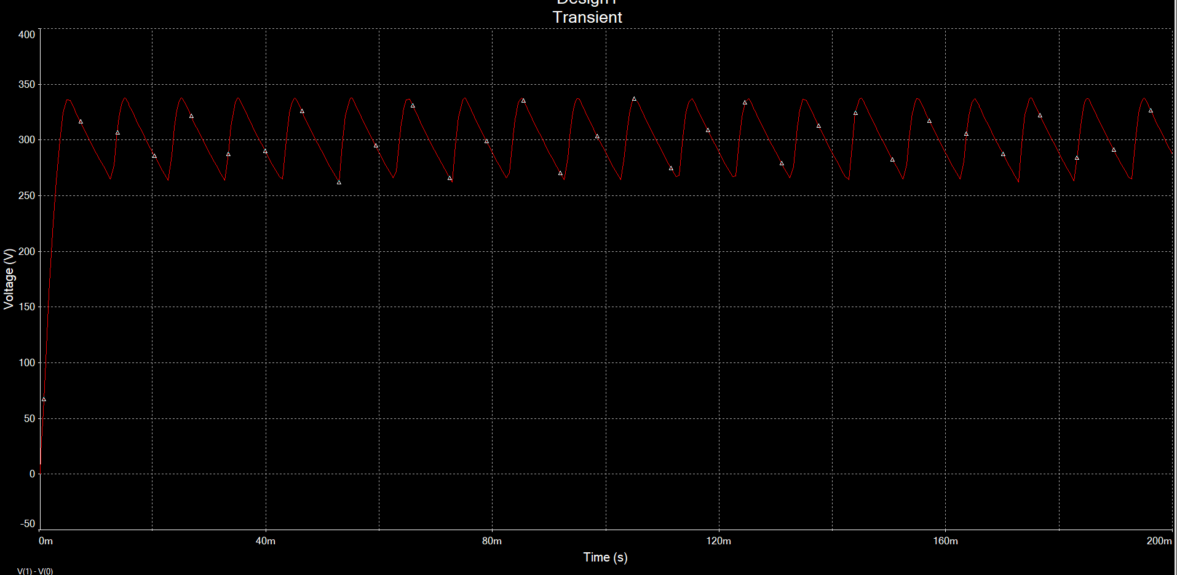  V_in min 250  V_in max 350
01/07/2024
 | - Bleed Resistor Calculations  - Set Selection Criteria  - Select IC | Bleed Resistor Selection  Calculations  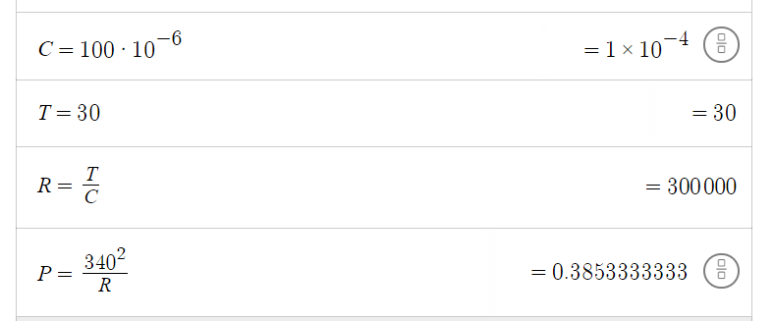  Criteria  T= 30S  C=100uF  R= 300kohm  P>1W  Resistor Resistance Power rating Voltage Rating  ERJ-UP6D3003V Panasonic | Mouser Vietnam 300k 500 mW 400 V  ERJ-UP8F3003V Panasonic | Mouser Vietnam 300 kOhms 660 mW 500 V  RN65D3003FB14 Vishay / Dale | Mouser Vietnam 300 kOhms 500 mW (1/2 W) 350 V  H4P300KFZA 300 kOhms 1 W 500 V  PR02000203003JR500 Vishay / BC Components | Mouser Vietnam 300 kOhms 2 W 500 V  ------------------------------------------------------------------------------------  Select  CRCW251260K4FKTG Vishay / Dale | Mouser Vietnam  ------------------------------------------------------------------------------------
02/07/2024 | Gate Diode Selection | NSR0320MW2T1G onsemi | Mouser Malaysia  Gate Resistor
 | Prototype 1 | DC/DC Calculations  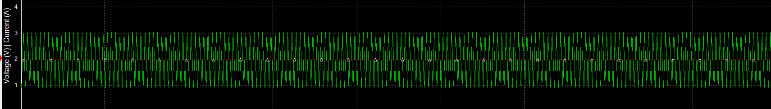  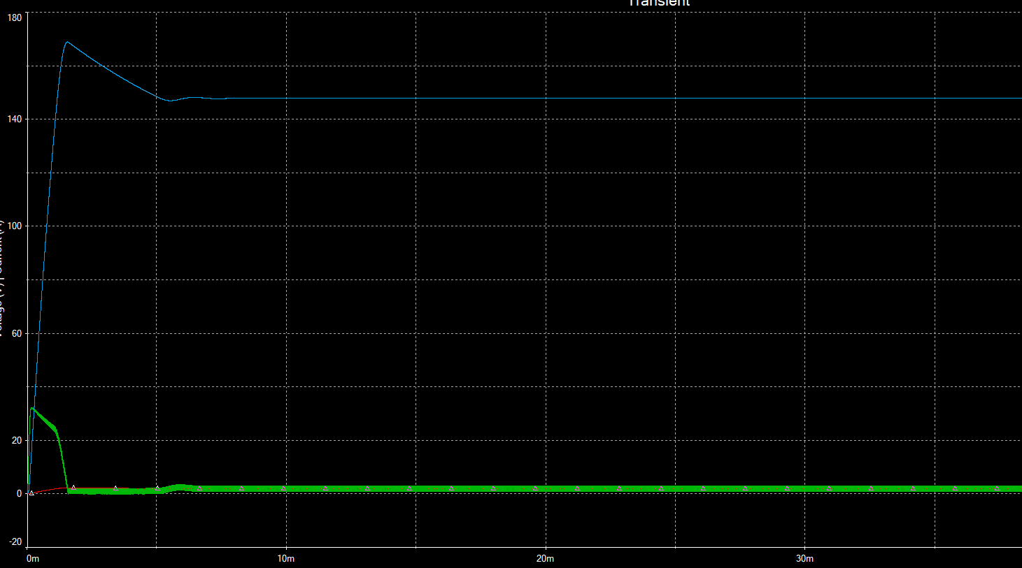  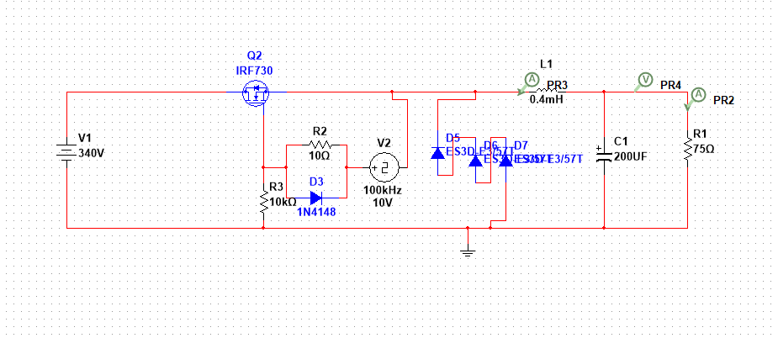  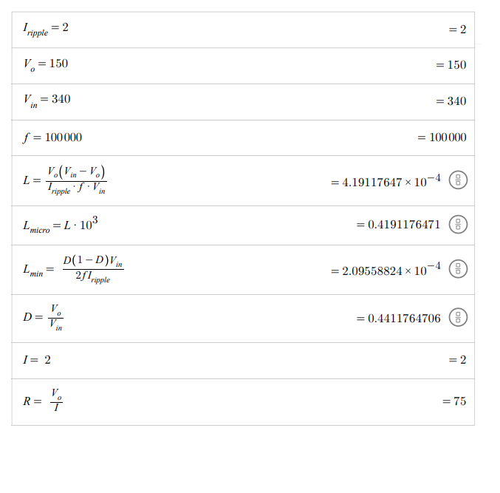  -------------------------------------------------------------  AC/DC & Power Supply Board
05/07/2024 |  | High Voltage deisng considerations  Understanding High Voltage PCB Materials    FR4 material  Fiber  Resin  Weave of the fiber  Higher resign material  More space less tight weave  Curing agent  Cphenolic  DICY  CTI  PLC  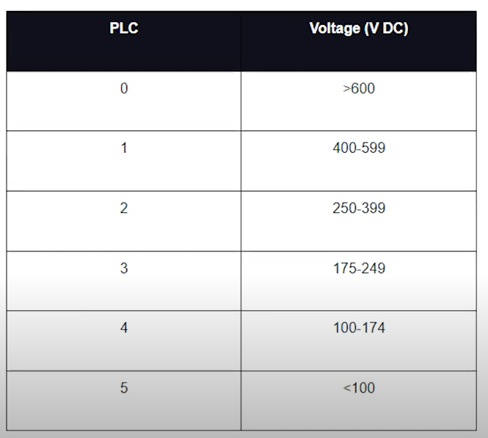  Deligniate  High frequency  Vs high voltage  CAF resistance  CTI Value  Material that has an approperiate CTI  CAF failue  You should build your own library  Size constraints  Layout is important  Ground Pour  Copper pour  Pour over the trace  Simulate a bus bar?  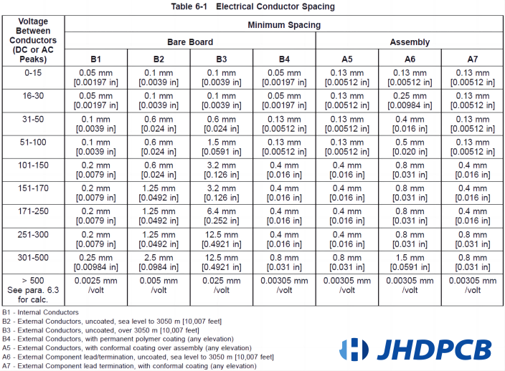  C3 coating  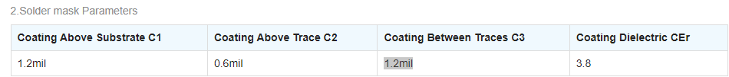  Spacing /Clearance  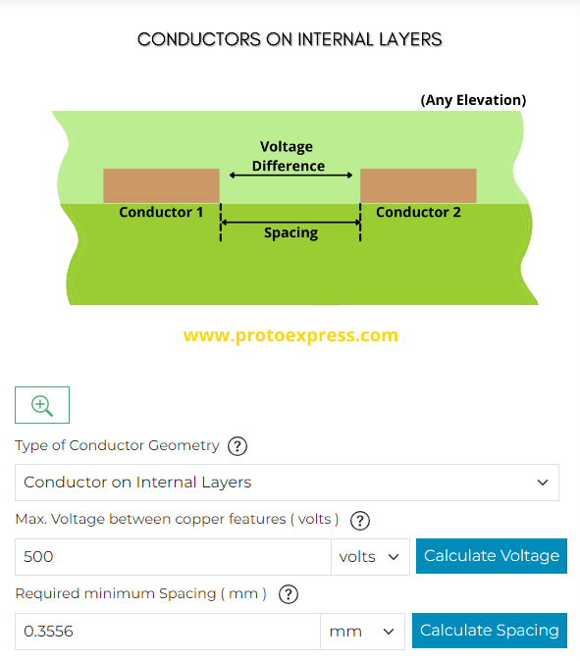  Trace width  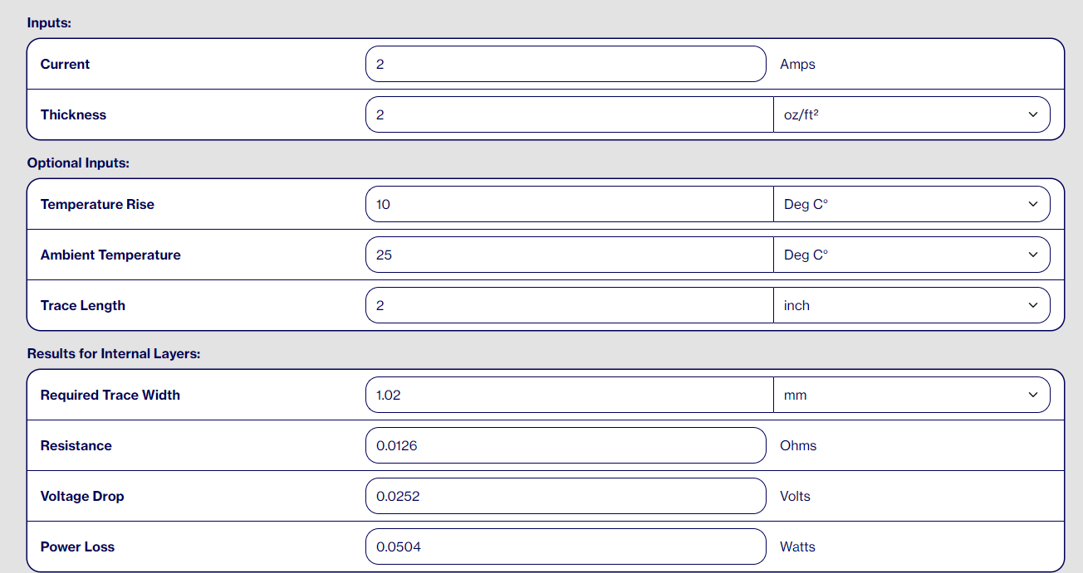  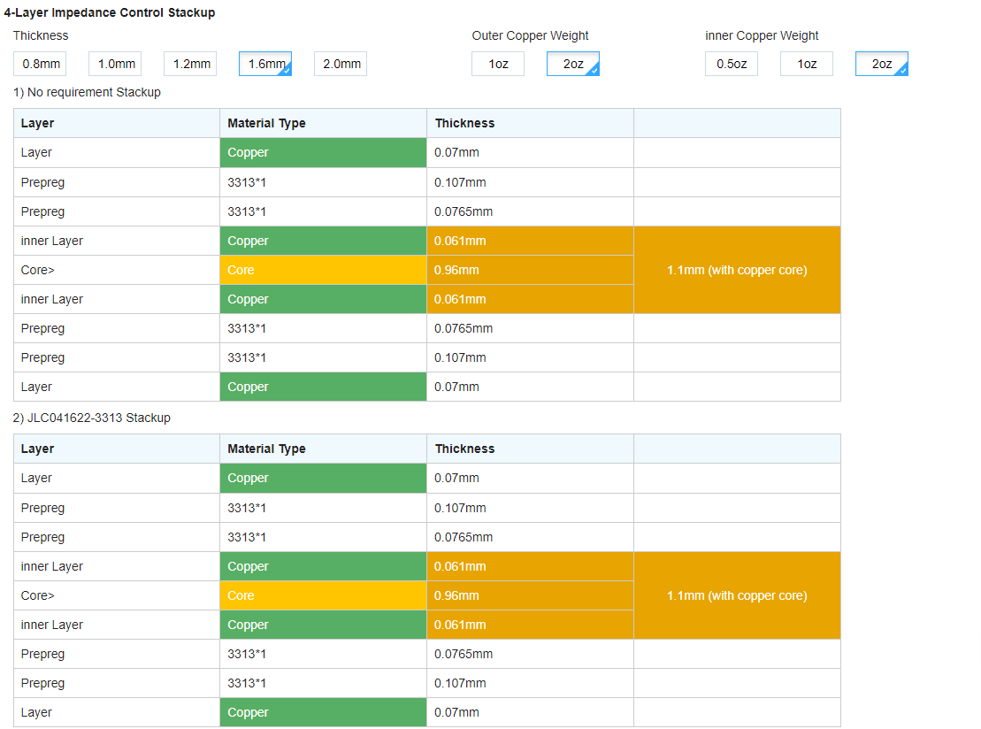  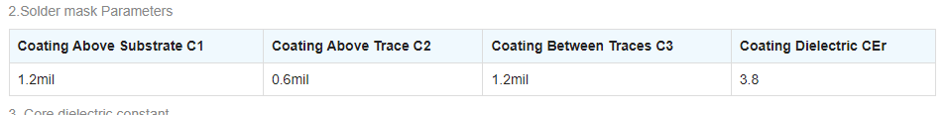  PCB Fabrication, Assembly, and Components | Sierra Circuits (protoexpress.com)  Trace Width Calculator | AdvancedPCB  Decided to keep the design onto one layer for simplicity, the board is a 4 layer board. There's redundancy
 | Control Circuit | Crystal  https://jlcpcb.com/partdetail/Yxc-X322525MOB4SI/C9006  https://www.mouser.vn/ProductDetail/RECOM-Power/R1S-3.33.3-H?qs=XF8hdbuHJAVie79Sg7ec0g%3D%3D

Inductor Selection

Inductors
Selection Criteria, in case you wanna buy it locally
Current > 3A
>250 uH
Designed for DC converter

Part Number | Saturation Current | Current | Inuductance
2218-H-RC Bourns | Mouser Vietnam |  | 3.3 A | 330 uH
PE-53117NL Pulse Electronics | Mouser Vietnam |  | 3 A | 330 uH
SHBC24W-2R1A0311V KEMET | Mouser Vietnam |  | 15 A | 311 uH
2100HT-221-V-RC Bourns | Mouser Vietnam |  | 3 A | 220 uH
2300HT-331-V-RC J.W. Miller | Mouser Vietnam |  | 5A | 330 uH
AIRD-03-331K ABRACON | Mouser Vietnam |  | 4.5 A | 330 uH
1433445C Murata Power Solutions | Mouser Vietnam |  | 4.5 A | 330 uH
PCV-2-105-02L Coilcraft | Mouser Vietnam |  | 2.3 A | 1 mH
-------------------------------------------------------------------------------------------------------------------------------------------------------------------------------

PCB layout

Zero ohm resistors to s
Start with the most important then place the secondary componets
Boot resistor placement doesn’t necessarily need to be close to the pin
Keep the ics with their componets close together. IMUss

------------------------------------------------------------------------------------------------------------------------------------------------------------------------------------------------------------------

Checking schematic

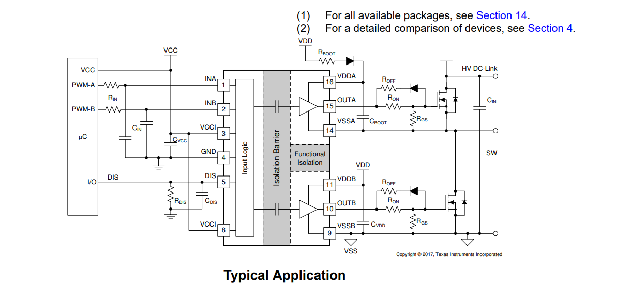

 | PCB Design Revision | - Traces, no sharp turns  - Traces carrying high currents should be sized appoperiately  - Traces carrying critical analog signals, should not run parallel to traces carrying fast changing signals. Due to noise issues  - Traces connecting inductors should not be wider than necessary  - Power plane on an internal layer  - 10 uF bulk capacitors, 100nF  - 1 decoupling cap for every power pin  - Delay lines for clock lines. Trance length equalization  - Timed relationship between multiple signals. e.g. routing high speed signal to multiple chips  - Inductors shouldn't be plaved too closely together  - Inductors shouldn't be plaved too close to large metalic objects.  - Power components shouldn't be plaved colse to each other  - The components associated with a switching regulator should be localized to a section of the PCB, far away from sections handing analog signals  - The AC section should be localized to one section of the board.  - A physical barrier seperating the ac from the rest of the borad.  - PCB solt seperating the 2 sections  - 4 layer boards. The Internal 2 layers should be the supply and the ground plane.  - If the design contains digital and analog sections. The ground should be split and only joined at one point. The power supply negative.  - Gound should connect at one point if we are using 2 layer boards.  - 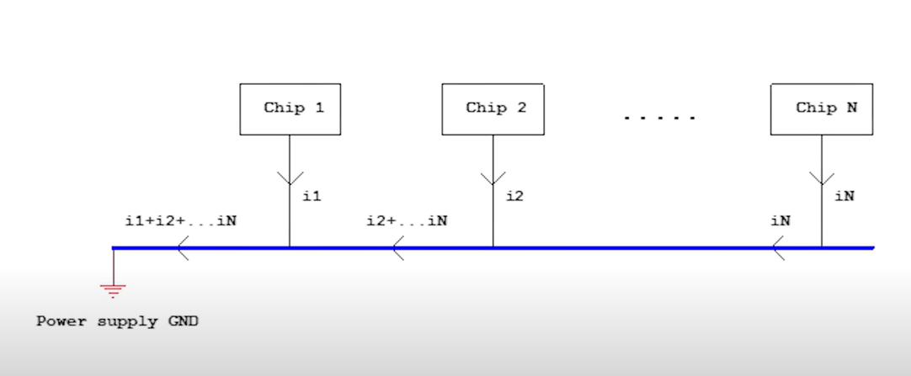  - Design for manufacturablility and design for testing  - Landing patterns. Print it out into 1 to 1 to see if matching. Order samples.  - Switching regulator layout rules  - Top 5 Beginner PCB Design Mistakes (and how to fix them)  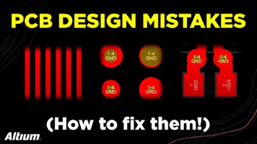  - Trace spacing > double check the DRE  - Keep clearcing wide.  - Cross coupling ?  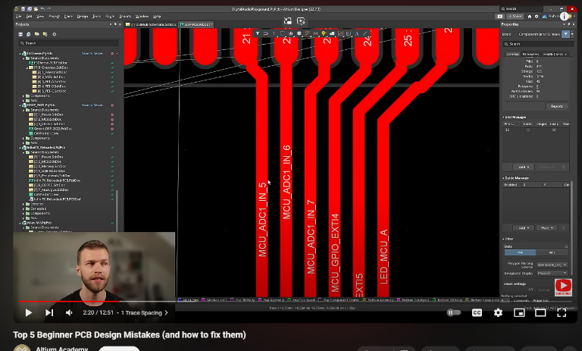 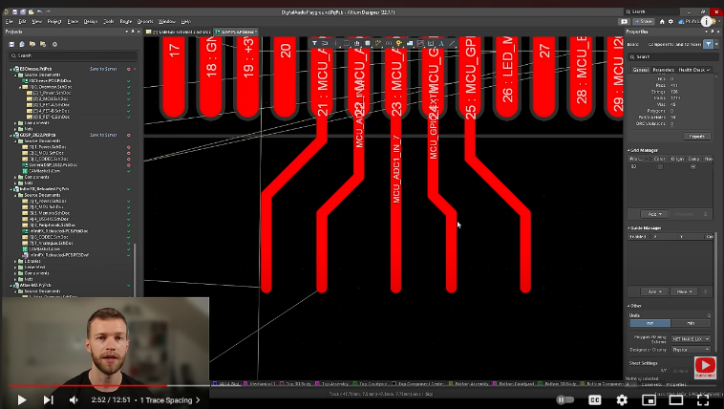  - Keep clearance 3X dilectric thickness of between the layers  - Keep parallel sigments between traces as short as possible  - High impedance trace is very sensitive to noise, to minimize any coupling to it, we keep the trace as wide as it needs to be  - For vias, 0.7, 0.3  - 0.5, 0.3  - Benefit of the capacitance of the plane  - 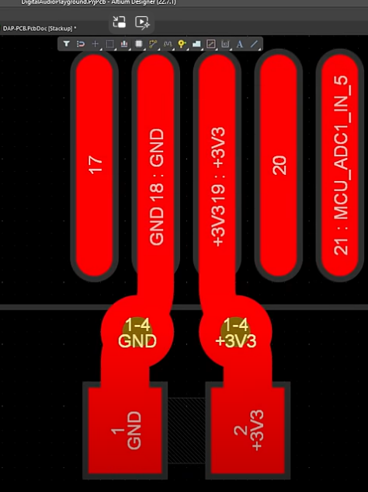  - Any signal trace should run adjacent to a reference (ground) or power plane  - 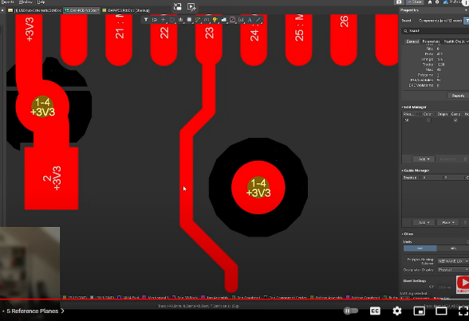  - Copper Thickness Deep Dive | PCB Manufacturing  
 | Preorder Review | AC/DC  Bleed Resistor updated  CMC wrong footprint  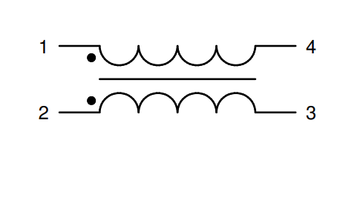  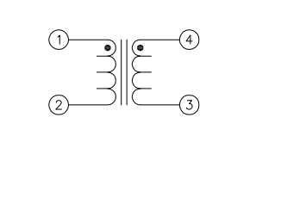  The difference?  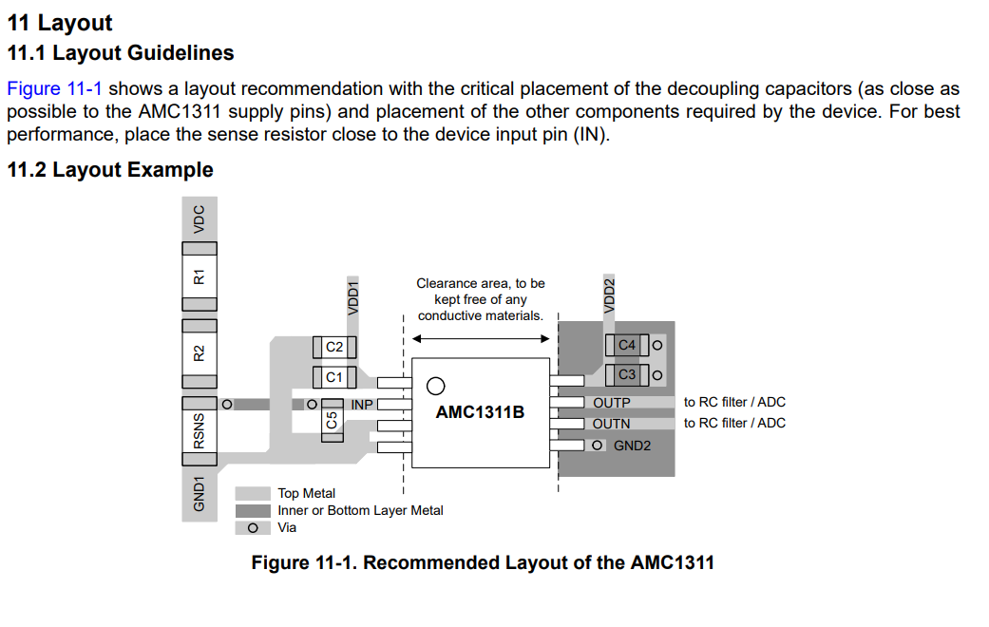  AMC requires 5V  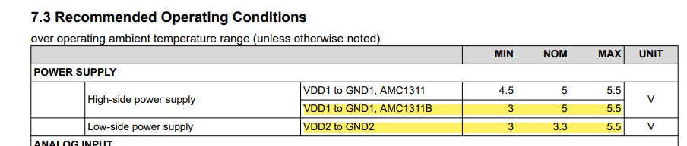  Modifying the power supply input voltage
 | Controller Design | Chat GPT  PID Control  Pros:  - Wide Usage: Well-understood and widely used in industry.  - Good for Steady-State Error Reduction: Can be tuned to reduce steady-state error effectively.  - Versatile: Can handle various types of systems with appropriate tuning.  Cons:  - Complex Tuning: Requires careful tuning of three parameters (Proportional, Integral, Derivative).  - Can be Overkill: Might be more complex than necessary if your system doesn't require high precision.  - Response Time: Not the fastest response time compared to simpler control methods.  2. Hysteresis Control  Pros:  - Simple Implementation: Easy to implement in a microcontroller.  - Fast Response: Very fast response time.  - Good for Switching Converters: Works well with switching power converters.  Cons:  - Variable Switching Frequency: Can cause electromagnetic interference due to the variable switching frequency.  - Noise Sensitivity: Sensitive to noise, which can affect performance.  3. Bang-Bang Control  Pros:  - Simplicity: Very easy to implement.  - Fast Response: Provides a very quick response.  - No Tuning Required: No need for parameter tuning.  Cons:  - Overshoot and Undershoot: Can cause significant overshoot and undershoot.  - Stress on Components: Can stress the power electronics due to frequent switching.  4. Model Predictive Control (MPC)  Pros:  - Advanced Control: Can predict future behavior and adjust accordingly.  - Optimal Control: Often results in optimal control performance.  Cons:  - Complex Implementation: More complex to implement and requires significant computational resources.  - Not Always Necessary: Might be overkill for simpler systems without stringent performance requirements.  Recommendation  For your application, I recommend starting with PID Control due to its balance between performance and complexity. It's widely used, well-documented, and provides good performance for a variety of systems. You can use tools like MATLAB or specific libraries to help with tuning the PID parameters.  If simplicity and fast response are more critical, Hysteresis Control might be a good alternative, especially for switching converters like a buck converter. However, be aware of the potential issues with variable switching frequency.  Would you like guidance on implementing any of these control algorithms in your microcontroller?  ------------------------------------------------------------------------------------------------------------------------------------------------------------------------  PID and Hysteresis Control seem to be a good fit  Investigate them further  PID Trial and Error Test  P  Stable  PI  Unstable  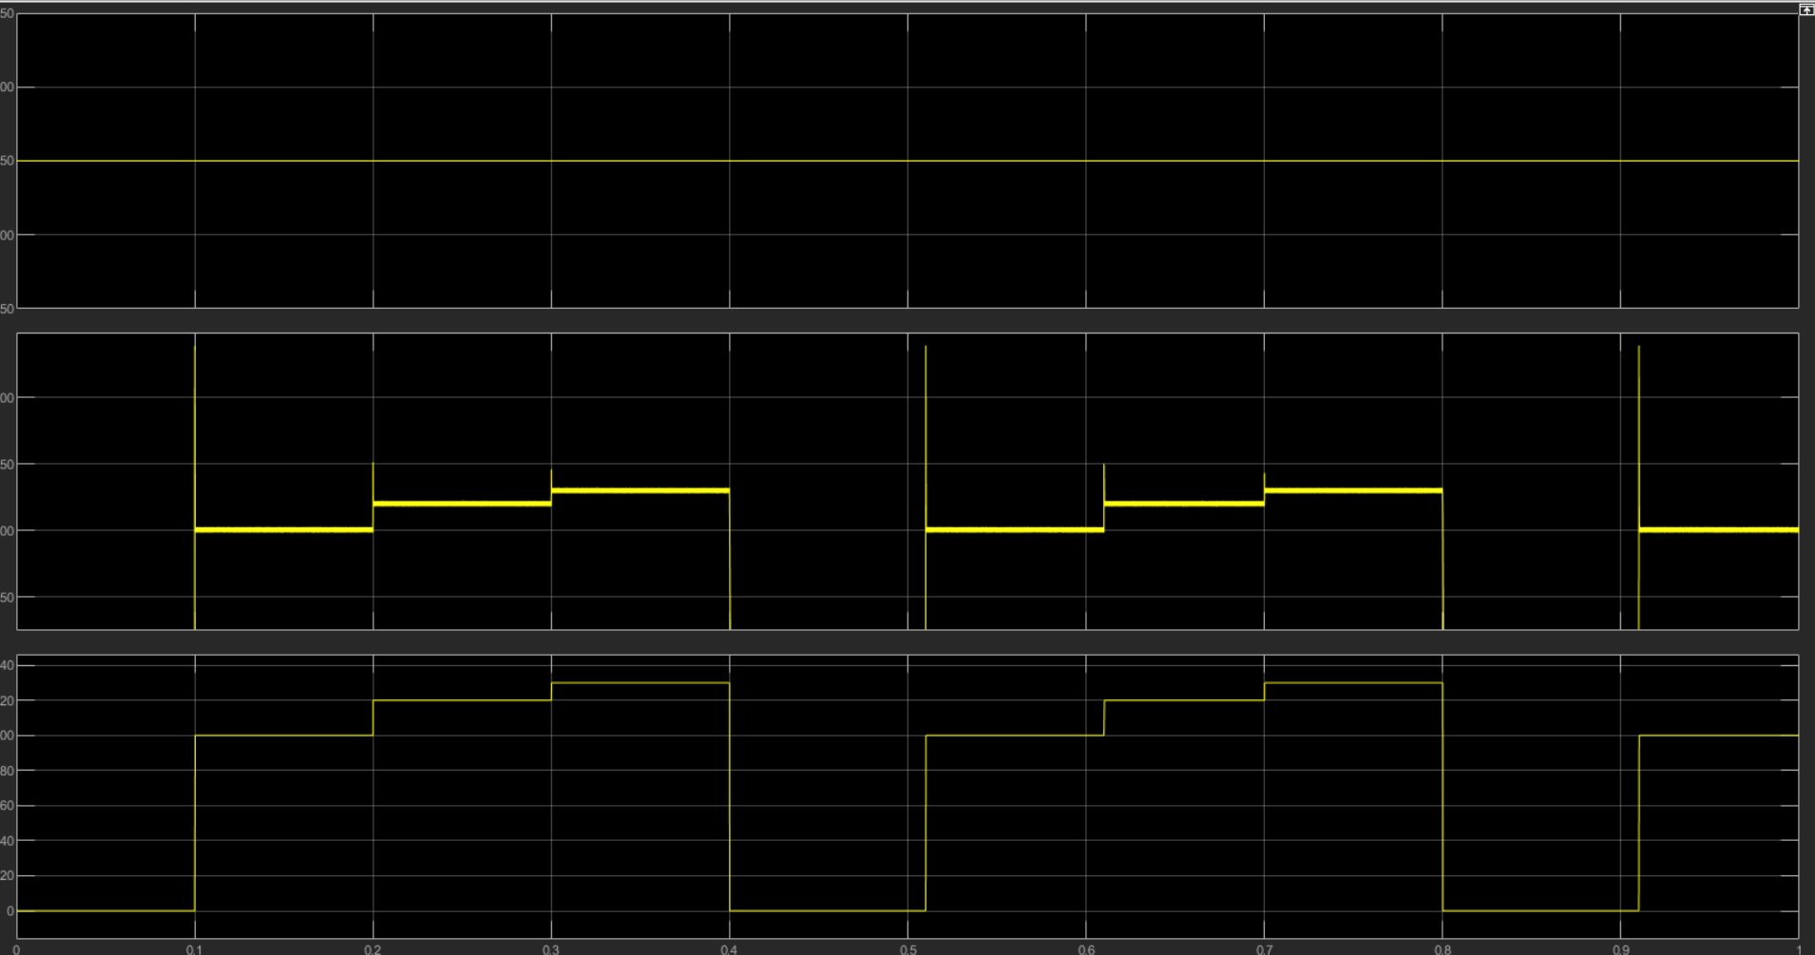  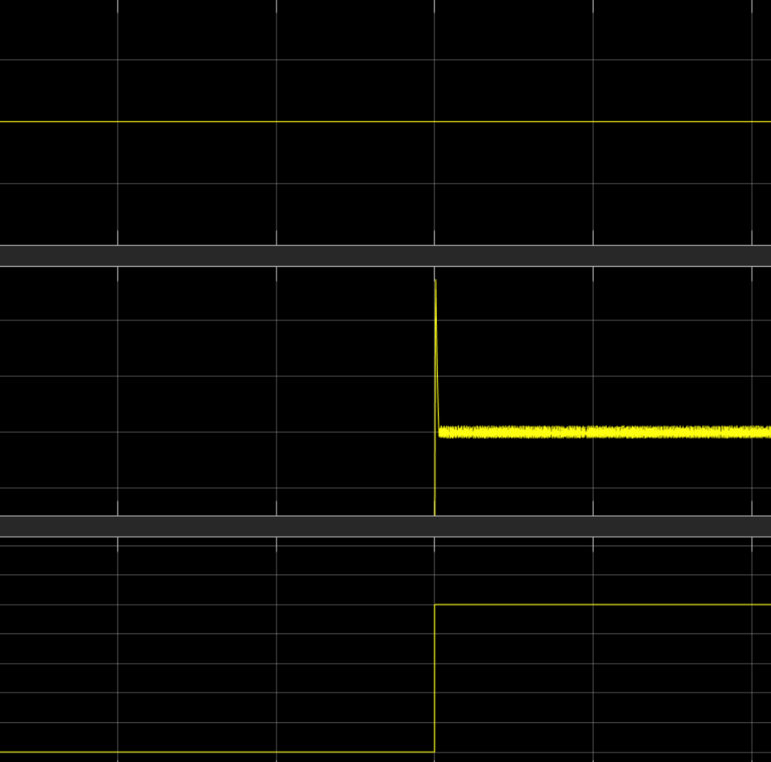  PID  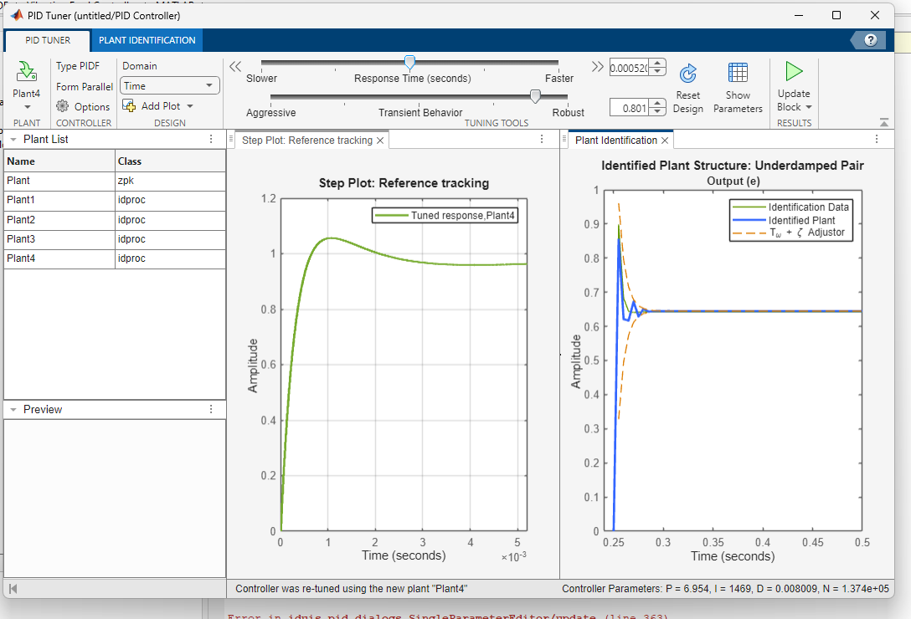  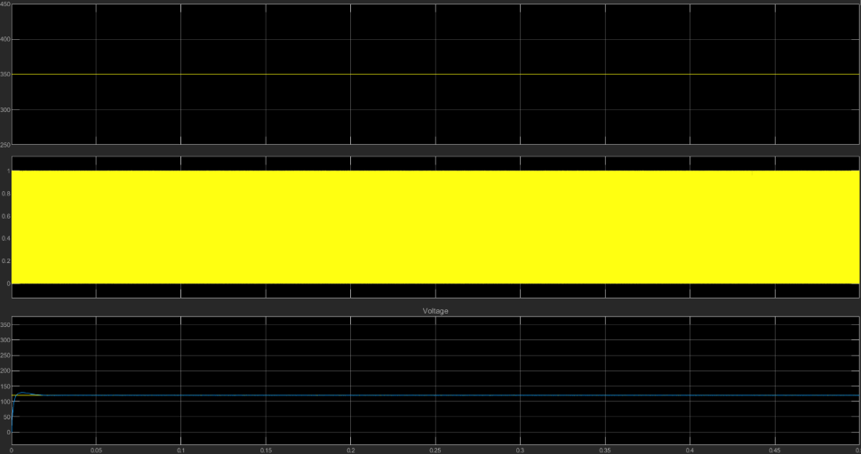  How to collect data from HW to PID Tune?
PID Controller Implementation in Software - Phil's Lab #6

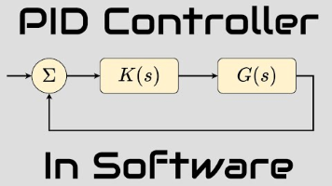

A real control system - how to start designing

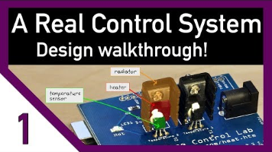

To design a buck converter using a PID controller with a “Hardware in the Loop” approach, you can follow these generalized steps based on the video:
  - Understand the System:
  - Identify the key components: buck converter, PID controller, sensors, and actuators.
  - Understand the physics and dynamics of the buck converter, including input voltage, output voltage, and load conditions.
  - Set Up the Hardware:
  - Use a microcontroller (e.g., Arduino) to manage the sensors and actuators.
  - Connect the buck converter to the microcontroller and set up the necessary sensors to measure output voltage and current.
  - Initial Testing:
  - Perform open-loop tests to understand the system’s response to different input conditions.
  - Record the step response of the buck converter to a given input voltage.
  - Develop a Mathematical Model:
  - Use the recorded step response to create a first-order plus dead time (FOPDT) model of the buck converter.
  - Identify the gain, time constant, and delay of the system.
  - Design the PID Controller:
  - Implement a basic PID controller in software (e.g., MATLAB or Python).
  - Use the FOPDT model to tune the PID parameters (P, I, D) for optimal performance.
  - Hardware in the Loop Testing:
  - Run the PID controller on your main computer and send commands to the microcontroller.
  - Monitor the buck converter’s response and adjust the PID parameters as needed.
  - Iterative Refinement:
  - Continuously test and refine the PID controller using the hardware setup.
  - Address any discrepancies between the model and the actual hardware performance.
  - Final Implementation:
  - Once satisfied with the controller’s performance, implement the PID controller directly on the microcontroller.
  - Conduct final tests to ensure stability and performance under various operating conditions.
By following these steps, you can effectively design and implement a PID controller for a buck converter using a “Hardware in the Loop” approach.

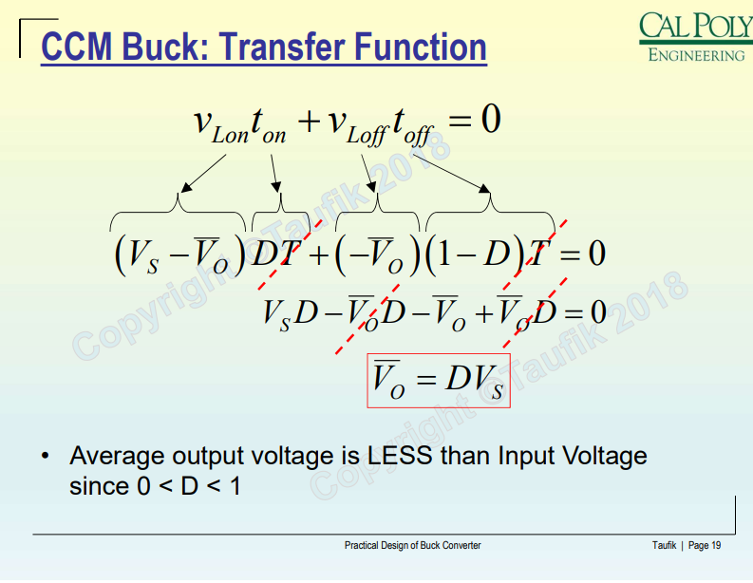

How to Model a Synchronous Buck Converter

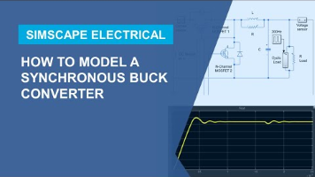

Linearizing Simulink Models


https://www.youtube.com/watch?v=VQ3Er89Mwa8&t=1s&ab_channel=katkimshow

 | System Modelling and Linearization | DC-DC Converter Control: Modeling  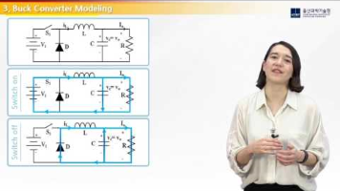  https://www.youtube.com/watch?v=aa5M1HiM7Ac&t=86s&ab_channel=katkimshow    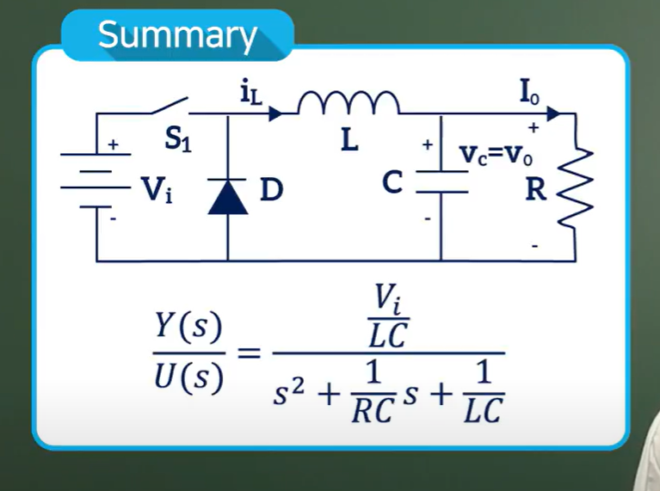
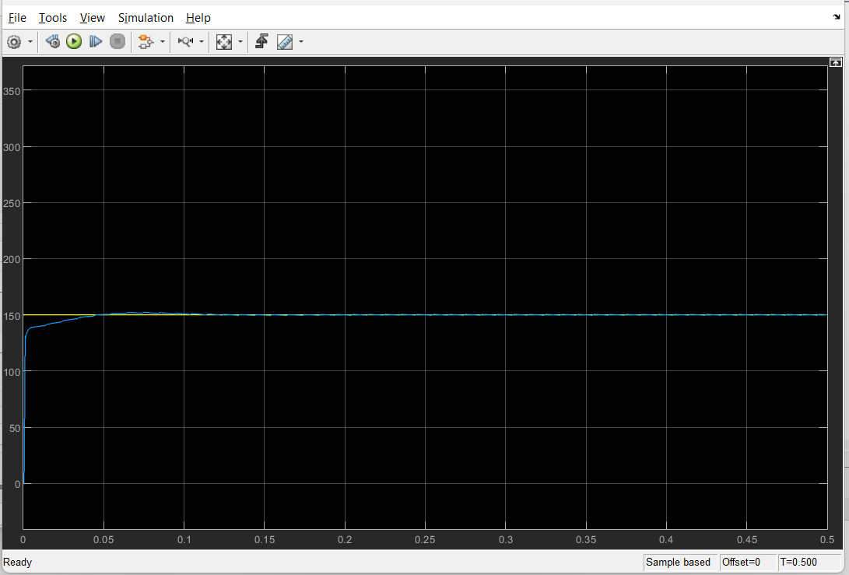

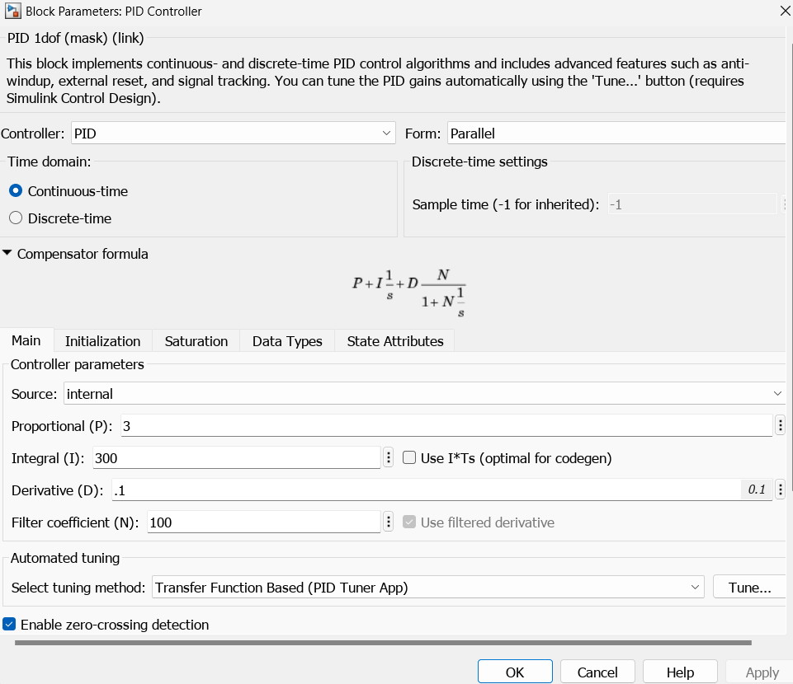

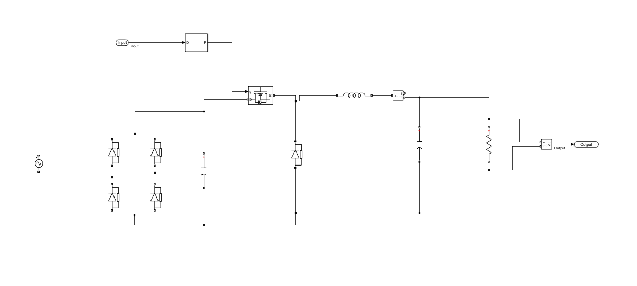

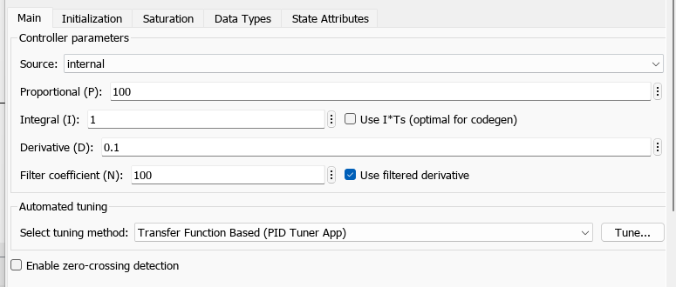

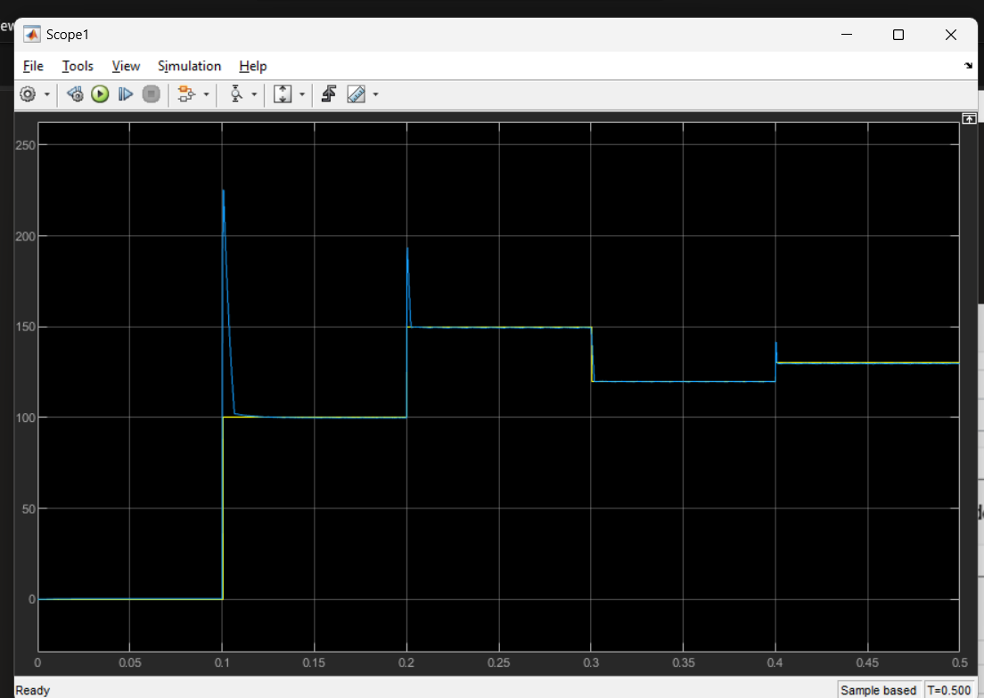

--------------------------------------------------------------------------------------------------------------------------------------------------------------------------------

The PID parameters are set. There's an overshoot when setting the voltage value. That has to be addressed with a damper.
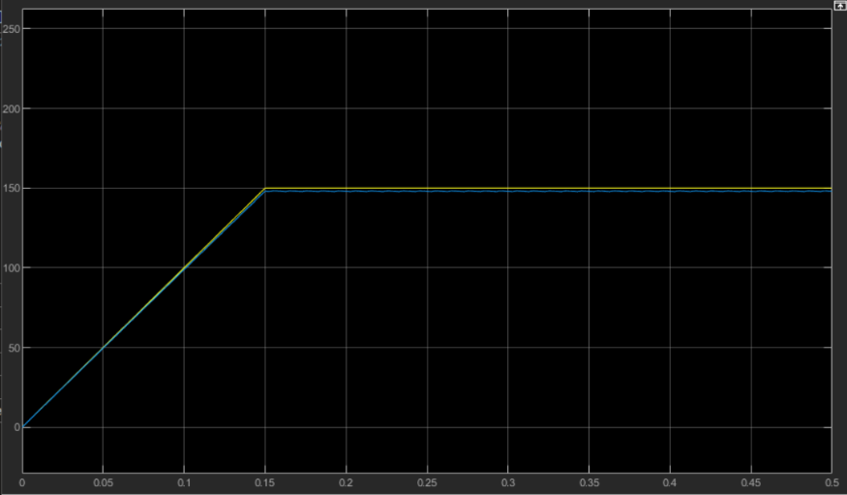

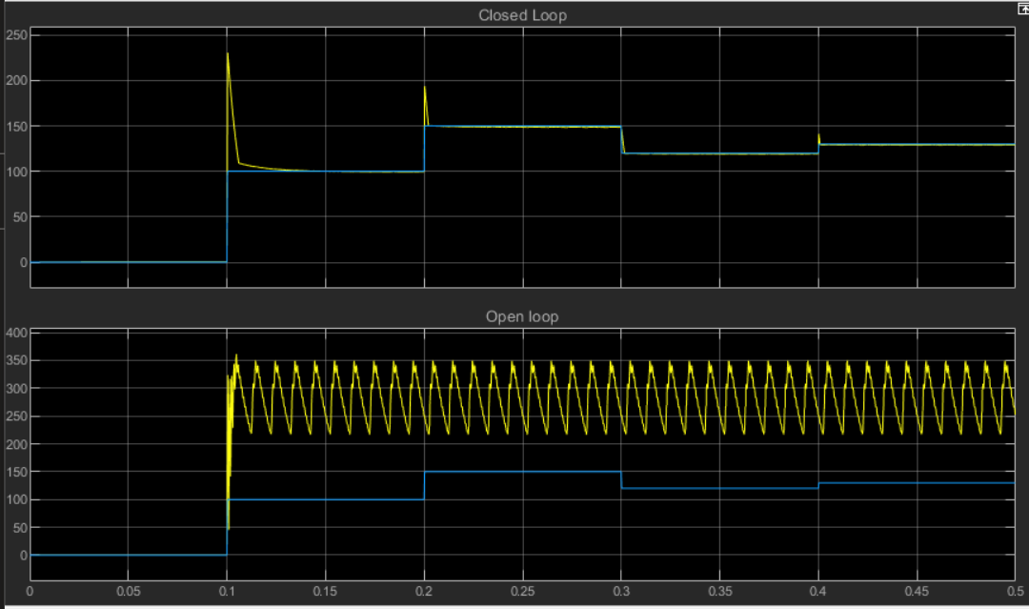

 | System Identification | https://www.mathworks.com/help/simulink/slref/output-simulation-data-with-blocks.html
 | PID Implementation in SW | PID Controller Implementation in Software - Phil's Lab #6    --------------------------------------------------------------------------------------------------------------------
SystemCoreClock = 64 MHz
Prescaler = 6400 -1 => TIM3 = 10 KHz,
ARR = 10 KHz /10,000-1 => 1 second interrupt

 | Interrupt config | https://community.st.com/t5/stm32-mcus/how-to-generate-a-one-second-interrupt-using-an-stm32-timer/ta-p/49858  Start timer  Start interrupt  Define an interrupt global fucntion  void HAL_TIM_PeriodElapsedCallback(TIM_HandleTypeDef *htim);  float MeasuredVoltage = ReadFBVoltage(&hadc1);  float normalizedVoltage = MeasuredVoltage * (R1 + R2) / R2;  float controlSignal = PIDController_Update(&pid, DESIRED_VOLTAGE,  normalizedVoltage);  setDutyCycle(&htim1, TIM_CHANNEL_1, controlSignal);  // MCU system clock  // uint32_t hclk_freq = HAL_RCC_GetHCLKFreq();
23/07/2024 | Interfacing | The MCU should have 2 MCUs.  - Interfacing with LCD  - buck PWM generation  What communication protocol to use?  - I2C is for streams of data  - CAN for signals  Steps  - User Interface circuit  - Draw a schematic & Define requirements  - Design circuit  - BOM  - Communication  I want to design a user interface circuit for the VFD.  Requirements  - Receive input voltage, input frequency from user  - Display curret voltage and frequency setting to the user
26/07/2024 | SMD Soldering and Assembly Requirements | Hot Air Gun if possible  High quality Solder paste  High quality solder <0.4  Flux  Alchohol  Cotton swabs  Very thin tweezers  Desoldering copper braid
30/07/2024 | Notes about the PCB assembly & BOM | Inductor missing, we improvised and used a smaller inductor value 200 uH, 3A and no datasheet
30/07/2024 30/07/2024 09:03 | LCD Interface  How to | 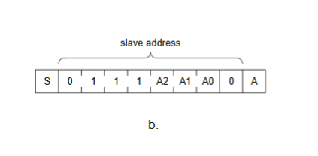  Rotary Encoder (KY-040) Debounce Circuit Tutorial  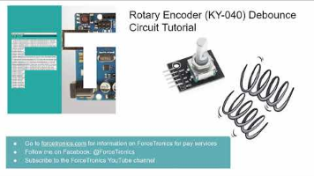
<<rectifiedData.xlsx>>
%%Time specifications:

Fs = 8000; % samples per second
dt = 1/Fs; % seconds per sample
StopTime = 0.02; % seconds
t = (0:dt:StopTime-dt)'; % seconds
%%Sine wave:
Fc = 50; % hertz
x = 340*sin(2*pi*Fc*t);
% Plot the signal versus time:
figure;
plot(X,Y);
xlabel('time (in seconds)');
title('Signal versus Time');
zoom xon;

hold on

% Define the number of samples
samples = 64;
% Generate the x-axis values
samples = linspace(0, StopTime, samples);

% Generate the sinusoidal signal
y = 340*sin(2 * pi * samples*Fc);

% Plot the sinusoidal signal
stem(X, Y, 'b', 'LineWidth', 0.1); % Blue lines
plot(X, Y, 'bo', 'LineWidth', 1); % Blue circle markers

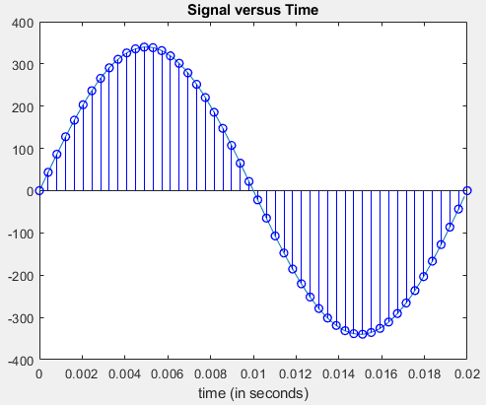

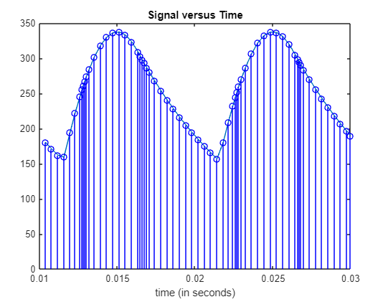

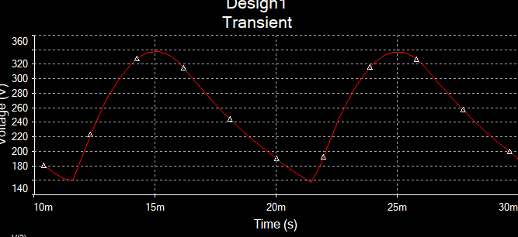

 | Design review | I have divided the program into 2 parts; User Interface and control scheme.  User Interface  Componets: LCD, Rotary Encoder  Function:  The user input the desire voltage and frequency using the encoder and it gets displayed on the LCD  Control Scheme  Componets: 2 parts; Buck and Inverter  Function: It send the PWM signal to the buck switching element, and send the inveter H-bridge to control the frequency.  When the system starts,  by default it starts at 50V and 20Hz.  The user can adjust these values by switching between 2 modes. Frequency and Voltage  The user has to first input the desried voltage value then it gets displayed on the LCD.  The display displayes 2 values; Desired Voltage and Actual Voltage  The display is updated every one second.  Prepherals  Timers  Timers1: Buck PWM  Timer2: Inverter PWM  Timer3: Updated The LCD every one second  ADCs  ADC1 & ADC2: Voltage Sensor  -------------------------------------------
Modular and state management code

Why Use a State Machine?
A state machine helps in:
- Organizing Code: It makes the code easier to read and maintain by clearly defining states and transitions.
- Managing Complexity: It simplifies the management of different modes and their transitions.
- Avoiding Bugs: By clearly defining transitions, it reduces the risk of unexpected behavior.

 | Stm32 cofiguration | ADC Configuration  How to use adc 1 channel 1 and 2 to read the data?

Buck Calibration
Objective: determine the output voltage to the feedback voltage ratio
Provide the buck with a 50% duty cycle to determine the

Procedure
Provide the buck with varying duty cycle and measure the output voltage and the feeback voltage to determine the output.

------------------------------------

 | Testing and verification | Buck Test  In this step I am testing the functionality of the buck converter measuring the input and the output voltages and the feedback signal  --------------------------------  Test the regulation mechanism  The ISR routine takes too long.
 | Using Usart | using usart I want to establish communication between 2 MCUs, where one would sends data every one second and the other receives it.  one mcu is used for control and the other is for interface.  the protocol is uart.  First the user inputs the desired voltage and frequency, the data get's transferred to the Control interface the second part of the  I need a way of determing when the desired data has been received  If the a certain character is received, proceed

Total ISR duration 61us
How long does each segement take???

Segment | function | Cycles | Time (us) | Optimized code | Cycles  After optimization | Time (us)  After optimization
ADC1_SetChannel(ADC_CHANNEL_0, ADC_REGULAR_RANK_1); | Setting the first channel | 275 | 3.7 |  | 46 | 0.64
measuredVoltageCh1 = ReadFBVoltage(&hadc1); | Reading and converting the voltage | 1779 | 24.708334 |  |  | 6.9
ADC1_SetChannel(ADC_CHANNEL_1, ADC_REGULAR_RANK_1); | Setting 2nd channel | 232 | 3.22222209 |  |  | 0.64
measuredVoltageCh2 = ReadFBVoltage(&hadc1); | Measuring the second channel | 1780 | 24.7222214 |  |  | 6.9
differentialVoltage = measuredVoltageCh1 - measuredVoltageCh2;  normalizedVoltage = differentialVoltage * VoToVfb;  ccm_val = __HAL_TIM_GET_COMPARE(&htim1, TIM_CHANNEL_1);  if (normalizedVoltage < DESIRED_VOLTAGE) {  ccm_val += 1;  } else if (normalizedVoltage > DESIRED_VOLTAGE) {  ccm_val -= 1;  }  __HAL_TIM_SET_COMPARE(&htim1, TIM_CHANNEL_1, ccm_val); | Calculating the measured voltage | 390 | 5.41666651 |  |  | 5.26388884

Sum: 61us
Optimized :19us

Tim1
Tim2
DMA | Mode: circular, word, word, Disable global interrupt

