Supporting information
The Cyanotype Process and its Potential in Chemistry Education
Alexander Kmeť *, Anna Drozdíková, Soňa Nagyová, Peter Ikhardt
Faculty of Natural Sciences, Comenius University in Bratislava, Department of Didactics in Science, Psychology and Pedagogy, Ilkovicova 6, Bratislava, Slovakia 84215
* kmet45@uniba.sk

Making cyanotypes – the blue photographs
A laboratory experiment for high-school students: ISCED 3 level student handout

Course: _____________ Name: ______________ ____________
Instructor: ________________ Date: _____________

Context:
Some compounds undergo chemical changes when exposed to light, which makes them useful in the process of analogue photography. One of the compounds is potassium ferrioxalate, a bright-green complex iron salt, easily prepared from basic chemicals. The process of making photographs with iron salt, the resulting image made of Prussian blue (Iron(II) ferricyanide) is typically called cyanotype and is one of the very first photographic processes. During this lesson, potassium ferrioxalate will be synthetised and further used in making the cyanotypes of plants.

Making of cyanotypes
Equipment: 3 beakers (100 ml), marker, tripod, wire gauze, Bunsen burner (or a hot plate), Büchner funnel, Büchner flask (250 ml), stirring rod, filtration paper, clip-in frame, matches, brush, scissors
Chemicals: students prepare solutions and mark the beakers according to the table S1:
Table S1. Preparation of the solutions
Beaker | A | B | C
Water | 15 ml | 45 ml | 10 ml
Substance | 1,1 g of iron(III) sulphate | 1,1 g of potassium oxalate monohydrate | 1,4 g of potassium ferricyanide
 |  | 0,76 g of oxalic acid dihydrate

Diagram:
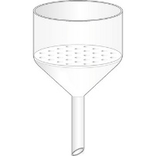
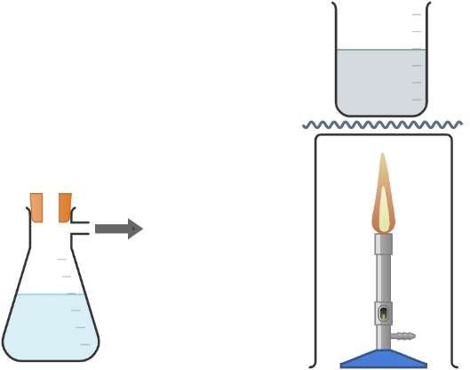
Figure S1. The diagram of the synthesis
Experimental procedure:
Step A: Potassium ferrioxalate synthesis
- Mark the solutions A, B, C and prepare the solutions according to the table.
- Ask the teacher to add 5 ml of sodium hydroxide solution (20 %) into beaker A. Note the changes.
- Filter the precipitate on the Büchner funnel.
- Start heating beaker B and add the precipitate while mixing.
- When all the precipitate dissolves, stop the heating and let the solution cool down.
Step B: Making of the cyanotypes
- Mix the solutions B and C.
- Spread the mixed solutions onto the paper using a brush.
- Arrange objects on the paper and put it into the clip-in frame.
- Take the frames outside and expose them to sunlight for 4 minutes. The paper should be dark blue after the exposure.
- Wash the paper under running water until yellow areas become white.

Questions:
- Name the brown precipitate obtained in steps A2 – 3.
- What is the difference between artificial light and sunlight? What component of sunlight caused the sensitized paper to undergo the reaction?
- What is the light-sensitive compound used in conventional B&W photography?

