Supporting information
The Cyanotype Process and its Potential in Chemistry Education
Alexander Kmeť *, Anna Drozdíková, Soňa Nagyová, Peter Ikhardt
Faculty of Natural Sciences, Comenius University in Bratislava, Department of Didactics in Science, Psychology and Pedagogy, Ilkovicova 6, Bratislava, Slovakia 84215
* kmet45@uniba.sk

Making cyanotypes – the blue photographs
A laboratory experiment for high-school students: The instructor notes for ISCED 3

List of all chemicals:
- Water
- iron(III) sulphate (CAS 10028-22-5)
- iron(II) sulphate (CAS 7720-78-7)
- potassium ferricyanide (CAS 13746-66-2)
- potassium oxalate monohydrate (CAS 6487-48-5)
- oxalic acid dihydrate (CAS 6153-56-6)
Hazards:
Iron(II) sulphate and oxalic acid are hazardous in the case of skin and eye contact (irritant). Iron(III) sulphate is hazardous when swallowed and in case of skin and eye contact. Potassium oxalate is a toxic substance (acute toxicity cat. 4) and an irritant. Sodium hydroxide is a corrosive substance, therefore only the teacher is allowed to work with it.
Every student should wear a lab coat, protective goggles, and gloves. All students with long hair must tie it, most importantly during the heating. No eating nor drinking is allowed during the lesson.

Context:
Some compounds undergo chemical changes when exposed to light, which makes them useful in the process of analogue photography. One of the compounds is potassium ferrioxalate, a bright-green complex iron salt, easily prepared from basic chemicals. The process of making photographs with iron salt, the resulting image made of Prussian blue (Iron(II) ferricyanide) is typically called cyanotype and is one of the very first photographic processes. During this lesson, potassium ferrioxalate will be synthetised and further used in making the cyanotypes of plants.

Demonstration of Prussian blue formation (≈ 10 minutes, performed by the teacher)
Equipment: 3 small beakers, marker
Chemicals: 5 % iron(III) sulphate solution, 5 % iron(II) sulphate solution, 5 % potassium ferricyanide solution
Demonstration: Mark the beakers “iron(III)”, “iron(II)”, and “ferricyanide” and add the solutions. Add few drops of ferricyanide into both other beakers and observe. The Prussian blue forms in Iron (II) sulphate solution only. The instructor explains, that some iron(III) salts can be reduced by sun, which is used in photography.

Making of cyanotypes (≈ 80 minutes, performed by the students)
Equipment: 3 beakers (100 ml), marker, tripod, wire gauze, Bunsen burner (or a hot plate), Büchner funnel, Büchner flask (250 ml), stirring rod, filtration paper, clip-in frame, matches
Chemicals: students prepare solutions and mark the beakers according to the table S1:
Table S1. Preparation of the solutions
Beaker | A | B | C
Water | 15 ml | 45 ml | 10 ml
Substance | 1,1 g of iron(III) sulphate | 1,1 g of potassium oxalate monohydrate | 1,4 g of potassium ferricyanide
 |  | 0,76 g of oxalic acid dihydrate

The teacher also needs to prepare a sodium hydroxide solution (w = 20 %; 5 ml for each group).
Diagram:
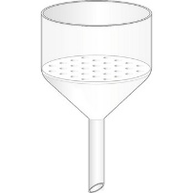
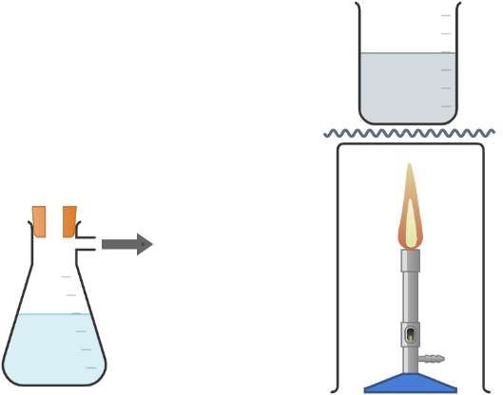
Figure S1. The diagram of the synthesis
Experimental procedure:
Step A: Potassium ferrioxalate synthesis
- Mark the solutions A, B, C and prepare the solutions according to the table
- Ask the teacher to add 5 ml of sodium hydroxide solution (20 %) into beaker A. Note the changes.
- Filter the precipitate on the Büchner funnel.
- Start heating beaker B and add the precipitate while mixing.
- When all the precipitate dissolves, stop the heating and let the solution cool down.
Step B: Making of the cyanotypes
- Mix the solutions B and C.
- Spread the mixed solutions onto the paper using a brush.
- Arrange objects on the paper and put it into the clip-in frame.
- Take the frames outside and expose them to sunlight for 4 minutes. The paper should be dark blue after the exposure.
- Wash the paper under running water until yellow areas become white.
Practical notes for the procedure:
Step A2: The students are not allowed to work with the hydroxide solution of this concentration; therefore the instructor adds it into each students’ beaker. Caution is advised while preparing the solution: the dissolution of sodium hydroxide is a very exothermic process.
Step A4: Instead of scratching the precipitate from the paper with spatula, a whole paper can be added directly to the pre-heated solution B.
Step A5: If whole paper is added, it needs to be pulled out after all the precipitate dissolves.
Step B2: The paper should be wet, but not soaked and have yellow colour. There is no need to dry papers if we’re gonna use them immediately.
Step B4: There’s no need to adjust the exposure time in cloudy or sunny days, since there’s no gradient in photograms (the contrast is represented only by exposed and unexposed areas). The 4-minute exposure has been efficient regardless the weather.
Step B5: Washing needs to be careful, since some papers tend to break under running water.

