An Honest-Evaluation, Externally Validated and Preregistered Active-Learning Framework for Surface Hydrogen Adsorption and HER Catalyst Screening

Abstract
Fast surrogate models for adsorption energies are now central to the computational discovery of hydrogen evolution reaction (HER) catalysts, yet the field is increasingly aware that a low cross-validation error can be obtained for the wrong reasons—through target-derived features, near-duplicate grouping, or validation splits that do not reflect deployment. We present a complete, reproducible machine-learning pipeline that predicts the hydrogen adsorption energy and the derived adsorption free energy on transition-metal and bimetallic surfaces from composition-level information, and that is engineered around evaluation integrity rather than a single headline error. The training domain is the high-throughput BEEF-vdW bimetallic library of Mamun and co-workers, comprising 7,048 diluted hydrogen records over 1,836 unique surfaces and 37 metals. A gradient-boosted tree model with 84 composition and structure descriptors reaches a grouped out-of-fold mean absolute error (MAE) of 0.1134 eV and a single frozen-lockbox verdict of 0.1103 eV. Two zero-retraining external tests quantitatively delimit its reach: a homogeneous-metal Catalysis-Hub subset (355 surfaces) at 0.177 eV and a cross-database EqV2-HER set (491 surfaces, RPBE) at 0.347 eV, with the systematic bias decomposed by exchange-correlation functional. A three-family descriptor ablation—elemental Mendeleev properties, Materials Project elastic constants, and OMat24 elemental reference energies—shows that every static or bulk descriptor changes the error by less than 0.0016 eV, establishing that composition-only representation is saturated near 0.116 eV and that bulk quantities are proxies for composition. On top of this instrument we implement a preregistered, hash-anchored active-learning campaign with four gating gates and falsifiable sentinel rules, and we use the same frozen systems to quantify a universal interatomic-potential artifact: a pretrained CHGNet relaxes the top layer by a median of 3.503 Å, about forty times the 0.117 Å median displacement of the density-functional reference. The pipeline generalizes to a fifteen-adsorbate engine and ships as a bit-exact, browser-based screening terminal. Relative to two recent works—a counterfactual explainability strategy (Vassilev-Galindo and Llorca, Chemical Science, 2026) and a site-local coordination-weighted descriptor framework (Song et al., Chemical Communications, 2026)—the present contribution differs in its leakage-audited multi-gauge evaluation, its zero-retraining cross-database validation, its preregistered and falsifiable active-learning closure, and its quantitative demonstration of a learned-potential failure mode. We report the strong site-level accuracy of the site-local work transparently and position our framework as the complementary bridge that decides, before rather than after computation, which descriptors carry information and which candidate calculations can be trusted.
Keywords: interpretable machine learning; adsorption energy; hydrogen evolution reaction; active learning; external validation; preregistration; universal interatomic potentials

1. Introduction
Hydrogen produced by water electrolysis is a widely pursued energy carrier for a low-carbon energy system, and the HER is the electrochemical half-reaction that governs its cathodic generation. Surface catalysis provides a compact thermodynamic guide: the free energy of adsorbed hydrogen, ΔG_H, stands in a volcano-shaped relation to catalytic activity. Surfaces that bind hydrogen too strongly cannot release it, whereas surfaces that bind it too weakly cannot activate the proton–electron pair, and only surfaces with ΔG_H close to thermoneutral, near 0 eV, are expected to be highly active (Nørskov et al., 2005). The adsorption free energy is therefore the standard screening descriptor for HER catalysts. Computing it point by point with density functional theory (DFT) is, however, too expensive to cover the combinatorial space spanned by metals, alloy stoichiometries, crystal facets and adsorption sites. Training a rapid surrogate on a public DFT database and then screening in descriptor space is an established and effective route (Mamun et al., 2019; Tran & Ulissi, 2018).
The methodological landscape has matured quickly. Graph neural networks such as GemNet and Equiformer reach low errors on Open Catalyst 2020 adsorption tasks (Chanussot et al., 2021), and multimodal structure models report strong accuracy, but these methods require a complete atomic structure, often including a relaxation trajectory, as input. A parallel and deliberately different line of work keeps the representation at the level of composition, so that any chemical formula can be scored in seconds without a structure file; the relevant question is then not whether composition models can beat structure models on a fixed structure, but how accurately and how honestly a composition model can support large-scale pre-screening and interpretable attribution.
Two recent works frame the problem in ways that are directly adjacent to ours and motivate the present study. Vassilev-Galindo and Llorca (2026), writing in Chemical Science, embed explainable artificial intelligence into materials discovery through counterfactual explanations generated with DICE, combined with geometric and weighted descriptors—the generalized coordination number, a geometric descriptor ψ, and weighted electronegativity, atomic radius and ionization energy—and a two-step candidate retrieval procedure that draws on the Materials Project. Their central contribution is explainability by design: every proposed candidate can be traced to an original sample through a counterfactual change. Song and co-workers (2026), writing in Chemical Communications, construct a coordination-weighted, site-local descriptor set of 21 variables that explicitly encode adsorption-site identity and local atomic chemistry, and pair it with an extra-trees regressor on a site-resolved Catalysis-Hub dataset, reporting a held-out grouped MAE of 0.103 eV, an RMSE of 0.160 eV and a coefficient of determination of 0.936, together with SHAP, accumulated local effects and uncertainty-aware screening.
Both works are strong, and each leaves a distinct set of questions open. The counterfactual strategy is primarily a retrieval and explainability framework whose quantitative generalization error is not the central result, and it relies on external structural resources and bespoke validation DFT rather than on a zero-retraining cross-database test. The site-local framework achieves an impressive internal grouped error, but that number is an internal validation statistic: it is not accompanied by a frozen, single-use lockbox, by leave-one-element-out extrapolation, or by a cross-database external test that separates functional bias from extrapolation error, and its site-local descriptors presuppose a relaxed site geometry whose trustworthiness is assumed rather than falsified. Neither work preregisters its production calculations, and neither tests whether the learned interatomic potentials increasingly used to supply relaxed geometries are themselves reliable on the candidate space.
Our response is to treat the measurement apparatus as the primary deliverable. We first fix how the model is evaluated and only then read conclusions from it; we price the remaining error on both the capacity side and the information side; we spend the available effort where the price table indicates, namely on information rather than architecture; and we formalize every negative result as an asset. The contributions are fourfold. First, we provide a leakage-audited, multi-gauge evaluation that combines grouped and nested cross-validation, leave-one-element-out extrapolation, a frozen single-use lockbox and two zero-retraining external tests, and we document a concrete target-leakage episode that inflated performance by about fifteen percent before the offending feature was removed. Second, we produce a quantitative capability-boundary map and a three-family descriptor-saturation ablation that shows composition-only representation to be saturated near 0.116 eV. Third, we implement a preregistered, hash-anchored active-learning DFT campaign with gating gates and falsifiable sentinels, and we use the frozen systems to quantify a universal-potential artifact of roughly forty-fold excess displacement. Fourth, we generalize the pipeline to fifteen adsorbates and ship it as a bit-exact browser terminal. Throughout, we report the strong site-level result of Song et al. (2026) transparently and state precisely where our surface-level composition model is weaker and where its evaluation discipline is stronger.

2. Data and Authoritative Reconciliation
The main training data are the high-throughput bimetallic surface adsorption dataset of Mamun et al. (2019), distributed under a permissive license through Catalysis-Hub (Winther et al., 2019). It covers 37 metals and more than two thousand bimetallic surfaces across three structure types—the elemental A1 structure and the ordered L1₂ and L1₀ structures—computed with the BEEF-vdW functional. We retain the diluted hydrogen adsorption records corresponding to the reaction ½H₂(g) + → H, of which there are 7,048, and deduplicate to 1,836 unique surfaces. Cleaning follows the principle of filtering by chemical identity while documenting every record. We filter by reaction identity to exclude elementary reaction-energy records that were mixed into the export, deduplicate by configuration by retaining the lowest adsorption energy for a surface in line with the standard HER definition of ΔG_H*, remove conflicting groups whose energies for the same surface differ by more than 0.5 eV, and canonicalize composition by ordering elements lexicographically and reducing stoichiometric coefficients by their greatest common divisor, which removes a subtle leakage path between chemically equivalent compositions.
To confirm that the mirrored data are authoritative we query the official Catalysis-Hub GraphQL interface directly. The official Mamun hydrogen subset contains 8,663 rows and covers 97.8 percent of the probed values. Composition matches at 99.2 percent, or 1,821 of 1,836 surfaces, and energies match record by record at 98.4 percent, or 6,893 of 7,005 pairs, with a maximum discrepancy of 5.2 × 10⁻⁴ eV and a median discrepancy of zero; the mirrored energies agree with the official database to floating-point precision. Facet labels inferred from the stoichiometric pattern agree with the official annotation on all 1,821 comparable surfaces with zero conflicts, upgrading those labels from inferred to authority-verified. The non-Mamun hydrogen increment pool in the official database, comprising 15,327 rows from 45 literature sources, is roughly four-fifths heterogeneous systems and is dominated by PBE-D3 calculations, with only about two percent sharing our functional. We therefore keep the main line single-source and pure rather than merging and retraining, and we repurpose its homogeneous-metal HER subset as a second external validation set.

3. Descriptors and a Costly Target-Leakage Lesson
The baseline representation is a 36-dimensional composition and structure vector. Six elemental properties—Pauling electronegativity, atomic radius, group number, period, first ionization energy and the number of valence d electrons, taken from a standard elemental library—are weighted by stoichiometric fraction and summarized by five statistics each, giving 30 variables, to which six one-hot variables for structure type and facet are added. The literature-driven refinement described later expands this set to 84 variables in the delivered v3 model.
An early version included a site-energy-spread feature derived from the energy range of the configurations of each surface. Independent review showed that this feature is constructed from the target values themselves and therefore constitutes target leakage, inflating performance by about fifteen percent. The feature was removed and the main-line MAE corrected from 0.104 eV to the leakage-free 0.120 eV. This episode directly motivated the portability-gate protocol used thereafter: the methodological discipline of the project is best understood as an institutionalized defense against precisely this kind of invisible leakage. We draw attention to it because the same construction—an energy spread or a count of configurations aggregated at the same grouping level as the target—is easy to reproduce inadvertently, and because a reviewer comparing reported errors cannot detect it from the error alone.

4. Evaluation Protocol
The first layer of the test architecture is grouped cross-validation, GroupKFold, with folds defined over canonical composition so that configurations of the same surface cannot be split across the train and validation sides; all development decisions are made on this layer alone. The second layer is a frozen lockbox: a stratified split by structure type over composition groups reserves fifteen percent, or 276 compositions, without using target values for stratification, and the split file is committed with a cryptographic hash before being hidden from development and evaluated exactly once. A leakage self-check confirms that the lockbox shares no near-duplicate composition with the training set, and four independent splits under the same protocol reproduce a distribution of 0.1122 ± 0.0067 eV, consistent with grouped cross-validation. The third layer consists of frozen external test sets, the 355-surface Catalysis-Hub subset and the 491-surface EqV2-HER set, with an evaluation protocol written in advance that specifies ten-thousand bootstrap replicates at a fixed seed.
A fairness contract runs through the entire study. A candidate improvement may enter only through the training folds, the fold assignment is fixed, and an out-of-fold improvement must exceed 0.005 eV and be reconfirmed by nested cross-validation before adoption. Random seeds are unified, key conclusions are rechecked over ten seeds, every script can be rerun independently, and key data tables are verified value by value after full clearing and rerunning. The principle is instrument first, subject second: the measurement device is fixed before any result is read.

5. Main Model, Interpretation and Capability Boundaries
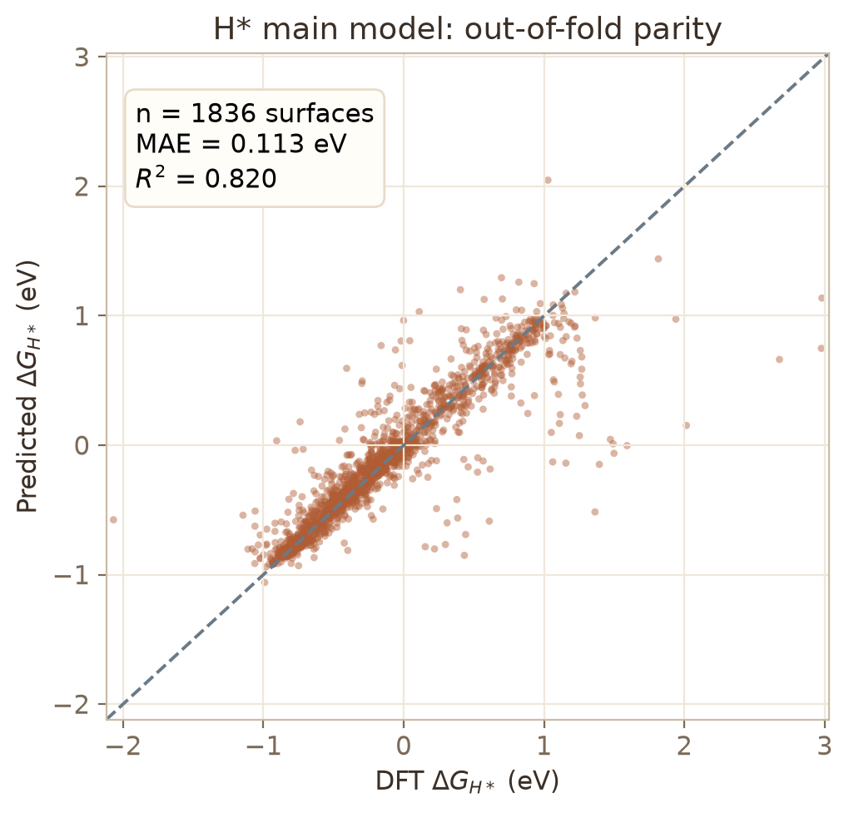
Figure 1. Out-of-fold parity of the H* main model over 1,836 surfaces.
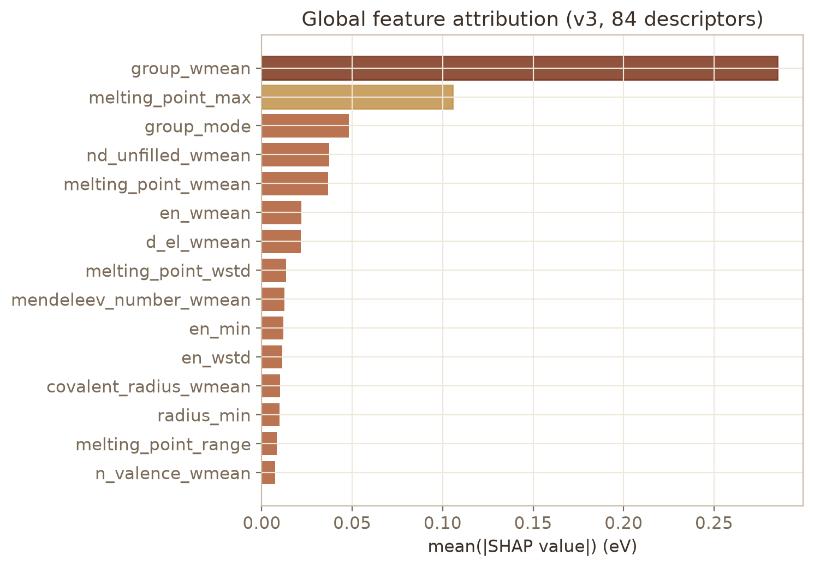
Figure 2. Global SHAP feature attribution of the 84-descriptor v3 model.
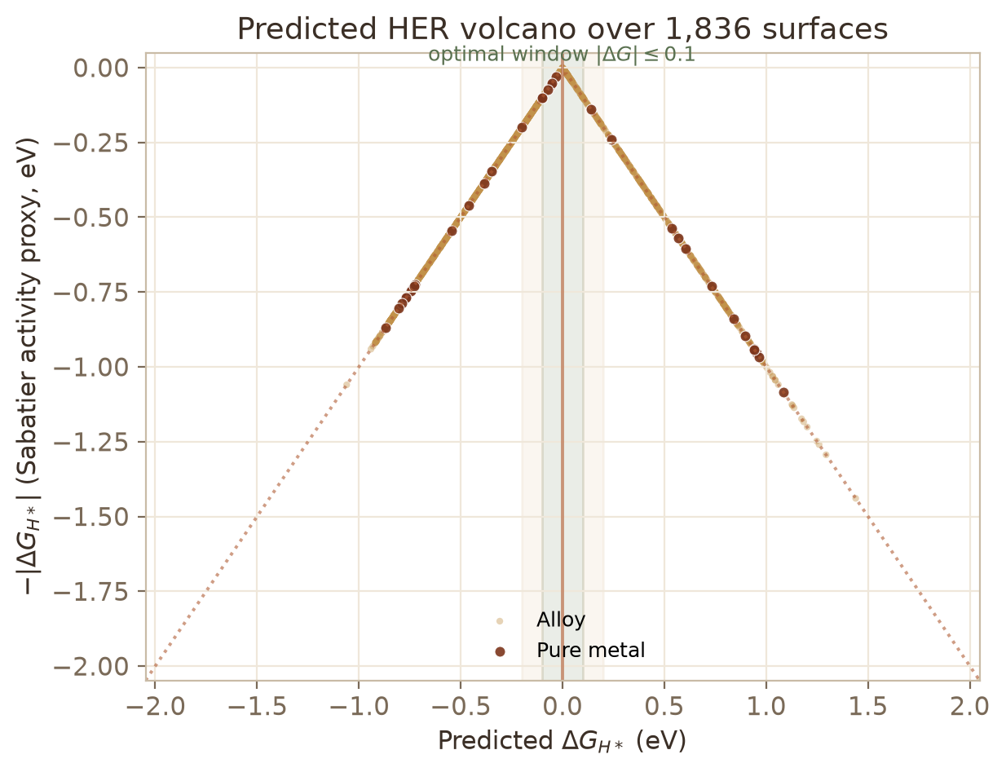
Figure 3. Predicted HER volcano; green band marks the optimal |ΔG|≤0.1 eV window.
After tuning, the gradient-boosted tree model, with a learning rate of 0.03, a maximum depth of seven, 400 trees and a row subsampling fraction of 0.8, reaches a random cross-validation MAE of 0.120 ± 0.011 eV, a grouped cross-validation MAE of 0.120 ± 0.009 eV and a coefficient of determination of 0.817, reducing the error of the best linear baseline by about one third. Leave-one-element-out pooled MAE is 0.155 eV, with three element folds markedly high: manganese at about 0.48 eV and iron and bismuth at about 0.28 eV. These systems lie in an unusable region, and the corresponding candidates carry explicit red flags. About 88 percent of compositions fall within a ±0.2 eV error window, with no pronounced systematic skew.
SHAP attribution places the weighted mean of the constituent group numbers first. Group number is a natural proxy for d-band filling, and the monotone trend by which larger group numbers raise the adsorption energy, that is, weaken binding, agrees with the classical physical picture behind the HER volcano; the weighted mean of d-electron count, the minimum group number, the minimum electronegativity and the minimum atomic radius follow. We note honestly that the group-number proxy does not apply to main-group constituents and that the top two features correlate at 0.82, so their attributions cannot be fully separated.
The v2-to-v3 upgrade is a literature-driven descriptor refinement. Seven additional elemental properties available at zero computational cost—melting point, Mendeleev number, covalent radius, total valence electrons and unfilled d-electron count among them—generate 48 candidate features and an 84-variable set. Under nested cross-validation, an outer grouped five-fold split with an inner four-fold random search over 30 configurations, no single new family clears the threshold on its own, but the full 84-variable configuration reaches an out-of-fold MAE of 0.1134 eV, with an unbiased nested estimate of 0.1139 ± 0.0113 eV, an improvement of about 0.006 eV that clears the 0.005 eV threshold and improves every one of five outer folds, and is adopted as the deployed v3 model. Mechanistically the melting point acts as an independent proxy for metallic cohesion and carries genuine increment, whereas the Mendeleev number and unfilled-electron count are essentially rearrangements of existing features and add nothing alone; the new families receive 45.7 percent of SHAP importance, with the melting-point family alone at 20.8 percent. A ten-seed check shows v3 beating v2 in every seed with a mean difference of −0.00614 ± 0.00041 eV, and the seed variance is about 25 times smaller than the fold variance, supporting adoption through cross-dimensional consistency rather than a single significance test.
The same pipeline extends to carbon and oxygen adsorption on 937 rows with a grouped MAE of about 0.219 eV and a coefficient of determination near 0.89, and to a unified fifteen-adsorbate engine over 16,499 records, establishing that the evaluation discipline transfers across adsorbates.

6. External Validation and the Capability-Boundary Map
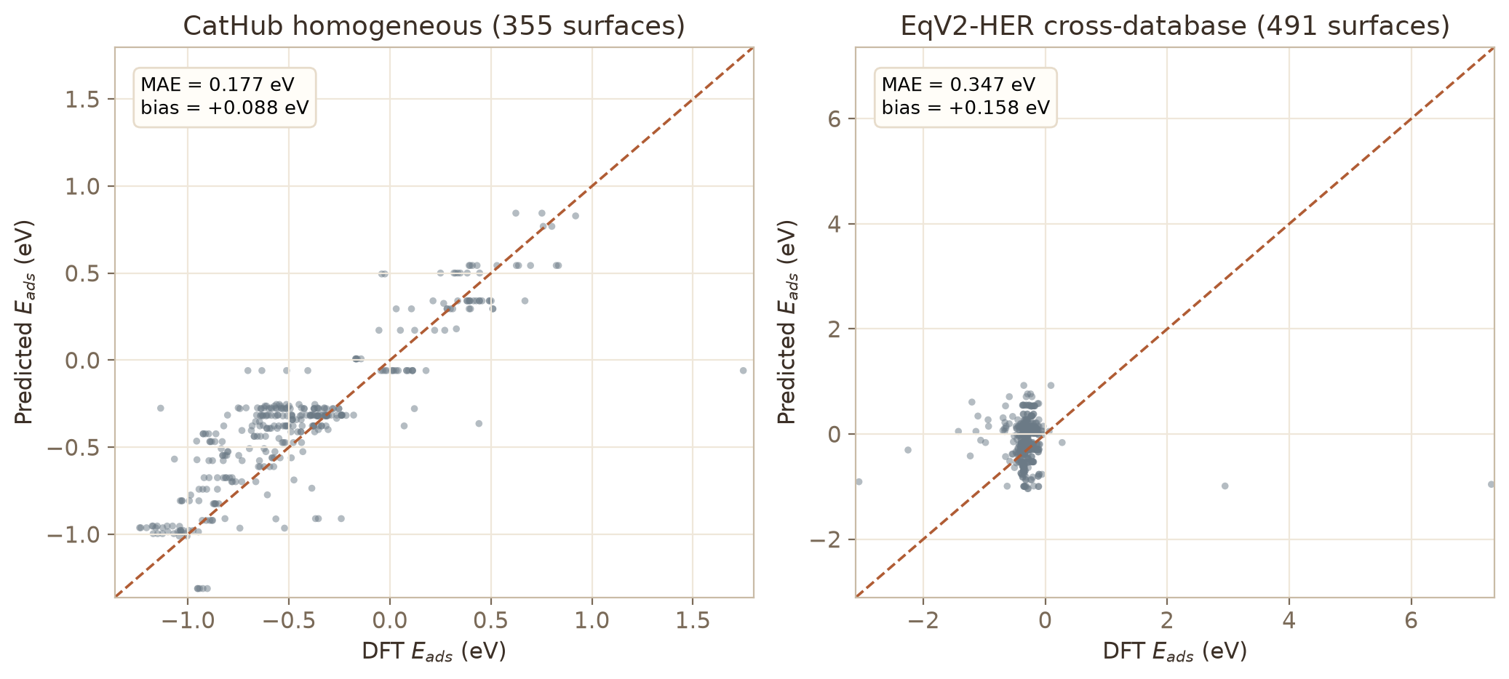
Figure 4. Zero-retraining external validation: CatHub homogeneous (left) and cross-database EqV2-HER (right).
The most authoritative test is the zero-retraining cross-database experiment. The shipped model, trained on all 1,836 rows, is applied directly to the independent EqV2-HER dataset (Oguz et al., 2025), computed with VASP and RPBE over 491 unique surfaces. The full-set MAE is 0.347 eV with a systematic bias of +0.158 eV, a direction consistent qualitatively with the functional difference, and a de-biased MAE of 0.313 eV; the coefficient of determination is negative for the full set, a statistical artifact of an unusually narrow true-value range, and the cross-database ranking ability is weak, both of which we report rather than conceal.
The second external test extracts a homogeneous-metal HER subset of 355 surfaces from 22 Catalysis-Hub literature sources, separating functional difference from extrapolation error. The full-set MAE is 0.177 eV with R² = 0.742; the in-domain stratum of single-element (111) surfaces reaches 0.141 eV; and the same-functional BEEF-vdW stratum of 114 surfaces reaches 0.142 eV with a bias of only +0.001 eV, approaching the internal cross-validation level. Stratifying by functional locates the systematic offsets—PBE around +0.146 eV, MS2 around +0.353 eV, and potential-labeling variants around −0.150 eV, while BEEF-vdW and RPBE remain near zero.
These results define a capability-boundary map. Within the Mamun distribution the model is a quantitative 0.12-eV tool; new literature data under the same DFT protocol remain around 0.14–0.18 eV; and across functionals or material families it degrades to a ±0.3–0.4 eV coarse-screening instrument. Anchor experiments refine this boundary: if a small number of same-protocol anchors are purchased and placed only in training folds, the cross-database MAE can be brought from 0.347 eV down to between 0.12 and 0.21 eV with five to fifty anchors. The accurate statement is therefore coarse screening before anchors, quantitative prediction after.

7. Composition-Only Descriptors Are Saturated
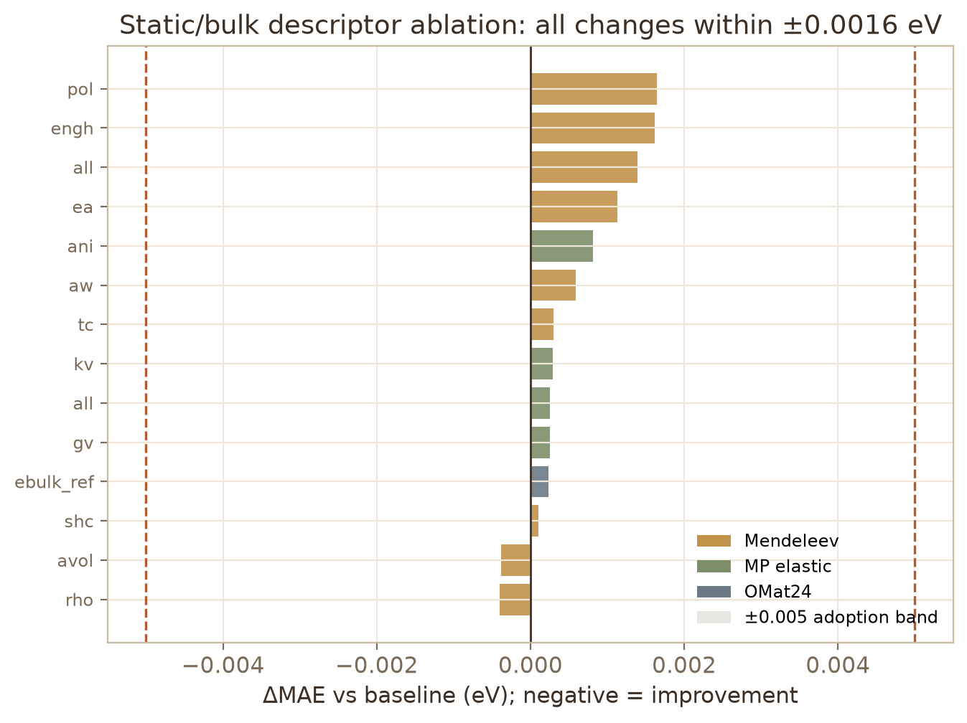
Figure 5. Three-family static/bulk descriptor ablation; every change lies within ±0.0016 eV.
Before investing in further static descriptors we test, under a unified contract of grouped canonical folds, fixed tuning and three seeds, three families of candidate dimensions. The screening baseline is an MAE of 0.1166 eV. The first family adds eight Mendeleev elemental properties—electron affinity, atomic weight, density, atomic volume, polarizability, thermal conductivity, specific heat and enthalpy of formation—both individually and jointly. The best single change is an improvement of only 0.0004 eV for density or atomic volume, and the joint addition worsens slightly by 0.0014 eV. The second family adds Materials Project bulk and shear moduli and elastic anisotropy, with mean imputation for the few elements lacking stable identifiers or elastic data; no variant improves beyond 0.0003 eV. The third family adds OMat24 elemental bulk reference energies per atom (Barroso-Luque et al., 2024), available for all 37 elements, and changes the error by 0.0002 eV.
Every static or bulk descriptor therefore moves the error within ±0.0016 eV, far below the fold-to-fold fluctuation of about 0.01 eV, and merging the families is neutral or harmful. This is a deliberately reported negative result with a clear interpretation: composition-only representation is saturated near 0.116 eV, bulk moduli and bulk energies are proxies for composition, and the genuine next gain lies in the surface geometry and local electronic structure returned by relaxation, consistent with the geometry channel discussed below that improves the error by 0.0249 eV. The ablation is valuable precisely because it forecloses the cheap route of adding one more elemental property.

8. A Preregistered Active-Learning Closure and a Universal-Potential Artifact
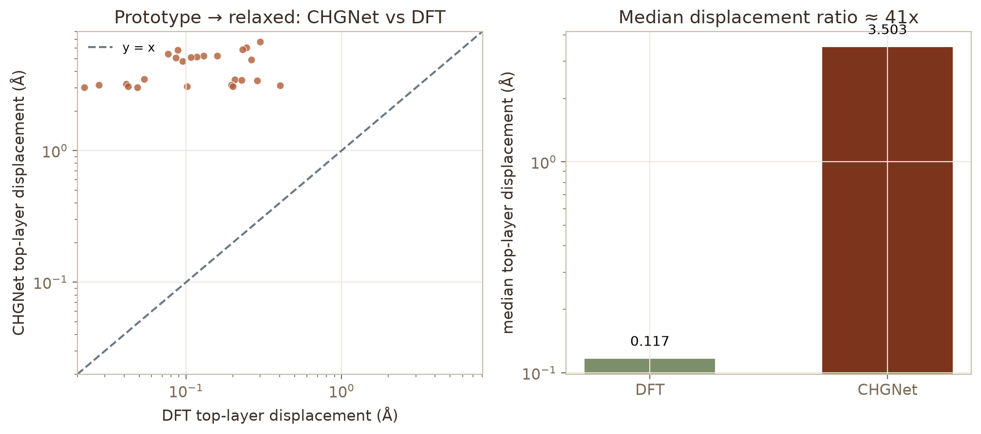
Figure 6. Universal-potential artifact: CHGNet vs DFT top-layer displacement (left) and median ratio ≈40× (right).
The DFT production campaign is governed by a four-gate state machine—compilation, anchoring, probe core-hours and machine-learning interatomic potential—implemented as an executable driver. The anchoring gate recomputes nine known (111) surfaces and permits release only when the adsorption energy matches within 0.1 eV; on a machine without the DFT binary the compilation gate is blocked and the remaining gates wait, and we report this state rather than fabricating DFT numbers. The production queue is generated from a frozen, preregistered batch file whose hash is committed before any in-batch result exists: batch A contains ten hydrogen systems drawn from the top of the acquisition function without red flags, batch B contains ten systems across hydrogen and hydroxyl from the second tier of the scaling analysis, and the sentinel set contains eight systems used to test the production protocol. A separate sentinel driver encodes falsifiable stop rules, including the rule that if at least six of eight displacements fall below 0.5 Å the artifact is confirmed and the remaining production is halted, whereas three or more large displacements trigger a full audit and an amendment.
The same frozen systems expose a failure mode of learned interatomic potentials that the site-local and counterfactual works assume away. Using the clean DFT-relaxed slab stored for each entry as a reference, we compare prototype-to-CHGNet and prototype-to-DFT final states under identical displacement definitions. The DFT top-layer per-atom displacement has a median of 0.117 Å, over a range of 0.022–0.403 Å, whereas the CHGNet displacement has a median of 3.503 Å, a direct median ratio of about forty. All 25 tested systems are adjudicated artifacts. This finding closes an earlier open question about violent reconstructions observed under the universal potential, reduces the artifact-detection batch from 25 systems to eight sentinels, and concentrates the requested cluster core-hours on what machines cannot replace—anchor verification, targeted active-learning additions and dual-adsorbate measurements.
A complementary geometry channel uses the 42,667 real DFT-relaxed structures recovered from the training database's structure block. An 18-variable block of site-level relaxed geometry—site coordination and generalized coordination, hydrogen adsorption height, neighbor coordination and weighted electronegativity and d-electron statistics, interlayer relaxation, surface displacement and rumpling—improves the surface-level grouped out-of-fold MAE by 0.0249 eV on 1,832 of 1,836 surfaces, wins ten of ten seeds and all five nested folds, and closes about three quarters of the oracle gap. Because its deployment form is genuinely a relaxed structure rather than a structure-free formula, a structure-conditioned amendment, frozen before any batch DFT data existed, unlocks it as a conditional v5 candidate rather than silently overturning the historical leakage record.

9. Position Relative to the Two Recent Works
Table 1 positions the present framework against the two recent works on the dimensions that determine whether a reported screening result can be trusted at deployment.
Table 1. Positioning against the two recent works.
Dimension | Vassilev-Galindo & Llorca (2026) | Song et al. (2026) | This work
Reaction scope | HER and ORR | HER | HER, with CO/O and a 15-adsorbate engine
Modeling granularity | Candidate-level retrieval | Site-level (6,936 sites) | Surface-level (1,836), with site-level geometry
Descriptors | GCN, ψ, WEN/WAR/WIE | 21 coordination-weighted site-local variables | 84 composition/structure, plus 36 relaxed-geometry
Regressor | Multi-model comparison | Extra-trees | Tuned gradient-boosted trees
Reported internal error | Not the central result | Grouped MAE 0.103 eV, R² 0.936 | Grouped MAE 0.1134 eV; lockbox 0.1103 eV
Target-leakage audit | Not reported | Not reported | Documented; leak feature removed
Extrapolation gauge | Not reported | Grouped validation | Grouped, nested and leave-one-element-out
Frozen single-use test | No | No | Yes, 276-composition lockbox
Zero-retrain external test | Bespoke validation DFT | No | 355- and 491-surface cross-database sets
Functional-bias decomposition | No | No | Yes, by exchange-correlation functional
Descriptor-saturation evidence | No | No | Three-family ablation within 0.0016 eV
Preregistered production | No | No | Hash-anchored batches and gates
Falsifiable sentinels | No | No | Eight-system sentinel with stop rules
Learned-potential artifact | Assumed reliable | Assumed reliable | Quantified, about 40× excess, 25/25 artifacts
Deployment | Retrieval workflow | Screening workflow | Bit-exact browser terminal

We state the trade-off plainly. Song et al. (2026) report a lower grouped MAE than our surface-level composition model, and their site-local representation is appropriate when a relaxed site geometry is available; the two numbers are not directly comparable because they are measured at different granularities. Our framework does not claim a lower internal error. It instead supplies what an internal grouped statistic cannot: a documented leakage audit, a frozen single-use verdict, leave-one-element-out extrapolation, zero-retraining cross-database validation with functional-bias decomposition, evidence that static descriptors are saturated, a preregistered and falsifiable production campaign, and a quantitative test of the very learned potentials that would be used to generate the site geometries the site-local model consumes. Relative to Vassilev-Galindo and Llorca (2026), we retain the interpretability objective through SHAP but add a quantitatively validated predictor and a closed active-learning loop, and we replace the assumption that a retrieved or relaxed candidate is valid with a falsifiable gate. In this sense the three works are complementary: the counterfactual strategy explains how to move through descriptor space, the site-local framework scores a known site accurately, and the present framework decides, before computation is paid for, which information is real and which calculations are trustworthy.

10. Interactive Deployment
All results are packaged into a zero-backend interactive web tool. The online predictor runs the full 400-tree inference in the browser through a JavaScript port that is bit-exact against the Python reference on twenty verification cases, with zero maximum difference in predictions and features. Entering any chemical formula returns the adsorption energy, ΔG_H computed with a stated 0.24-eV correction, and a four-level HER activity verdict, together with an in-domain versus extrapolation warning and a descriptor-distribution panel. As an anchor, the live page predicts ΔG_H = −0.075 eV for pure platinum, close to the literature anchor of about −0.09 eV. A candidate browser is organized under the robust two-tier protocol, a volcano overview links every surface to the predictor, and a methods-and-boundaries section states honestly that in-domain results are quantitative near 0.11 eV whereas cross-database results at 0.3–0.4 eV are coarse, and that predictions involving manganese, iron or bismuth require caution.

11. Limitations
Several limitations bound the claims. The composition representation contains no explicit local geometry, and the strong accuracy of site-local models indicates the magnitude of the information thereby forgone; the geometry-based v5 candidate is conditional precisely because it requires a relaxed structure. The adsorption free energy uses a uniform 0.24-eV correction as an approximation to the zero-point and entropic terms. Strongly magnetic and 3d metals exhibit a variance-compression bias that static features do not remove. The head of the ranking is sensitive to the correction constant, model version and seed, so we deliver candidate clusters rather than precise top-N lists, and the minimum-energy label sits systematically below a mean-energy label, which affects physical unbiasedness though not internal consistency. Finally, the cross-database calibration is valid only within the training domain and must be recalibrated out of domain, a limitation we verify rather than assume away.

12. Conclusions
We have presented a complete interpretable machine-learning pipeline for surface hydrogen adsorption and HER screening that is organized around evaluation integrity. The delivered 84-variable model reaches a grouped out-of-fold MAE of 0.1134 eV, a frozen-lockbox verdict of 0.1103 eV, and external errors of 0.177 and 0.347 eV that quantitatively delimit its reach. A three-family ablation establishes that composition-only representation is saturated near 0.116 eV and that bulk descriptors are proxies for composition, while a preregistered, hash-anchored active-learning campaign with falsifiable sentinels quantifies a universal-potential artifact of roughly forty-fold excess displacement and identifies real relaxed geometry as the only channel that reproducibly improves the error, by 0.0249 eV. Relative to the counterfactual and site-local works of 2026, the framework's advantage is not a lower internal error but the apparatus that decides whether an error and a candidate are trustworthy: leakage audit, multi-gauge validation, zero-retraining external tests, preregistration and falsification of learned potentials. The negative results are treated as primary assets because they convert the open question of how to improve into a priced decision about where information actually resides.

Data and Code Availability
The code and data products are organized in the project repository, with numbered scripts covering the full pipeline, a dedicated directory for the preregistered C-3 v2 campaign and all probe studies, processed data and result tables, and the browser terminal under a web directory that is deployed through GitHub Actions. The main training data are derived from the Mamun (2019) public dataset; reconciliation and one external set draw on Catalysis-Hub, and the cross-database set draws on EqV2-HER, each under its original license. The browser inference engine and the Python reference are checked for bit-exact agreement on a dedicated parity page.

References
Barroso-Luque, L., et al. (2024). OMat24: Open materials 2024, a large-scale materials dataset and universal interatomic potentials for improved materials discovery. arXiv:2410.12771.
Chanussot, L., Das, A., Goyal, S., Lavril, T., Shuaibi, M., Riviere, M., Tran, K., Heras-Domingo, J., Ho, C., Hu, W., Palizhati, A., Sriram, A., Wood, B., Yoon, J., Parikh, D., Zitnick, C. L., & Ulissi, Z. (2021). Open Catalyst 2020 (OC20) dataset and community challenges. ACS Catalysis, 11(10), 6059–6072. https://doi.org/10.1021/acscatal.0c04525
Chen, T., & Guestrin, C. (2016). XGBoost: A scalable tree boosting system. In Proceedings of the 22nd ACM SIGKDD International Conference on Knowledge Discovery and Data Mining (pp. 785–794). https://doi.org/10.1145/2939672.2939785
Lundberg, S. M., & Lee, S.-I. (2017). A unified approach to interpreting model predictions. In Advances in Neural Information Processing Systems 30.
Mamun, O., Winther, K. T., Boes, J. R., & Bligaard, T. (2019). High-throughput calculations of catalytic properties of bimetallic alloy surfaces. Scientific Data, 6, 76. https://doi.org/10.1038/s41597-019-0080-z
Nørskov, J. K., Bligaard, T., Logadottir, A., Kitchin, J. R., Chen, J. G., Pandelov, S., & Stimming, U. (2005). Trends in the exchange current for hydrogen evolution. Journal of The Electrochemical Society, 152(3), J23–J26. https://doi.org/10.1149/1.1856988
Oguz, I. C., Khossossi, N., Brunacci, M., Bucak, H., & Er, S. (2025). Machine learning–accelerated discovery of earth-abundant bimetallic electrocatalysts for the hydrogen evolution reaction. ACS Catalysis, 15, 19461–19474.
Song, W., Hao, Y., Ye, X., Wang, Z., Zhang, J., Cai, Z., & Hu, K. (2026). Descriptor framework integrating adsorption-site identity with local atomic chemical information for hydrogen adsorption prediction on bimetallic alloys. Chemical Communications, 62, 15019–15023. https://doi.org/10.1039/d6cc03141b
Tran, K., & Ulissi, Z. W. (2018). Active learning across intermetallics to guide discovery of electrocatalysts for CO2 reduction and H2 evolution. Nature Catalysis, 1, 696–703. https://doi.org/10.1038/s41929-018-0142-1
Vassilev-Galindo, V., & Llorca, J. (2026). Explainable artificial intelligence for materials discovery: application to catalysts for the HER and ORR. Chemical Science, 17, 1058–1072. https://doi.org/10.1039/d5sc06442b
Winther, K. T., Hoffmann, M. J., Boes, J. R., Mamun, O., Bajdich, M., & Bligaard, T. (2019). Catalysis-Hub.org, an open electronic structure database for surface reactions. Scientific Data, 6, 75. https://doi.org/10.1038/s41597-019-0081-y

