1. Title: the userstory :

As a user I want to be able to tap on an object to interact with it or get an description of the object.

2. Screenshot of unit test (or UI test automation) code

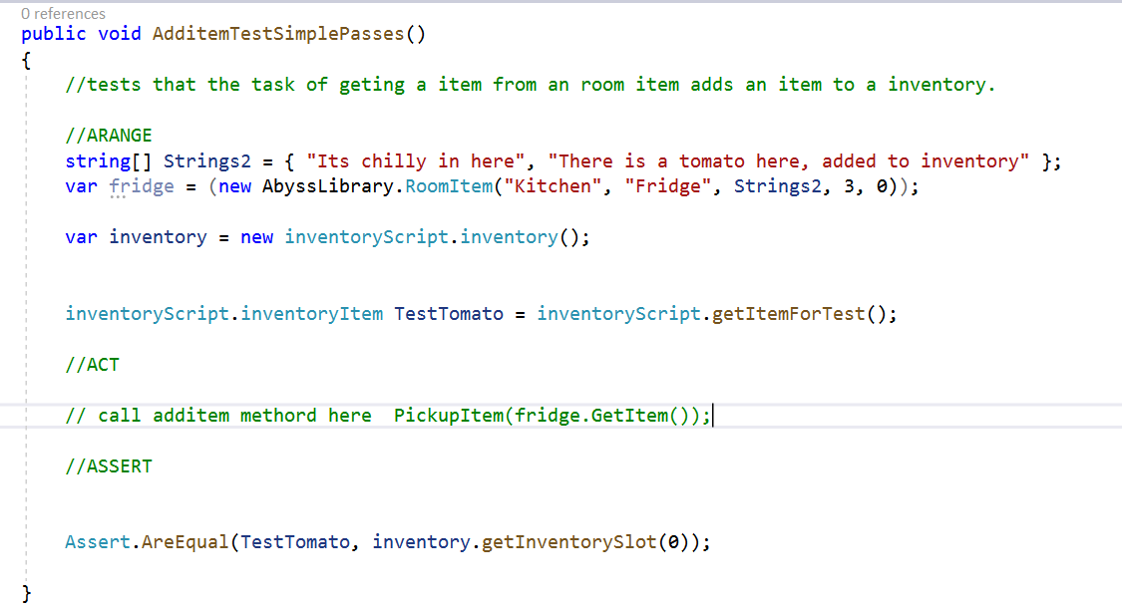

3. Screenshot of test fail in the testing framework

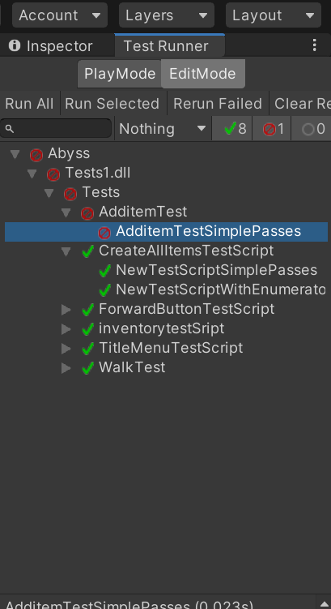

4. Screenshot of the code to pass the test

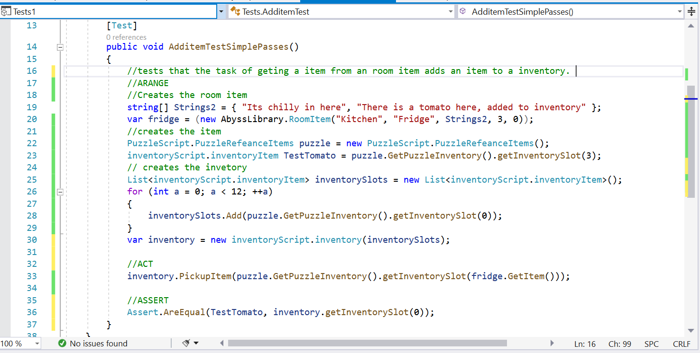

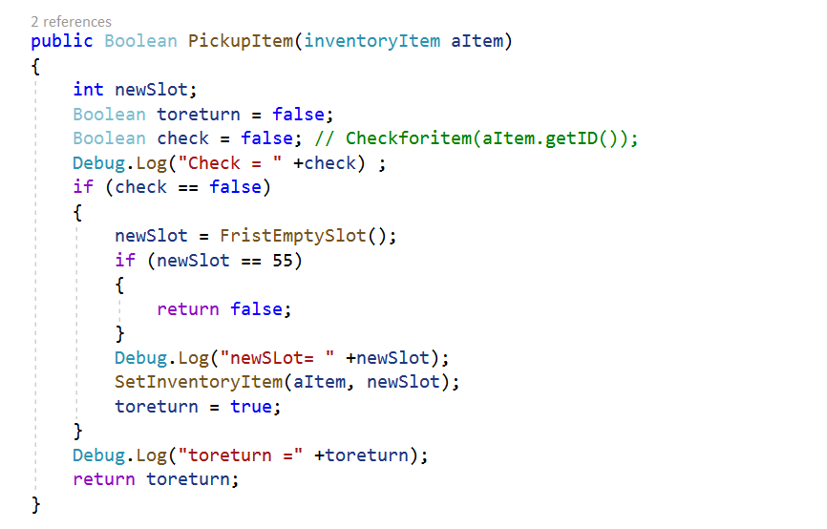

5. Screenshot of test passing in the testing framework

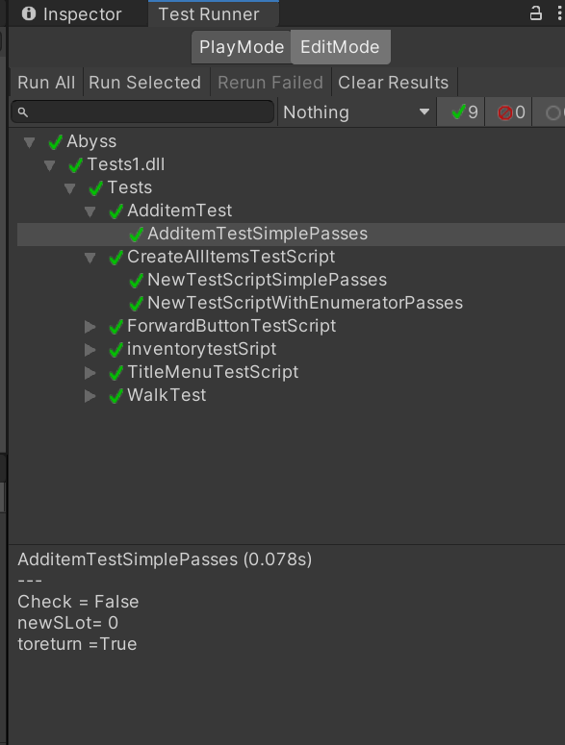

1. Title: the userstory

As a user I want to be able to store pages in a notebook so that I can look and view them at any time.

When I am reading the notes, then I am able to press the left arrow at the bottom of the screen to go back a page.

2. Screenshot of unit test (or UI test automation) code

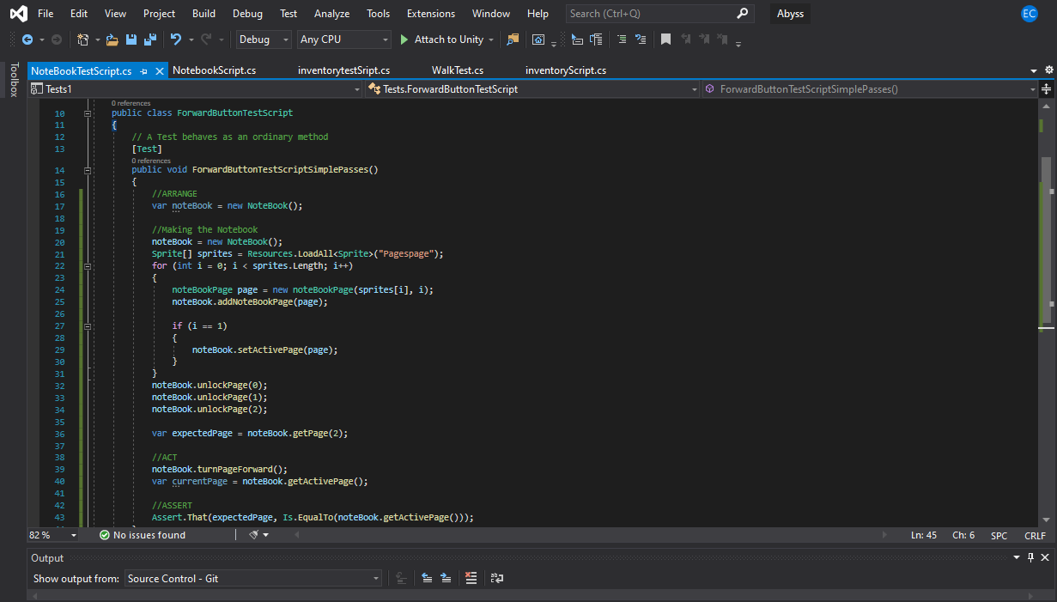

3. Screenshot of test fail in the testing framework

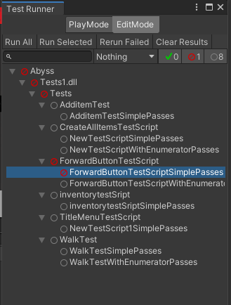

4. Screenshot of the code to pass the test

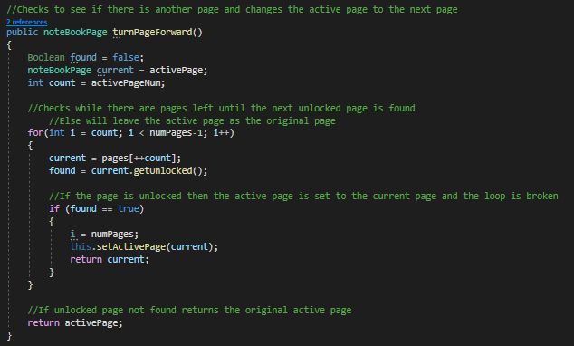

5. Screenshot of test passing in the testing framework

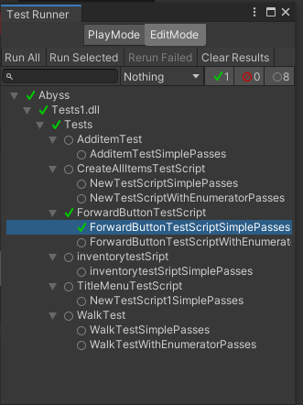

(gonna ask lecture to clear up what is actually needed

1. Title: the userstory

2. Screenshot of unit test (or UI test automation) code

3. Screenshot of test fail in the testing framework

4. Screenshot of the code to pass the test

5. Screenshot of test passing in the testing framework