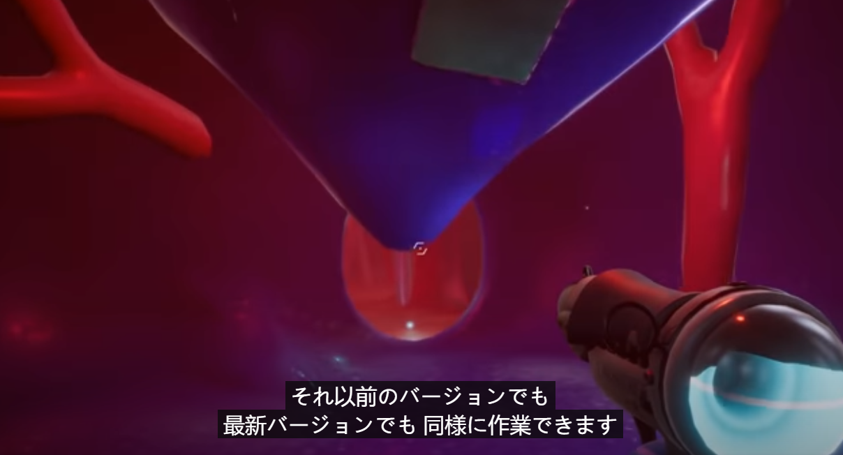

<https://github.com/amel-unity/Multi-Scene-workflow.git>

第一人称射击