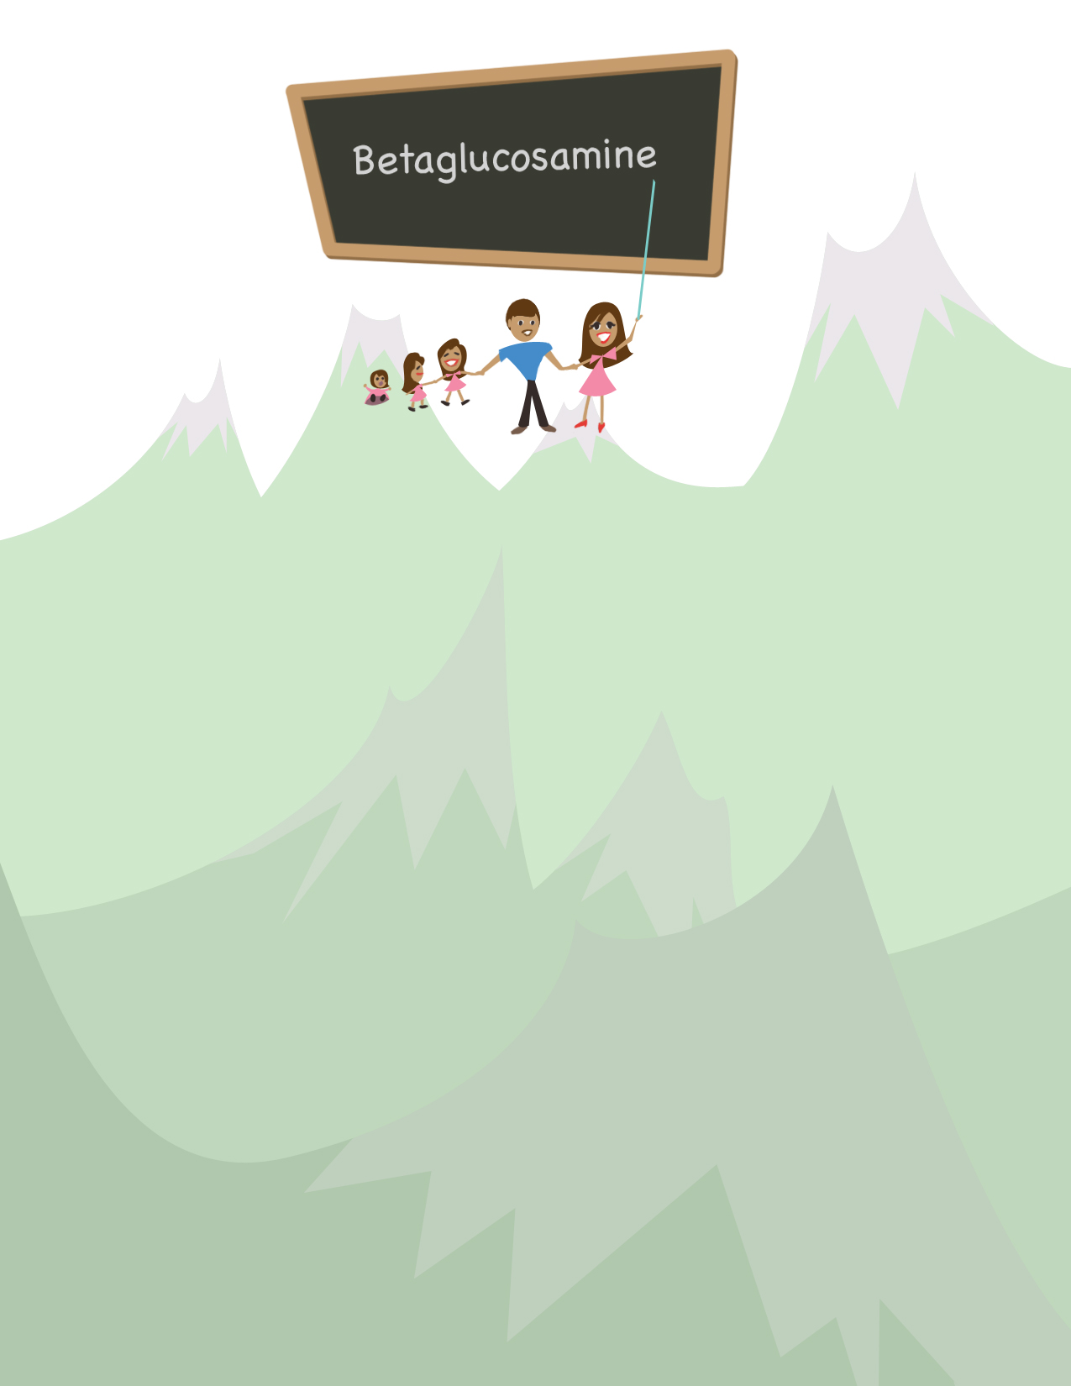
When
Yaneth
Montes was
nine years old,
her family came to the
United States from Mexico.
"According to my dad we were coming for summer vacation. But actually his intention was for us to be raised and educated here," she says.

The family stayed, Yaneth got her education, and now she makes a living educating others. It's not only because of the lessons she learned in American schools, but the lessons her mother taught her as well. As a little girl in Mexico seeing people in need, Yaneth had always wanted to work in the medical field. "Helping others, being nice, giving back," she says as she talks of her mom's influence and her reasons for working at the Imperial Beach Health Center.

Yaneth started out at the IB Health Center five years ago as a Receptionist, and then became a Medical Assistant. Then came a challenge. The doctor she worked with had been focused on diabetes patients and received a grant to create an educational position to benefit them. "She asked me if I wanted it. So I went for more intensive training." Yaneth became a Diabetes Care Coordinator, the position she holds now.

"At first it was overwhelming," Yaneth says. "But after I'd seen the progress we made with the patients, it became rewarding." Not only do words like "betaglucosamine" roll off her tongue now, but she can teach those words to people who are far less aware of their medical needs. "We teach them that the more they take their meds and monitor their sugars, the better their health will be and the longer they'll live."

June 2006

Now, Yaneth wants to go further with the once- overwhelming task.
She hopes to return to school to become certified as a
Diabetes Educator so she can do
outreach in the community. "Unfortunately, many people out there don't realize how important it is to get
basic health care to begin with," she notes.

Yaneth's unusual name is her father's invention. "When I was a kid I didn't like it," Yaneth admits. "People didn't pronounce it right, they didn't spell it right. But when I was about ten, I realized it was a unique name and I started liking it." Yaneth, too, is unique -- yet in many ways, she is the familiar, hard-working mom. She has three little girls, Verenise almost 8, Andrea just 4, and Jasmine 10 months. Her husband, Guillermo, is a truck driver and a very involved father. "He helps me a lot. He's a good husband," Yaneth says emphatically.

Her parents are both living in town, and she and her four brothers and sisters -- along with spouses and children -- all get together every Wednesday evening with their parents for dinner and family time. Yaneth's family also goes to Mexico about once a year to visit relatives. "I want my kids to have that connection between my family and their family," she says. Her daughters enjoy the different lifestyle, walking in the mountains and eating the farm-grown foods that Guillermo's father raises.

"I support my daughters in their own decisions, whatever they want," says Yaneth. "At first my oldest wanted to be a doctor. Then she decided to be a teacher. But now she wants to be a firefighter," she laughs. Verenise is now close to the age that Yaneth was when she first came to America to live a life her father had determined on. Making his dream come true means that Verenise can enjoy visiting the home he left years ago, while making her own choices in the new one.

