Alantric, a close friend of yours, is a bookworm who reads around a thousand books a year (or 2-3 books day on the average). However, because he is allergic to dust, he does not keep his books, but sells them instead at bargain prices. Alantric wants to keep track of the books he has bought, read and sold. When he learned that you are a software engineer, he asked if you could build a system that would help him keep track of the books he has bought and sold.

Interview Guide:

1. Do you encounter problems when it comes to managing book records, if yes, what are those?
2. Do you have any ways to keep track of the books you have bought, if yes, how?
3. What are your needs in the system you want to be build?
4. How many books do you usually buy in a week/in a month?
5. What are type of books do you have in your book collection?
6. Is there a certain situation that you buy a book for how many copies?
7. What are the important book details that you want to have in the system?
8. Any other needs you want to have in the system?

Minutes of the MeetUp

Q1: Do you encounter problems when it comes to managing book records, if yes, what are those?

Notes: The client encounter problems like:

* the client doesn’t have records of his book collection.

* the client doesn’t have any means of tracking book records that he had bought, read and sold.

Q2: Do you have any ways to keep track of the books you have bought, if yes, how?

Notes: The client doesn’t have any process in tracking book.

Q3: What are your needs in the system you want to be build?

Notes: The client wants to have the system a mechanism that can:

* save book information

* update book information

* delete book information

Q4: How many books do you usually buy in a week/in a month?

Notes: The average number of books the client bought books is 5.

Q5: What are type of books do you have in your book collection?

Notes: The client read books not only one genre. He also read other genres like:

* comedy

* inspirational

* romance

* suspense

* educational

Q6: Is there a certain situation that you buy a book for how many copies?

Notes: The client buy not only one book. Sometimes the client buy book for several copies.

Q7: What are the important book details that you want to have in the system?

Notes: The client is only concern with book details like:

* Title

* Author

* Publisher

* Genre

* ISBN

Q8: Any other needs you want to have in the system?

Notes: * The client want to have a simple system for him to entry book information

* He wants to know how many books he has in his collection

* He wants to have a book icon on the main interface of the system

* He may designate his secretary to enter book information in the system, a separate account can be used by the secretary

* He wants the system can search book details using the title or author or any buttons that can

be used for scanning the book in the system.

List of Observations

1. Books are kept in bookshelf
2. The secretary arranges the book by genre
3. The client and the secretary don’t have book records of his collections
4. The client has computer desktop in his office.
5. There are lots of books in his collections.
6. One book could have more than one copy.
7. Some copies where sold or give to his friends.

User Requirements

Functional Requirements:

1. Save book information
2. Update book information
3. Delete book information
4. Search mechanism for book
5. Count the number of books in his possession
6. Books are categorized by genre
7. The System should have book details like Title, Author, Publisher, Genre, ISBN
8. Separate user account for him and his secretary

Non-Functional Requirements

1. The main interface has book ICON
2. The system has simple interface

Entity Relationship Diagram

Has

Delete

Update

Add

Database Schema

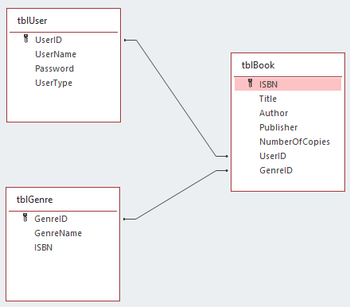

Data Dictionary

|  |  |  |
| --- | --- | --- |
| tblUser | | |
| Field Name | Type | Description |
| UserID | Short Text | ID of the user |
| UserName | Short Text | Username of the account |
| Password | Short Text | Password of the account |
| UserType | Short Text | User level (Admin / Non-Admin) |

|  |  |  |
| --- | --- | --- |
| tblBook | | |
| Field Name | Type | Description |
| ISBN | Short Text | Books ISBN number |
| Title | Short Text | Book title |
| Author | Short Text | Book author |
| Publisher | Short Text | Book pblisher |
| NumberOfCopies | Number | Copies of book in the Dbase |
| UserID | Short | ID of the user |
| CategoryID |  |  |

|  |  |  |
| --- | --- | --- |
| tblCategory | | |
| Field Name | Type | Description |
| CategoryID | Short Text | Username of the account |
| GenreName | Short Text | Password of the account |
| ISBN | Short Text | User level (Admin / Non-Admin) |

Hierarchy Chart

Use Case Diagram

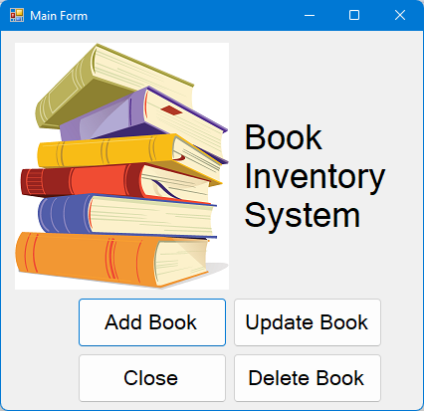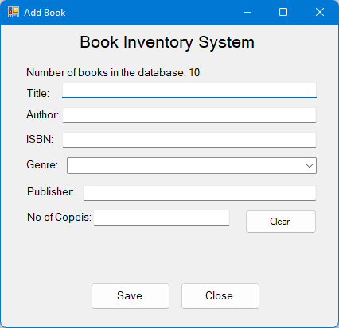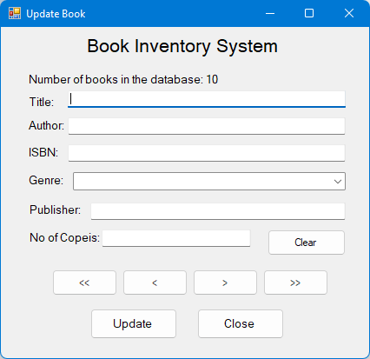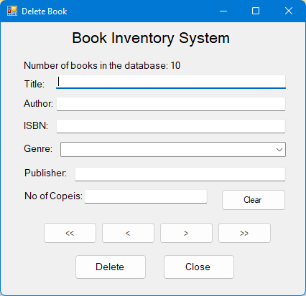

Use Case Description

|  |  |  |
| --- | --- | --- |
| Use Case: | Add Book | |
| Description: | This form will be executed when add book button is press. This form is used to add book information in the system | |
| Actor: | | System |
| Normal Flow | | |
|  | | 1. System display Add Books Form |
| 1. User enter book details like Title, Author, ISBN, select Genre, and Number of Copies 2. User press Save Button | |  |
|  | | 1. System display confirmation message |
| 1. User press ok button 2. The user press the close button | |  |
|  | | 1. System close the Add Book form and display the Main Form |
| Alternate Flow | | |
| 1. The user press clear button instead of save button | |  |
|  | | 1. System clear the textbox |
| 1. The user press close button | |  |
|  | | 1. System close the Add Book form and display the Main Form |
| Alternate Flow | |  |
| 6. The user enter another book details  7. User press save button | |  |
|  | | 8. System display confirmation message |
| 9. User press ok button  10. The user press the close button | |  |
|  | | 11. System close the Add Book Form and display the Main Form |
| Exception Flow | | |
| 3. User press save button | |  |
|  | | 4. System detects an error on No of Copies  textbox.  5. System display error message.  6. Text Cursor set to No of Copies textbox |
| 1. User will correct data entry for No of Copies 2. User press save button | |  |
|  | | 1. System display confirmation message |
| 1. User press the close button | |  |
|  | | 1. System close the Add Book Form and display the Main form |

|  |  |  |
| --- | --- | --- |
| Use Case: | Update Book | |
| Description: | This form will be executed when update book button is press. This form is used to update book information in the system | |
| Actor: | | System |
| Normal Flow | | |
|  | | 1. System display Add Books Form |
| 1. User enter book details Title or Author to search the book | |  |
|  | | 1. System display in the textbox the match the keyword |
| 1. User press <<, <, >, >> to search the book details. 2. User update data entry of the book 3. User press update button | |  |
|  | | 1. System display confirmation message |
| 1. User press ok button 2. User press close button | |  |
|  | | 1. System close the Update Book form and display the Main Form |
| Alternate Flow | | |
| 9. User press <<, <, >, >> button to search for  another book to update instead of close  button  10. User update data entry of the book  11. User press update button | |  |
|  | | 1. System display confirmation message |
| 1. User press ok button 2. User press close button | |  |
|  | | 1. System close the Update Book form and display the Main Form |

|  |  |  |
| --- | --- | --- |
| Use Case: | Delete Book | |
| Description: | This form will be executed when delete book button is press. This form is used to book information in the system | |
| Actor: | | System |
| Normal Flow | | |
|  | | 1. System display Add Books Form |
| 1. User enter book details Title or Author to search the book | |  |
|  | | 1. System display in the textbox the match the keyword |
| 1. User press <<, <, >, >> to search the book details. 2. User press delete button | |  |
|  | | 1. System display confirmation message |
| 1. User press ok button 2. User press close button | |  |
|  | | 1. System close the Delete Book form and display the Main Form |
| Alternate Flow | | |
| 1. User press <<, <, >, >> button to search for another book to delete instead of close button 2. User press update button | |  |
|  | | 1. System display confirmation message |
| 1. User press ok button 2. User press close button | |  |
|  | | 1. System close the Delete Book form and display the Main Form |



