Chapter 4

**DISCUSSION OF FINDINGS**

This chapter contains a discussion about the existing process, and the different difficulties being experienced in the current process of the Registrar's records management, as well as the features of the proposed system and the acceptance of the proposed system in terms of functionality, reliability, usability, efficiency, maintainability, and portability.

**Current Process in Registrar's Records Management**

The proponents conducted an interview with the Acting Registrar of PSU-Alaminos City Campus Mrs. Rose Dyan L. Sagun who is responsible for the records and transactions of the student in requesting documents. The proponents found out that the Registrar Office is still using manual processes in recording transaction records.

Requesting official documents. Requesting official documents requires an official receipt after paying the corresponding amount to the cashier. The registrar will take the official receipt for the requested documents of the student.

Requester of the documents needed to write down their information such as, name and department. The registrar will process the request documents until it is ready for release. Upon receiving the documents, the student needed to sign their name, course, receive date and signature in the Official Transaction Record.

Figure 6:

Requesting official documents in Registrar.

Get Receipt

Stack the receipt according to their time

Print the documents based on the collected receipt

Released the printed documents.

Logbook for those released documents.

Keeping of student records. Registrar’s Office keeping all the records of student upon the first day of enrollment of the student. The registrar collects all the requirements and records of student for keeps the student’s requirements, documents, and records into an envelope and store in the shelf’s.

Figure 7:

Keeping of student records

Registrar collect student requirements

Store in the shelf

Searching of student records. Searching for the student records the registrar need to do it manually. The registrar scan through the shelf to find the records that the registrar needed.

Figure 8:

Searching of records

The registrar was notified to search a record

Scan records in the shelf

Found records

**Difficulties encountered in Registrar's Records Management**

Based on the data gathered from the interview conducted with Mrs. Rose Dyan L. Sagun, the following are the difficulties encountered by Mrs. Rose Dyan L. Sagun.

Recordkeeping. Due to the enormous number of students on the campus keeping all their records organized has become challenging. There are times wherein they experience loss and misplacement of records that are being stored manually. Mrs. Dyan is having a tough time searching for the files she needs because of the enormous number of receipts.

Time-consuming in searching records. Searching of records is done manually. Registrar’s office staff must search through files/folders on the drawers’ manual which makes it time-consuming. It requires more time to locate the records needed, especially if that record needed is from the students of the past few years.

Generation of reports. The registrar is having difficulty in producing reports needed by different offices or units. There are some instances where the registrar needs to count the number of students who have requested in different transactions in the office.

Delayed releasing of documents. During the times when students need documents for their scholarship requirements, a lot of requests need to be processed in a day. It requires a lot of time to produce documents because of bulk requests.

Unable to send notification to the requestor. Every process in requesting and claiming files/documents in the Registrar’s office is done on a manual process. Sometimes students return multiple times to check on their request. It requires a lot of effort for the students to check on their request progress/status.

**Features of the proposed records management system** The development of registrar’s records management system for PSU-ACC is designed to provide the following features.

Manage Request. This feature allows the registrar to view pending, claimable, released, overdue, and update requests. The registrar can view the following: pending request list, claimable request list, released request list, and overdue request list, and all request list the summary of all the request documents. This feature allows the register to update the status of the request documents. The figures below show the different functionalities of the feature.

Figure 9:

Pending Request

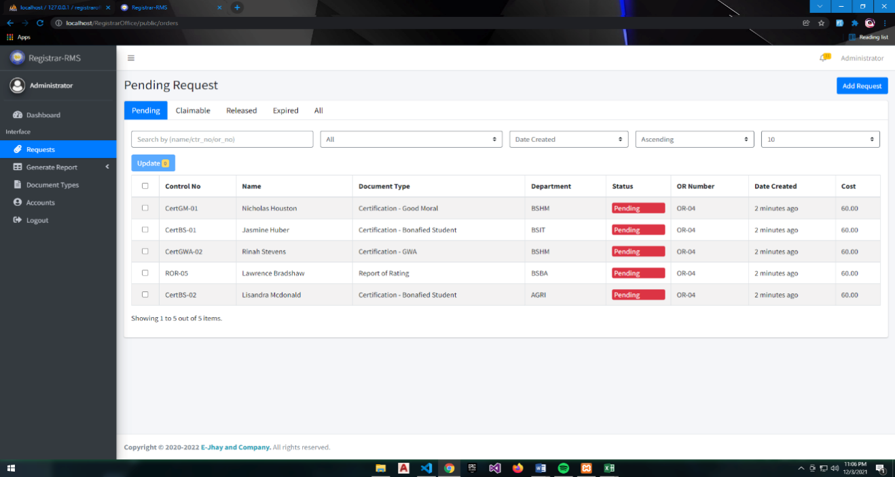

Figure 5.

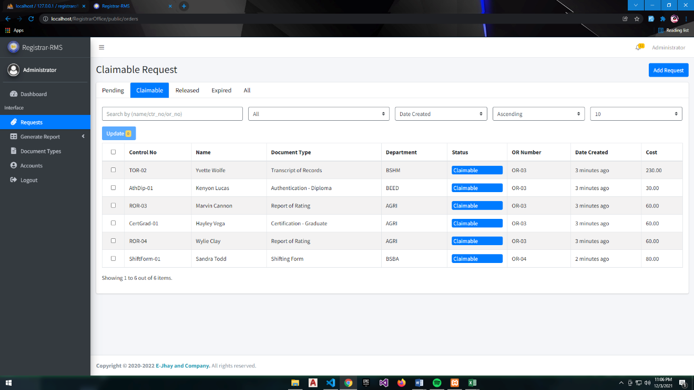Claimable Request

Figure 6

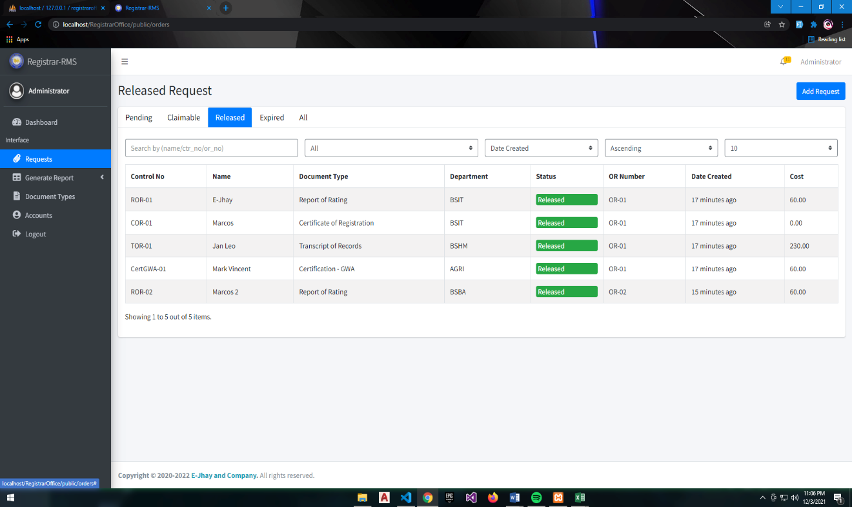Released Request

Figure 7

Overdue Request

Figure 11

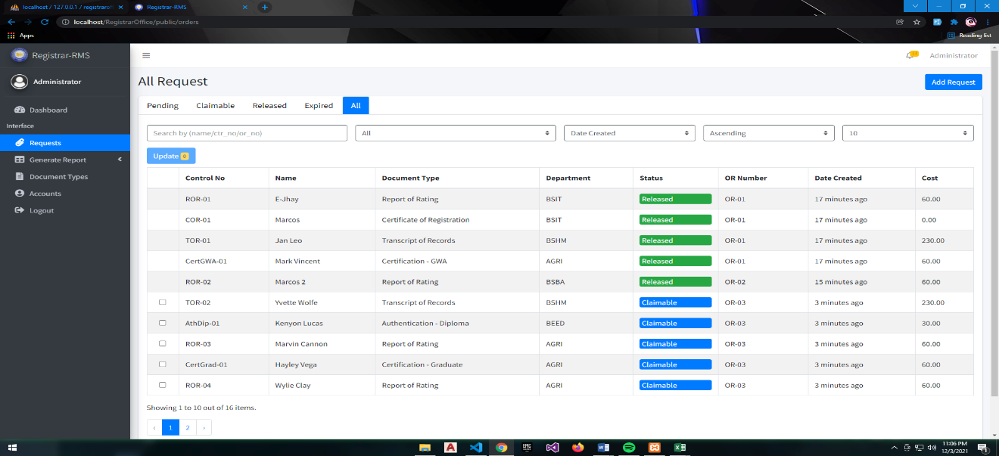All Request

Generation of Reports. This feature allows the registrar to produce transaction reports of student’s request into two categories monthly and quarterly in excel or document type.

In the monthly accomplishment reports this report contains a summary of all the requests that are released. Quarterly reports are the summary of the quarter transaction in a different format monthly. Figure below shows the format of monthly and quarterly reports of the system.

Figure 11.

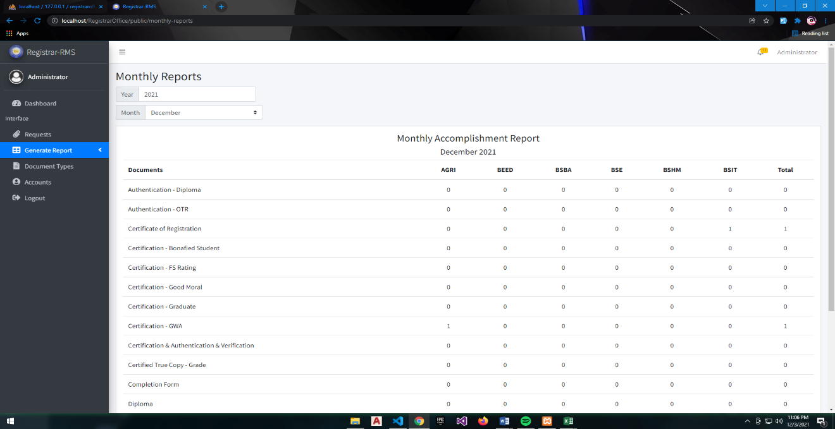Monthly Accomplishment Report

Figure 12.

Quarterly Report

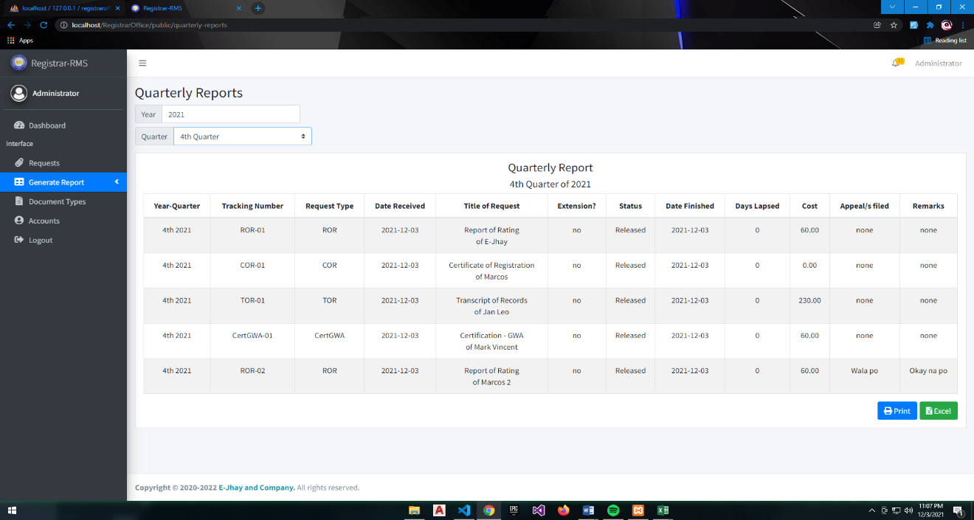

Manage Document Types. This feature allows the registrar to add, view and edit document types for the different requests.

Adding and editing of new and existing document types in the list needed to provide the following information: document name, document code, date of expiry and price of the documents. This features also allows the registrar to the list of all document types. Figure bellows show the follow functionalities.

Figure 13

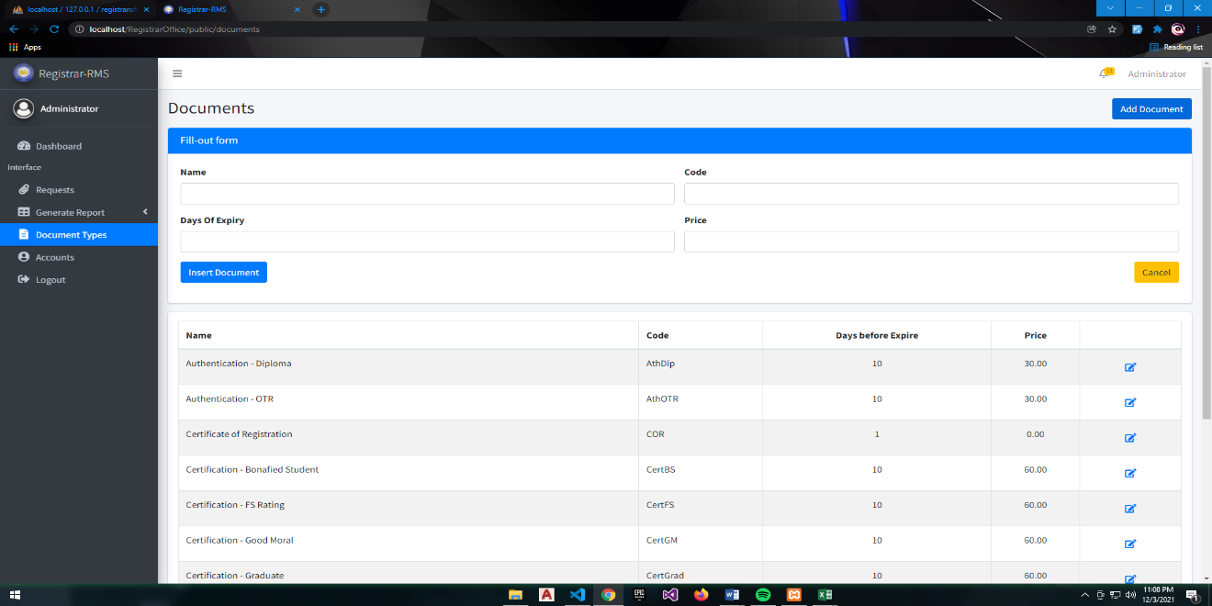Add and Edit form of document types

Figure 13.

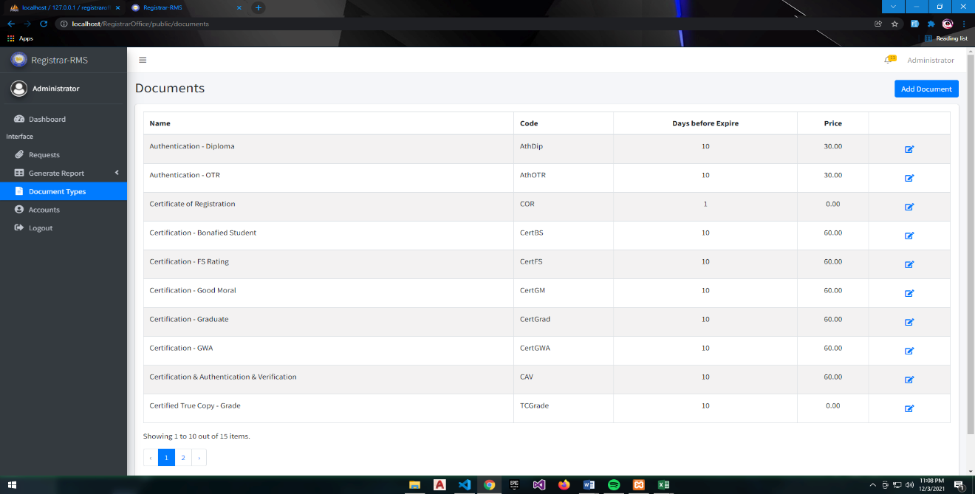Viewing Document types

Notification. This feature allows the registrar to notify the requester upon updating the status of the request. The requester will be notified through SMS (Short Message Service), the SMS will contain confirmation that the request is processed and ready to claim. It also contains the PSU (Pangasinan State University) – Alaminos City Cam City Campus Appointment link. Figures below sample notification of the system through SMS.

Figure 14.

Sample SMS Notification

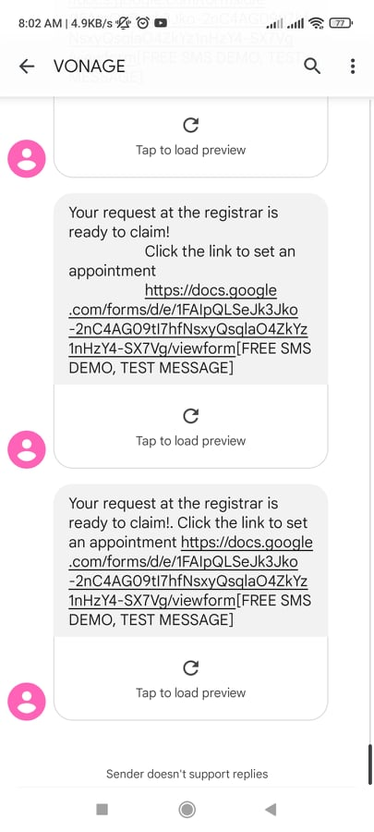

Add Request. This features allow the student to input their request. The student needed to input their cellphone number, official receipt number and name. After entering the required information, the student will choose their document types and department. This feature helps the registrar to lessen they work load.

Figure 15

Add Request Form

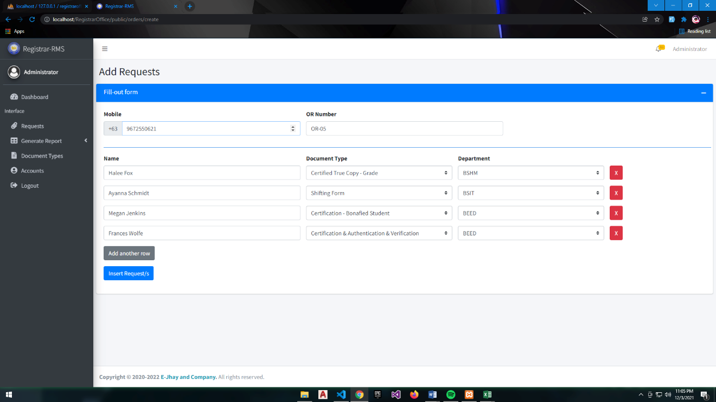

**Acceptability test of RMS**

In the completion of RMS for the Registrar Office of the PSU – ACC, the system will be accessed by the registrar and the IT faculty of PSU – ACC.

Functionality. Table 3 shows the perception of evaluators on the system with respect to its functionality. The respondent rate functionality of the system is reflected with an overall mean of 4.73 which interprets as excellent. The functions of the system are appropriate in terms of suitability, with a total average weighted mean of 4.4, which translates to excellent. The measured data can be used by the registrar for data appropriateness. In terms of accuracy, PSU-ACC Registrar Office RMS has a total average weighted mean of 4.4, which translates to excellent, the RMS adheres to existing standards and policies. For security, the system prevents unauthorized access with an average weighted mean of 4, which is considered very good. The developed system can provide security to authorized personnel such as usernames and passwords in accessing the system.

Table 3:

System Evaluation According to Functionality

|  |  |  |
| --- | --- | --- |
| **Functionality** | **Mean** | **DESCRIPTION** |
| 1. Suitability – Function of the system are appropriate. | 4.4 | Excellent |
| 1. Accuracy – The system’s Results are accurate. | 4.4 | Excellent |
| 1. Security – It prevents unauthorized access. | 4 | Very Good |
| **Weighted Mean** | 4.267 | Excellent |

Reliability. Table 4 page 49 shows the perception of evaluators on the system with respect to its reliability. The respondents rated the systems as excellent, with a total mean of 4 indicating that the system performs consistently. In maturity, there is minimal frequency of fault/failures the system with an average weighted means of 4 which translate as very good, the system capable in handling changes of its environment. In fault tolerance, the system has capability of handling system errors with an average weighted means of 3.75, adheres that the system is capable of continuing its normal operation. In recoverability, the develop system performance is re-establishing from failure with an average weighted mean of 4.25 that translate excellent, the system continuously receives data from the internet.

Table 4:

System Evaluation According to Reliability

|  |  |  |
| --- | --- | --- |
| **Reliability** | **Mean** | **DESCRIPTION** |
| 1. Maturity – there is minimal frequency of software faults/failures. | 4 | Very Good |
| 1. Fault Tolerance – The system has capability of handling system errors. | 3.75 | Very Good |
| 1. Recoverability – System’s performance is re-establishing from failure. | 4.25 | Excellent |
| **Weighted Mean** | 4 | Very Good |

Usability. Table 5 shows the perception of evaluators on the system with respect to its usability. The respondents rate the usability of the system with an average weight mean of 4.73 which interprets as excellent. In understandability, concepts of the PSU – ACC Registrar’s Office Record Management System are easily recognized with an average weighted mean of 4.8 that interpret as excellent, that the respondent clearly understand the concept of the system. In learnability, effort in learning the system is reduced with an average weighted mean of 4.8 that translate excellent. And in operability, the mobile application and device is easy to use or operate with an average weighted mean of 4.6 which interpret as excellent.

Table 5:

System Evaluation According to Usability

|  |  |  |
| --- | --- | --- |
| **Usability** | **Mean** | **DESCRIPTION** |
| 1. Understandability – Concepts are easily recognized. | 4.8 | Excellent |
| 1. Learnability – Effort in learning the system is reduced. | 4.8 | Excellent |
| 1. Operability – The system is easy to use or operate. | 4.6 | Excellent |
| **Weighted Mean** | 4.73 | Excellent |

Efficiency. Table 6 shows the perception of evaluators on the system with respect to its efficiency. The respondents rate efficiency of the application as reflected with an overall mean of 4.4 which interprets as excellent. In time behavior, there is fast response time of the system with an average weighted mean of 4.2 which translate as very good. And in resource behavior, resources used for system performance are accessible with an average weighted mean of 4.6 which interprets as excellent.

Table 6:

System Evaluation According to Efficiency

|  |  |  |
| --- | --- | --- |
| **Efficiency** | **Mean** | **DESCRIPTION** |
| 1. Time Behavior – There is fast response time of the system | 4.2 | Very Good |
| 1. Resource Behavior – Resources used base for the system performance are accessible | 4.6 | Excellent |
| **Weighted Mean** | 4.4 | Excellent |

Maintainability. Table 7 shows the perception of evaluators on the system with respect to its maintainability. The respondents rate on the maintainability of the application as reflected with an overall mean of 4.5 which interprets as excellent. In analyzability, there is less effort in identifying system and device failure causes with an average weighted mean of 4 which interprets as very good. In terms of changeability, effort of in modifying the system are reflected with an average weighted mean of 4.75 which translate as excellent. In terms of stability, the sensitivity of the system to modification are reflected with an average weighted mean of 4.75 which interprets as excellent.

Table 7:

System Evaluation According to Maintainability

|  |  |  |
| --- | --- | --- |
| **Maintainability** | **Mean** | **DESCRIPTION** |
| 1. Analyzability – There is less effort in identifying system failure causes. | 4 | Very Good |
| 1. Changeability – Effort in modifying the system | 4.75 | Excellent |
| 1. Stability – Sensitivity to modification | 4.75 | Excellent |
| **Weighted Mean** | 4.5 | Excellent |

Portability. Table 7 in page 53 shows the perception of evaluators on the application with respect to portability. The respondents rate portability of the system as reflected with an overall mean of 4.67 which interprets as excellent. In adaptability, specification changes in the system are done easily with an average weighted mean of 4.8 which interprets as excellent. In installability, there is effortless process of installing the application in mobile phone with an average weighted mean of 4.6 which interprets as excellent. In conformance, the mobile application and device is compliant to portability standards with an average weighted mean of 4.6 which interprets as excellent.

Table 7:

System Evaluation According to Portability

|  |  |  |
| --- | --- | --- |
| **Portability** | **Mean** | **DESCRIPTION** |
| 1. Adaptability – Specification changes are done easily. | 4.8 | Excellent |
| 1. Installability – There is effortless of installing the system. | 4.6 | Excellent |
| 1. Conformance – System is compliant to portability standards. | 4.6 | Excellent |
| **Weighted Mean** | 4.67 | Excellent |

**Overall: 4.427 Excellent**