## ED5502 (Specialist Diploma) Homework 1

Modify the program of Lab 1 so that it moves a single ON LED across a LED bar array in one direction, then another.

Each LED should stay ON for 500ms at a time.

The LEDs are connected as follows:

LED0, LED1 not connected

LED2 - D2 - PA10

LED3 - D3 - PB3

LED4 - D4 - PB5

LED5 - D5 - PB4

LED6 - D6 - PB10

LED7 - D7 - PA8

LED8 - A5 - PC1

LED9 - A4 - PC0

Use the Lab sheets of Lab 1 as a guide and use STM32CubeMX to configure the pins.

You can use similar setups as in Doc 7 on creating the Blink program, but you will need to configure the pins driving LEDs 2-9 as GPIO Output pins.

They should appear as follows in STM32CubeMX:

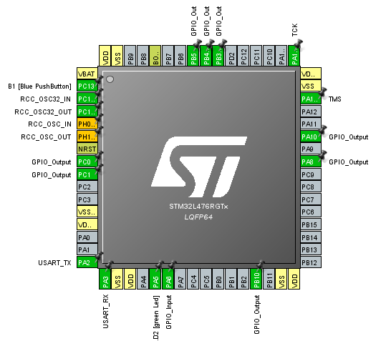

The LED array writing function should be left in main.c. Submit your source code using Sulis and display a working version of your program in Week 4.

Note: As agreed at the lecture (30 Jan 2019) this homework exercise is optional. I would encourage people to try it out, however, and I would hope that at least some people can demonstrate a working version of the program.