## Specialist Diploma in Embedded Systems: ED5502 Spring 2019, Homework 2

This homework sheet counts for 5% of the module assessment.

Submission date: Wednesday, 20 February 2019 (Week 5)

1. Bitwise logical operations in C:

Suppose that we have

unsigned char var1, var2, var3, var4, var5, var6, var7;

var1 = 0x51;

var2 = 0xb4;

var3 = var1^var2;

var4 = var1 | var2;

var5 = var1 & var2;

var6 = var1 & ~var2;

var7 = var2 & 0x80;

What values do you expect to find in var3, var4, var5, var6, var7?

2.

(a) Suppose that all bits of GPIOB have been set as inputs. I want to test Port B bit 6. What is wrong with the following line of code?

if ((GPIOB->IDR & 0x00000040) == 1)

{

/* some useful code here */

}

(Note that 0x40 does correspond to bit 6 – that’s not the problem.

(b) Rewrite the if statement to correct the error.

3. CMSIS compliant register naming and use

The following description of the ADC interrupt register is found in the STM32L476RG Reference Manual:

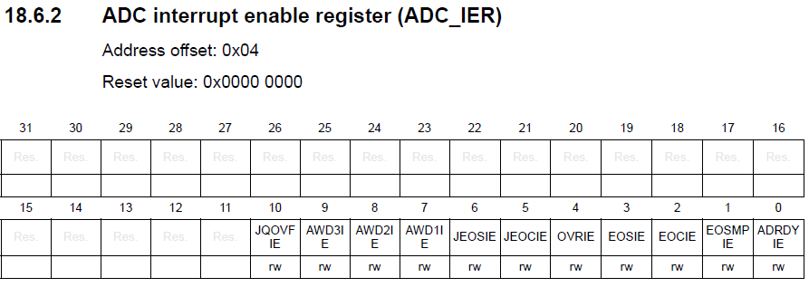

(a) At what address in the STM32 memory space is this register located?

(b) Write a line of C code to set bits 6 & 3 of this register.

4. GPIO Ports, bit setting, bitwise logic

(a)

I want to write a ‘1’ to GPIO Port C bit 10, leaving all other bits unchanged.

Write a line of C code to do this.

I want to write a ‘0’ to GPIO Port C bits 7 and 2, leaving all other bits unchanged.

Write a line of C code to do this.

(b)

Suppose my microcontroller is operating in a safety critical environment. Rewrite the lines of code of part (a) so that only atomic bit setting and resetting operations are used.

5. GPIO initialisation

I want to setup GPIO Port B such that a pull up resistor is enabled on Pin 11 and a pull down resistor is enabled on Pin 2. Write a line of C code to do this. (Assume that all other Port B registers have been setup appropriately).

Submission:

Please submit your answers on Sulis before 5pm Wed 20 February 2019, in plain text, MS Word, pdf or any other readable format.

All questions carry equal marks.