# 字符串构造方式

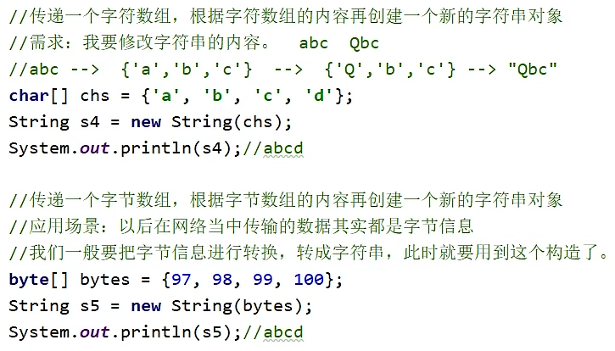

# 比较字符串是否相等

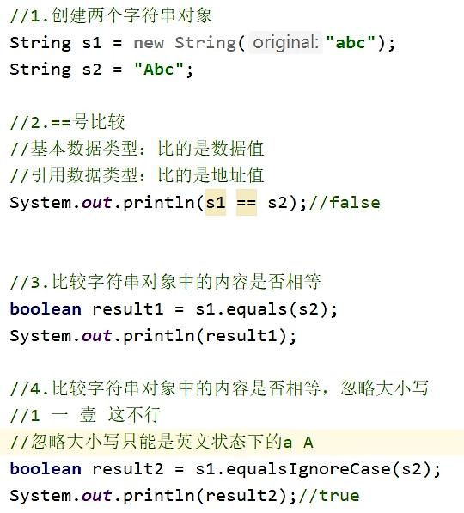

# 字符串金额转换练习

import java.util.Scanner;  
  
public class Main {  
 public static void main(String[] args) {  
 Scanner sc = new Scanner(System.*in*);  
 int money;  
 *//获取金额* while (true) {  
 System.*out*.println("请输入金额：");  
 money = sc.nextInt();  
 if (money > 0 && money <= 9999999) break;  
 else System.*out*.println("金额无效");  
 }  
  
 *//修改金额成中文* String res = new String();  
 String[] unit = {"元", "拾", "佰", "迁", "万", "拾", "佰"};  
 int i = 0;  
 while (money > 0) {  
 int cur = money % 10;  
 money /= 10;  
 res = *getChinese*(cur) + unit[i] + res;  
 i++;  
 }  
  
 *//补位* int count = 7 - i - 1;  
 for (int j = count; j < 7; j++) {  
 res = *getChinese*(0) + unit[j] + res;  
 }  
 System.*out*.println(res);  
 }  
  
 public static String getChinese(int num) {  
 String[] ch = {"零", "壹", "贰", "叁", "肆", "伍", "陆", "柒", "捌", "玖"};  
 return ch[num];  
 }  
}

# StringBuilder

常用方法

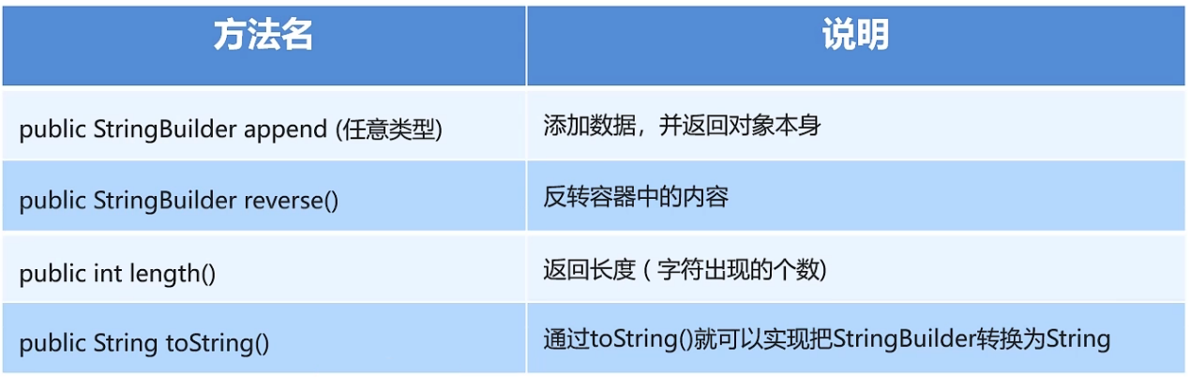

例子：

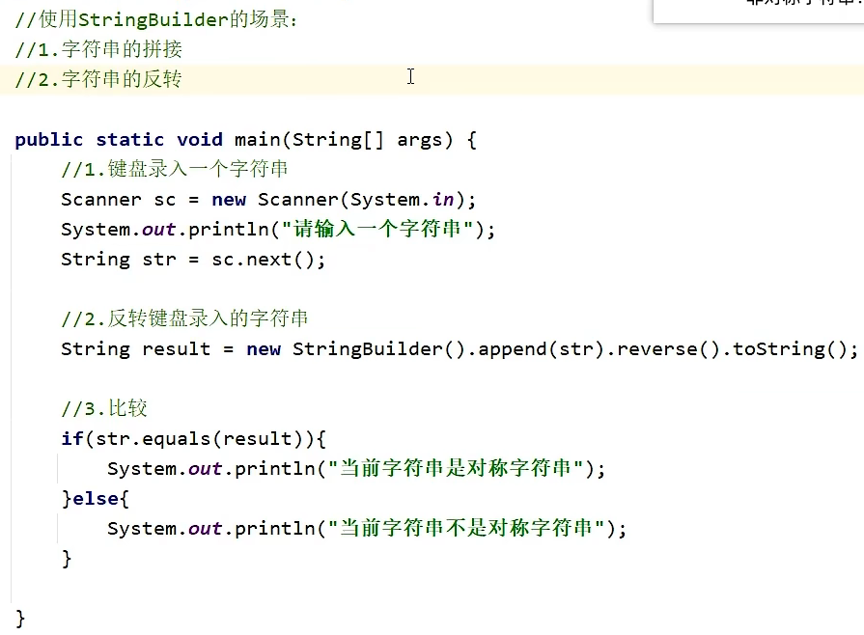

# StringJoiner

构造方法

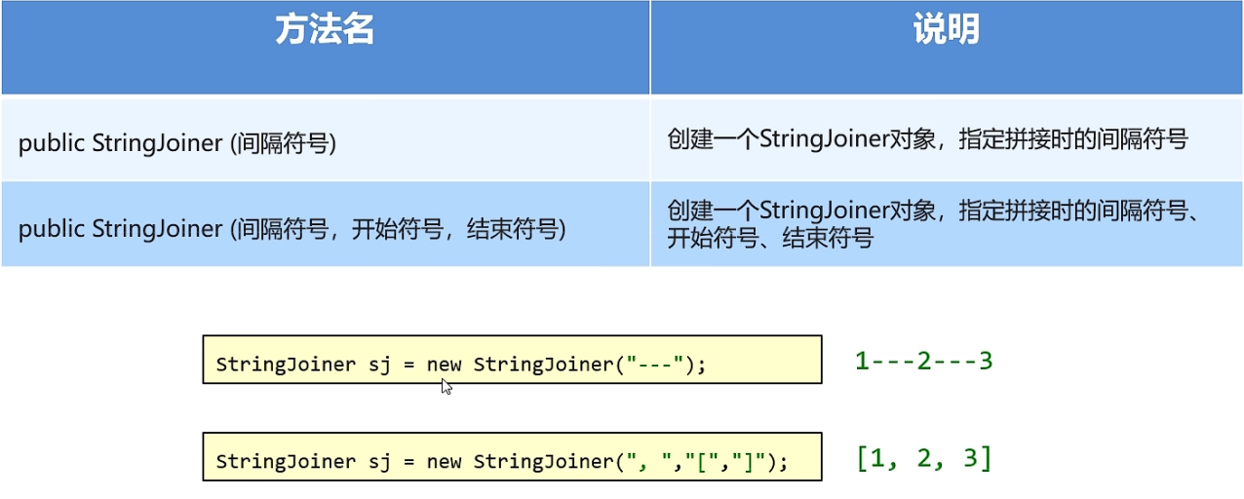

成员方法

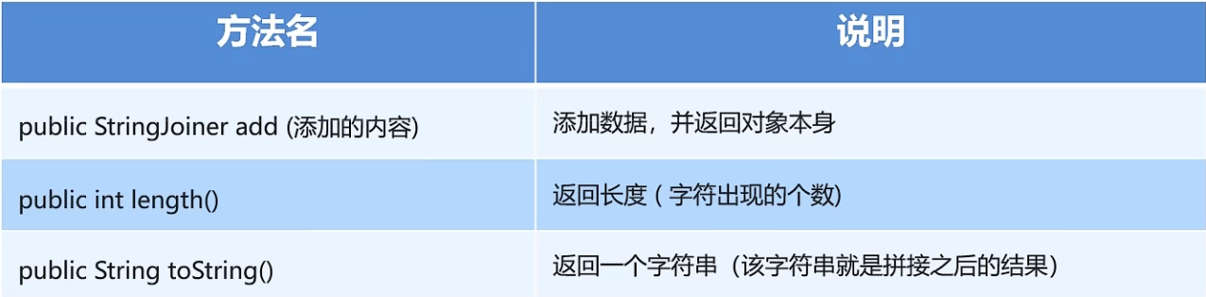

例子：

