Group 4, Milestone #2
Team Members: Zak Nizam, Caleb Schumacher
Selected Case Study: Willson Financial Services

Core Business Rules
These are the business rules based on the selected case study:
- A Client may have many Transactions.
- Each Transaction must belong to one and only one Client.
- Each Client has a total amount of Assets Under Management (AUM) recorded in the system.
- A Client is uniquely identified by a client_id.
- Each Transaction must include a transaction date and transaction amount.
- Each Transaction must be classified by a transaction type (e.g., deposit, withdrawal, transfer).
- The system must track the date a Client was added to the firm.
- The system must support reporting on the number of Clients added per month.
- The system must support calculating the average assets across all Clients.
- The system must support identifying Clients with more than ten transactions within a single month.
- An Employee may schedule many Client Appointments.
- Each Appointment must be associated with one Client and one Employee.

Assumptions
Because the case study does not explicitly define every detail, the following assumptions were made:
- “Client added” refers to the client_created_date field stored in the database.
- Assets are stored as a single aggregated currency value per client, rather than broken down into individual holdings.
- Transactions are stored individually and include transaction_date and transaction_amount.
- A month is determined using the transaction_date field.
- Each employee has a unique employee_id.
- Billing structure changes will be modeled in later milestones if needed.
- Currency values will be stored using a DECIMAL data type.
- Dates will be stored using the DATE data type in YYYY-MM-DD format.
- Entity Relationship Diagram (ERD)
  - The ERD below reflects the business rules defined above:
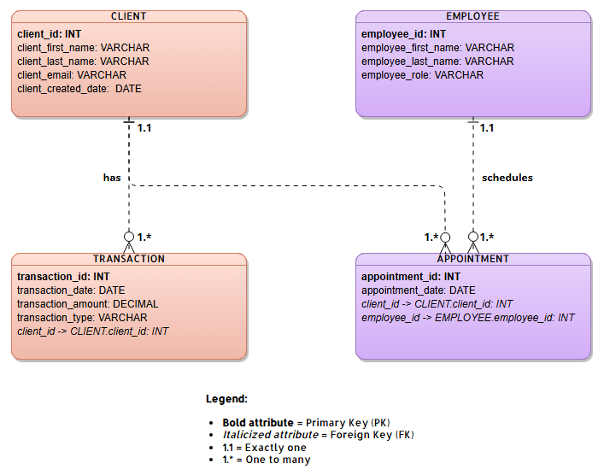

Database Display

