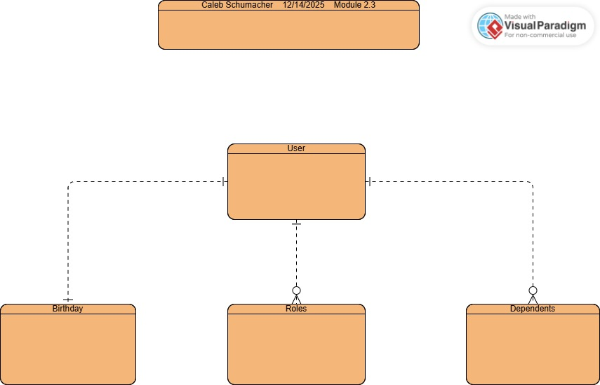

NoSQL Data Structure:
{
“birthdate” : 1/1/2025,
“roles” : [
{
“type” : “programmer”
},
{
“type” : “data analyst”
},
]
“dependents” : [
{
“name” : “Sara Bland”
}
]
}

