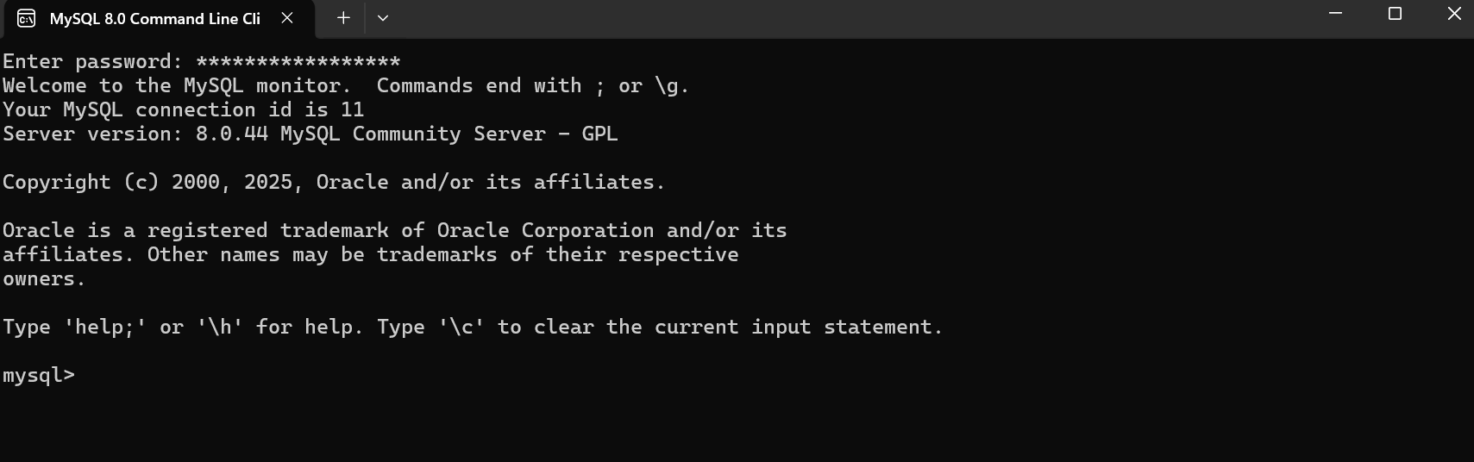

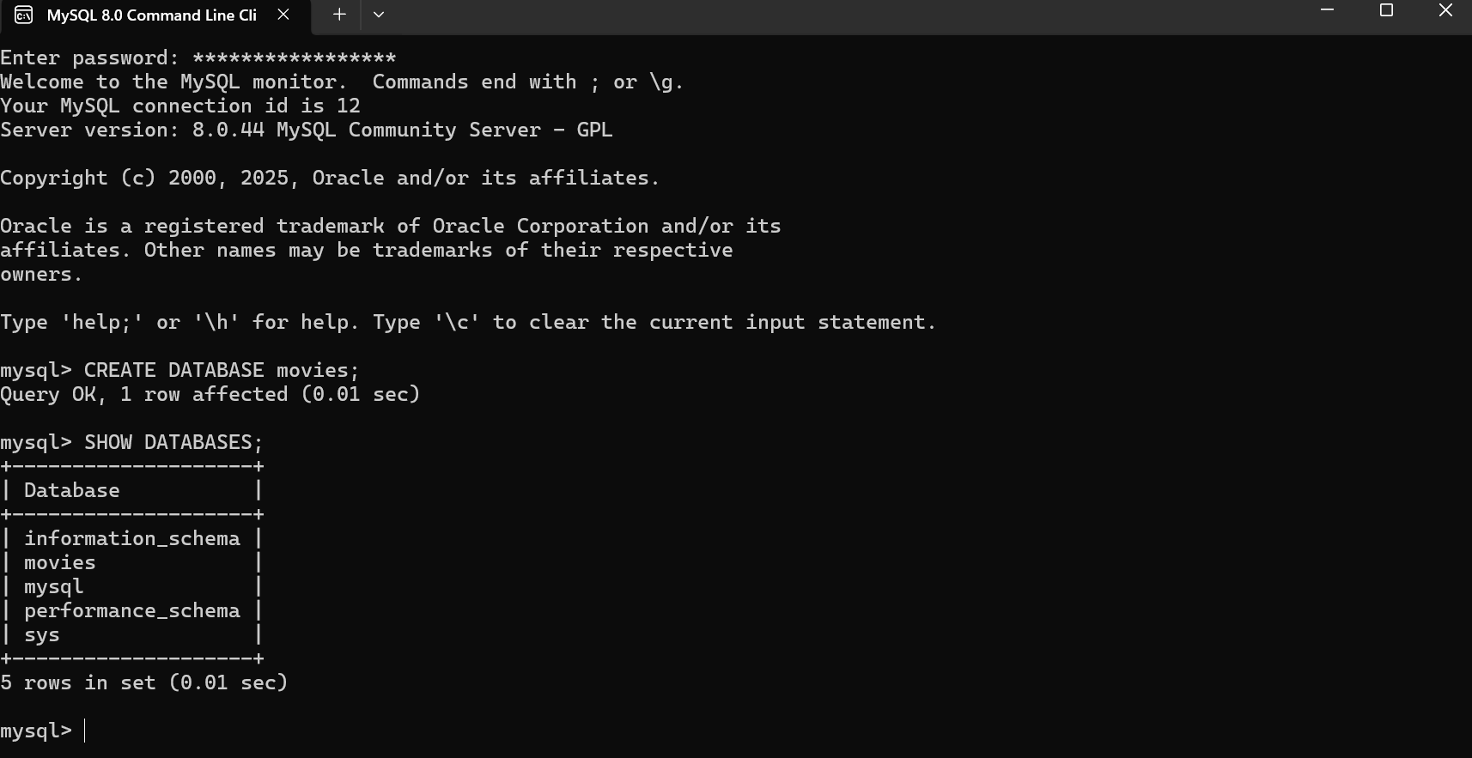

3 Functions
CREATE TABLE
Used to create tables within a database
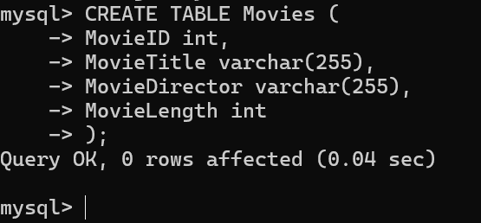
SELECT
Used to select data from a database, either data within a table or a table itself
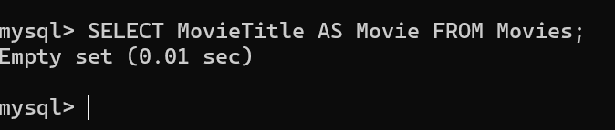
INSERT INTO
Inserts data into a table
