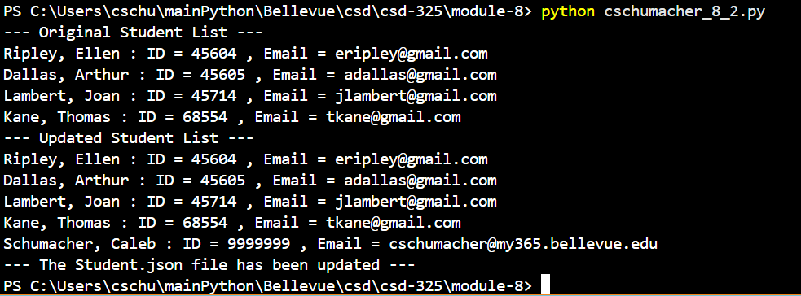

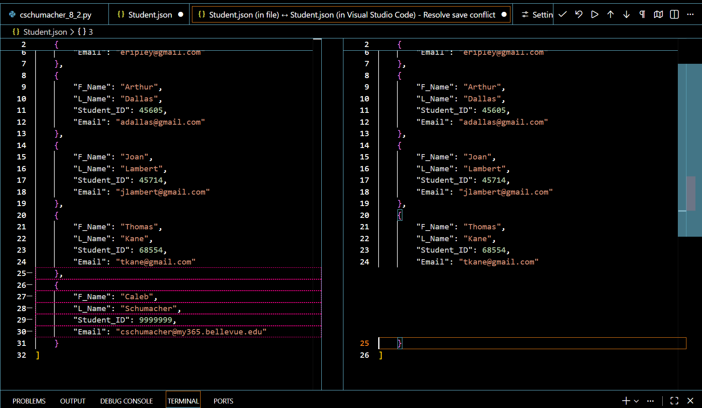
VS Code does not want to give me the notification for the json file being changed. The above screenshot is the best I could get, by editing the json file first without saving it, then running the program, then saving the json file causing the save conflict.

