Style Guide:
1. Semantic Document Structure
- <header>: Contains the subject’s name (H1) and a simple <nav> if using anchor links to different sections.
- <main>: Wraps the core content.
- <section>: Use individual sections for My Brother, Biography, and Gallery.
- <article>: Used for the 10 interview questions to treat them as independent pieces of content.
2. Interview Question Markup
- Since questions are scattered, use a consistent class structure to manage their "floating" positions via CSS
- Make the answers to the 10 questions hidden until the user clicks or scrolls past them to encourage exploration
3. Biography Implementation
- The 250-word description should be kept in a clean, readable container to contrast with the scattered elements.
4. Accessible Media (The 7 Images)
To keep the site accessible while maintaining the playful aesthetic:
- Alt Text: Every <img> tag must have descriptive alt text (e.g., alt="Seven-year-old boy wearing a dinosaur cape and jumping off a playground slide").
- Figure/Figcaption: For images tied to specific interview questions, wrap them in <figure> tags to semantically link the image to its "scattered" context.
5. Performance & Loading
- Lazy Loading: Apply loading="lazy" to the 7 images (especially those in the bottom gallery) to keep the initial page load snappy.
- Responsive Images: Use the srcset attribute so mobile users aren't downloading full-resolution desktop photos.
6. Visual Identity & Color
- A bold, high-contrast palette keeps the site engaging and easy to navigate
- Primary Palette:
  - Electric Blue (#007AFF): For interactive elements and buttons.
  - Sunshine Yellow (#FFD700): For highlights and question "callouts."
  - Grass Green (#32CD32): For background sections and biographical text cards.
- Secondary Palette:
  - Cool Grey (#F2F2F7): Neutral background for long-form biographical text to improve readability.
  - Deep Charcoal (#1C1C1E): For all primary body text.
7. Typography
- Mix "fun" header fonts with highly legible body fonts to maintain a professional look while feeling youthful.
- Headers: Fredoka One. Use for the subject's name and the 10 interview questions.
- Body Text: Nunito. A rounded sans-serif that remains friendly but readable for the 250-word biography.
8. Layout & Content Distribution
- The site should be a single-page scrolling journey with three distinct content zones along with a footer.
- The Hero Zone:
  - Subject Intro: Name in large, playful typography.
  - Image 1: A high-quality "Hero" shot of the child.
  - Scattered Elements: The first 2 questions and answers (e.g., Q: "Favorite Snack?" A: "Cheese crackers!") floating as "chat bubbles" in the margin.
- The "All About Me" Zone (Biography):
  - Text Placement: The 250-word biography centered in a clean, white "paper" card with rounded corners.
  - Supporting Images: Images 2-4 (Action shots: sports, hobbies, or pets) staggered around the biography text.
  - Scattered Elements: Questions 3-6 tucked between image captions or as "tooltips" on the photos.
- The Gallery & Fun Facts Zone:
  - Image Grid: Images 5-7 in a "messy polaroid" style grid.
  - Scattered Elements: Questions 7-10 scattered as handwritten-style notes pinned near the polaroids.
- Final Call-to-Action: A fun footer like "Thanks for visiting!" with a bright Email/Contact Button.

Ten Question Interview
- What’s your favorite food?
  - I like steak, because that’s your favorite food.
- What do you want to be when you grow up?
  - I dunno, maybe I could go into the army and become a soldier.
- What’s your favorite sport?
  - I like hockey, but I also like soccer. I scored 7 goals at our last soccer practice.
- What’s your favorite thing to do outside?
  - Probably going on an adventure in the woods.
- What’s the best vacation you’ve been on?
  - Branson was my favorite. They had really good shows and mini-golf.
- If you could go to outer space for a day, would you want to go?
  - Yeah! That would be literally so cool. But I wouldn’t want to stay very long.
- What’s your favorite subject in school?
  - Science. Learning about rocks is really cool.
- What’s your favorite instrument?
  - I think I like the guitar the best since lots of people play it.
- Do you prefer cake or pie?
  - Cake!
- What’s your favorite book?
  - Right now, I like Little House on the Prairie because Mom reads it to me every night.
Jackson is my seven year old younger brother. My family adopted him when he was just a newborn baby and he has brought a bright energy into all of our lives. He is a lively young boy with an effervescent personality which has melded into our family in a fantastic way. Because all of his older siblings are adults, he has developed quite the personality having been heavily influenced by my two brothers, my two sisters, and I. Even with that older sibling influence, Jackson already had a lot of unique traits that make him stand out as a person.
Jackson loves playing outside. He has a lot of energy and likes to spend it going on adventures in the woods outside his home. He also loves playing soccer as well as hockey (when he’s able to!) He really likes anything to do with the U.S. army and thinks soldiers are the coolest people in the world. He likes eating steak (probably because that’s his big brother’s favorite food) and his favorite subject in school is science. He loves reading, and he especially loves when Mom reads him good stories before bed, such as Little House on the Prairie. He enjoys cake and likes when people play guitar. Jackson has a really big heart and loves talking to people regardless of their age. Whether it be his friends at school, his older siblings, or random people out at a restaurant, he loves putting himself out there. He is a dynamic, outgoing, and highly energetic young person and I love hanging out with him. I’m excited for what he’s going to become as he grows up!

Wireframe:
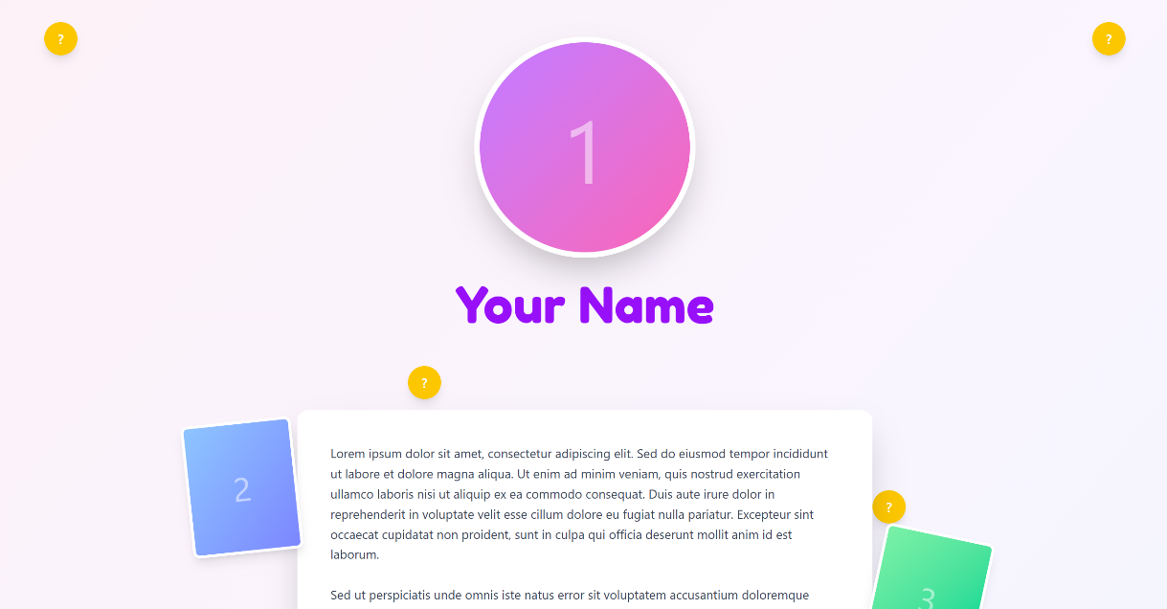

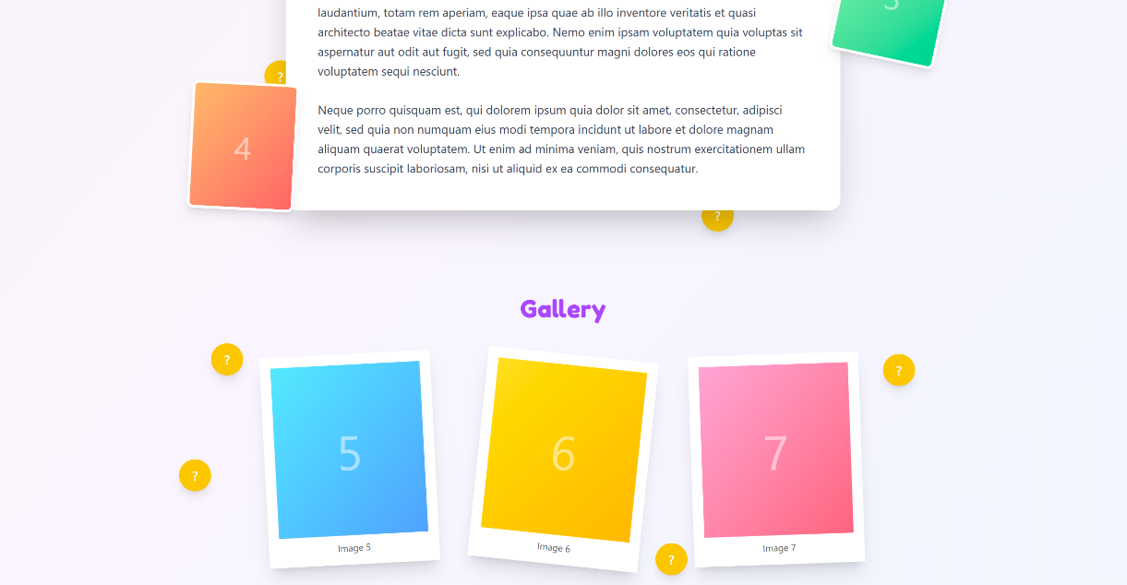



Images:
