Test Case Plan
Todo Application Test Plan
Name | Zak Nizam
Assignment | Module 4.2 Assignment - Test Plan Discussion
Project | Todo Application Test Plan
Course | CSD380-T301 DevOps (2267-1)
Description | Functional test plan for the Todo application based on the Todo Business Requirements document. The plan covers URL access, task list viewing, task creation, task editing, task deletion, form validation, invalid URL handling, and mobile/tablet views.
Date | 2026/07/02

Table of Contents
Test 1: Website Access and Task List View 2
Test 2: Create Todo Task and Add Form Validation 3
Test 3: Edit Todo Task and Edit Form Validation 4
Test 4: Delete Todo Task 5
Test 5: Invalid URL and Responsive Device Views 6

Testing note: Peer tester fields and screenshots should be completed by the assigned peer tester after they execute the same steps. Developer pass/fail values should be updated if an observed result differs from the expected result.

Test 1: Website Access and Task List View
Test Objective |  | Verify users can access the Todo website through the standard URL and view the list of todo task items. Covers requirements 10 and 1.
Developer |  | Zak Nizam |  | Peer tester |  | Caleb Schumacher
Date tested |  | 2026/07/02 |  | Date tested |  | 2026/07/05
Step | Action |  | Expected results |  | Developer pass/fail |  | Tester pass/fail + Screenshot
1 | Visit https://buwebdev.github.io/todo/. |  | The Todo application loads without a browser or application error. |  | Yes |  | Yes  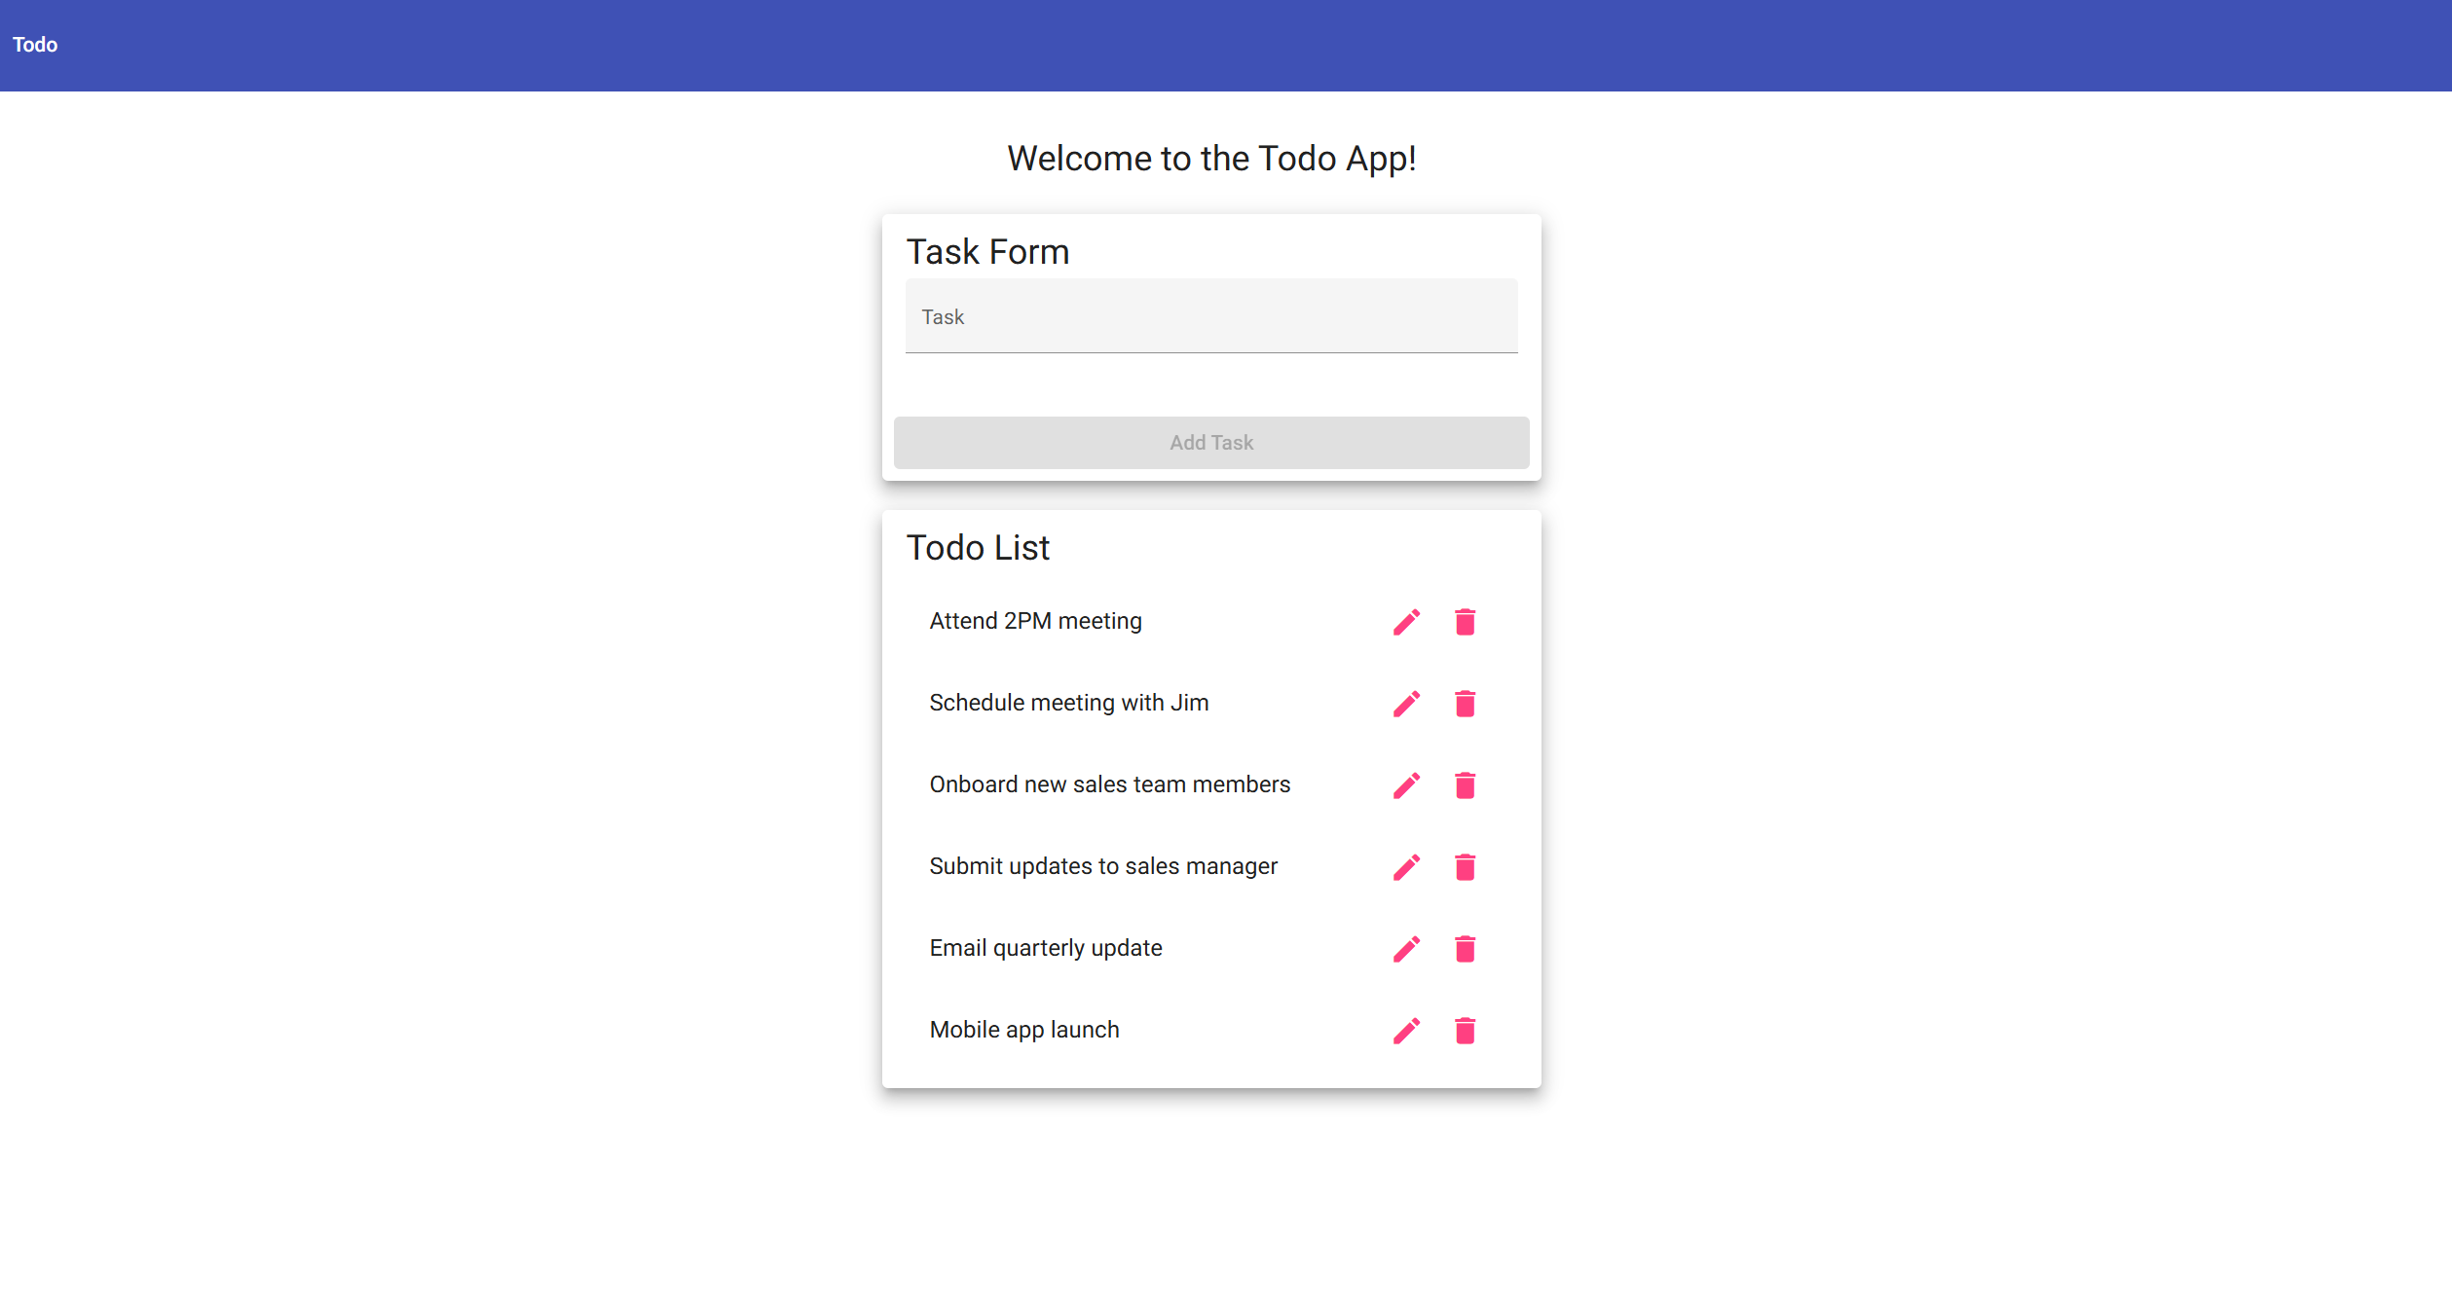
2 | Confirm the page header/navigation displays Todo and the welcome message is visible. |  | The landing page content is visible and readable. |  | Yes |  | Yes
3 | Confirm the Task Form area displays a Task input field and Add Task button. |  | The task entry form is present on the landing page. |  | Yes |  | Yes
4 | Confirm the Todo List section displays multiple task items. |  | The task list is visible with existing todo items and edit/delete controls. |  | Yes |  | Yes
5 | Refresh the browser window. |  | The application reloads at the same URL and the Todo List view remains available. |  | Yes |  | Yes  
Comments |  |  | This test confirms that the application can be reached through the required website URL and that the primary list view loads correctly. The refresh step is only checking that the page reloads properly; persistent storage after a refresh is not listed as a business requirement.

Test 2: Create Todo Task and Add Form Validation
Test Objective |  | Verify a user can create a new todo task item and cannot submit the add task form without entering a todo item. Covers requirements 2 and 6.
Developer |  | Zak Nizam |  | Peer tester |  | Caleb Schumacher
Date tested |  | 2026/07/02 |  | Date tested |  | 2026/07/05
Step | Action |  | Expected results |  | Developer pass/fail |  | Tester pass/fail + Screenshot
1 | Open the Todo application and leave the Task input field blank. |  | The task form is displayed and no task text has been entered. |  | Yes |  | Yes  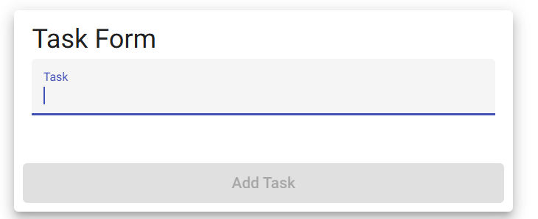
2 | Attempt to submit the blank form or confirm the Add Task button is disabled. |  | The blank task is not added to the Todo List. |  | Yes |  | Yes  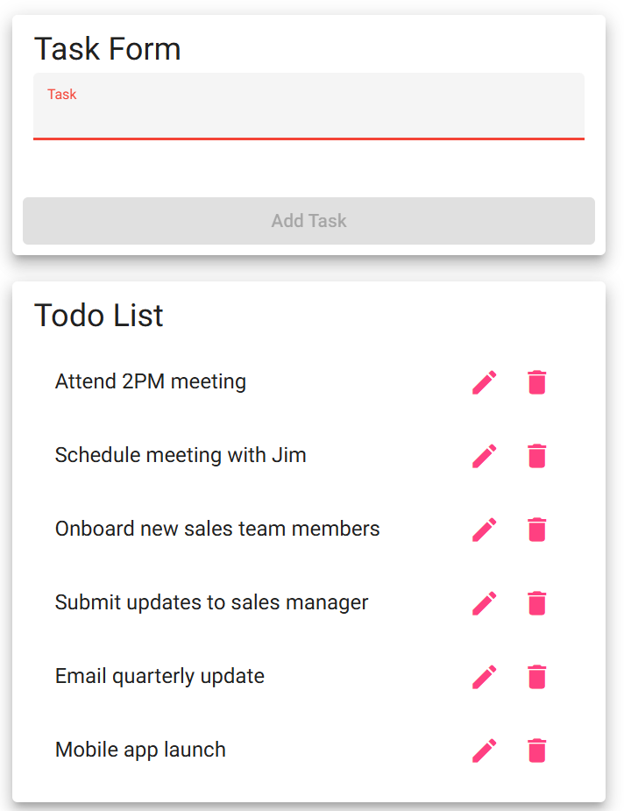
3 | Enter a unique task name such as Test task - Module 4.2. |  | The task text appears in the Task input field. |  | Yes |  | Yes  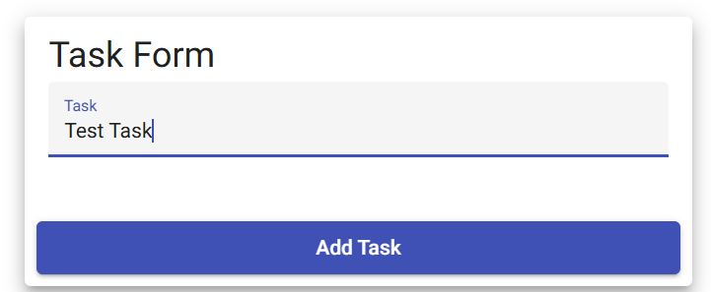
4 | Click the Add Task button. |  | The new task appears in the Todo List. |  | Yes |  | Yes  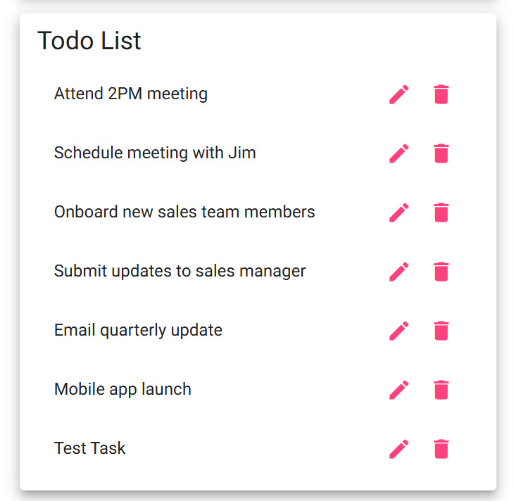
5 | Confirm the form is ready for another entry and no duplicate/error message appears. |  | The application remains usable after the task is added. |  | Yes |  | Yes
Comments |  |  | This test covers the highest-priority create requirement and confirms that the add form does not accept blank tasks. It also keeps the expected result focused on the business requirement instead of assuming that newly added tasks must persist after a browser reload.

Test 3: Edit Todo Task and Edit Form Validation
Test Objective |  | Verify a user can edit a todo task item and cannot submit the edit form without entering a todo item. Covers requirements 3 and 7.
Developer |  | Zak Nizam |  | Peer tester |  | Caleb Schumacher
Date tested |  | 2026/07/02 |  | Date tested |  | 2026/07/05
Step | Action |  | Expected results |  | Developer pass/fail |  | Tester pass/fail + Screenshot
1 | Locate Test task - Module 4.2 or another existing task and click the edit/pencil icon. |  | The edit form opens for the selected task. |  | Yes |  | Yes
2 | Confirm the edit form displays the current task text. |  | The selected task text is populated in the edit input field. |  | Yes |  | Yes  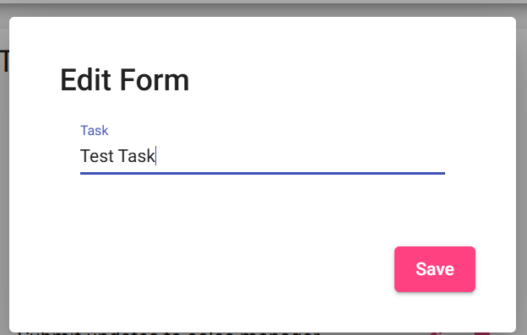
3 | Delete all text from the edit field and attempt to save, or confirm the Save button is disabled. |  | The blank edit is not saved and no empty task is created. |  | Yes |  | No  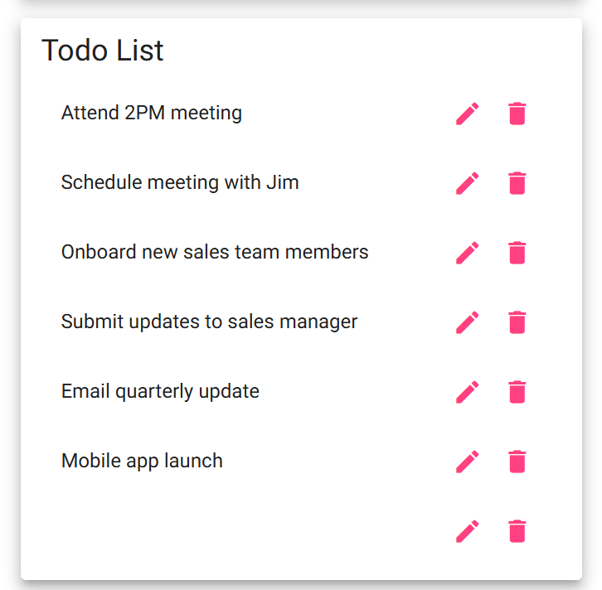
4 | Enter Updated test task - Module 4.2 and click Save. |  | The edit form saves the updated task text. |  | Yes |  | Yes
5 | Return to the Todo List and confirm the updated task is displayed. |  | The Todo List shows the updated task and no blank task item appears. |  | Yes |  | Yes  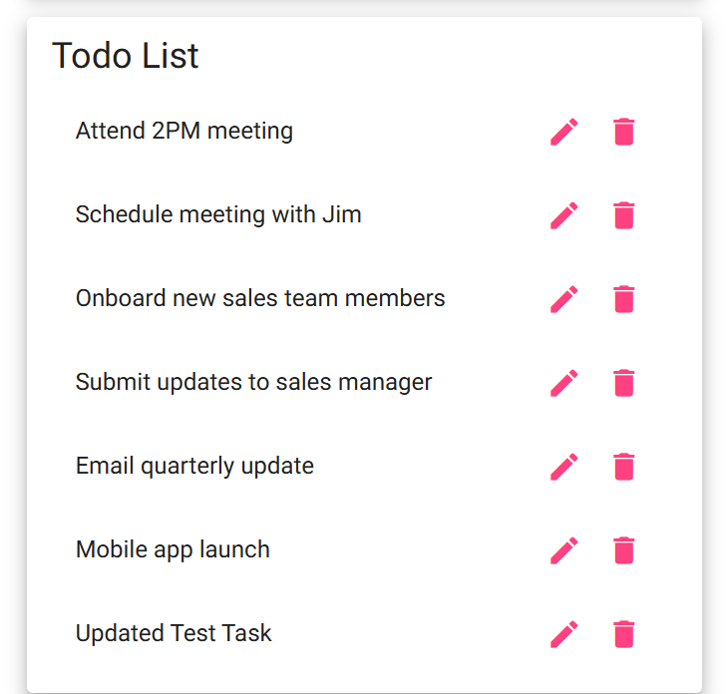
Comments |  |  | This test verifies that an existing todo item can be updated while still requiring valid task text. The validation step is important because allowing blank edits would make the Todo List less useful and would not meet the stated edit form requirement.  When editing a task, an empty task is allowed to persist on the task list. There needs to be a logic check that does not allow tasks being edited to be saved when they are empty.

Test 4: Delete Todo Task
Test Objective |  | Verify a user can delete a todo task item from the Todo List. Covers requirement 4.
Developer |  | Zak Nizam |  | Peer tester |  | Caleb Schumacher
Date tested |  | 2026/07/02 |  | Date tested |  | 2026/07/05
Step | Action |  | Expected results |  | Developer pass/fail |  | Tester pass/fail + Screenshot
1 | Confirm a disposable test task exists, or create one named Delete me - Module 4.2. |  | A task is available to delete without relying on default tasks. |  | Yes |  | Yes  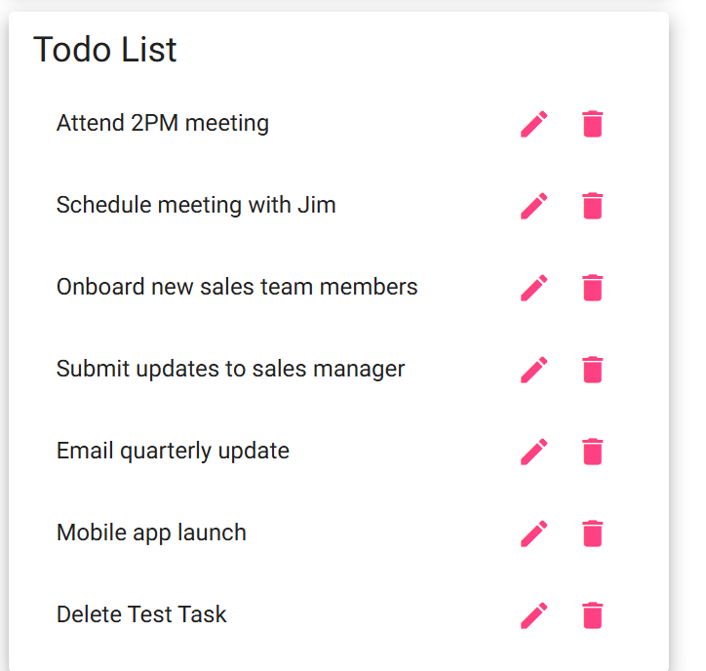
2 | Click the trash/delete icon for the disposable test task. |  | The delete action is accepted by the application. |  | Yes |  | Yes
3 | Confirm the selected task is removed from the Todo List. |  | The deleted task no longer appears in the list. |  | Yes |  | Yes  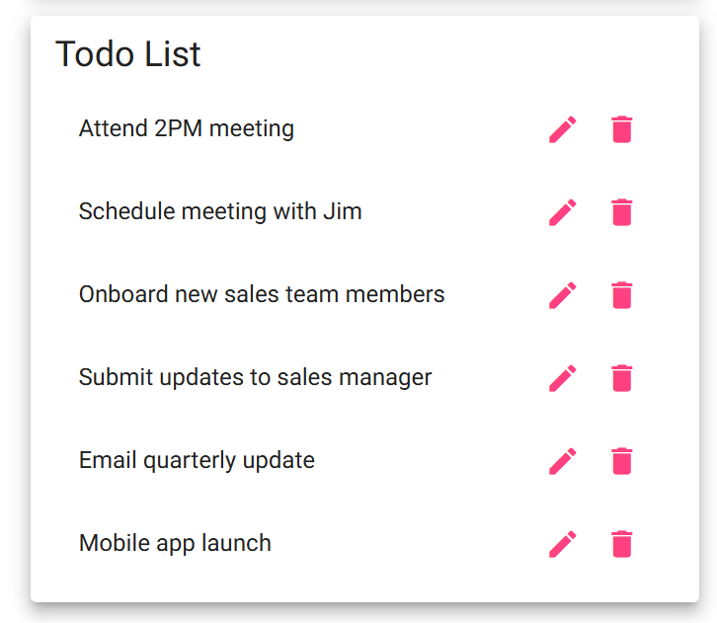
4 | Confirm the other Todo List items are still visible. |  | Only the selected task is removed; unrelated tasks remain unchanged. |  | Yes |  | Yes
5 | Continue using the page after deletion. |  | The application does not display an error and remains usable. |  | Yes |  | Yes  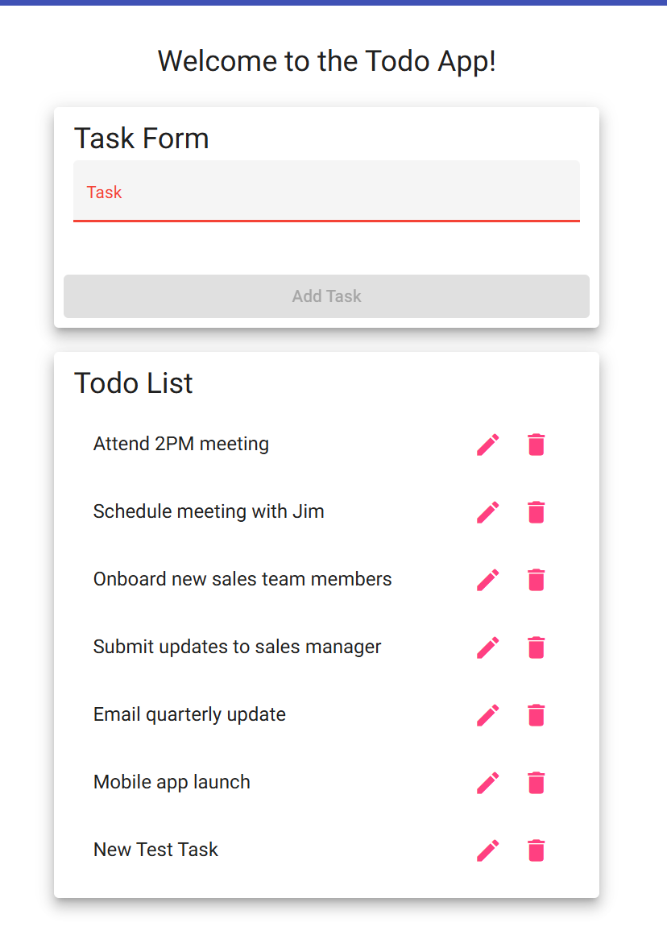
Comments |  |  | This test confirms the delete function without risking the removal of default list items needed for other verification. Creating a disposable item makes the result easier to confirm because the expected deleted task name is unique.

Test 5: Invalid URL and Responsive Device Views
Test Objective |  | Verify invalid URLs show a custom 404 page and confirm the application provides usable mobile and tablet views. Covers requirements 5, 8, and 9.
Developer |  | Zak Nizam |  | Peer tester |  | Caleb Schumacher
Date tested |  | 2026/07/02 |  | Date tested |  | 2026/07/05
Step | Action |  | Expected results |  | Developer pass/fail |  | Tester pass/fail + Screenshot
1 | Visit https://buwebdev.github.io/todo/invalid-test-page. |  | A custom 404 error page is displayed instead of an unstyled browser or server error. |  | Yes |  | Yes  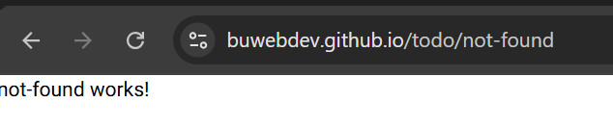
2 | Return to https://buwebdev.github.io/todo/. |  | The standard Todo application landing page loads again. |  | Yes |  | Yes  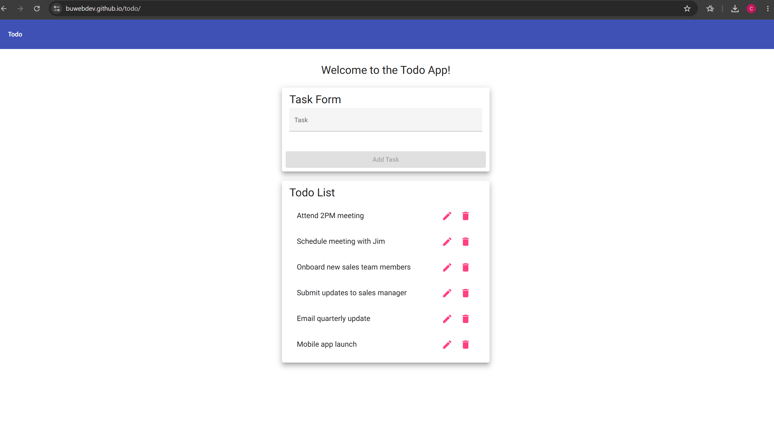
3 | Open browser developer tools and switch to a mobile viewport such as iPhone or approximately 390 x 844. |  | The Task Form and Todo List remain visible and usable on a mobile-sized screen. |  | Yes |  | Yes  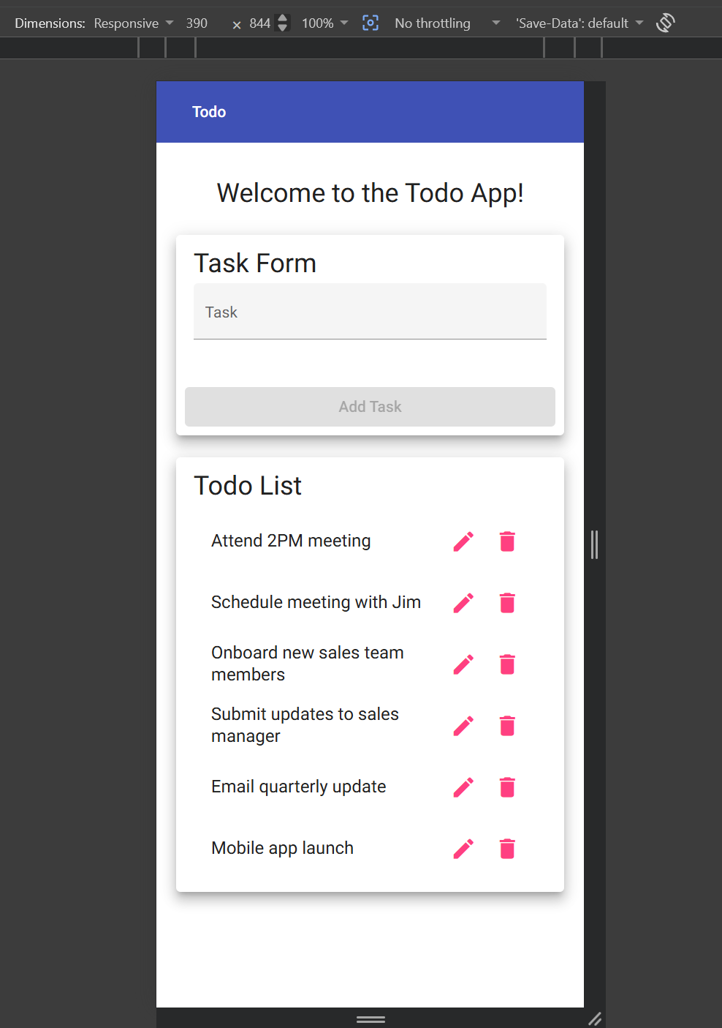
4 | Confirm the Add, Edit, and Delete controls are accessible in the mobile viewport without horizontal scrolling. |  | The mobile layout supports the main task actions. |  | Yes |  | Yes
5 | Switch to a tablet viewport such as iPad or approximately 768 x 1024. |  | The tablet layout remains readable and supports the task form and Todo List controls. |  | Yes |  | Yes  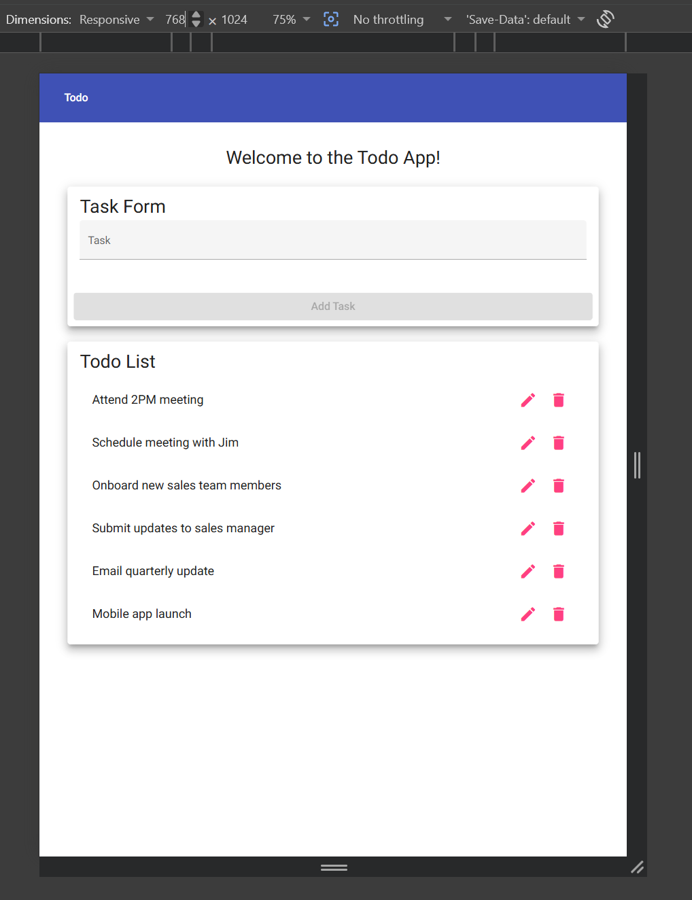
Comments |  |  | This test combines nonstandard navigation and responsive layout requirements because both verify how the application behaves outside a normal desktop view. The expected result is a clean error page for invalid URLs and a usable layout for both mobile and tablet screen sizes.

