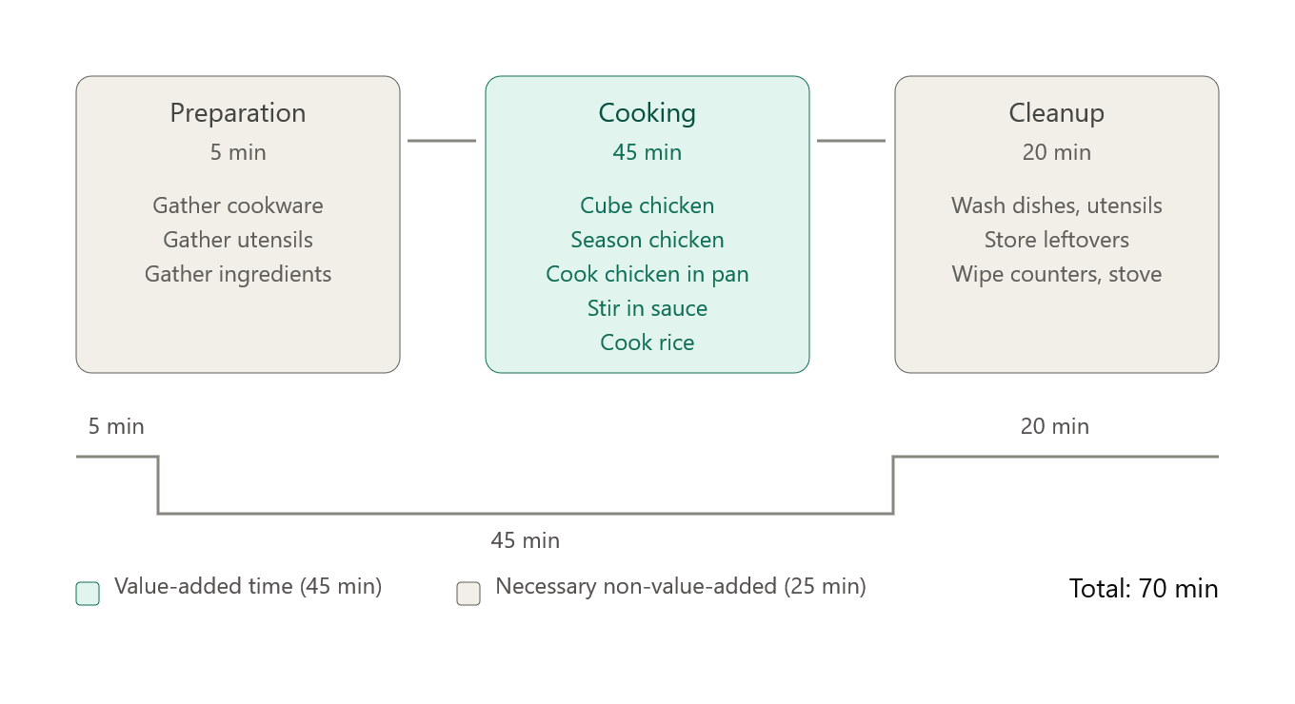
With the first 5 minutes and last 20 minutes being necessary non-value-added time, the real opportunity for waste reduction is within the 45 minutes of cooking time. There are several improvements to be made within the cooking block as well as a couple of smaller improvements that can combine the preparation and cleanup blocks into the cooking block.
The preparation block can be utilized more effectively by gathering the pot for the rice and pan for the chicken first and heating them while gathering the rest of the ingredients. This avoids any dead time caused by waiting for the pans to heat. In the cooking block, the rice can be prepared first as it will cook in the background while the chicken is being prepared. This cuts almost 15 minutes off total cook time. Finally, the cleanup block can be incorporated into the last part of the cooking block. The chicken needs to simmer in the sauce for at least 10 minutes, so any used utensils and dishes can be cleaned while the chicken simmers and while the rice finishes cooking.
The end result of optimizing this VSM is creating a single monolithic cooking block that incorporates the tasks from the other two blocks so that waiting time for some tasks (cooking the rice, simmering the chicken) gets paired with parallel work. These optimizations reduce the total time for this task down to 45-50 minutes depending on how many servings were made and how long it takes to put the resulting leftovers away. This is a 30% reduction in total process time.

