Diagonal Difference
Write a program that finds the difference between the sums of the square matrix diagonals (absolute value).
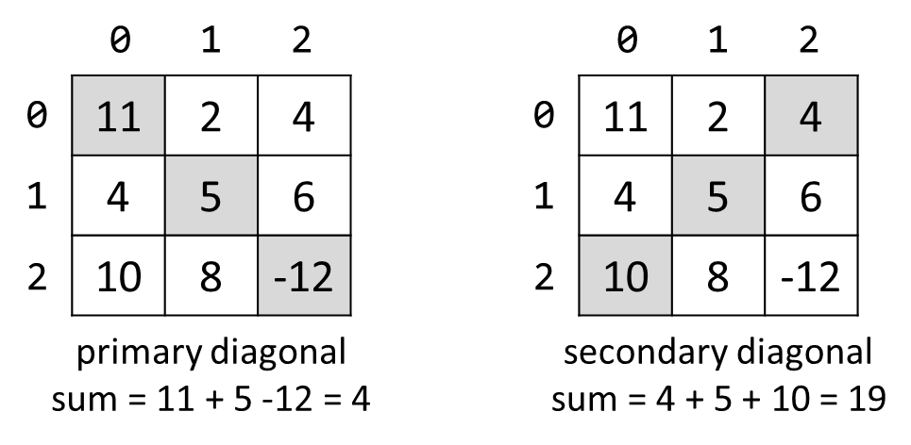
Input
- On the first line, you are given the integer N – the size of the square matrix.
- The next N lines holds the values for every row – N numbers separated by a space.
Output
- Print the absolute difference between the sums of the primary and the secondary diagonal.
Examples

Input | Output | Comments
3  11 2 4  4 5 6  10 8 -12 | 15 | Primary diagonal: sum = 11 + 5 + (-12) = 4  Secondary diagonal: sum = 4 + 5 + 10 = 19  Difference: |4 - 19| = 15

