Maximal Sum
Write a program that reads a rectangular integer matrix of size N x M and finds in it the square 3 x 3 that has maximal sum of its elements.
Input
- On the first line, you will receive the rows N and columns M. On the next N lines you will receive each row with its columns.
Output
- Print the elements of the 3 x 3 square as a matrix, along with their sum.
Examples
Input | Matrix | Output
4 5  1 5 5 2 4  2 1 4 14 3  3 7 11 2 8  4 8 12 16 4 | 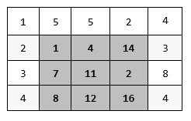 | Sum = 75  1 4 14  7 11 2  8 12 16

