Text display:

-Game Begin-

(Score and Money should not be shown here)

Title screen:

{

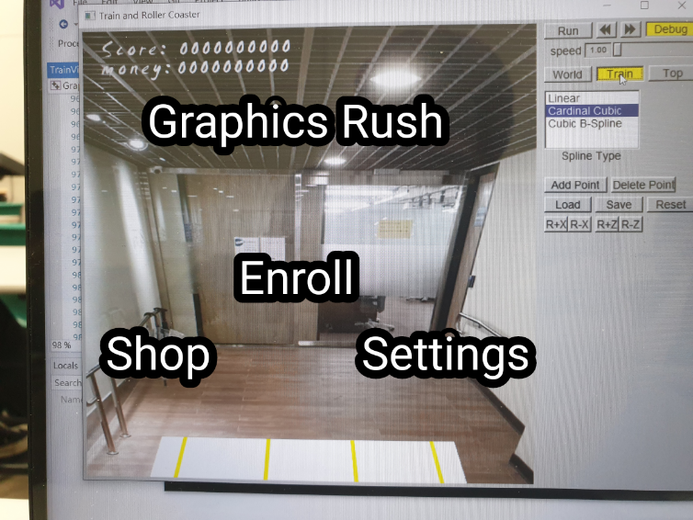

Enroll/Shop/Settings should be replaced with icons

Clicking on them will bring up different events

}

After pressing “Enroll”:

{

Would you like to use Power-ups?

Big Thigh/Shader/Cuda

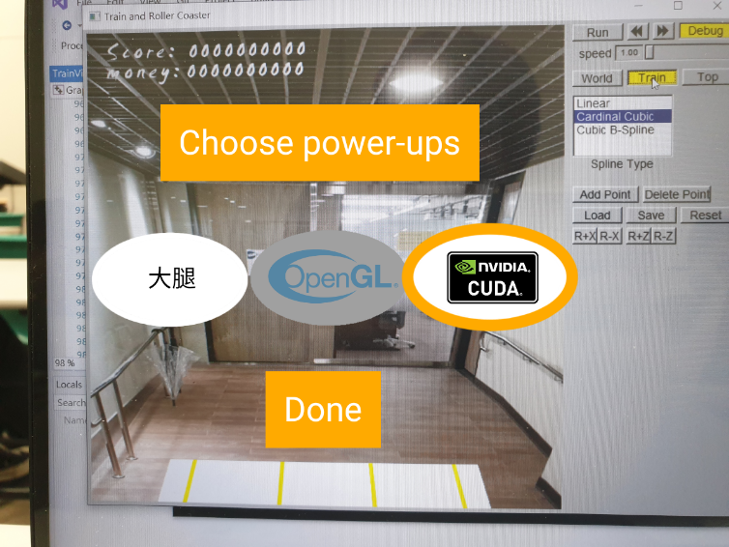

White: Default (Not selected)

Gray: Need to buy more

Orange frame: Selected (Can be more than one)

(Icons can be made smaller to fit more power-ups.)

}

After pressing “Shop”:

{

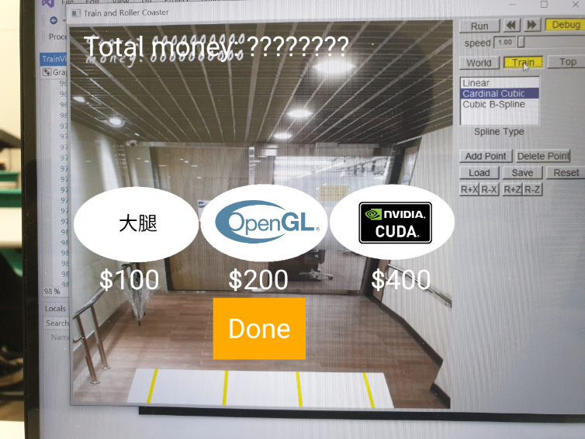

The icons should be moved upwards

Pricing should be discussed

}

After pressing “Settings”:

{

No idea / Music volume probably

}

-Game End-

End Screen:

{



