Welcome to Research Methods in Year 2

Dr. Gordon Wright

# Title of Lecture

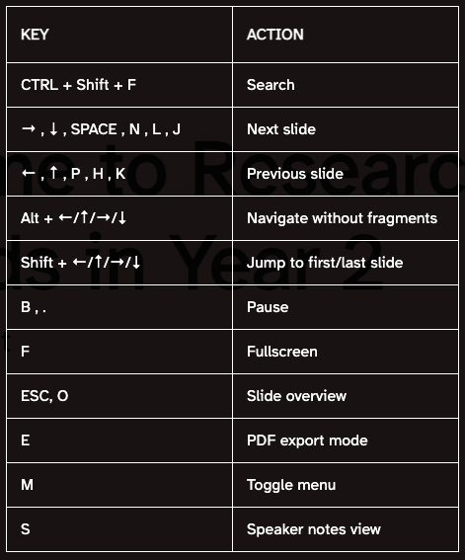

## subtitle of lecture

text

## Slide 2

test

## Slide three

testings

# PART 1 With code

## 2 column layout - source

|  |  |
| --- | --- |
| original stuff | Stuff |

## 2 column layout -visual

initial stuff

more stuff

## 3 column layout - source

## Columns

::: columns ::: {.column width=“30%”} 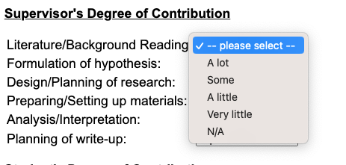 :::

(**greenspan?**) 2009 model is a cornerstone in gullibility research and even inspired the creation of the only existing gullibility scale (Teunisse et al., 2020). But let’s not mince words: the model lacks empirical backbone, having never been subjected to validity or reliability tests. Greenspan identifies four key players in the drama of gullibility: situation, cognition, personality, and state. Situation is all about the deceiver’s skill in crafting a compelling tale. Cognition tackles the victim’s mental state—think cognitive load or mood. State zeroes in on the victim’s physical and mental readiness to critically engage, while personality zooms in on trust and agreeableness.

## 3 column layout - source

## Columns

|  |
| --- |
|  |

Greenspan’s 2009 model is a cornerstone in gullibility research and even inspired the creation of the only existing gullibility scale (Teunisse et al., 2020).

## 🗣 Content

This is what will be discussed today.

Always good to explain the agenda so audience can have clear expectations.

Therse are animated bullet points:

* 📜 Point one
* 🧫 Point two
* 🚀 Point three

…You ca

## Fragments

Incremental text display and animation with fragments:

Fade in

Slide up while fading in

Slide left while fading in

Fade in then semi out

. . .

Strike

Highlight red

Learn more: [Fragments](https://quarto.org/docs/presentations/revealjs/advanced.html#fragments)

Learn more: [Chalkboard](https://quarto.org/docs/presentations/revealjs/presenting.html#chalkboard)

## Slide Backgrounds

Set the background attribute on a slide to change the background color (all CSS color formats are supported).

Different background transitions are available via the background-transition option.

Learn more: [Slide Backgrounds](https://quarto.org/docs/presentations/revealjs/#color-backgrounds)

## Media Backgrounds

You can also use the following as a slide background:

* An image: background-image
* A video: background-video
* An iframe: background-iframe

Learn more: [Media Backgrounds](https://quarto.org/docs/presentations/revealjs/#image-backgrounds)

## Absolute Position

Position images or other elements at precise locations

Learn more: [Absolute Position](https://quarto.org/docs/presentations/revealjs/advanced.html#absolute-position)

## Auto-Animate

Automatically animate matching elements across slides with Auto-Animate.

Learn more: [Auto-Animate](https://quarto.org/docs/presentations/revealjs/advanced.html#auto-animate)

## Auto-Animate

Automatically animate matching elements across slides with Auto-Animate.

Learn more: [Auto-Animate](https://quarto.org/docs/presentations/revealjs/advanced.html#auto-animate)