Lab 01: Replace it!

This is a meaningful subtitle

Dr. Gordon Wright

October 2, 2023

# Show Attendance QR Code

# Heading 1 - Section Head

This is a subtitle to the section header

## Heading 2 - new slide title

Heading 2 copy

### Heading 3 - italic emphasis

## Spans for text accentuation - available in source mode

.shout accent3(red) 1.5em and Bold

.alert accent3(red) no change to font size

.fg .bg

.button accent1 whitetext button for link

.button-success

.takeaway

.highlight

## Citations

Wright et al. (2012)

Cohen (1992) In text citation @Cohen1992

(Cohen, 1992) not in-text citation `(Cohen, 1992)

just type `@` and a search box comes up for your Zotero library or a .bib file associated with the project

## Image|content 2 column

Slide with image and commentary in two columns and some explanatory text above

text text text text text text text text text text text text

text text text text text text text text text text text text

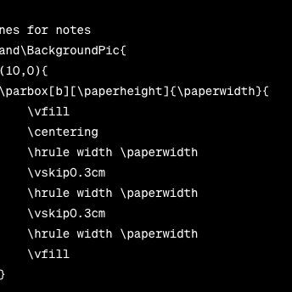

Here is some text

* Bullet 1
* Bullet 2
* Bullet 3

## Callouts

## Note Callouts

|  |  |
| --- | --- |
|  | **Note default**  content |

|  |  |
| --- | --- |
|  | **Note simple**  content |

|  |
| --- |
| **Note minimal**  content |

## Icons by FontAwesome

These are cool but they do need a full render e.g. $ quarto render in order to be seen.

They can also be used in pdfs

Fontawesome

| input | output |
| --- | --- |
| {{< fa binoculars >}} | Prepare |
| {{< fa chalkboard-teacher >}} | Lecture |
| {{< fa users >}} | Lab |
| {{< fa bookmark >}} | Reading |
| {{< fa book >}} | Mini-Dissertation |

## References

Cohen, J. (1992). A power primer. *Psychological Bulletin*, *112*, 155–155. <https://doi.org/10.1037/0033-2909.112.1.155>

Wright, G. R. T., Berry, C. J., & Bird, G. (2012). “You can’t kid a kidder”: association between production and detection of deception in an interactive deception task. u1 - wright2012. *Frontiers in Human Neuroscience*, *6*, 87. <https://doi.org/10.3389/fnhum.2012.00087>