Lecture 01: Let’s start at the beginning!

This is the way!

Dr. Gordon Wright

October 2, 2023

# Attendance QR Code HERE

## Key topics today

* Module structure and coursework introduction
  1. Critical Proposal (15%)
  2. Mini-Dissertation (70%)
  3. Conceptual, Historical & Integrative Perspectives Log (CHIP Log) (15%)
* Labs in general and the lab tomorrow
* Materials, independent study, SUCCESS!

## A bit about me…

* Formerly worked in the advertising industry for top London agencies
* Impulsively started a Psych degree in 2006 (age 30+)
* My research interests are interpersonal deception, antagonistic personalities and behaviours, and how people obtain, process, and use social information/person perception in their everyday lives
* Got my PhD in 2014, post-doc with the Intelligence Agencies, Teaching Fellow then Lecturer in the department of Psychology
* And I LOVE IT !! The Psychology we do here is unique and thrilling!
* My mission is to turn you into Research Rebels and Data-Driven Disruptors!

## But first

* The importance of your ‘participation’
* If you don’t engage, it is difficult to respond to your needs
* I want you to find **“MyPsychology”**
* Easier to keep up than catch-up
* We have numerous safeguards in place to protect you this year, but be your own best friend
* The only thing that should be worried this year is Shoddy Science!

# Module Overview

## Module weighting and assessment

Research Methods is a 30 credit weighted module. As I always say, a coursework essay, say for Cognitive Psychology, is worth 1/10th of your Mini-Dissertation. It does NOT make sense to miss a lab working on an essay that might not even count towards your grade.

To pass, you must pass all 3 assessment elements:

Critical Proposal 1,800 words (15%)

Mini-Dissertation 2,500 words (70%)

CHIP Learning Log 1,200 words (15%)

## Gannt Chart

|  |
| --- |
| Deadlines |

# So what’s the point?

[APA Skillful Psychology Student](https://www.apa.org/ed/precollege/psn/2019/02/skillful-student)

|  |
| --- |
|  |

Naufel, K. Z., Appleby, D. C., Young, J., Van Kirk, J. F., Spencer, S. M., Rudmann, J., …Richmond, A. S. (2018).The skillful psychology student: Prepared for success in the 21st century workplace. Retrieved from: <https://www.apa.org/careers/resources/guides/transferable-skills.pdf>

## Cognitive Skills

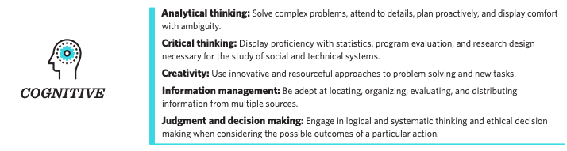

## Communication Skills

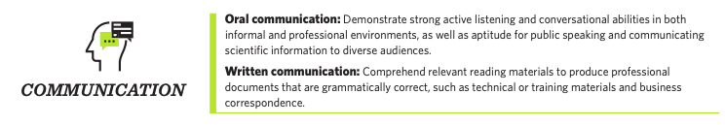

## Personal Skills

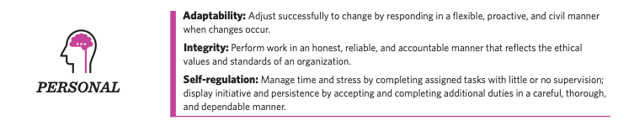

## Social Skills

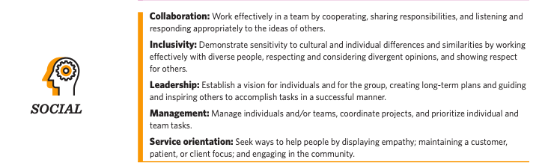

## Technological Skills

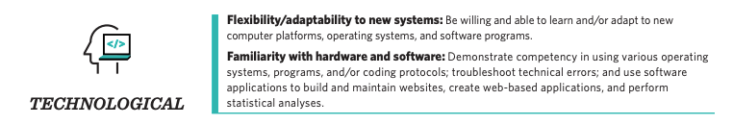

## These are valuable skills

I’m going to try to ‘connect the dots’ for you along the way

* Cognitive (e.g., creativity and information management).
* Communication (e.g., active listening and public speaking).
* Personal (e.g., conscientiousness and integrity).
* Social (e.g., collaboration and leadership abilities).
* Technological (e.g., flexibility and familiarity with hardware and software).
* No actual mention of the ‘content’ - **Psychology** or **Research**

## You aren’t spectators any more, you’re Scientists!

In small groups of 3 or 4 people, you will:

* Identify an area of psychological research
* Review and critique the literature in this area (Critical Proposal)
* Develop a testable hypothesis
* Design a 2x2 ANOVA experiment unique to you (within your group study)
* Obtain Ethical Approval for your experiment
* Collect REAL data
* Analyse these data
* Write up the results in APA format with Open Data and Materials (Mini-Diss)
* Reflect on your learning and development journey (CHIP Learning Log)

## Consider it a ‘warm up’ for your Y3 Dissertation

* The same 20-week timeline
* The same skills and techniques you will need
* Careful step-by-step guidance and support in the lab setting
* Scaled-down experiments and write-ups - but all the same moving parts
* The security of working in a group
* Tips and advice from world-class researchers
* Opportunities to think carefully about your final year Dissertation, and how to crush it!!

## Support and guidance

* Gordon (Module Coordinator and Enthusiast in Chief)
* 6 gobsmackingly amazing Lab Tutors
* Your Mini-Dissertation group (3 or 4)
* Your Personal Tutor
* Your PT group
* The entire Goldsmiths Research Community!

This is a team-sport

## Access to me

I will be in every Research Methods lecture and I have a Student Hour from 1-2 (TBC) every Monday.

**Available at g.wright@gold.ac.uk and my office is WB200/1**

I genuinely could not imagine anything I would rather do that this. So please talk to me and help me get to know you!

Questions relating to Module Content must be asked via the Forum. There will be no exceptions.

## A friendly warning

|  |
| --- |
| Warning |
| All coursework is INDIVIDUAL and subject to normal plagiarism and collusion rules.  Just don’t risk it. Be mindful of how you read, take notes and share coursework.  See previous information about the use of AI. It can be a wonderful tool, but do NOT use it for the wholesale production of written content. It must be a support, not a shortcut. You’ll regret it. |

## Module structure

1 x 1 hr Lecture per week (Monday 11-12 PSH LG02 (winter term))

1 x 2 hr Lab per week (Tuesday - see personal timetable)

4 x Personal Tutor meetings across the year

## Weekly Structure

Each week there will be a very brief ‘**Overview to set out the main topics and to give you a set of milestones or preparatory activities**’ designed to keep you on track.

**Lecture** (slides available as a Reveal Slideshow via Quarto and as pdf, docx, and if you wish for anything else, please just ask.)

**Lab**

|  |
| --- |
| Lab structure |

* **Lab Notebook** - find a solution that works for you, but make sure that you have it every week, so a cloud-based system would be best. You will be expected to show notes of your progress to your Lab Tutor
* Lots can be achieved in the labs, but independent study and coordinated group work will be required. We will be asking about this aspect of the process regularly.

## DangerZone

|  |
| --- |
| All hail the Kenny! |

You’ll never say hello to you,  
Until you get it on the red line overload.  
You’ll never know what you can do,  
Until you get it up as high as you can go!

Most weeks, there will be Extras - called the DangerZone [in honour of the best movie ever made (Top Gun) and the Yacht-Rock and fashion icon legend Kenny Loggins]. These are opportunities to consider aspects of Research procedure beyond the level expected for this year, but ‘on the table’ for next year and any future research endeavours. They are research-based in a loose sense - they will include programming, literature search and management, academic and knowledge management tools, tips and hacks that might (or might not) be of interest or useful. If the term is going well, they might even be fun. All ideas welcome.

## Coursework

The courseworks ALL require critical reflection and meta-cognitive practice. This will be discussed in a number of lectures, but it contributes to effective learning and your integration of the skills and experience of doing this research exercise.

## Time management and teamwork

..will both be required.

I ask you to see both as an opportunity to develop these important skills.

You will see we have some ideas to make this more relevant to careers and employability

It is easier to ‘keep up than to catch up’.

## Resources

We will be releasing a series of valuable resources to help you through every step of the process

These will have value for your final year dissertation too.

Contribution to and comment on these is welcome and hoped for!

Open Educational Resources will be used extensively, and most core readings are available online via the library.

## Before tomorrow, please…

Add an email signature to your college email, including your student number, programme, lab tutor, and personal tutor. It will speed up responses to any emails you send to staff.

## Lectures Term One

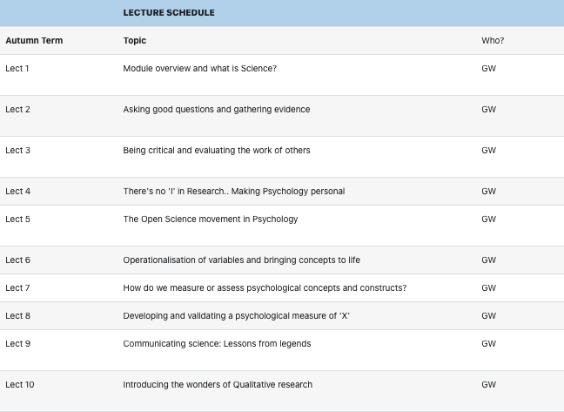

## Lectures Term Two

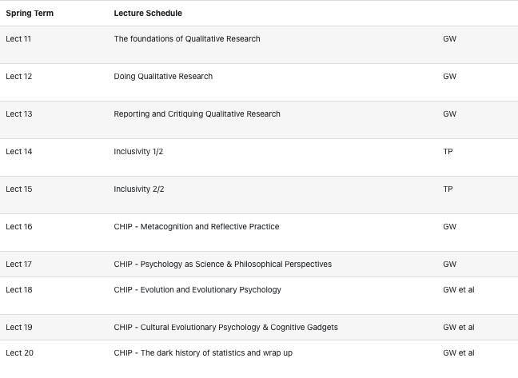

## Labs Term One

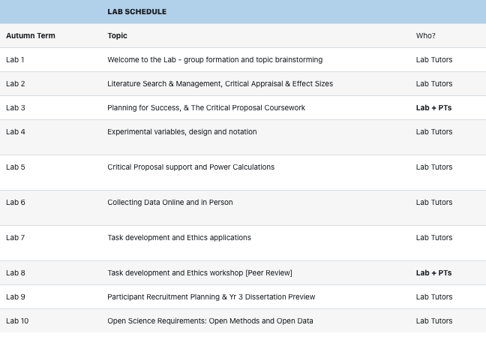

## Labs Term Two

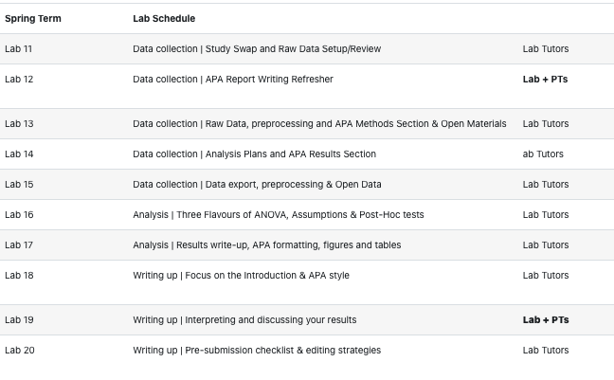

## Mini-Dissertation structure

Your individual Mini-Dissertation project **MUST** conform to the following definitive rules:

* **2x2 ANOVA design with 2 categorical IVs (each with 2 levels) and a single continuous DV**
* **You must obtain ethical approval and show individual involvement in the process of application**
* **You must make a sample size estimation / Power calculation**
* **You must contribute to group recruitment and data collection efforts either online or in-person**

## Mini-Dissertation Submission

**Your Mini-Dissertation final submission must comprise ALL of the following COMPULSORY elements:**

* a 2,500 word APA7 empirical paper with a complete reference list and appendices
* Open Data - a single, cleaned, clearly-labelled data set
* Open Materials - a complete, replication-ready materials package detailing materials relevant to your individual write-up
* A reflective account covering the Mini-Dissertation (not a moan about your group or strikes or having to do research)

## Illustrative MD topics

* The effect of gender stereotype and task difficulty on memory performance
* The role of facial symmetry and filter type on ratings of attractiveness of online dating profile pictures
* Exposure to negative news media, trait anxiety and the BAME community under COVID-19
* The effects of Agentic and Communal Narcissism, attitudes towards COVID-19 and lockdown compliance
* The effect of personality and sleep disturbance on academic performance
* Need for cognition, pre-sentencing information and perceptions of guilt in a jury decision making task

## But let’s deep dive this one

**The effect of Conscientiousness and Caffeine intake on Academic Self-Handicapping**

* *The effect of Independent Variable A and Independent Variable B on a continuous Dependent Variable*
* Conscientiousness IV(A1) Low or IV(A2) high - Independent Variable IV(A)
* Caffeine intake IV(B1) Low or IV(B2) high - Independent Variable IV(B)
* Academic Self-Handicapping (6 item 1-5 Likert style, ‘continuous’ Dependent Variable DV)
* What about the other 3 people in the group?

## Rest of the group:

**The effect of Conscientiousness and Caffeine intake on Academic Self-Handicapping**

1. Extraversion (Low/High) & Sleep (Sound/Disturbed) on ASH
2. Openness to experience (Low/High) & Family Attitude to Education (Pro/Con) on ASH
3. Neuroticism (Low/High) & Attitude to Feedback (Open/Sensitive) on ASH
   * Not too complicated, right?
   * Can you see the economies of effort and implicit support opportunities?

# Experimental Design Schematic

## You will be asked to keep and update the following image in draw.io

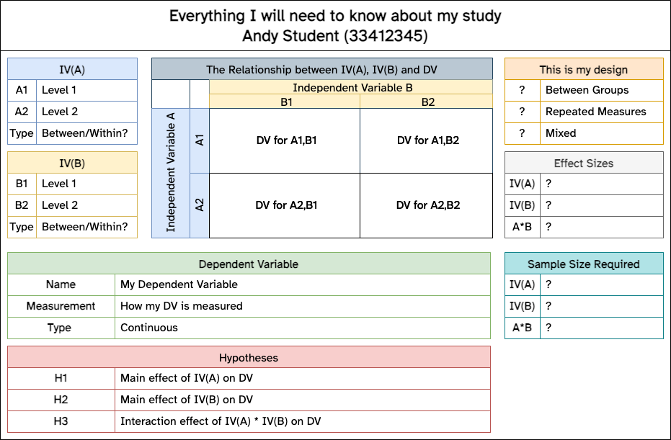

## Lab 01

* Scan your attendance, find a place to sit.
* Verify access to IT systems (e.g. the critically important OneDrive) and add a signature to your emails to assist College answering any questions you have.
* Start brainstorming ideas for research topics for your Mini-Dissertation.
* Consider ‘how’ you want to work this year
* Detailed information in Lab 01 worksheet, but allow the Lab Tutor to guide you and try to get involved!

## Please don’t get hung up on topic selection

|  |
| --- |
| Tip |
| You might think coming up with a research topic is a difficult thing. For this year, it is NOT super-important. Your Lab Tutors will be available to help you make sure it’s feasible, challenging enough but not too difficult etc.  It does help if you are interested in it though, as it will help keep motivation up!  If in doubt.. What about Academic Success? What aspects of personality, lifestyle, behaviour, attitude, life history etc contribute to it? And how on earth do you measure Academic Success? |

## Advance warning

|  |
| --- |
| Important |
| You will confirm your group members (3 or 4), a group name (puns encouraged), and maybe a topic area in the first half hour of Lab 02. There will be no more time available. But that will have allowed you over a week to work it out. Leave this week’s lab either with a pretty good idea of who you want to work with, ot a list of the people still un-grouped in your PT group. And then sort it out. |

## Some things to consider

|  |
| --- |
| Caution |
| * Picking something without much of a literature behind it can make life VERY difficult * We will try to make sure things remain manageable, we are not trying to ‘restrict’ you * You will not be able to do research   + on Children   + on Vulnerable or protected groups   + using methods that require extensive training or specialist facilities (e.g. EEG, TMS)   + that raises anything more than minimal ethical considerations   + for which recruitment will be too onerous or time-consuming |

## Data Carpentry suggests the following for their labs

* Use welcoming and inclusive language
* Be respectful of different viewpoints and experiences
* Gracefully accept constructive criticism
* Focus on what is best for the community
* Show courtesy and respect towards other community members

## Recurse Center ‘Social Rules’

|  |
| --- |
|  |

## On behalf of the whole teaching team

Have a wonderful year!

### Any Questions?

## References