Lab 01: Group formation and Topic Brainstorm!

Let’s jump right in

Dr. Gordon Wright

October 2, 2023

# Welcome to the Research Methods Labs

## My role as Lab Tutor

* To help you every step of the way
* Your first point of contact for questions or queries on Research Methods
* To share my passion for research and the experience I have gained
* To show how I have learned to find answers and solve problems
* To challenge you to achieve your best this year and next

## Not

* To do the work for you
* To chase you or to make you do your work (attendance and coursework is compulsory!)
* To tell anybody how to behave either individually or in your groups

## 100% of our focus in the lab

* We are here to be your guide and mentor in the lab
* Outside of lab hours, your point of contact is Gordon
* If you have an emergency, your Personal Tutor or Gordon are your primary contacts

## Lab structure

This should be familiar to you now. Any questions?

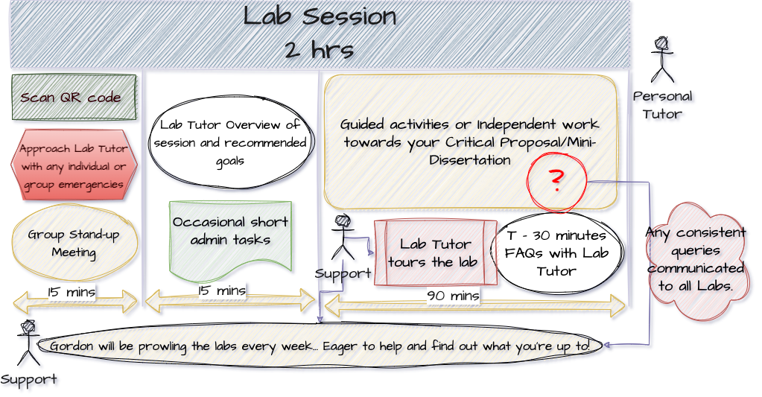

## Goals for today/this week

The immediate goals for this session, and for this week (including your independent study time)

* Identify potential group members and have this confirmed by the start of Lab 2
* Identify potential research topics and methodologies you might use
* Clarify any questions that may persist
* After today, we move on and start doing work. Any more time spent on these tasks is wasted time.
* You should be almost sorted by the end of the session today, at least with a short-list of topics, methods, or potential team-mates, and prepared to use independent study time to finalise your group (for sure) or to continue thinking about topics & methods.
* Next week will be Literature search support for this module and the Personality Essay (Double Whammy!) and discussing Effect Sizes and how to calculate and convert them. A requirement for the week 3 Essay Submission! (Triple Whammy?)

## The rules of the Mini-Dissertation game

* Your ultimate individual Mini-Dissertation project MUST conform to the following definitive rules:
* 2x2 ANOVA design with 2 categorical IVs (each with 2 levels) and a single continuous DV
* You must obtain ethical approval and prove individual involvement in the process of application
* You must make a sample size estimation / Power calculation
* You must collect data online and individually contribute to group data collection efforts
* Your Mini-Dissertation final submission must comprise:
  + a 2500 word APA7 empirical paper with a critical reflection and complete reference list
  + a single, cleaned, clearly-labelled data set in Excel format (or similar) - Open Data
  + a complete, replication-ready materials document detailing materials relevant to your submission - Open Materials

## Critical Proposal

There is a detailed brief on the Critical Proposal (Due Week 5) on the VLE.

It will be the focus of week 3 in both Lecture and Lab, but requires you to identify an empirical paper on your research topic, so more on that in due course.

## Activities for today.

These labs are driven by you. The only things that will EVER be compulsory are short administrative tasks on a roughly fortnightly basis (group progress update) and the next activity. Otherwise you can use the time as you see fit either alone or in your group, but we know that there is wisdom in the crowd for coming up with topic ideas, identifying cool research ideas and setting the tone for the year ahead.

## Let’s get going.

* Lab Challenge! [15 mins]
* Research Skill Audit
* Topic Speed Dating
* Methods Matching
* Goal Alignment and Group Ethos

## Lab Challenge

To be introduced by the Lab Tutor. hehe!

## Research Skill Audit

By assessing your current confidence level, you will be able to think strategically about the 20 weeks ahead.

## Topic Speed Dating

The worksheet will provide some tips and ideas for finding a topic to research. Even if you think you’ve nailed it, let’s discuss it.

## Methods Matching

It is easy to only think about online questionnaires. It may be some of the only research you’ve done, but frankly, it would be a shame to not think more expansively. Some ideas will be discussed, and a discussion about the Lab Challenge might prompt some ideas.

## Goal Alignment and Group Ethos

Another aspect of effective Group work is Goal Alignment. Even if you are working with your best buddy, they may want to just get in and out, while you want to immerse yourself in the task ahead.

This would be a conflict that is potentially dangerous. Think about your goals, your aspirations, and then consider how your might formalise these in to a set of guidelines.

Please do take the time to do this. Being able to point to a set of principles (for your group or for the whole lab) may smooth the process or be of help in resolving difficulties.

## References