Lecture 03: Being Critical

An intellectual virtue

Dr. Gordon Wright

October 16, 2023

## Key topics today

The week ahead

* Personal Tutor Meeting about MD this week
* also Weeks 8 (ethics), 13 (write-up prep), 17 (Stats)
* Critical Proposal overview and tips
* Lab preview - Your Critical Proposal Target Paper

## Personal Tutor Meeting Week 3

This week (week 3) you have 50 minutes with your Personal Tutor to discuss the Mini-Dissertation.

|  |  |
| --- | --- |
|  | Your Personal Tutor is ANOTHER source of guidance and support.  Give them the information they need to best help you on this journey. |

Dear PTs, “Next week, you are given **no information whatsoever**, and are asked to turn up to your session with nothing other than perhaps a pen and paper, a big smile, and anticipation of lots of exciting research in the making.”

## Future PT Sessions devoted to the MD

Week 8 - Check on status of Ethics application, and troubleshooting

Week 13 - Session to support Analysis Planning and Writing up/Submission preparation

Week 17 - Result interpretation, and any concerns arising in the final phase of the MD

## Please fill in a group on your Lab Miro Board.

Even just your names… Help us to help you. Please.

|  |
| --- |
|  |

# Any Questions?

# Being critical and evaluating the work of others

## This is a topic and skill you’ve already been shown





Review these materials and consider your performance of the assessment, and any feedback

## This year Critical Analysis has a ‘point’

The objective of the Critical Proposal is that you start to deploy the tools you have practiced in the service of your Mini-Dissertations.

A ‘practical’ exercise, which we are giving feedback to once… but that you will do multiple times for your Mini-Dissertation.

GOAL: to develop some aspect of your study design or methodology.

You will probably follow this process ‘a few times’ for your final year dissertation!

## The Four ‘Big’ Validities

**Internal Validity**: The degree to which an experiment accurately assesses variable relationships without interference from confounding factors.

**External Validity**: The degree to which study results can be applied to different populations or settings, indicating generalizability.

**Construct Validity**: The evaluation of whether a test effectively measures the intended theoretical construct using multiple indicators.

**Statistical Validity**: The assessment of whether statistical methods used in data analysis yield accurate conclusions from the data.

<https://opentext.wsu.edu/carriecuttler/chapter/experimentation-and-validity/>

## Reading list items (Barber 2002; 2004)

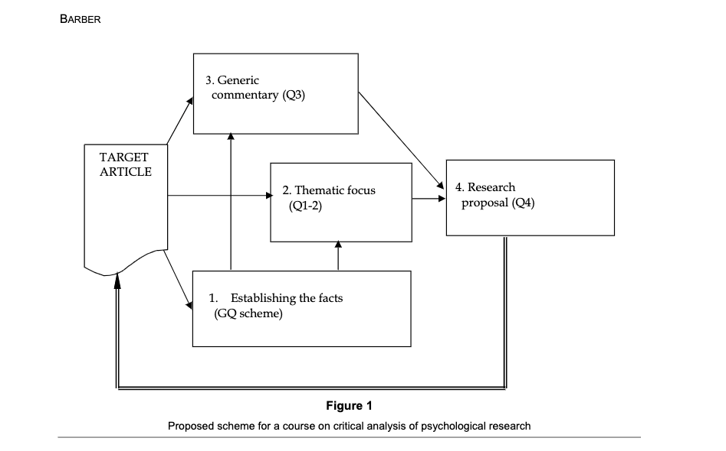

## 

## Let’s look at the example from last week

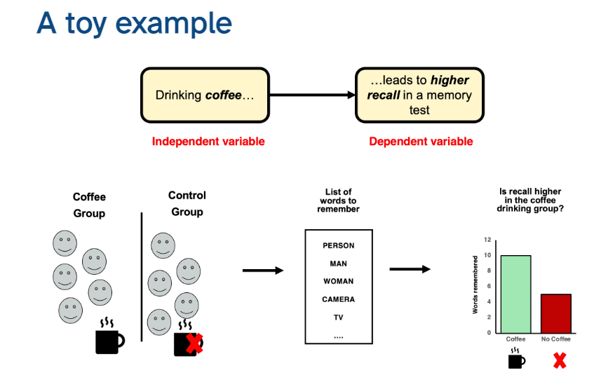

## How do I do it? [one approach]

Review literature on a key part of your ‘puzzle’ (an IV, a ‘tool’, the DV etc)

Apply critical evaluation to carefully chosen paper(s)

Consider how it might realistically guide or inform your own research

Identify a procedure to partially replicate, replicate, or replicate and extend/improve

Detail how that takes shape and reflect on your confidence, skill base, perception of value

## or

You could approach it strategically as a group.

Identify areas to take ownership of, then divide and conquer!

Or fly solo and agree to later apply the same process to a mutually beneficial part of your study

# Critical Proposal Support

## Briefing and Rubric

|  |
| --- |
|  |

## Briefing

|  |
| --- |
|  |

## Rubric

|  |
| --- |
|  |

## Please follow the suggested outline

|  |
| --- |
|  |

## Design information

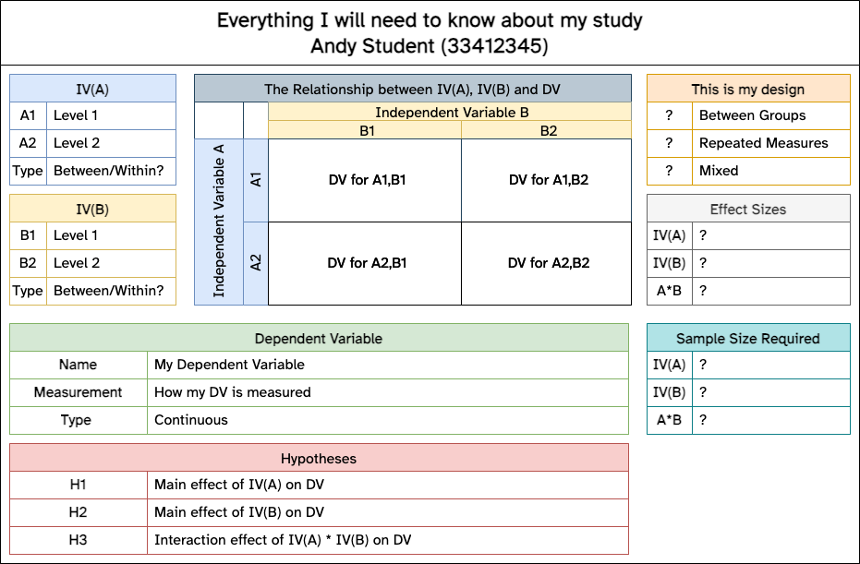

## More tips

* Please review the “SUGGESTED ESSAY OUTLINE” in the coursework briefing
* No need to follow it roboticly, be strategic & selective in terms of details
* Selection of a ‘good’ paper to focus on is an integral part of the assessment!
* Do you think the first google result will be a fruitful paper? No, of course you don’t!
* Use your Lab Tutor and me to get a sense of confidence. Early.
* Tell us how you are searching and what you are looking for
* Confirm the paper with us in a lab session [Priority given for this]

## Even more tips

* Use some of the tools presented in the previous lab activity to help track down a suitable paper
* Give yourself time to read, review, re-read and select your juiciest points
* Avoid any discussion of methodologies that cannot inform your study directly
  + e.g. Clinical diagnostic procedures, fMRI technicalities, Criminal Record or Case Study review procedures

## You can (will) use LOTS of this in your MD!

This isn’t a sidetrack exercise. It’s a critical step in your project

Note your references, note your main points, be organised

## Weeks 4 & 5

Talking about Variables and the 3 ‘flavours’ of ANOVA in week 4

Week 5 is ‘power calculations’ and opportunity to discuss CP

But we will be moving on and the CP will be part of your independent study

Same opportunities for RASA submissions/summer deferrals & resubmissions

# Questions?