Lab02

Dr. Gordon Wright

## Today’s activities

1. Complete the Pulse
2. Finalise your groups (3 or 4 people, all from same Personal Tutorial group)
   * Submit a list of names to your Lab Tutor
   * Discuss any problems you are facing
3. Agree a broad general focus for your group research and write it in your lab notebook
4. Start establishing how you are going to work as a team and identifying milestones
5. Prepare for your Week 3 Mini-Dissertation intro to your Personal Tutors

# Key Project Milestones

# Teamwork & Project Management ideas

## Apply “Scrum” process?

In short, it’s a transparent, accountable, transparent and pragmatic approach to project delivery.

*“Scrum” is a project management approach used extensively in the tech and media sectors

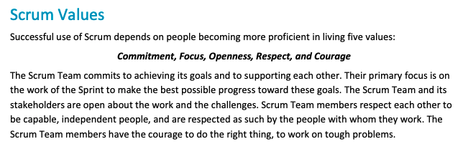

## Scrum-style ‘stand-up’ meetings at the start of each lab?

3 questions for a ‘stand-up meeting’ every week. No more than 10 minutes. Face to face or online.

1. **What have you done since the last lab session? (Progress)**
2. **What will you be doing before the next lab session? (Plan)**
3. **Can you identify any obstacles to achieving the plan? (Problems)**

If anything arises in point 3… Engage with your Lab Tutor during the session and resolve it!

# Key Project Milestones

## Milestones(4 key phases of activity)

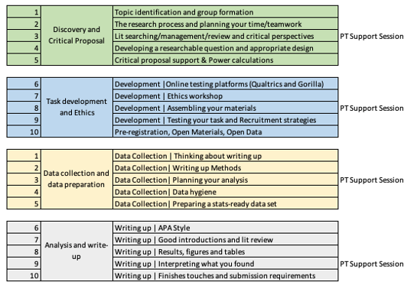

## The unmissables

* Submission of Critical Proposal by 10am 4th November
* Ethics submission prior to end of Term 1
  + Requires fully developed task and materials inc. Information Sheet, Informed Consent, Debriefing Materials
  + Lab Tutors must sign off all ethics applications (1 week turnaround) and they could very likely return it to you for changes
  + Ethical Approval will be ‘fast-tracked’ but can take 1-2 weeks
* Data collection can begin as soon as you have Ethical Approval
* Data collection will be halted at Reading Week in Term 2
* Mini-Dissertation deadline 10am 31st March 2023

## Think about the rest of your coursework

Try to anticipate when you will have busy times in the year and plan ahead

Do you have any personal obligations that will affect your availability?

## Think about your average week

When will you do your independent study?

When will you meet as a group?

What will you do if you miss class due to illness?

## Your first MD Personal Tutor Session is next week

You will need to present your general topic area, and any thoughts around how you are going to do the research.

Your personal tutor will be able to help you think about the realities of doing the work, but signalling the general area and type of research you want to do is most useful.

* How will you do this most effectively?
* What visual aids will you use?
* Will you identify references?
* Will you plan or prepare? You’ve got 50 minutes for all your groups…

## Personal Tutor management

Your Personal Tutor will be a HUGE help this year. Make sure they get the best information possible right at the start.

Do you think it might be a good idea to work as an entire Personal Tutor group and put something together to help your PT manage potential information overload?

* A document with group name, topic and team members?
* Maybe a shared folder with some illustrative papers?
* What about a brief powerpoint with 1 slide per group that your PT can use moving forwards?

## Over to you!