Lecture04

Research, me-search & Inclusivity

Dr Gordon Wright

24 October, 2022

## Key topics today

The week ahead (week 4)

* Personal Tutor Meeting about well-being
* Departmental Seminar (week 5)
* Design & Analysis Quiz due next week (week 5)
* Research as a human enterprise
* Lab preview - Keep pressing on with Critical Proposal (due week 5)
  + Try to nail down your variables and your design ON THE PAGE!

## Personal Tutor Meeting Week 4

This week (week 4) your PT session is all about well-being

|  |
| --- |
| Tip |
| Please familiarise yourself with well-being services available in college  <https://www.gold.ac.uk/students/wellbeing/wellbeing-service/> |

## Departmental Seminar (week 5)

|  |
| --- |
| Dr Valentina Cazzato Liverpool JMU |
| Behavioural and Neural Signatures of Visual Body (mis)perception  Thursday, 3 November 2022 at 16:00 – 17:00 - RHB 300a  Visual representation of the body is a key aspect of self-body image. Its importance in our social life is proved by the unreasonable time and effort we put on taking care of our physical appearance, including use of plastic surgery, as well as by the severe mental disorders linked to its disturbance, such as Eating Disorders. |

# Any Questions?

## In the first lecture I mentioned…



## But what did I mean?

Your individual ‘take’ on Psychology?

The Psychology you need or want for the future?

A career path with hundreds of different routes?

or is it more personal than that?

## Do you need a ‘passion’ in Psychology?

We (staff) talk about this sometimes.

Is it critical that you find a topic of interest to you?

Does it help? Does it hinder?

Is it possible to be a Psychologist without a personal stake?

## Around us a crisis is unfolding

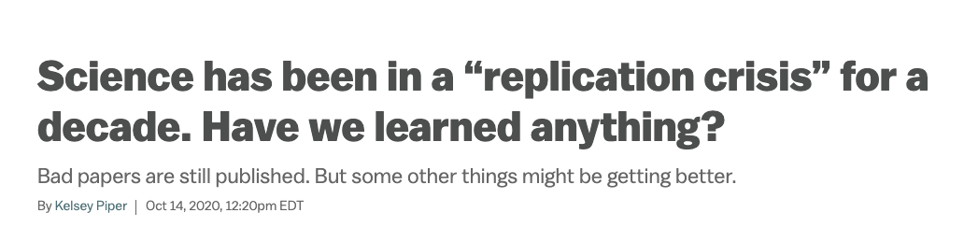

## Psychology is grossly misunderstood

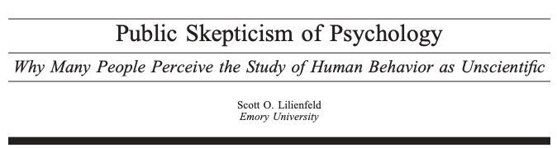

## Next week

The Replication Crisis and our ongoing response - Open Science

The practice of Psychology we encourage in you!

## Research & me-search

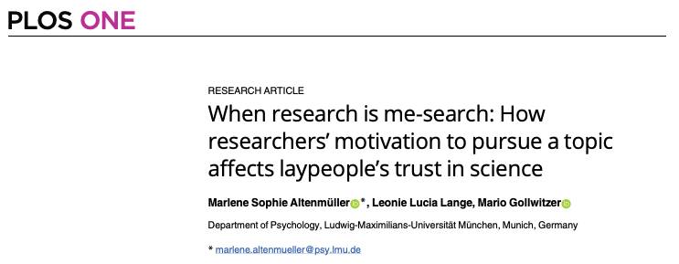

(Altenmüller et al., 2021)

## Reflexivity

Reflexivity and the psychologist

Reflexivity generally refers to the examination of one’s own beliefs, judgments and practices during the research process and how these may have influenced the research.

An integral part of the Qualitative ‘tradition’

(Morawski, 2005)

## Inclusive Research

Inclusive research is a term that was coined in the early twenty first century to embrace participatory and emancipatory approaches to research with people with learning/intellectual disabilities (Walmsley 2001)

Inclusive research embraces participatory and emancipatory approaches to research.

Its characteristics are that it:  
· Is owned (not necessarily initiated) by lay people  
· Furthers the interests of lay people, researchers are on their side  
· Is collaborative  
· Enables lay people to exercise control over process and outcomes  
· Produces outputs that are accessible.

## context

Research situated within the wider rights movement.

#### “Nothing about us without us” (Aspis, 2000).

a slogan of the disabled people’s movement, has been applied to research as well as other areas.

“exclusivity not only touches but also contorts and diminishes all aspects of psychological science” (Ledgerwood et al., 2022, p.2).

Ledgerwood et al. (2022)

## OSF (Open Science Foundation)

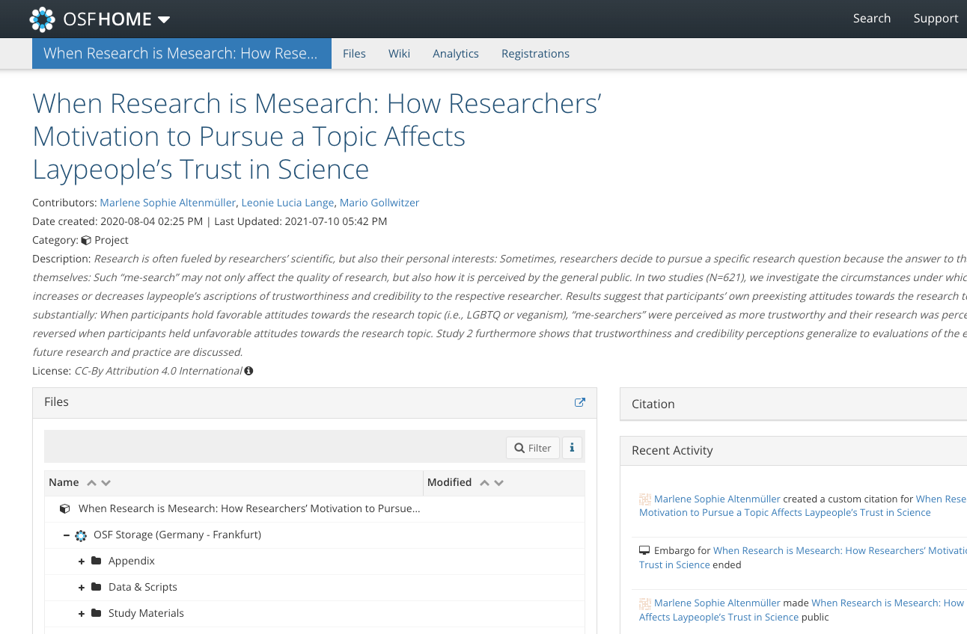

## Open Data and Open Materials

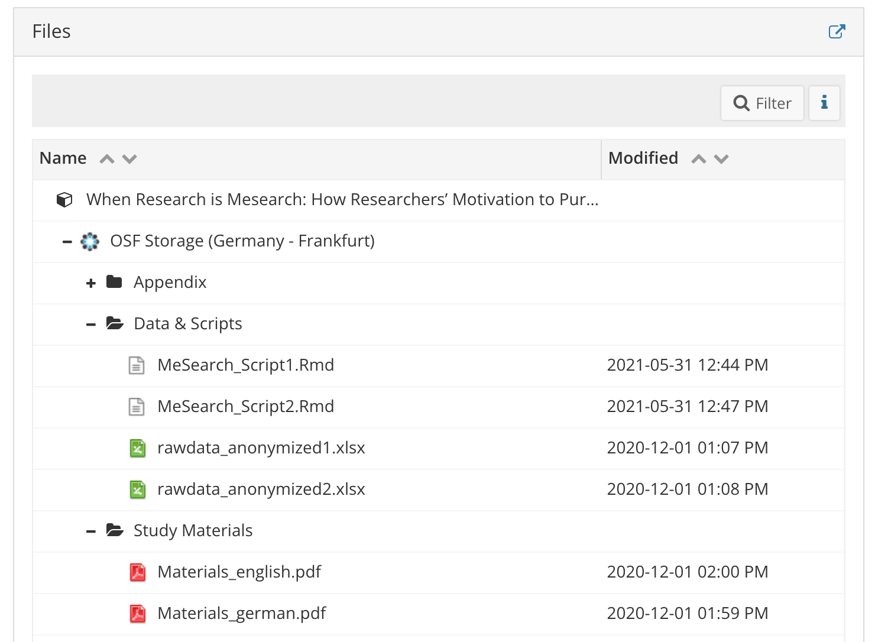

## Open Data

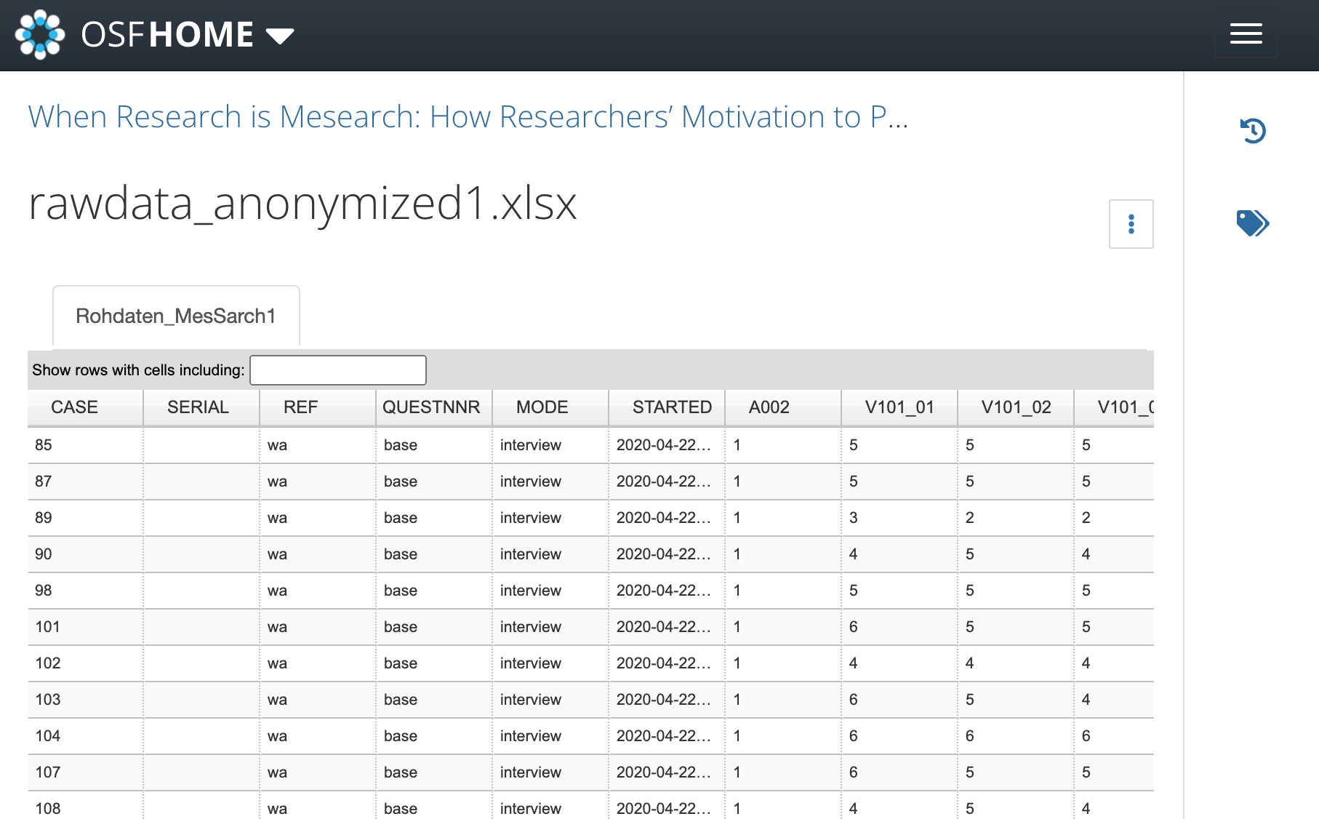

## Open Materials

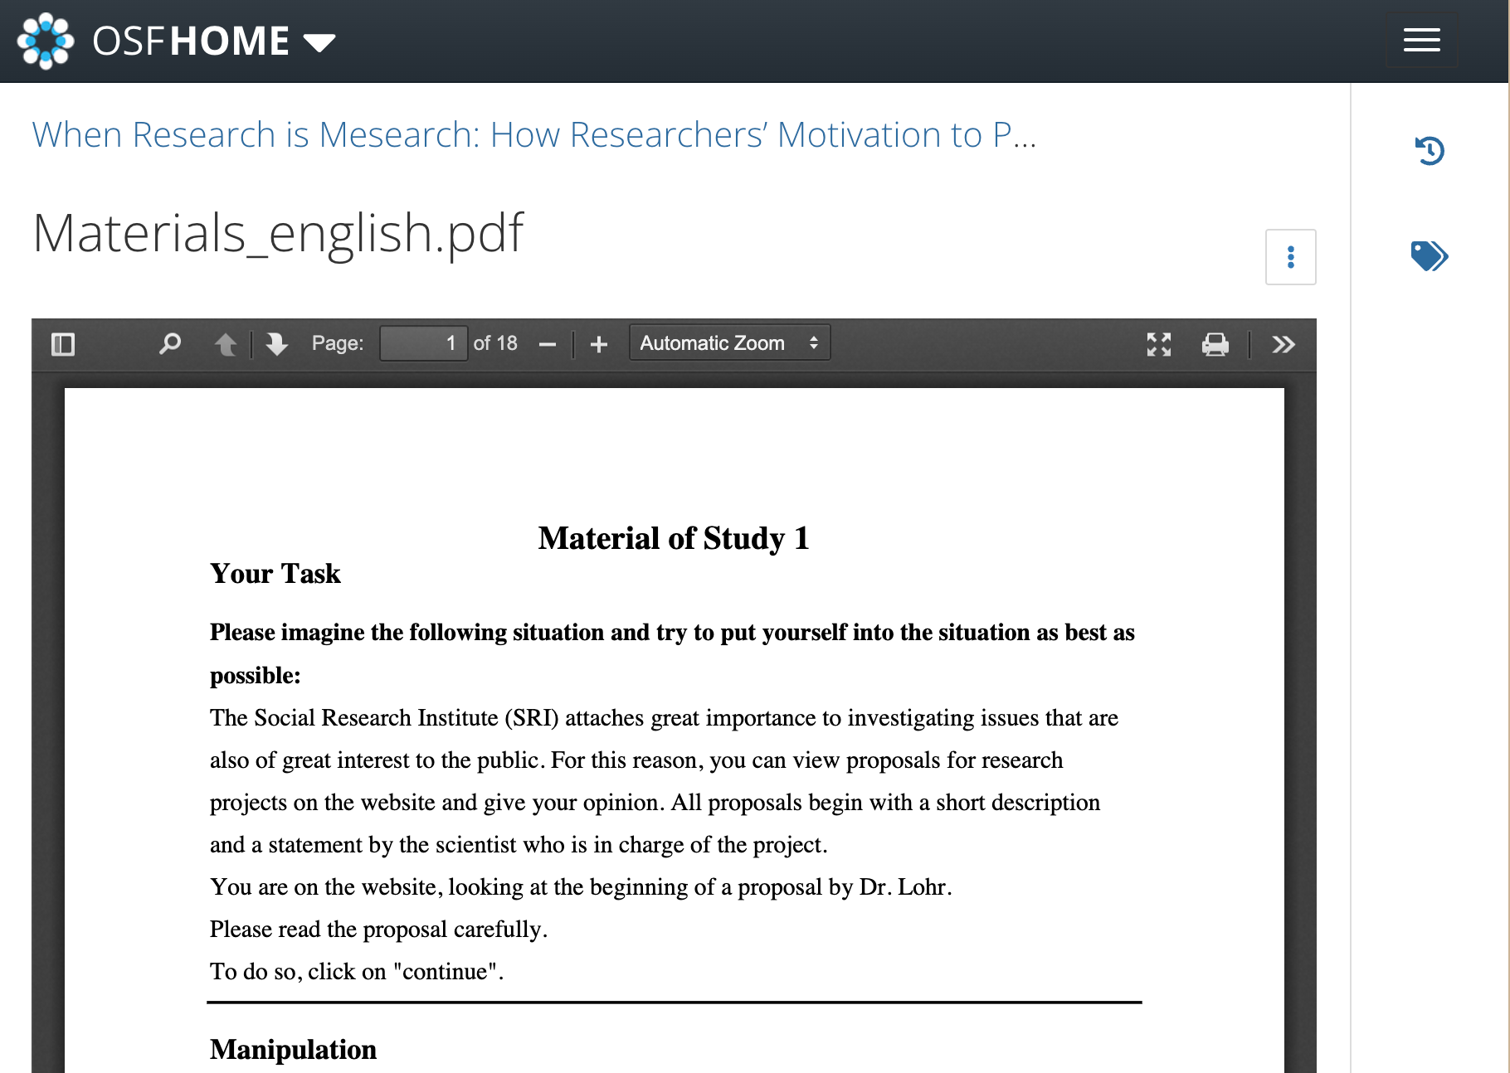

## Psyarxiv

Conry-Murray & Silverstein (n.d.)

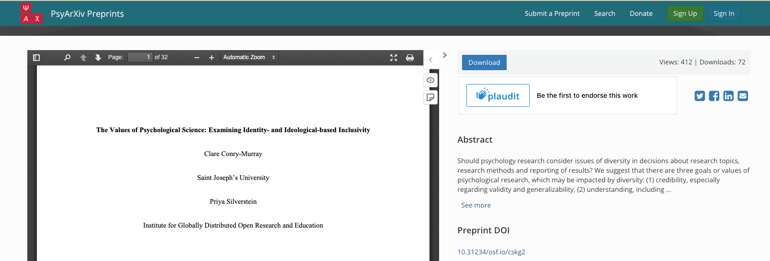

# Questions?

## Lab activities

Keep working!

Formalise your individual design

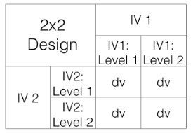

## More specific

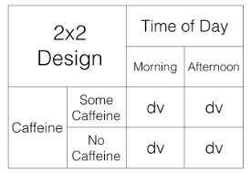

## Notation

We use a notation system to refer to these designs:

2x2 = Two-way ANOVA. There are two IVS, the first IV has two levels, the second IV has 2 levels. There are a total of 4 conditions, 2x2 = 4.

2x3 = Two-way ANOVA. There are two IVs, the first IV has two levels, the second IV has three levels. There are a total of 6 conditions, 2x3 = 6

4x4 = Two-way ANOVA. There are two IVs, the first IV has 4 levels, the second IV has 4 levels. There are a total of 16 condition, 4x4=16

**2x3x2 = Three-way ANOVA**.There are a total of three IVs. The first IV has 2 levels. The second IV has 3 levels. The third IV has 2 levels. There are a total of 12 condition. 2x3x2 = 12.

## Review

[Crump, M. J. C., Navarro, D. J., & Suzuki, J. (2019, June 5). Answering Questions with Data (Textbook): Introductory Statistics for Psychology Students. https://doi.org/10.17605/OSF.IO/JZE52](https://crumplab.github.io/statistics/)

CC BY SA 4.0

<https://crumplab.com/statistics/07-ANOVA.html>

<https://crumplab.com/statistics/10-MixedANOVA.html#x2-designs>

## 3 ‘flavours’ of 2x2 ANOVA

**2bx2b** - Between-subjects/Factorial ANOVA

**2wx2w** - Within-subject/Repeated Measures ANOVA

**2bx2w** or **2wx2b** - Mixed ANOVA

You will be using one of these (all supported by SPSS Exercise 1 & 2)

JAMOVI is a reasonable alternative to SPSS

## The 3 effects possible in a 2x2 ANOVA

Main effect of IV1

Main effect of IV2

Interaction of IV1*IV2

## therefore 8 possible ‘outcomes’ of a 2x2 ANOVA

* no IV1 main effect, no IV2 main effect, no interaction
* IV1 main effect, no IV2 main effect, no interaction
* IV1 main effect, no IV2 main effect, interaction
* IV1 main effect, IV2 main effect, no interaction
* IV1 main effect, IV2 main effect, interaction
* no IV1 main effect, IV2 main effect, no interaction
* no IV1 main effect, IV2 main effect, interaction
* no IV1 main effect, no IV2 main effect, interaction

## graph key

* 1 = there was a main effect for IV1.
* ~1 = there was **not** a main effect for IV1
* 2 = there was a main effect for IV2
* ~2 = there was **not** a main effect of IV2
* 1x2 = there was an interaction
* ~1x2 = there was **not** an interaction

## Bar charts

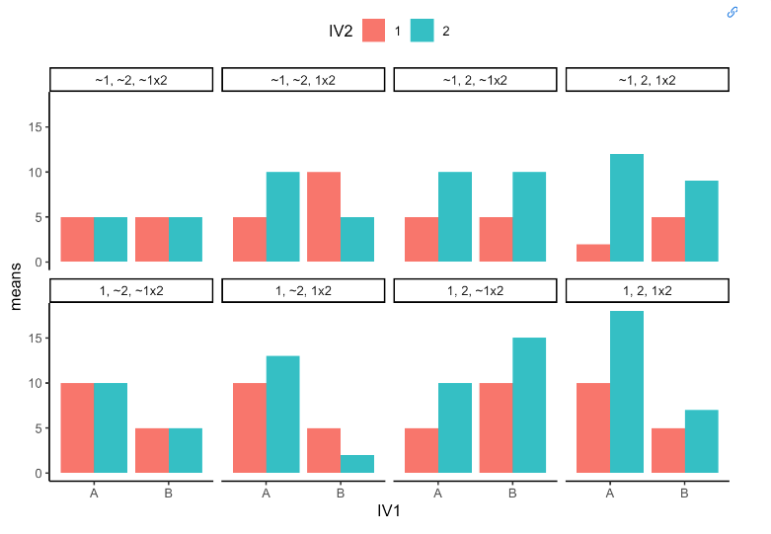

## Line plots

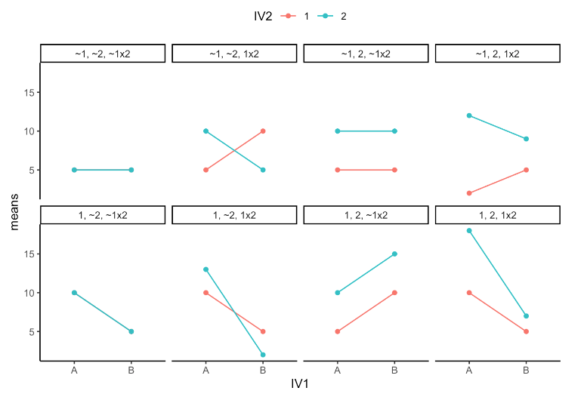

## References

Altenmüller, M. S., Lange, L. L., & Gollwitzer, M. (2021). When research is me-search: How researchers’ motivation to pursue a topic affects laypeople’s trust in science. *PLoS ONE*, *16*(7), e0253911. <https://doi.org/10.1371/journal.pone.0253911>

Conry-Murray, C., & Silverstein, P. (n.d.). *The role of values in psychological science: Examining identity-based inclusivity*. <https://doi.org/10.31234/osf.io/cskg2>

Ledgerwood, A., Hudson, S. T. J., Lewis, N. A., Maddox, K. B., Pickett, C. L., Remedios, J. D., Cheryan, S., Diekman, A. B., Dutra, N. B., Goh, J. X., & al., et. (2022). The pandemic as a portal: Reimagining psychological science as truly open and inclusive. *Perspectives on Psychological Science*, *17*(4), 937–959. <https://doi.org/10.1177/17456916211036654>

Morawski, J. G. (2005). Reflexivity and the psychologist. *History of the Human Sciences*, *18*(4), 77–105. <https://doi.org/10.1177/0952695105058472>