Lecture09

Review of Mini-Dissertation and CHIP Learning Log

Dr Gordon Wright

05 December, 2022

# Overview

## The week ahead

The week ahead (week 9)

* W9 Personal Tutor session ‘Checking in’
* Any general concerns or queries
* Mini-Dissertation Ethics status
* W10 Cognitive Essay Tutorial
* Psych Society Pub Quiz on Wednesday 7:30 (SU)
* Labs - Ethics, Ethics, Ethics

# Mischief Update

## You are amazing!



## or rather

. . .

**Mischief Measured: Development and Validation of a Mischief Typology Measure**

. . .

Authors: Goldsmiths Psychology, Class of ’24

# Reflective Practice

## Metacognition

The process of thinking about ones own thinking

. . .

Most usually with reference to ‘learning’

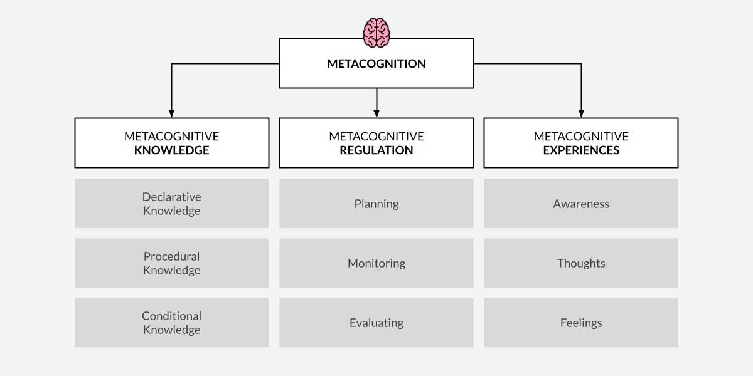

## Critical Proposal

. . .

In the most part, the Critical Proposal showed a very high quality of work

. . .

Clear engagement with the critical evaluative process taught last year.

. . .

A modest progression towards the practicalities and process of real research.

. . .

|  |
| --- |
| Important |
| You were required to present a ‘critical reflection’ |

. . .



## Critical Proposal Briefing

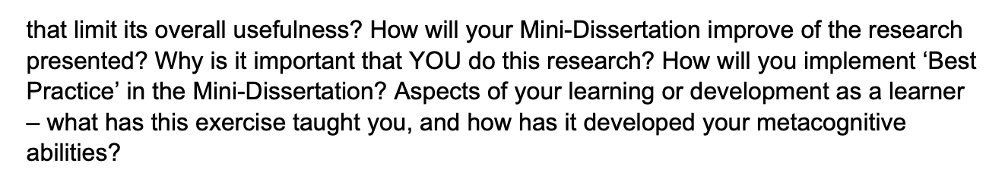

## The example given

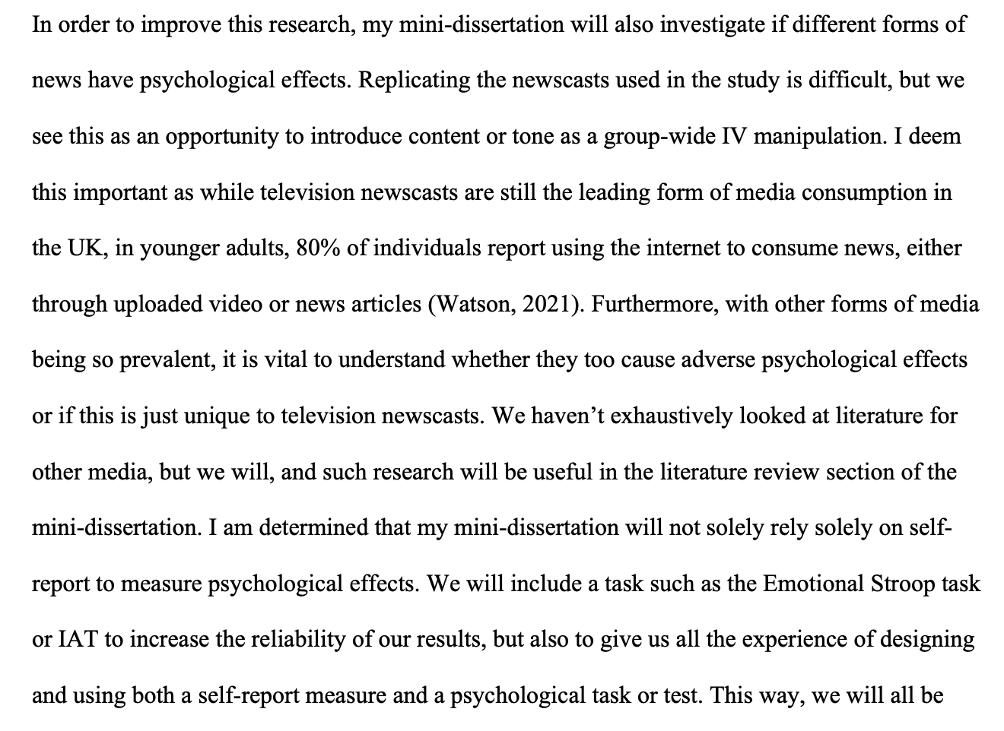

## Mini-Dissertation also requires a ‘Reflective Account’

An integral part of the assignment

Worth valuable marks

## While we are on the topic

Your ultimate individually written up Mini-Dissertation project MUST conform to the following definitive rules:

2x2 ANOVA design with 2 categorical IVs (each with 2 levels) and a single continuous DV

* You must obtain ethical approval and prove individual involvement in the process of application
* You must make a sample size estimation / Power calculation
* You must collect real data (on- or off-line) and individually contribute to group and cohort data collection efforts
* Open Data (Clearly labelled .csv file e.g. Excel, with codebook or explanations of variables)
* Open Materials (All materials relevant to the task in as immediately reproducible a format as possible - stimulus sets, stimulus creation instructions, scripts or code, experiment design information e.g. random allocation techniques)

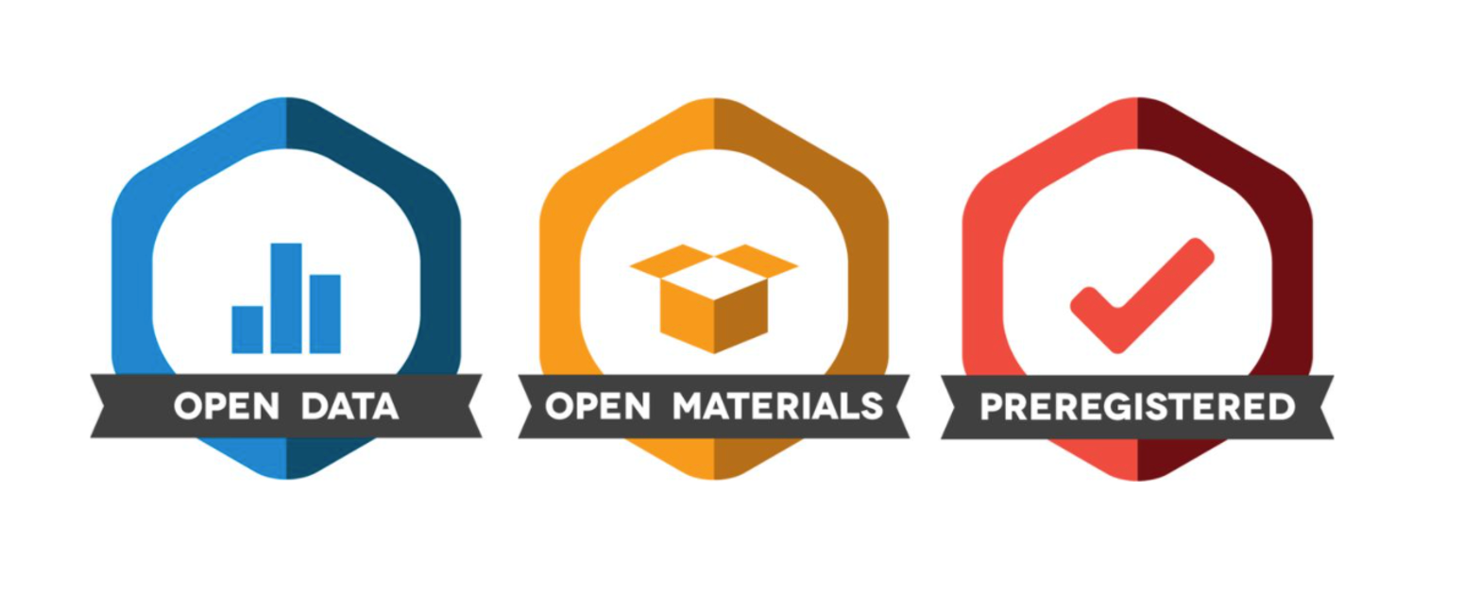

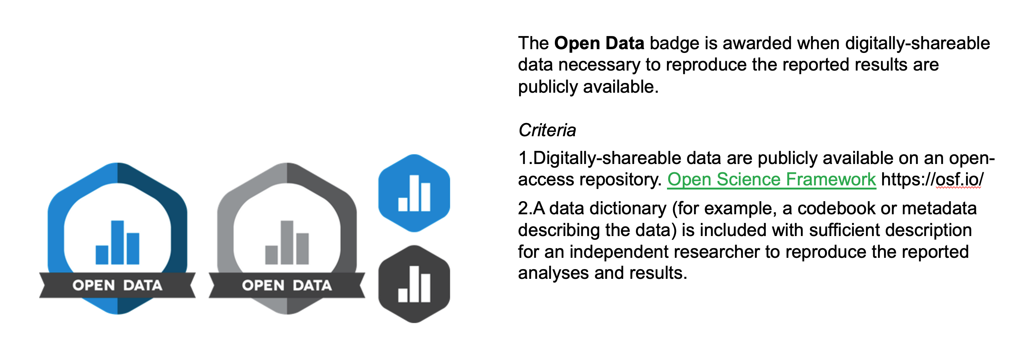

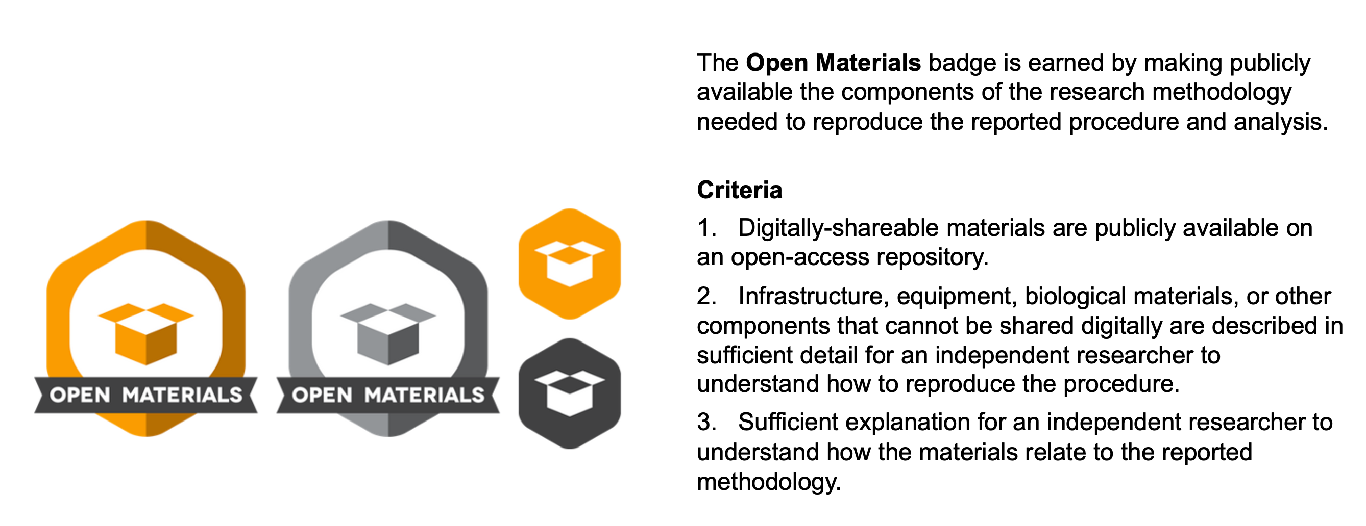

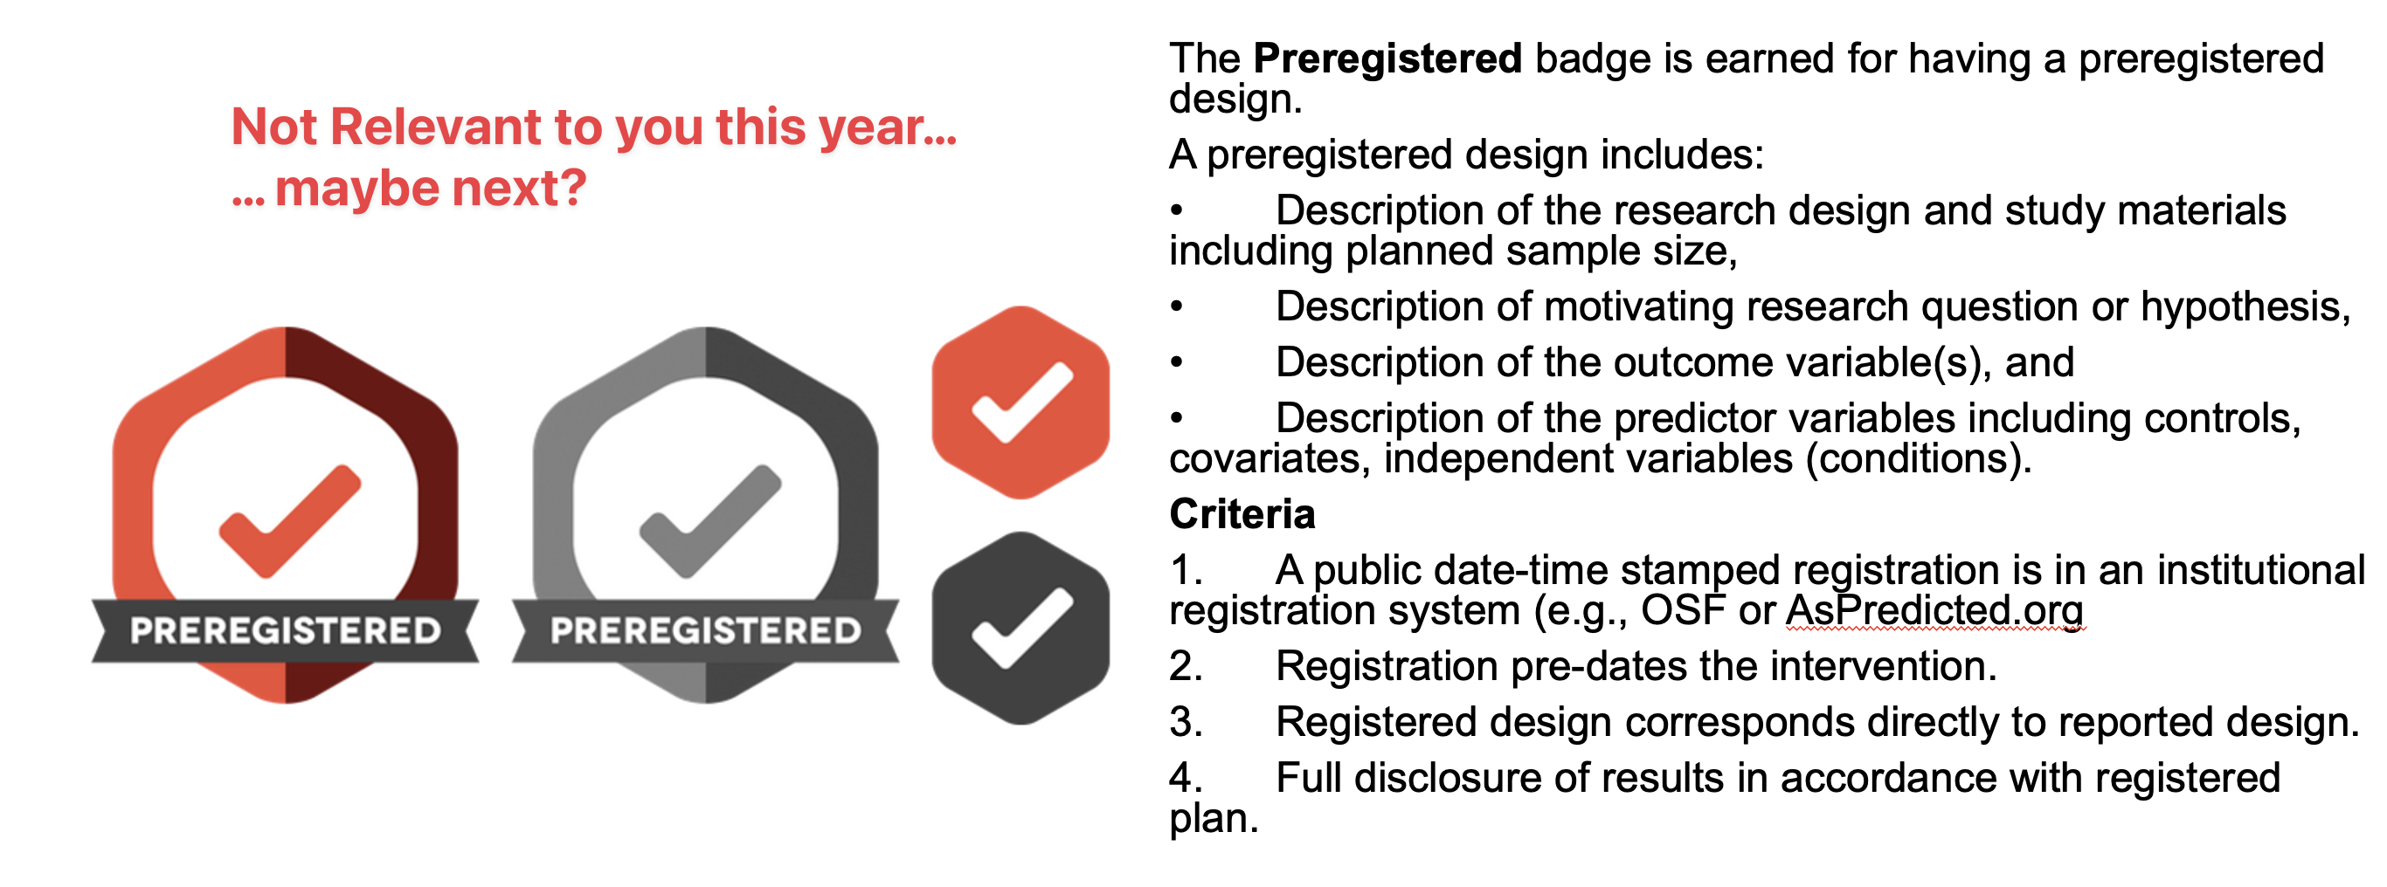

# CHIP Learning Log

Designed to introduce you to:

* Conceptual and Historical & Integrative issues in Psychology
* Big picture stuff! Controversies!

Traditional topics are:

* A history of Paradigms in Psychological Research
* Psychology as a Science
* Evolution
* Consciousness

## Surprise* hit last year

Inclusivity – 2 lectures from Dr Tegan Penton

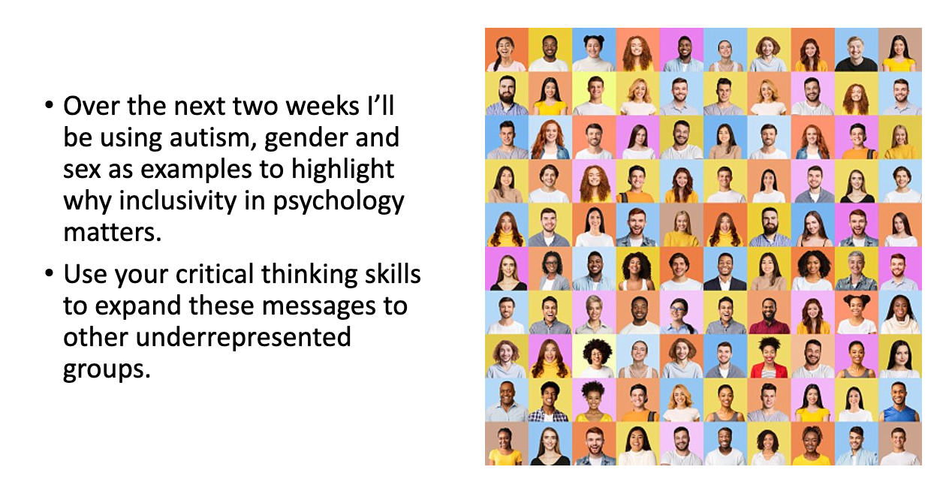

## CHIP Assignment(s)

* Coursework piece designed to allow you to engage reflexively with the ‘big picture’ of your degree
* Think about how these issues link into psychology as a discipline, and how they relate to your own thoughts about what psychology is or should be
* Two essays of max 700 words each
* **Marks are awarded for reflection**, evidence of learning and bring topics together. Please see marking criteria for both essays.
* Not looking for a restatement of the facts in the lectures etc.
* **They are designed to be personal and reflective – embrace this aspect!**

## Essay 1

Essay 1 is based on the content of ONE of the topics and should adopt at least two of the following 6 ‘perspectives’.

* + As a **STUDENT** of psychology
  + As a **TRAINEE** psychologist
  + In relation to a **RESEARCH** application in your future
  + As an **HISTORIAN** of psychology
  + Reporting on the culture or **PRACTICE** of psychology as it currently exists here or across cultures
  + As a critic or supporter of psychology’s status as a **SCIENCE**

## Essay 1 tips

* + Ask a specific question – and answer it.
  + Intro, body, conclusion structure.
  + Reflect on the topic and give your own opinion as to the answer!
  + Present a journey in your learning or appreciation of the topic
  + Ensure your answer is argued using examples
  + Use evidence in your argument from a range of sources, ideally do some strategic wider reading
  + Present and reference it well

## Essay 2

Essay 2 should focus on at least one of the OTHER topics covered in the course.

* + This answer should focus on a primary reading associated with the lectures and then any further reading you have done (strongly encouraged).
  + You must identify that primary reading explicitly in the essay itself.
  + You should not simply restate what the authors thought or found, but rather briefly summarise the point that stimulated your interest in the reading and use that as a springboard to discuss the topic or issue.
  + Think about your perspective on the issues.
  + What do you think about this debate or issue? We want to know!
  + And what do you think are interesting directions for psychologists to take this debate or issue in the future?

## Essay 2 tips

* + Explicitly identify a single initial reading and build upon that.
  + Discuss a debate or issue that you think is interesting or important
  + Give your own opinion and how this has developed or changed as a result of the lecture, the course more widely, and/or the reading.
  + Argue your opinion explicitly, own it and back it up with examples
  + Use evidence in your argument from a range of sources, ideally do some strategic wider reading
  + Present and reference it well

## Overlapping content

* + You can combine across different topics in Essay 2 (e.g., you could talk about Evolution and Consciousness, or Inclusivity and Science), and thinking about links between topics is strongly encouraged.
  + However, the material covered in Essay 2 must be different from Essay 1. Students will be penalised for covering identical topics.

## Details

* + Due 10 am 21st April 2023 - about 3 weeks after the end of term
  + Both answers should be written in essay-style prose (e.g., with APA references where you refer to sources) put in a single document and submitted to the coursework submission page.
  + Max 700 words per answer (references not included in word count)
  + Remember that this only accounts for a smaller portion of the module grade (15%). Should hopefully be an enjoyable way to reflect on issues on the course you found interesting.

## Essay 1

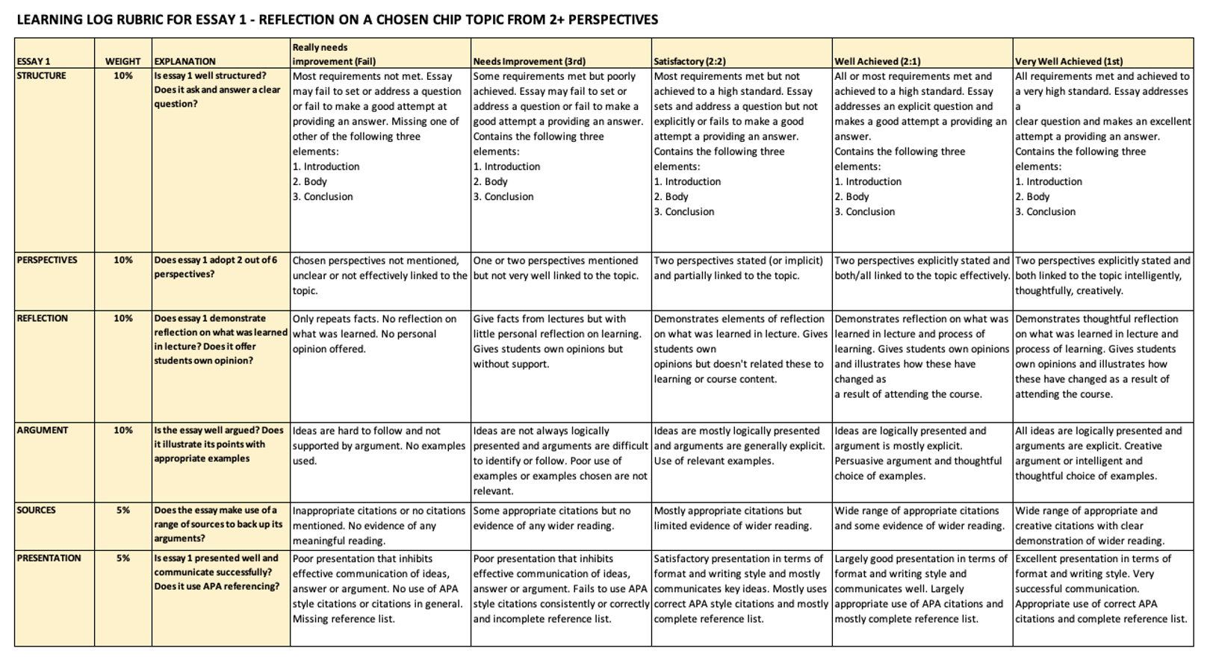

## Essay 2

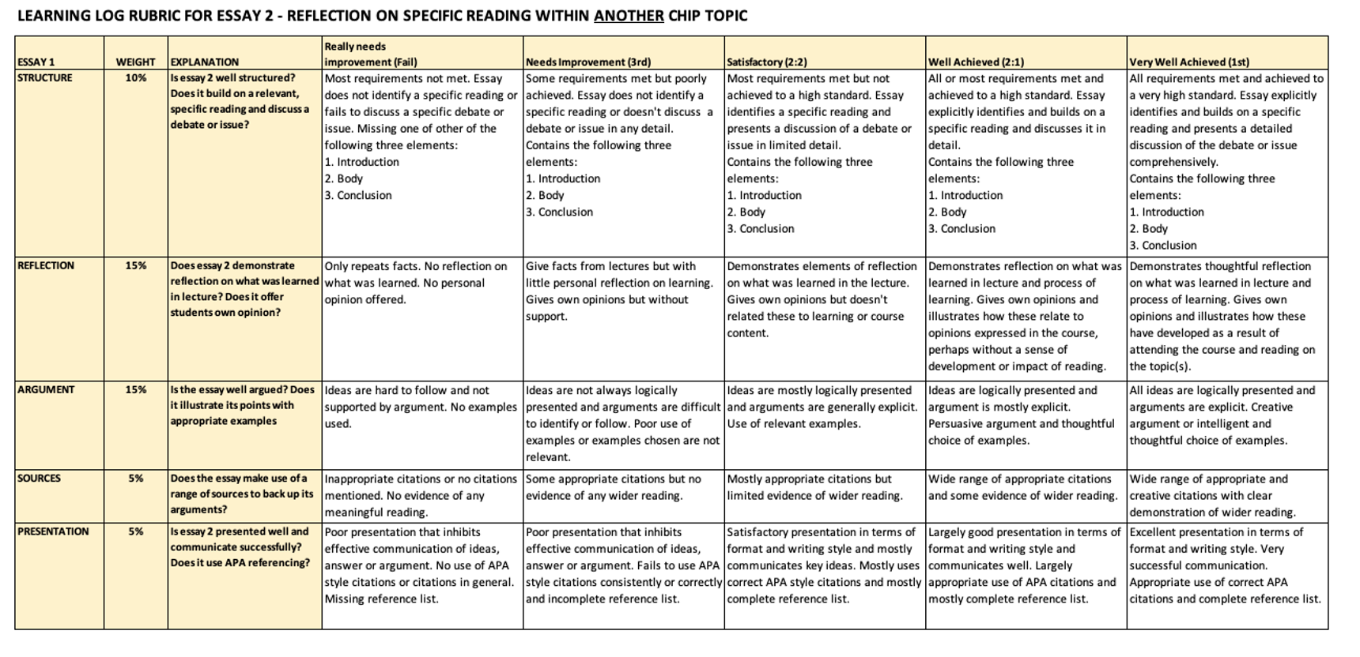

# Any questions?

# Have a great week!