Lecture03

Being critical and evaluating the work of others

Dr Gordon Wright

17 October, 2022

## Key topics today

The week ahead

* Personal Tutor Meeting about Mini-Dissertation this week
* also Weeks 8 (ethics), 13 (write-up prep), 17 (Stats)
  + It is your time, PTs have been told to follow your lead
* Critical Proposal overview and tips
* Lab preview - Literature search and management
  + Your Critical Proposal Target Paper

## Personal Tutor Meeting Week 3

This week (week 3) you have 50 minutes with your Personal Tutor to discuss the Mini-Dissertation

|  |
| --- |
| Tip |
| Your Personal Tutor is ANOTHER source of guidance and support.  Give them the information they need to best help you on this journey. |

Dear PTs, “Next week, you are given **no information whatsoever**, and are asked to turn up to your session with nothing other than perhaps a pen and paper, a big smile, and anticipation of lots of exciting research in the making.”

## Future PT Sessions devoted to the MD

Week 8 - Check on status of Ethics application, and troubleshooting

Week 13 - Session to support Analysis Planning and Writing up/Submission preparation

Week 17 - Result interpretation, and any concerns arising in the final phase of the MD

# Any Questions?

# Being critical and evaluating the work of others

## This is a topic and skill you’ve already been shown





Review these materials and consider your performance of the assessment, and any feedback

## This year Critical Analysis has a ‘point’

The objective of the Critical Proposal is that you start to deploy the tools you have practiced in the service of your Mini-Dissertations.

A ‘practical’ exercise, success if determined in light of practical value.

Helping to develop some aspect of your study design or methodology.

You will probably follow this process ‘a few times’ for your final year dissertation!

## Reading list items (Barber 2002; 2004)

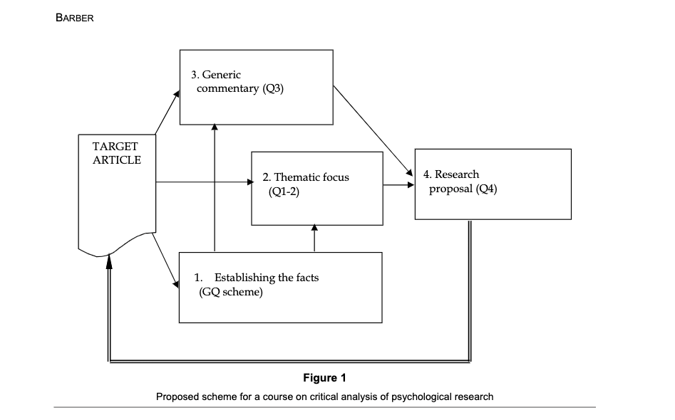

## 

## Let’s look at the example from last week

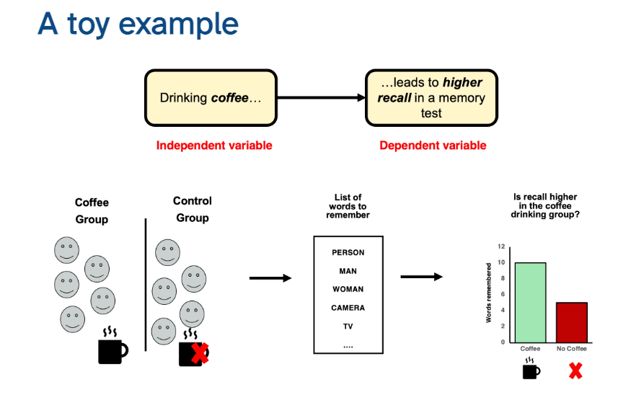

## How do I do it? [one approach]

Review literature on a key part of your ‘puzzle’ (an IV, a ‘tool’, the DV etc)

Apply critical evaluation to carefully chosen paper(s)

Consider how it might realistically guide or inform your own research

Identify a procedure to partially replicate, replicate, or replicate and extend/improve

Detail how that takes shape and reflect on your confidence, skill base, perception of value

## or

You could approach it strategically as a group.

Identify areas to take ownership of, then divide and conquer!

Or fly solo and agree to later apply the same process to a mutually beneficial part of your study

## Critical Proposal Support

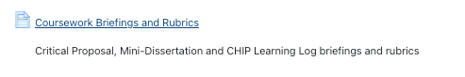

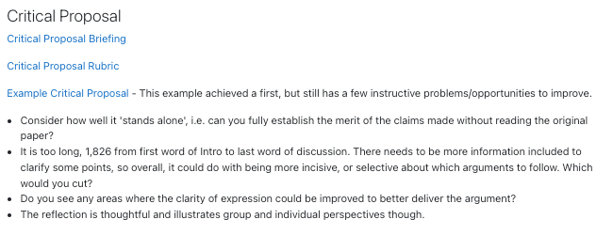

## Briefing

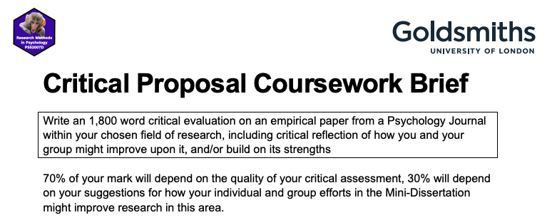

## Please follow these

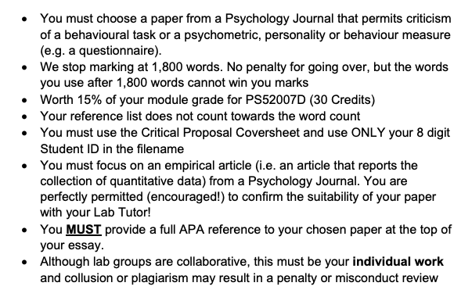

## More tips

* Please review the “SUGGESTED ESSAY OUTLINE” in the coursework briefing
* No need to follow it roboticly, be strategic & selective in terms of details
* Selection of a ‘good’ paper to focus on is an integral part of the assessment!
* Do you think the first google result will be a fruitful paper? No, of course you don’t!
* Use your Lab Tutor and me to get a sense of confidence. Early.
* Tell us how you are searching and what you are looking for
* Confirm the paper with us in a lab session [Priority given for this]

## Even more tips

* Use some of the tools presented in the lab activity to help track down a suitable paper
* Give yourself time to read, review, re-read and select your juiciest points
* Avoid any discussion of methodologies that cannot inform your study directly
  + e.g. Clinical diagnostic procedures, fMRI technicalities, Criminal Record or Case Study review procedures

## You can (will) use LOTS of this in your MD!

This isn’t a sidetrack exercise. It’s a critical step in your project

Note your references, note your main points, be organised

## Weeks 4 & 5

Talking about Variables and the 3 ‘flavours’ of ANOVA in week 4

Week 5 is ‘power calculations’ and opportunity to discuss CP

But we will be moving on and the CP will be part of your independent study

Same opportunities for RASA submissions/summer deferrals & resubmissions

# Questions?

## New Teaching Fellow in Lab 03 WB300 9:30-11:30

Dr. Faize Eryaman

I’m going to meet her directly after this.

New to Goldsmiths, but a fantastic researcher and teacher.

Please help her settle in!

## Roving Gordon

I shall be more available across all the labs now, and looking to help out as much as I can!

I’m looking for opportunities:

* To share good ideas or practice
* To help confirm consistency and give you confidence
* To be another “guide at the side”
* To challenge you
* But not to confuse you or contradict your Lab or Personal Tutors

# Questions?