Lecture06

Operationalising variables and bringing concepts to life

Dr Gordon Wright

14 November, 2022



## Key topics today

The week ahead (week 6)

* Personality & Individual Differences Essay Tutorial (Submission Fri, 25th Nov)
  + How and why does intelligence predict important life outcomes?
* RASA and EC deadline for Critical Proposal (Fri, 18th Nov)
* PsychSociety film number 2!
  + Tuesday (15/11/2022). You can find out more information and book [**here**](https://www.eventbrite.com/e/psychology-film-fest-tickets-459930523577?fbclid=PAAabR7OJ38LFeXWvs6oj8MN-Kq3z_8wdyrTYCnCOnpq7HVv6fpHpV1_1CPwY). [Three Identical Strangers](https://en.wikipedia.org/wiki/Three_Identical_Strangers).
* Strike days - 24th (Thu), 25th (Fri), 30th (Wed)
* Labs - Online (and Offline) Data collection

# Any Questions?

# ‘Operationalisation’ of variables

Operationalisation of variables requires a consideration of the reliability and validity of the method of operationalisation.

Operationalisation of variables also requires specification of the scale of measurement: nominal, ordinal, interval, or ratio.

Finally, operationalisation of variables can also specify details of the measurement procedure.

See Howitt and Cramer Chapter 3.3 (Box Research Example - Condon & Crano 1988)

## Attitude similarity and interpersonal attraction

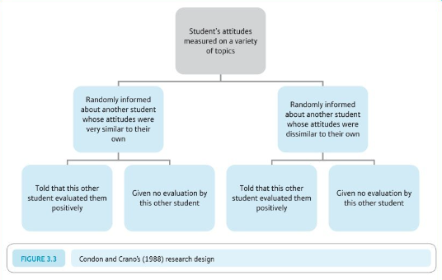

## Their DV (consider pros and cons)

This person would like(dislike) me

This person would like(dislike) working with me in an experiment

## The Student Room (question)

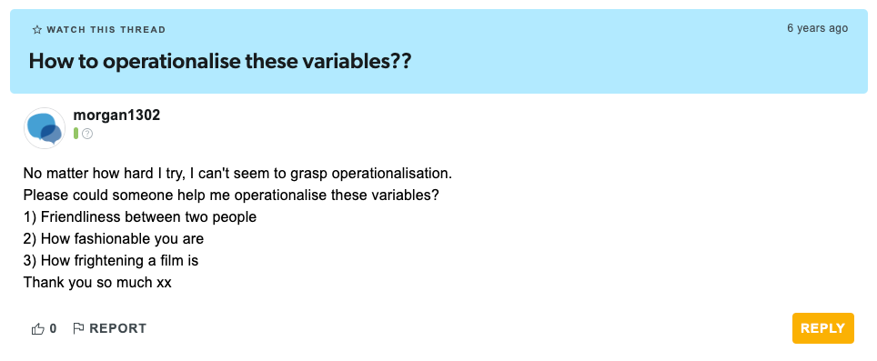

## The Student Room (answer 1)

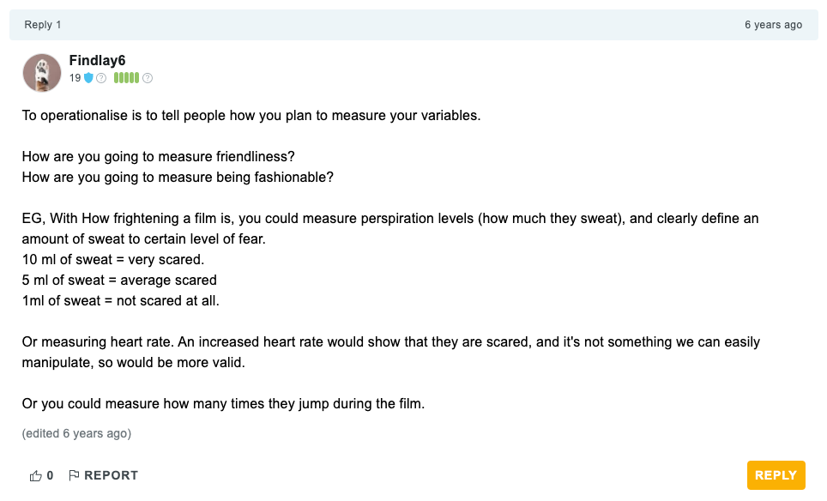

## The Student Room (answer 2)

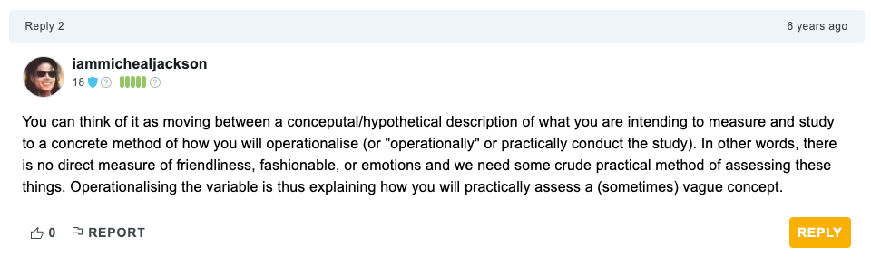

## Let’s think about your forthcoming Personality essay

Two key concepts you’ll be thinking about and reading around…

* Intelligence
* important life outcomes

## Hopefully, you will ask yourself…

How are these important and very tricky concepts

* Defined
* Measured
* And brought to life in the lab!

## Of great importance that you reflect on this for your MD too

How have you defined your variables of interest?

* IVs and DVs

How have you measured or categorised your variables of interest?

* e.g. Social Media use
* Gender
* Frequency or low/high extraversion

## **The research process**

•Develop research aims

•Specify research questions/hypotheses related to these aims

•Identify relevant constructs and concepts

•Translate constructs and concepts into variables (i.e., a logical set of characteristics/features)

•Translate variables into measurements (i.e., the quantification of characteristics/features)

## Quantitative Research

A systematic examination of relationships between variables

‘Variables’ are ‘translated’ concepts, constructs or phenomena

## Types of Variable

Independent

* Experimental - The variable I manipulate
* Non-Experimental - Comparison groups

Dependent

* The variable you measure, that you propose to be influenced by a manpulation of the IVs

## Types of Measurement

Nominal/Categorical

* Male/Female/…
* Vegan, Vegetarian
* Smoker/Non-Smoker

## Types of Measurement

Ordinal

Numbers representing a rank position in a group

Not representative of an actual definite number/score/value - without information about the ‘gap’ between numbers

* First, second, third
* Tallest/Shortest

## Types of Measurement

Interval

Numbers represent equal units giving information about the ‘gap’ between numbers

* Temperature
* Psychological Scales

## Types of Measurement

Ratio

Interval measurements with an absolute zero, of equal units,

* Weight
* Length
* Time/Reaction time*

## Dani Navarro

A legend. Author of Learning Statistics with Jamovi/R

# [learnstatswithjamovi.com](https://www.learnstatswithjamovi.com/#)

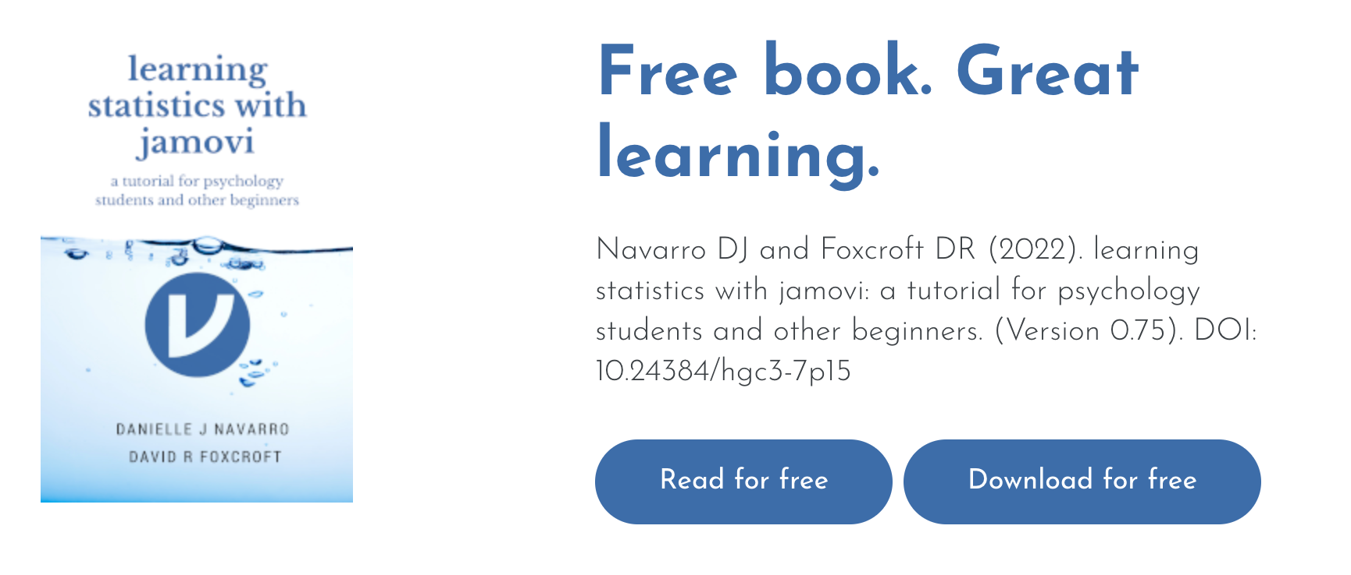

## Dani’s example:

• My age is 33 years.

• I do not like anchovies.

• My chromosomal gender is male.

• My self-identified gender is male*

*see footnote 2, page 14 Learning Statistics with Jamovi

## Median Splits

|  |
| --- |
| Dangerzone! |
| We often suggest a median split to dichotomise a continuous variable, e.g. for the purposes of creating a 2 level IV.  It’s a useful exercise in calculating a ‘computed variable’ in SPSS or Jamovi  It is NOT best-practice usually. |

It is a key learning outcome that you are able to perform a standardised set of analysis, specifically, the 2x2 ANOVA with any necessary assumption checks and post-hocs + plots

## Think about this

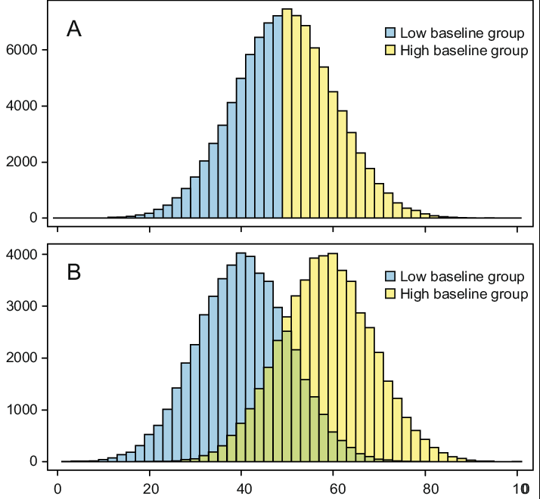

## Operationalisation, measurement and definitions impact…

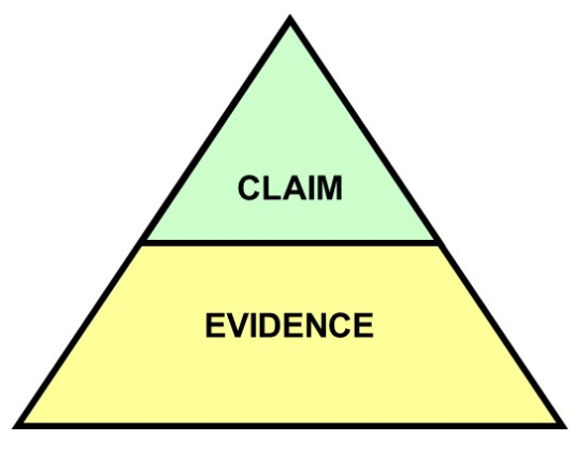

## Summary

You should think carefully about:

* How you define your variables - this is probably a part of the introduction that students DON’T think about enough
* How you measure or categorise your variables (IVs and DVs) - this is probably the single thing I look at first when peer-reviewing research!
* How well your manipulation does what it claims to. Does you manipulation bring the thing it proposed to to life well?

# Questions?

## Lab activities

Qualtrics (99% of you will use this!)- Full Support in Tomorrow’s labs (5mins)

* Log in to an account with your Goldsmiths ID!!
* 10% of you will apply for the wrong type of account and be stuck for 2 weeks

Familiarise yourself with the Ethics Application process (10mins)

Consider the steps required to bring your study to life! (the rest)