Lab 10: Preview to next term

Lots of fun ahead

Dr. Gordon Wright

December 10, 2024

# Welcome to Lab 10

* **Today’s Focus**: Finalise your ethics applications

## Looking ahead to term 2!

* **Study Swap**: Opens in week 11 and you learn by doing!
* **Goal**: Learn from peers by participating in each other’s studies.
* **Why?**: Experience the challenges and creativity under shared constraints.

# Compulsory Participation

## How It Works

* **Everyone Participates**: All second-year students will take part in each other’s studies.
* **Participation Cap**: There will be a maximum number of required participations.
* **Flexibility**: You are encouraged to join more studies if interested.

# Why Participate?

## Key Learning Outcomes

* **Shared Constraints**: See how peers solve similar research challenges.
* **Research Insight**: Learn what works and what doesn’t from others’ approaches.
* **Improved Design Thinking**: Refine your study delivery ideas for future projects.

## Learning by Doing

* **Understand All Moving Parts**:
  + Study design choices
  + Data collection methods
  + Participant management
  + Ethical considerations

## Learning by Doing

* **Think Critically About Delivery**:
  + How will you run your study next year?
  + What methods will you avoid or adopt?
  + How do study conditions affect data quality?

## Summary

* **Participate**: Engage with as many studies as possible.
* **Observe**: Learn from different designs and execution strategies.
* **Reflect**: Apply insights to future research projects.
* **Ask Questions**: Use labs and forums for feedback and clarification.

## Participation will be monitored!

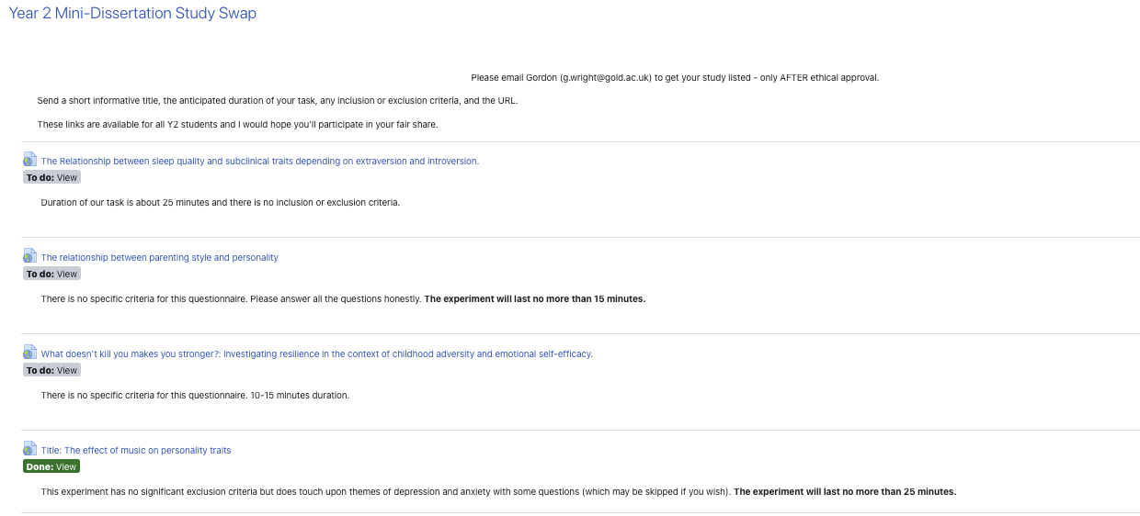

## Thank You!

* Be curious, be engaged, and learn by doing!
* Have a great break and see you next term!