Raspberry Pi User Documentation
ENGR 7
Author: Jiale Jiang Editor: Shen Jun Huang
This guide covers our classroom connection setup, basic Sense HAT functions, and the challenges we encountered.

Hardware and classroom network
1. Check the kit for the Raspberry Pi 3 Model B+, power supply, short USB cable, and USB Wi-Fi dongle. Confirm that the kit number matches the assigned IP label on the Pi.
2. Turn on the lab computer and keep its Ethernet cable connected. Insert the USB Wi-Fi dongle into its USB port.
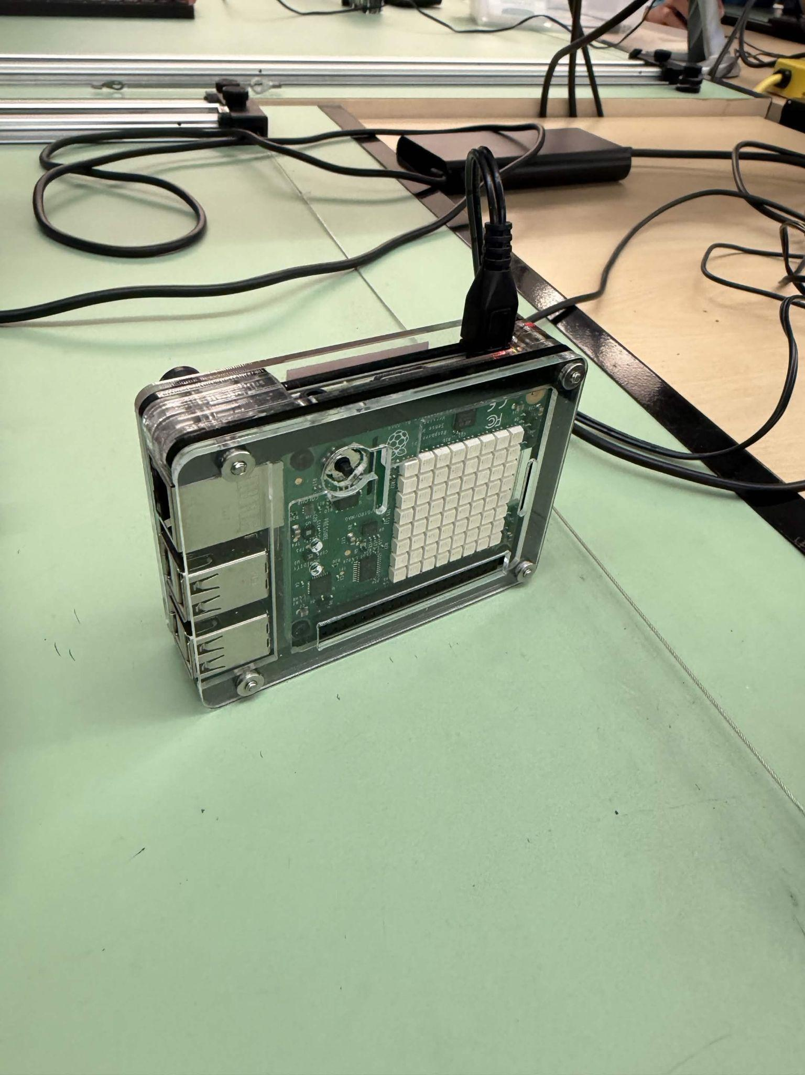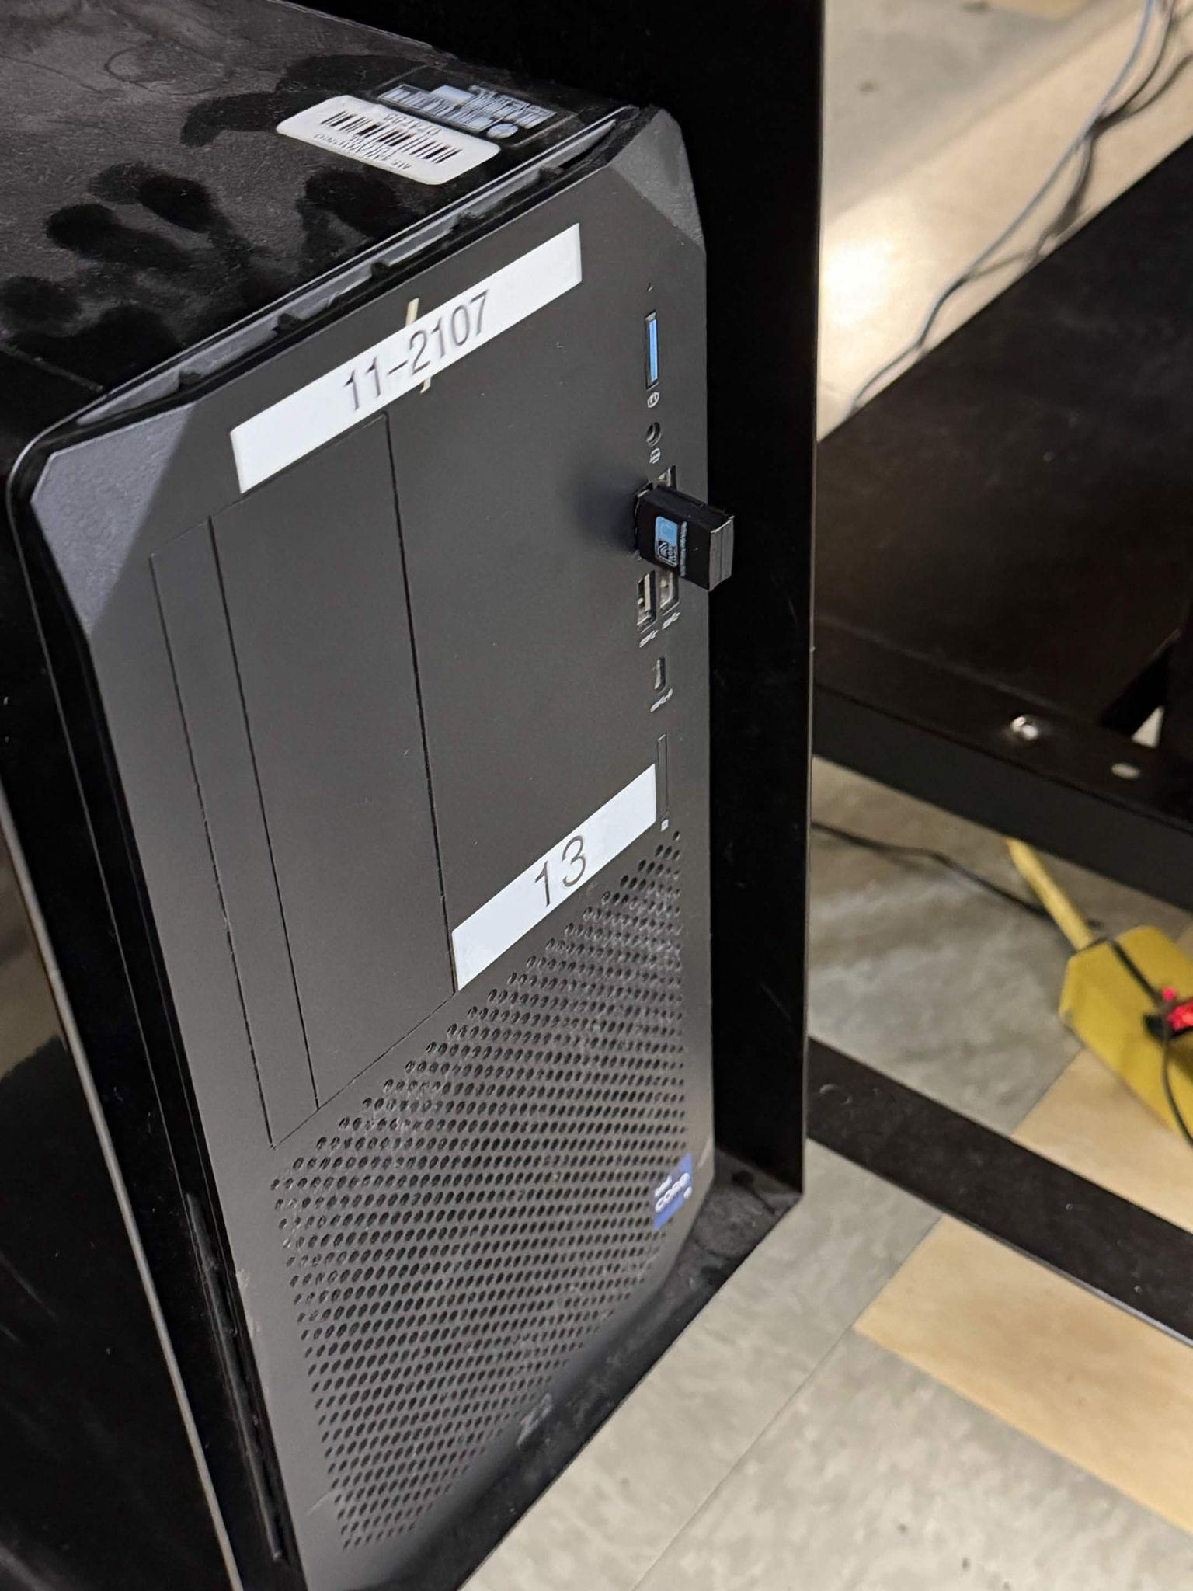
Figure 1. Our Raspberry Pi and the USB dongle connected to the lab computer.
3. Click the network icon at the bottom-right of the desktop, select Wi-Fi, and connect to MT_SAC_ENGR_7 using welcometoengr7. Confirm that it is connected. "No Internet" is normal for this classroom network; the computer may still have Internet through Ethernet.
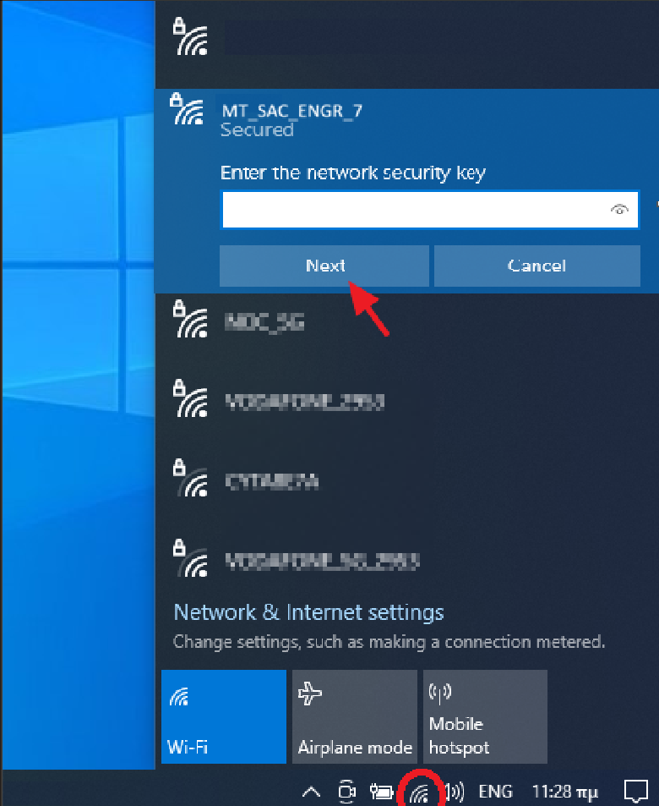
Figure 2. Edited example showing the classroom Wi-Fi selection.
4. Connect the Pi to its supplied power cable and outlet, turn on the cable switch if fitted, and allow it to boot. Do not use the USB-to-USB-C cable for this setup. Read the Pi's assigned IP label; use that same address in RealVNC and MATLAB.
RealVNC connection
5. Open RealVNC Viewer and select File > New Connection. Enter your Pi's assigned IP address in VNC Server and your group name in Name. Save the connection; an icon should appear in the address book.
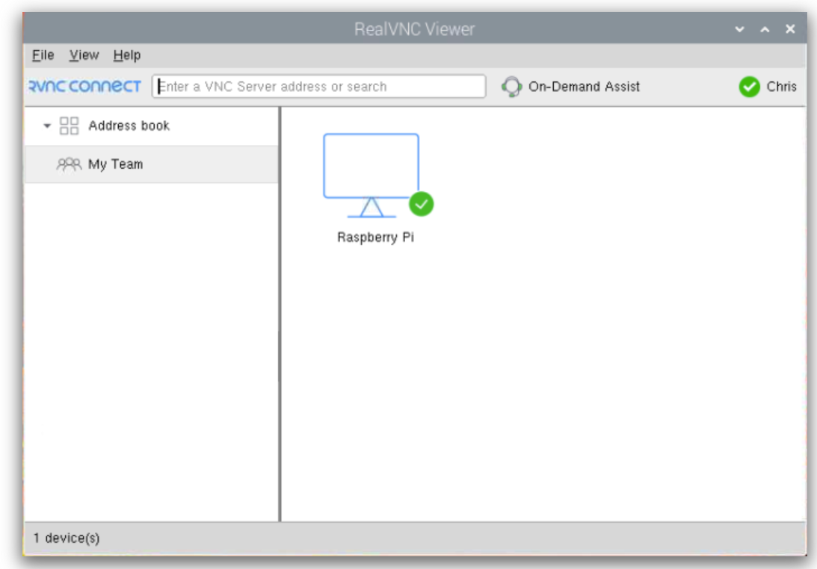
Figure 3. RealVNC new connection setup page
6. Double-click the saved connection. If an identity warning appears, verify the assigned IP and check with the instructor before continuing. In the authentication window, enter username pi and password raspberry, then click OK.
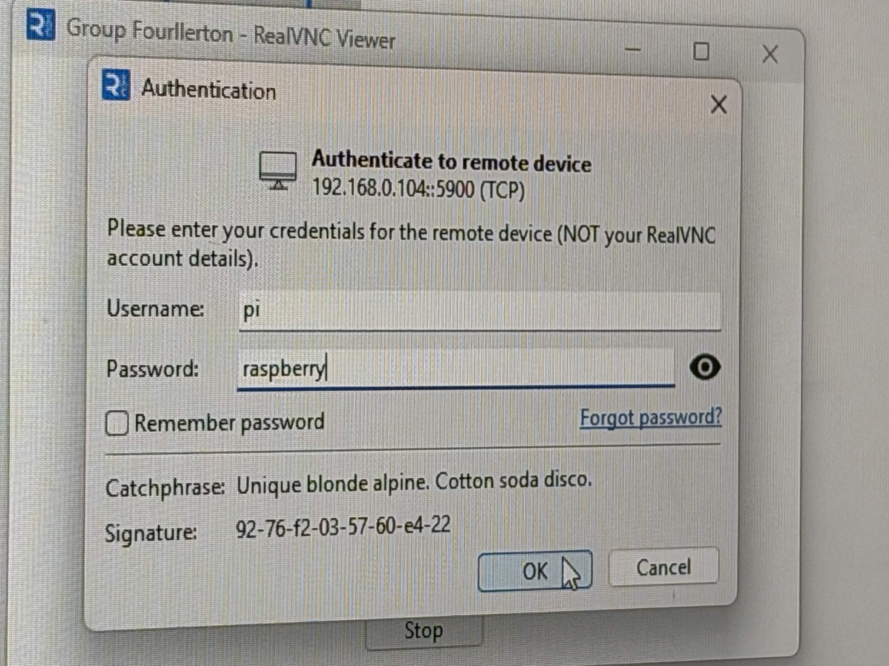
Figure 4. RealVNC authentication using the Pi account. The IP shown is an example.
7. Confirm that the Raspberry Pi desktop opens and responds to the mouse. The VNC Server icon appears near the upper-right corner. Leave this desktop available while connecting MATLAB.

Figure 5. Our Raspberry Pi desktop connected through RealVNC Viewer.

MATLAB connection
MATLAB connects directly to the Pi. RealVNC lets us check its desktop but is not required to keep MATLAB connected.
8. Open MATLAB R2022b on the lab computer. In the Command Window, enter the commands below, replacing IP_ADDRESS with your Pi's assigned address. raspi creates the connection object; sensehat creates the Sense HAT object.
rpi = raspi('IP_ADDRESS','pi','raspberry');
mysh = sensehat(rpi);
9. Type rpi and mysh without semicolons to view their properties. Confirm that rpi and mysh both appear in the Workspace before using the Sense HAT.
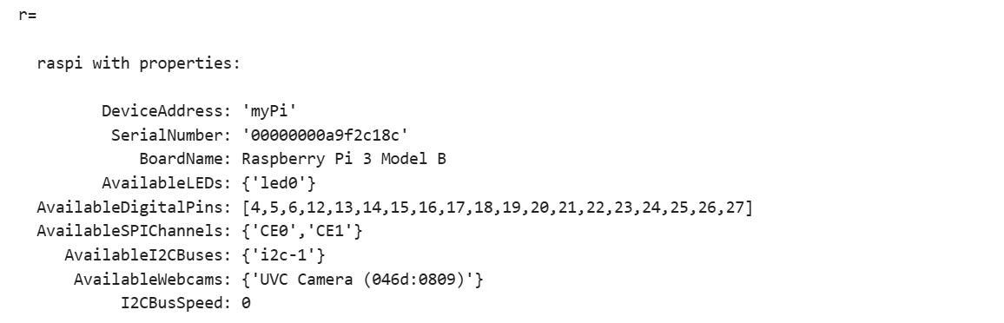
Figure 6. Raspberry Pi connection properties displayed in MATLAB.
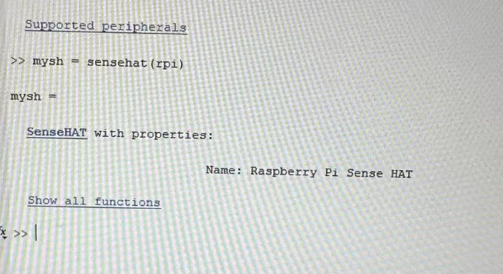
Figure 7. Our MATLAB output after creating the mysh Sense HAT object.

MATLAB and Sense HAT functions
- displayImage(mysh,img) displays an 8-by-8-by-3 uint8 RGB image on the Sense HAT LEDs. An optional third argument sets orientation to 0, 90, 180, or 270 degrees.
- clearLEDMatrix(mysh) turns all LED pixels black, clearing the display.
- writePixel(mysh,[row col],'red') sets an LED's color. Row and column indices must be from 1 to 8.
- img = imread('picture.png') reads image data into an array. RGB images have three color channels; the file determines the original dimensions, not necessarily 8-by-8.
- imshow(img) displays the image in a MATLAB figure, not on the Sense HAT.
- img = imresize(img,[8 8]) resizes the image to eight rows and eight columns. RGB input stays RGB; grayscale or indexed images need conversion before LED display.
- direction = readJoystick(mysh) returns 0 for no press, 1 for center, 2 for left, 3 for up, 4 for right, and 5 for down.

Troubleshooting connections
10. If a connection times out, check the power supply, USB Wi-Fi dongle, network connection, and assigned IP address. Retry after correcting any loose connection.
11. If the Pi remains unreachable, connect it to a lab monitor and check its current IP address. If it differs from the label, update the address in the saved RealVNC connection and the MATLAB raspi command.
12. If MATLAB reports an existing connection, clear mysh, rpi, and any other objects sharing that connection before creating new ones.
If RealVNC reports "Duplicate device identity," confirm the assigned IP with the instructor before clicking Continue.
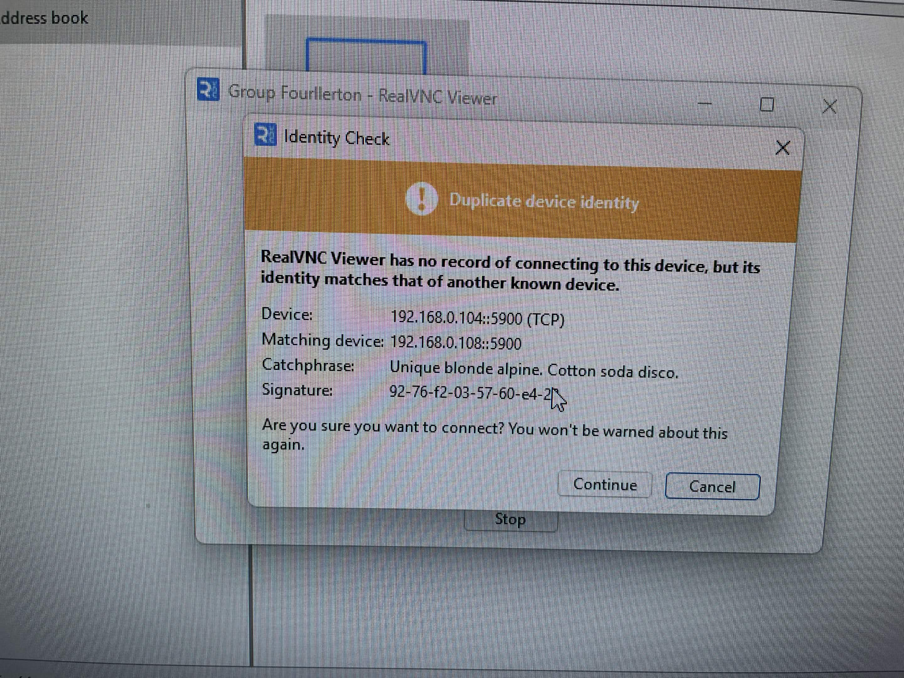
Figure 8. Example duplicate-device-identity warning in RealVNC Viewer.

Our joystick attempt and challenge
- Jiale Jiang first used readJoystick with if/elseif/else conditions to convert joystick input into changes in pixel position. The while loop was intended to read the input repeatedly, update the location, and call writePixel to display the pixel again.
- The pixel did not move when we operated the joystick. We tried to identify the cause but did not resolve it during class.
- We then switched to the course template. We did not have enough time to test it before class ended, so this attempt remained unfinished. We discussed the project and packed up our equipment.

Disconnecting and shutting down
13. Stop the running MATLAB code. Run clearLEDMatrix(mysh), then clear mysh rpi. Clear any other objects using the same connection. This releases MATLAB connections; it does not shut down the Pi.
14. Use the Pi desktop in RealVNC to shut down the operating system. Wait for shutdown to finish before unplugging power. Close the Viewer session and remove your saved connection if required by the lab.

